St Ninian’s High School
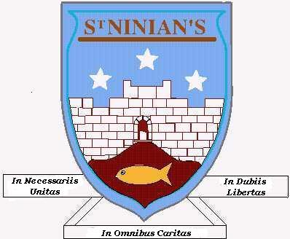

Level E
CHECKLIST


- I understand this part of the course =
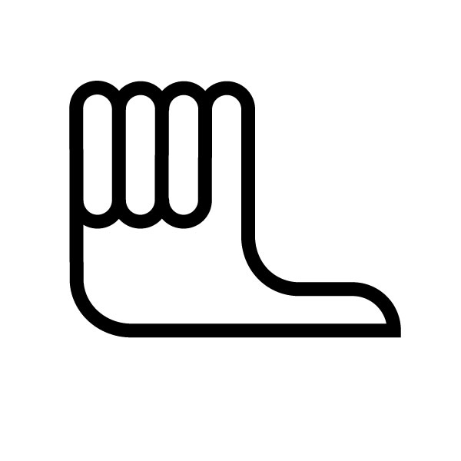
- I am unsure of this part of the course =

- I do not understand this part of the course =

Topic 1 - Whole Numbers (Chapter 1)
1
2
3
4
5

6
7
8.
9
10.

- Place Values
Units, tens, hundreds and thousands etc...

- Addition – Layout important

- Subtraction – Layout important

- Divide by a single digit

- Multiplication by a single digit.

- Multiplication by 10, 100 and 1000
78 x 1000 = 78000 (Add on 3 zeros)

- Division by 10, 100 and 1000
8600 ÷ 100 = 86 (Remove 2 zeros)

- Multiplying by 20, 30 and 500 etc...
83 x 500 = 83 x 100 x 5 = 8300 x 5 etc..

- Division by 20, 30 and 500 etc....
4500 ÷ 500 = 4500 ÷ 100 ÷ 5 = 45 ÷ 5 = 9

- Rounding
2.457 ⇨ 2.5 to 1 decimal place

Topic 2 – Decimal Numbers (Chapter 2)

1
2
3
4
5
6
7
8
- Addition - Layout important

- Subtraction – Layout important

- Divide by a single digit

- Multiplication by a single digit.

- Multiplication by 10, 100 and 1000
  - x 100 = 356 (move point to the right 2 places)

- Division by 10, 100 and 1000
7.38÷ 1000 = 0.0738 (move point to the right 3 places)

- Multiplying by 20, 30 and 500 etc...
  - x 500 = 2.6 x 100 x 5 = 260 x 5 etc..

- Division by 20, 30 and 500 etc....
4795 ÷ 500 = 4795 ÷ 100 ÷ 5 = 47.95 ÷ 5 = 9.99

Topic 3 – Money (Chapter 4)

1. Making up expressions
1
2
3

2x + 1

2. Evaluating an expression

a = 1 b = (-2) c = 5 abc = 1 x (-2) x 5 = -10

3. Like terms

x + x + y + y + x = 3x + 2y

Topic 3 – Algebra (Chapter 4)

1. Making up expressions
1
2
3

2x + 1

2. Evaluating an expression

a = 1 b = (-2) c = 5 abc = 1 x (-2) x 5 = -10

3. Like terms

x + x + y + y + x = 3x + 2y

Topic 4 – Angles (Chapter 3)

1
2
3
4
5
6
- Right Angle
Adds to 90º

- Straight Line
Adds to 180º

- Vertically Opposite
Opposite angles are equal

- Angles around a point.
Adds up to 360º

- Alternate Angles (Z-angles)
Alternate angles are equal

- Corresponding Angles (F-Angles)
Corresponding angles are equal.

%
Topic Test 1 - 4
Topic 5 – Information Handling (Chapter 5)

- Frequency Table (Tally Table)
1
2
3
4
5
Reading and Constructing

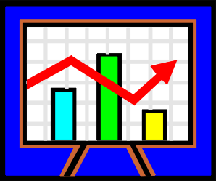
- Bar Charts
Reading and Constructing

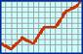
- Line Graphs
Reading and Constructing

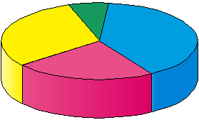
- Pie – Charts
Reading and Constructing

- Mean and Range

Topic 6 – Time & Temperature (Chapter 6)

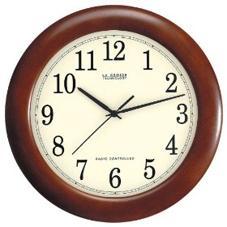
1
2
3
4
1. Converting between 12 / 24 clock
7.30pm ⇨1930 2215⇨1015pm

- Time Intervals
Counting Method
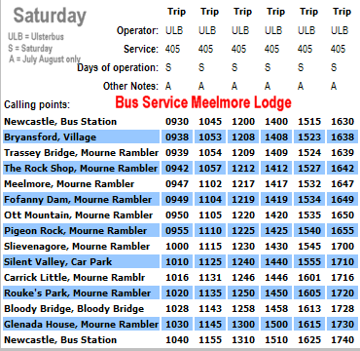

- Interpreting Timetables

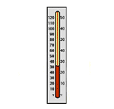
- Numbers below Zero
Thermometer -2ºC,
Seabed -1500ft,
Bank Account -£5

Topic 7 – Position & Movement (Chapter 7)

1. Three Figure Bearings
1
2
3
4
5

e.g. 087º always three figures

2. Back Bearing

Bearing of 120º back bearing is 300º

3. Coordinate Grid /( 4 Quadrants)
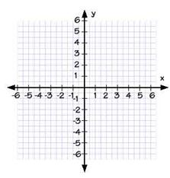
e.g. ( 1,1) ,
(-2,3),
(-4,-5),
(6,-2)

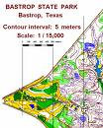
4. Scales on a Map

1 : 300

1cm represents 300cm on the map

5. Scale Drawings

Be able to construct a scale drawing.
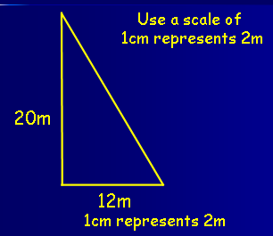

Topic 8 – Algebra (Chapter 8)

1. Solving equations of the type
1
2
3
4
5
6

2y = 6

2. Making up Equations

2y + 8 = 10

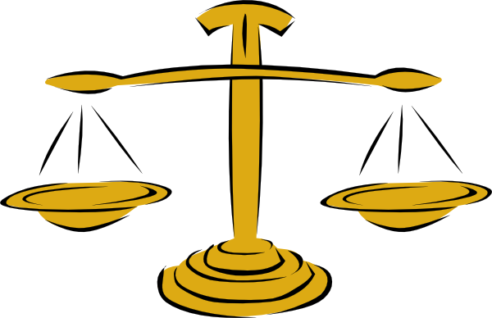
3. Solving Equations
Balancing Method

2x + 5 = 11
2x = 6
x = 3

4. Solving Harder Equations of the type

13 – 3y = 9

5. Solving Equations with Fractions

$\text{10}−\frac{1}{3}y=4$

6. Solving Inequalities

> greater than
< less than
≤ less than or equal to
≥ greater than or equal to
Topic 9 – Measurement (Chapter 9)

1. Perimeter
1
2

3

The outside of a shape

2. Length

Millimetres (mm)
Centimetres (cm)
Metres (m)
Kilometres (km)

3. Working with Scales & Scale Drawing

mm ⇨ (÷10) cm ⇨ (÷100) m ⇨ (÷1000) km

mm ⇦ (x10) cm ⇦ (x100) m ⇦ (x1000) km

1 : 500 means 1cm represents 500cm in real-life

Topic10 – Symmetry & Tiling (Chapter 10)

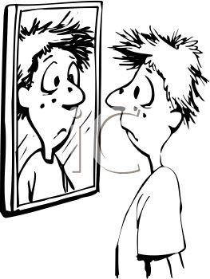
- Reflection
1
2
3
Mirror image

2. Rotational

Order of rotation 1, 2, 3, 4 etc...
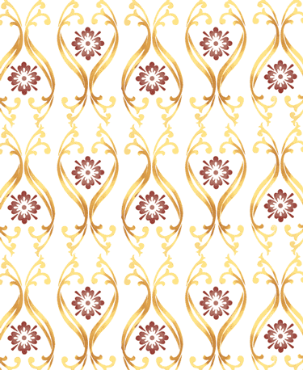
3. Glide

Wallpaper design

%
Topic Test 5 – 10

Topic 11 – Fraction & Percentages (Chapter 15)

- The term Fraction
1
2
3
4
5
6
7

- Equivalent Fraction

- Fraction of a Quantity

- The term Percentage

Out of a 100

- Calculating a Percentage

30% of 80
10% ⇨ 8
30% ⇨ 8x3 = 24

- Improper Fraction & Mixed Numbers

⇨

- Ratio

2 : 3

Topic 12 – Area (Chapter 11)

- Rectangle
1
2
3

B

L

- Triangle

h

b

- Composite

Area that is made up from basic shapes

A₁

A₂

A₃

Topic 13 – Linear Patterns (Chapter 12)

- Square Numbers
1
2
3
4

1, 4, 9, 16, 25, 36 ............

- Triangular Numbers

1, 3,6,10, 15, 21, 28 ............

- Simple Linear Pattern Rule

Find the difference in C

C = 5 g

- Complicated Linear Pattern Rule

Find the difference in b
Find the correction factor

b = 3a + 1

Topic 14 – Triangles (Chapter 13)

- Right-Angle 90º Triangle
1
2

3
4
5

6

7

- Isosceles Triangle

2 sides of equal length

2 angles of equal size

- Equilateral Triangle

3 sides of equal length

3 angles of equal size (60º)

- Angles in a Triangle

Adds to 180º

- Drawing SAS Triangles

ASA = side Angle Side

- Drawing ASA Triangles

ASA = Side Angle Side

- Drawing SSS Triangles

SSS = Side Side Side

Topic 15 – Weight & Volume (Chapter 14)

- Converting Weight
1
2
3

mg ⇨ (÷1000) g ⇨ (÷1000) kg ⇨ (÷1000) Tonnes

mg ⇨ (x1000) g ⇨ (x1000) kg ⇨ (x1000) Tonnes

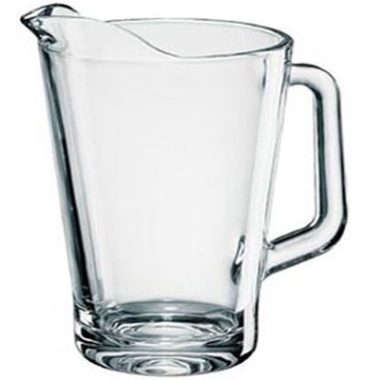
- Convert Units of Liquid

1 litre = 1000 ml

1ml = 1 cm³

- Volume

H
B

L

%
Topic Test 11 - 15

