St Ninian’s High School


Level E
TJ Book
CHECKLIST


- I understand this part of the course =

- I am unsure of this part of the course =

- I do not understand this part of the course =

Topic 1 - Whole Numbers (Chapter 1)
1
2
3
4
5

6
7
8.
9
10.

- Place Values
Units, tens, hundreds and thousands etc...

- Addition – Layout important

- Subtraction – Layout important

- Divide by a single digit

- Multiplication by a single digit.

- Multiplication by 10, 100 and 1000
78 x 1000 = 78000 (Add on 3 zeros)

- Division by 10, 100 and 1000
8600 ÷ 100 = 86 (Remove 2 zeros)

- Multiplying by 20, 30 and 500 etc...
83 x 500 = 83 x 100 x 5 = 8300 x 5 etc..

- Division by 20, 30 and 500 etc....
4500 ÷ 500 = 4500 ÷ 100 ÷ 5 = 45 ÷ 5 = 9

- Rounding
257 ⇨ 300 to nearest hundred

Topic 2 – Decimal Numbers (Chapter 2)

1
2
3
4
5
6
7
8
9
10
11
- Working with decimals

- Decimal scales
Work out what 1 interval means

- Rounding to 1 decimal place
2.357 ⇨ 2.4 to 1 decimal place

- Addition - Layout important

- Subtraction – Layout important

- Divide by a single digit

- Multiplication by a single digit.

- Multiplication by 10, 100 and 1000
  - x 100 = 356 (move point to the right 2 places)

- Division by 10, 100 and 1000
7.38÷ 1000 = 0.0738 (move point to the right 3 places)

- Multiplying by 20, 30 and 500 etc...
  - x 500 = 2.6 x 100 x 5 = 260 x 5 etc..

- Division by 20, 30 and 500 etc....
4795 ÷ 500 = 4795 ÷ 100 ÷ 5 = 47.95 ÷ 5 = 9.99

Topic 3 – Money (Chapter 4)

1. Mixed Money Problems
1
2
3
Bills and costs

2. Foreign Currency

£’s to euro, dollars etc....
(Multiplying by the exchange rate)

3. Converting back.

Euro, dollars etc...to £’s (Divide by exchange rate)

%
E1 Test (Topics 1 – 3)
Topic 4 – Statistics (Chapter 9)

- Mean and Range
1
2
3
4
5
Mean Total of all values ÷ by number of values
Range Highest – lowest

- Frequency Table (Tally Table)
Reading and Constructing

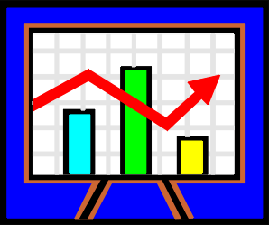
- Bar Charts
Reading and Constructing

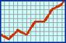
- Line Graphs
Reading and Constructing

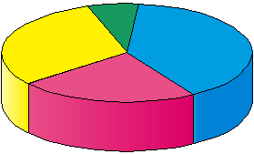
- Pie – Charts
Reading and Constructing

Topic 5 – Time (Chapter 3)

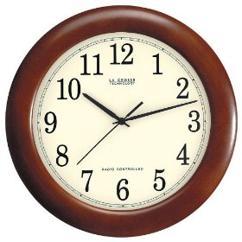
1
2
3
4
1. Converting between 12 / 24 clock
7.30pm ⇨1930 2215⇨1015pm

- Time Intervals
Counting Method
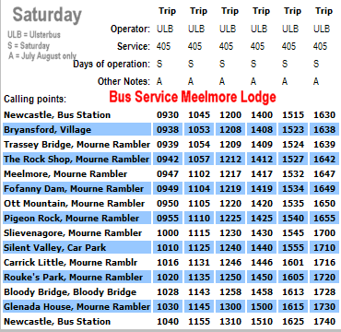

- Interpreting Timetables

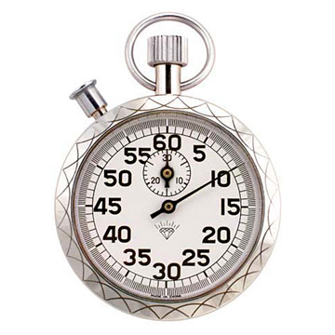
- Minutes, Second and Decimals

Topic 6 – Negative Numbers (Chapter 5)

- Understand – concept of +ve and –ve numbers
1
2
3
4

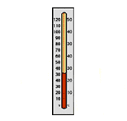
- Simple up and down
using thermometer

- Use thermometer
– to add / sub integers mentally

4. Coordinate Grid /( 4 Quadrants)

e.g. ( 1,1) ,
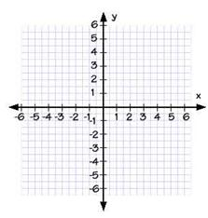
(-2,3),
(-4,-5),
(6,-2)

Topic 7 – Scale Drawings (Chapter 17)

1. Interpreting and using scales
1
2
3
4

1cm represents 300m

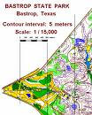
2. Simple Scale Drawing

3. Scale Drawing using a protractor.
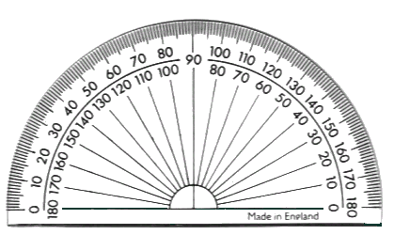

4. Bearings and Scale Drawings
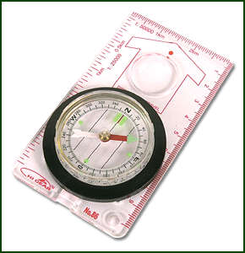

Topic 8 – Solving Equations / Inequations (Chapter 8)

1. Tidying up like terms
1
2
3
4
5
6
7

x + x + y + y + x = 3x + 2y

2. Number Machine

- Evaluating an expression

a = 1 b = (-2) c = 5 abc = 1 x (-2) x 5 = -10

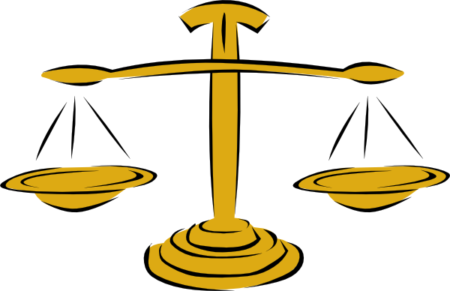
4. Solving Equations
Balancing Method

y + 2 = 10

2w = 8

5. Solving Harder Equations of the type

2x + 5 = 11
2x = 6
x = 3

6. Solving simple Inequalities

> greater than
< less than
≤ less than or equal to
≥ greater than or equal to

7. Solving Inequalities

14x > 140
Topic 9 – Measurement (Chapter 10)

1. Length
1
2

3
4
5

Millimetres (mm)
Centimetres (cm)
Metres (m)
Kilometres (km)

2. Perimeter

The outside of a shape

- Area of a Rectangle

B

L

- Composite Area

Area that is made up from basic shapes

A₁

A₂

- Area of a RAT (Right-Angled Triangle)

h

b

Topic10 – Symmetry & Tiling (Chapter 7)

- Line / Reflection
1
2
3
4
Mirror image

- Rotational / Turn

Half turn, quarter turn etc.....

Order of rotation 1, 2, 3, 4 etc...

- Creating Turn Symmetry


4. Translation / Glide / Slide

Wallpaper design etc....

E2 Test (Topics 4 – 10)
%

Topic 11 – Fraction & Percentages (Chapter 6)

- The term Fraction
1
2
3
4
5
6
7

- Equivalent Fraction

- Fraction of a Quantity

- The term Percentage

Out of a 100

(80 out of 100)

- Finding a Percentage using a calculator

29% of £250

- Finding a Percentage without a calculator

30% of 80
10% ⇨ 8
30% ⇨ 8x3 = 24

- Common Percentages / Fractions

Topic 12 – Volume (Chapter 16)

- Counting Cubes for Volume
1
2
3

- Volume Cuboid

H
B

L

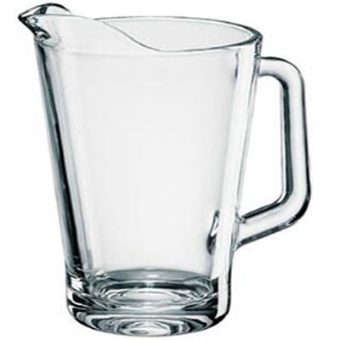
- Liquid Volume

1 litre = 1000 ml = 1000cm³

1ml = 1 cm³

Topic 13 – Linear Patterns (Chapter 11)

- Sequences
1
2
3
4

1, 2, 3, 5,8, 13 ............

- Square & Triangular Numbers

1,4,9,25,36,49,64,81,100 ........

1, 3,6,10, 15, 21, 28 ............

- Simple Linear Pattern Rule

Find the difference in C

C = 5 g

- Complicated Linear Pattern Rule

Find the difference in b
Find the correction factor

b = 3a + 1

Topic 14 – Angles (Chapter 12)
1
2
3
4
5
6
- Type of angles

Acute , Right-Angle , Obtuse , Straight , Reflex

Y
- Naming Angles

B
M
Name is ∠ YBM

- Calculating missing angles.

Right angle 90º
Straight line 180⁰
Opposite angles are equal
Angle round a point 360º

- Angles in a Triangle.

Adds up to 180º

- Corresponding Angles (F-Angles)
Corresponding angles are equal.

- Alternate Angles (Z-angles)
Alternate angles are equal

Topic 15 – Triangles (Chapter 14)

1
2

3
- Drawing SAS Triangles

SAS = Side Angle Side
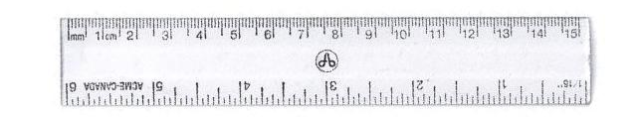

- Drawing ASA Triangles

ASA = Angle Side Angle

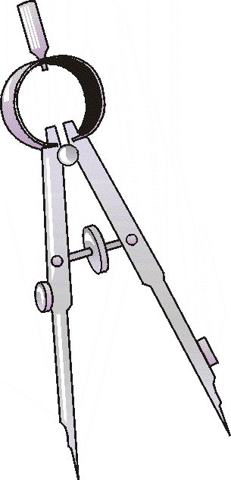

- Drawing SSS Triangles

SSS = Side Side Side

Topic 16 – Ratio (Chapter 15)

- Ratio – used to compare different quantities
1

2

3

2:3

- Simplifying Ratios – (including Fractional Ratios)

- Ratio Calculations

E3 Test (Topic 11 – 16)
%

