St Ninian’s High School


Common Language and Methodology

Teaching Numeracy
St. Ninian’s High School cluster groups

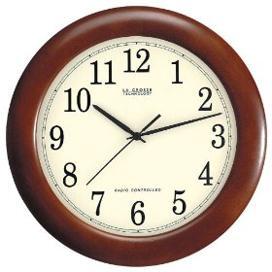
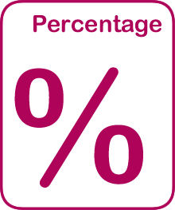
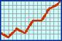

Common Language and Methodology for Teaching Numeracy
3-18
St. Ninian’s High Cluster


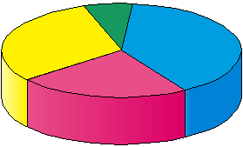

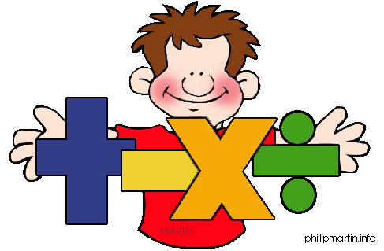

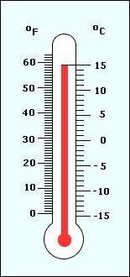

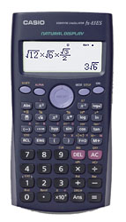

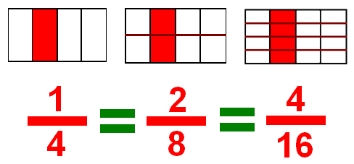

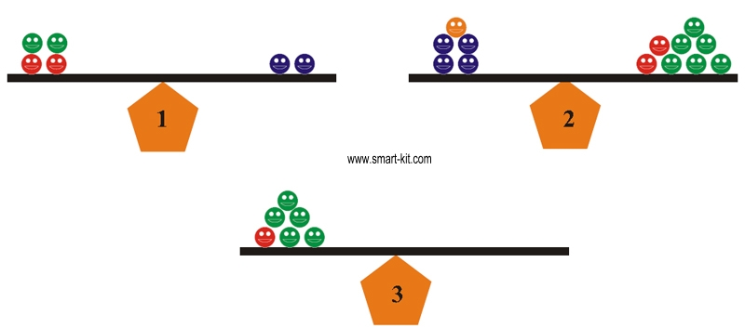

Contents Page

Introduction 1

Common Methodology – Basic Arithmetic 6

- Addition Subtraction Division and Multiplication

- Negative Numbers

Common Methodology – Fractions 11

- Fraction of a quantity

Common Methodology – Percentages 13

- Non – Calculator

- Calculator

Common Methodology – Ratio & Proportion 16

- Ratio

- Ratio – sharing

- Direct Proportion

- Inverse Proportion

Common Methodology – Time 21

- Converting Time

- Time intervals – Counting Method

- Decimal Time

- Time Speed Distance

- Graphs

Contents Page

Common Methodology Information Handling 27

- Terminology

- Pictograms / Pictographs

- Bar Charts / Bar Graphs

- Histogram

- Frequency Polygon

- Frequency Diagram

- Pie Chart

- Line Graph

- Stem Leaf Diagram

- Boxplot

- Scatter Graphs

Common Methodology – Algebra 38

- Evaluating Expressions

- Evaluating Expressions with Negative Numbers

- Tidying up Expressions

- Equations – Balancing Method

- Inequations / Inequalities

Common Methodology – Straight line 49

- Drawing Straight Lines

- Gradient

Introduction

This booklet has been developed to bring a common approach to the teaching of numeracy topics across the St. Ninian’s High School. This approach will help pupils use ideas and processes learned in one subject and apply them across other subjects in different situations.

It is envisaged that this booklet will be reviewed and updated on a regular basis. Members of staff wishing to contribute to this booklet with a new idea or topic should contact the Mathematics Department or bring their suggestion to the next review meeting.

Special thank you to the following for the use of their material

East Renfrewshire
www.mathsrevision.com

Common Methodology for Basic Operation

- Addition Subtraction

- Division and Multiplication

- Negative Numbers

Terminology for Basic Operations

Addition (+)
sum of
more than
add
total
and
plus
Subtraction (-)
less than
take away
minus
subtract
difference between
Multiplication (×)
multiply
times
product
lots of
Division (÷)
divide
share
split
groups of
Equals (=)
is equal to
same as
makes
will be

Addition and Subtraction

- It may be best to avoid the use of “and” when meaning addition e.g. “4 and 2 is 6”
- When “carrying”, the algorithm can be laid out as follows:

5 6
+ 3₁ 9
9 5

The “carry” digit usually sits above the line. Some pupils carry below the line.

Multiplication and Division

$$4|\overline{\text{756}}$$

- This can be said as “ 756 divided by 4”. Start as “7 divided by 4”.
Can be supported if necessary by saying “how many 4’s in 7?”
- When multiplying by one digit, the algorithm can be laid out as follows:

2 6
×₂ 4
1 0 4

The “carry” digit normally sits above the line. Some pupils carry below line.

- When multiplying by two digits, the algorithm can be laid out as follows:
4 7
×5₄ 6
2 8 2
3
2 3₁ 5 0
2 6 3 2

It is important to emphasise the difference between the carrying digits so that when pupils are adding they only include the relevant digits.
- The decimal point stays fixed and the digits “move” when multiplying and dividing.
- It is best not to say “add on a zero” when multiplying by 10. Say “the digits move one place to the left

Negative Numbers

Definition : An INTEGER is a negative or positive
whole number, including 0.

A negative number is less than zero.
-100, -25, -12 and -4 are all negative numbers.
POSITIVE
A positive number is more than zero.
4, 12, 89 and 568 are all positive numbers.
ZERO
The negative sign goes in front of a negative number.
Negative 4 is the same as -4.
° is the symbol for degree.
Celsius or C is a scale for measuring temperature.
6 degrees Celsius is the same as 6°C.
NEGATIVE
Negative temperatures are called below freezing.
Positive temperatures are called above freezing.
A negative number is less than zero

Addition & Subtraction

Multiplication & Division

Summary of Rules

Common Methodology for Fractions

- Fraction of a quantity
Fractions
Common Errors and Misunderstanding
It is useful to reinforce that dividing by ½ is the same as multiplying by 2
Terminology
Numerator means top number
Denominator means bottom number
Unitary fraction of a quantity

Simple fractions of a quantity

for a lower ability group

then

Common Methodology for Percentages

- Non – Calculator

- Calculator
Percentages
(with a calculator)

Pupils will be shown to set out examples in the following way

$\begin{aligned} \text{27}\text{\%}\text{ of }£\text{469} \\ =\frac{\text{27}}{\text{100}}×\text{£469} \\ =\text{27}÷\text{100}×\text{£469} \\ =0\text{.}\text{27 }×\text{ £469} \\ =\text{ £126}\text{.}\text{63}\end{aligned}$
The more able pupils are encouraged to convert the percentage to a decimal as the first line of working, for example
$\begin{aligned} \text{27}\text{\%}\text{ of }£\text{469} \\ =0\text{.}\text{27 }×\text{ £469} \\ =\text{ £126}\text{.}\text{63}\end{aligned}$

Teaching Points
- It is useful to reinforce percent means ‘out of 100’ and of means multiply
- Pupils benefit from showing working vertically with one ‘=’ sign per line
- Pupils should be discouraged from using the % button on a calculator

Percentages
(without a calculator)

Pupils will be shown to calculate amount using the following

$$\text{33}13\text{\%}$$ | $$13$$
$$\text{66}23\text{\%}$$ | $$23$$
Table 2

5% | 10% ÷ 2
2.5% | 5% ÷ 2
Table 3

Lower ability pupils experience more success when they associate percentages with fractions of a pound in pence eg. 20p is 1/5 of a pound, there are five 20 pence’s in £1.

Most percentages will be found using multiples of 10% and/or 1%

Examples

1% | $$1\text{100}$$
10% | $$1\text{10}$$
20% | $$15$$
25% | $$14$$
50% | $$12$$
75% | $$34$$
Table 1

- Find 17.5% of £220

10% is 22
5% is 11
2.5% is 5.5
17.5% is 38.5

C. Find 30% of 1800

10% is 180
30% is 180 × 3 = 540

Common Errors + Teaching Points
- It is useful to reinforce that 10% can be found by dividing by 10
- Many pupils try to divide by 5 to find 5%

Common Methodology for Ratio & Proportion

- Ratio

- Ratio – sharing

- Direct Proportion

- Inverse Proportion

Ratio and Proportion (1)

Ratios are used to compare different quantities.

Pupils will be shown to simplify ratios like fractions.

Example simplify the ratio 10:25 What is the highest number that can be = 2:5 divided into 10 and 25?
It is 5 so divide 10 and 25 by 5.

A ratio in which one of its values is ‘1’, is called a unitary ratio e.g. 1:12

Ratio Calculations should be set out in a table and pupils should put their working at the side.

Example The ratio of cats to dogs in an animal shelter is 4:7.
If there are 35 dogs in the shelter how many cats are there?

What do you multiply 7 by to get 35 ? answer 5

Therefore Cats = 4 x 5 = 20

Ratio and Proportion (2)

If sharing money in given ratios pupils must

● Calculate the number of shares by adding the parts of the ratio together.
● Divide the given quantity by the number of shares to find the value of one share.
● Multiply each ratio by the value of one share to find how the money has been split.

Example : £35 is split between Jack and Jill in the ratio 3:2.
How much does Jack receive and how much does Jill receive?

Solution: Number of shares = 2 + 3 = 5
value of 1 share = £35 ÷ 5 = £7
Jack’s share = 2 x £7 = £14
Jill’s share = 3 x £7 = £ 21.

(Check by adding the value of the shares £14 + £21 = £35 )

Ratio and Proportion (3)
Direct proportion

Pupils will be shown to

● set working out in a table with clear headings.
● divide by the given amount to find the unitary value.
● multiply to find the required amount.
● write final answer under the table.

With direct proportion as one quantity increases so does the other
Example : 6 copies of a textbook cost £69. Find the cost of 4 textbooks.

Textbooks Cost
6 → £69 (given in the question)
1 → £69 ÷ 6 = £11.50 (find out the cost of 1 textbook)
4 → £11.50 x 4 = £46.00 (multiply the cost of 1 by the number
of books you are asked to find the cost of)

The cost of 4 textbooks = £46.00

Ratio and Proportion (4)

Inverse Proportion

With direct proportion as one quantity increases so does the other.
With inverse proportion as one quantity increases the other decreases.

Pupils will be shown to

● Set out working in a table with clear headings.
● Multiply to find out how long/much the unitary value will be.
● Divide to find the required amount
● Write the final answer underneath the table.

Example :
If it takes 5 men 12 hours to paint a fence, how long would it take 6 men?

Solution:
Men Hours
5 → 12 (given in the question)

1 → 5 x 12 = 60 (find out how long it would take 1 man)
6 → 60 ÷ 6 = 10 (divide to find out how long take 6 men).

It takes 6 men 10 hours to paint the fence.

Common Methodology for Time

- Converting Time

- Time intervals – Counting Method

- Decimal Time

- Time Speed Distance

- Graphs

Time (1)
Pupils should be aware that using am and pm is very important when stating time in 12 hour notation. When time is written in 24 hour notation am and pm should not be used. All times written in 24 hour notation should have 4 digits.

Converting 12 hr → 24 hr

e.g. 8.00am → 0800 hrs
10.47am → 1047 hrs
5.15pm → 1715 hrs (5 hours and 15 minutes after 1200)

Converting 24 hr → 12 hr

e.g. 0240 → 2.40am
2345 → 11.45pm

Time (2)
Time Intervals

Pupils will be shown how to work out time intervals by “counting on”.

e.g. Calculate how long it is from 2.25pm to 7.25pm

2.25pm 7.25pm
5 hours

e.g. Calculate how long it is from 8.40am to 3.23pm

8.40am 9.00am 3.00pm 3.23pm.
20 mins 6 hours 23 mins

Total: 6 hours 43 mins

e.g. Calculate how long it is from 2250 to 0210

2250 2300 0200 0210
10 mins 3 hours 10 mins

Total: 3 hours 20 mins

Time (3)

Converting hours and mins to decimals hours

Pupils should already know:

• 30 mins = ½ hour = 0.5 hrs
• 15 mins = ¼ hour = 0.25 hrs
• 45 mins = ¾ hour = 0.75 hrs

hours, mins decimals
Rule
converting minutes to decimal hours → divide by 60
e.g. 24 minutes = 24/60 of an hour = 0.4 hr

3 hours 13 mins = [3 + (13/60)]hrs = [3 + 0.22]hrs = 3.22hrs ( to 2 d.p.)

decimals hours, mins
Rule
converting decimals hours to minutes → multiply by 60
e.g. 0.15 hr = (0.15 x 60) mins = 9 minutes.

3.4 hr = 3 + (0.4 x 60) mins = 3hrs + 24 mins = 3 hrs 24 mins.

Time (4)

Time (5)

Common Methodology for Information Handling

- Terminology

- Pictograms / Pictographs

- Bar Charts / Bar Graphs

- Histogram

- Frequency Polygon

- Frequency Diagram

- Pie Chart

- Line Graph

- Stem Leaf Diagram

- Boxplot

- Scatter Graphs

Information Handling

Discrete Data

Discrete data can only have a finite or limited number of possible values.
Shoe sizes are an example of discrete data because sizes 39 and 40 mean something, but size 39∙2, for example, does not.

Continuous Data

Continuous data can have an infinite number of possible values within a selected range.
e.g. temperature, height, length.

Non-Numerical Data (Nominal Data)

Data which is non-numerical.
e.g. favourite TV programme, favourite flavour of crisps.

Tally Chart/Table (Frequency table)

A tally chart is used to collect and organise data prior to representing it in a graph.

Averages

Pupils should be aware that mean, median and mode are different types of average.

Mean: add up all the values and divide by the number of values.
Mode: is the value that occurs most often.
Median: is the middle value or the mean of the middle pair of an ordered set of values.

Pupils are introduced to the mean using the word average. In society average is commonly used to refer to the mean.

Range

The difference between the highest and lowest value.

Pictogram/pictograph

A pictogram/pictograph should have a title and appropriate x and y-axis labels.
If each picture represents a value of more than one, then a key should be used.

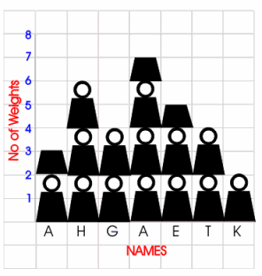
MEAN
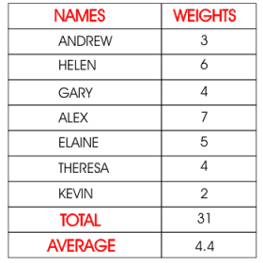
Represents 2 weights
Bar Chart/Graph

A bar chart is a way of displaying discrete or non-numerical data. A bar chart should have a title and appropriate x and y-axis labels. An even space should be between each bar and each bar should be of an equal width. Leave a space between the y-axis and the first bar. When using a graduated axis, the intervals must be evenly spaced.

Histogram

A histogram is a way of displaying grouped data. A histogram should have a title and appropriate x and y-axis labels. There should be no space between each bar. Each bar should be of an equal width. When using a graduated axis, the intervals must be evenly spaced.
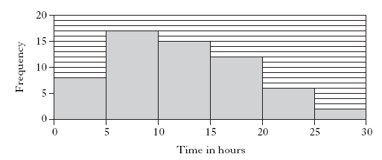

Frequency Polygon

To draw a frequency polygon, draw a histogram then join the midpoints of the top of each bar. It is then optional, whether or not you remove the bars. Frequency polygons are useful when comparing two sets of data.

Frequency Diagrams

Pie Charts

A pie chart is a way of displaying discrete or non-numerical data.
It uses percentages or fractions to compare the data. The whole circle (100% or one whole) is then split up into sections representing those percentages or fractions. A pie chart needs a title and a key.

In a recent survey, 90 people were asked for their favourite colour. The results are as follows:

Colour | Frequency | Working | Angle
Green | 35 | (35 ÷ 90) x 360 | 140˚
Blue | 20 | (20 ÷ 90) x 360 | 80˚
Red | 16 | (16 ÷ 90) x 360 | 64˚
Pink | 11 | (11 ÷ 90) x 360 | 44˚
Other | 8 | (8 ÷ 90) x 360 | 32˚

Line Graphs

Line graphs compare two quantities (or variables). Each variable is plotted along an axis. A line graph has a vertical and horizontal axis. So, for example, if you wanted to graph the height of a ball after you have thrown it, you could put time along the horizontal, or x-axis, and height along the vertical, or y-axis.

A line graph needs a title and appropriate x and y-axis labels. If there is more than one line graph on the same axes, the graph needs a key.

Stem-and-leaf diagram

A stem-and-leaf diagram is another way of displaying discrete or continuous data. A stem-and-leaf diagram needs a title, a key and should be ordered. It is useful for finding the median and mode. If we have two sets of data to compare we can draw a back-to-back stem-and-leaf diagram.

Example: The following marks were obtained in a test marked out of 50. Draw a stem and leaf diagram to represent the data.

3, 23, 44, 41, 39, 29, 11, 18, 28, 48.

Split the data into a stem and a leaf. Here the tens part of the test mark is the stem. The units part of the test mark is called the leaf.

Unordered stem-and-leaf diagram showing test marks out of 50

0 | 3
1 | 1 8
2 | 3 9 8
3 | 9
4 | 4 1 8
1| 3 means 13 out of 50 n = 10

The diagram can be ordered to produce an ordered stem and leaf diagram.

Ordered stem-and-leaf diagram showing test marks out of 50

0 | 3
1 | 1 8
2 | 3 8 9
3 | 9
4 | 1 4 8

1| 3 means 13 out of 50 n = 10

Boxplot Diagram

A boxplot is used to compare two datasets.

A five figure summary is used to construct a boxplot.

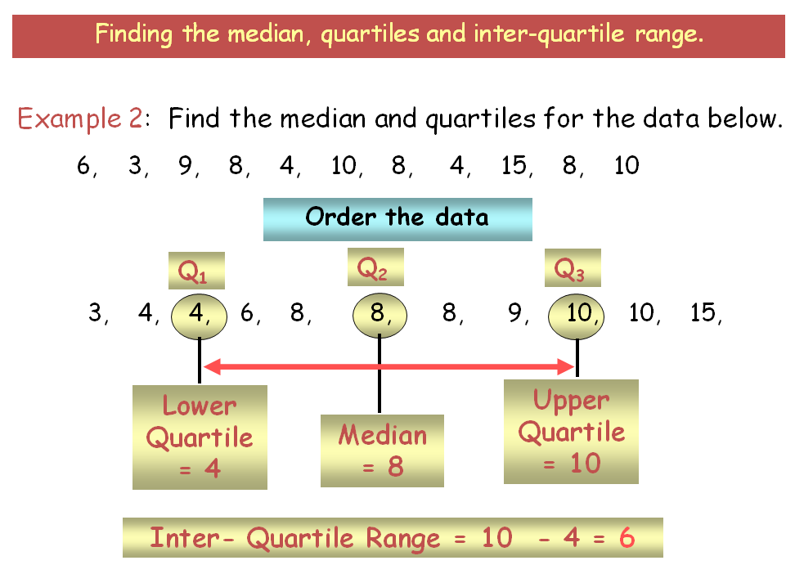

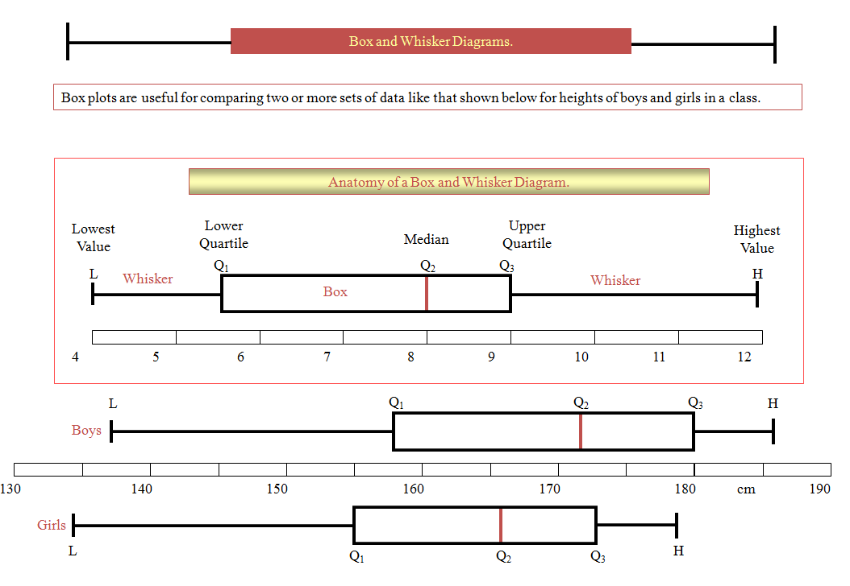

Scattergraphs (Scatter diagrams)

A scattergraph allows you to compare two quantities (or variables). Each variable is plotted along an axis. A scattergraph has a vertical and horizontal axis. It needs a title and appropriate x and y-axis labels. For each piece of data a point is plotted on the diagram. The points are not joined up.

A scattergraph allows you to see if there is a connection (correlation) between the two quantities. There may be a positive correlation when the two quantities increase together e.g. sale of umbrellas and rainfall. There may be a negative correlation were as one quantity increases the other decreases e.g. price of a car and the age of the car. There may be no correlation e.g. distance pupils travel to school and pupils’ heights.

Common Methodology for Algebra

- Valuating Expressions

- Evaluating Expressions with Negative Numbers

- Tidying up Expressions

- Equations – Balancing Method

- Inequations / Inequalities

Evaluating Expressions or Substitution

Staff need to make clear the difference between an expression

has no equals sign, e.g. $x−4$

that can be simplified or evaluated, and an equation

contains an equals sig, e.g. $x−4=8$ which can be solved.

Pupils should start by writing down the expression. Equals signs should appear on the next line on the left hand side. The letter should be substituted (replaced).
Pupils need to be clear on the order of operations (Brackets, Of, Division, Multiplication, Addition and then Subtraction i.e. BODMAS).

Example 1: Find the value of the expression $x−4$ if $x=\text{10}$.
This line where the substitution takes place must be shown.
Marks are awarded in examinations for demonstrating this step.

$$\begin{aligned}x−4 \\ =\text{10}−4 \\ =6\end{aligned}$$

Example 2: Find the value of $3y+2$ if $y=6$.
Pupils need to know 3y means 3×y
$$\begin{aligned}3y+2 \\ =3×6+2 \\ =\text{18}+2 \\ =\text{20}\end{aligned}$$

Example 3: Find the value of $5m+4n$ if $m=2$ and $n=4$.

$$\begin{aligned}5m+4n \\ =5×2+4×4 \\ =\text{10}+8 \\ =\text{18}\end{aligned}$$

Simplifying Expressions

The examples below are expressions not equations. We can simplify expressions by collecting like terms.

Example 1
Equals signs on left hand side.
Simplify

$$\begin{aligned}a+a+a \\ =3a\end{aligned}$$

Example 2

To start with, pupils should identify like terms, including the operator in front of it by using circles and squares. As pupils get used to simplifying they may stop using the shapes.

Simplify

$\begin{aligned}5x+3x−4x \\ =4x\end{aligned}$

Example 3

Simplify

$\begin{aligned}3y+2+5y+6 \\ =8y+8\end{aligned}$ or $\begin{aligned}3y+2+5y+6 \\ =8+8y\end{aligned}$

The convention in maths is to write the answer with the letters first, in alphabetical order, followed by number.

Example 4

Simplify

$$\begin{aligned}5x+3y+6+8x+4y−2 \\ =\text{13}x+7y+4\end{aligned}$$

Solving Simple Equations

The method used for solving equations is balancing. It is useful to use scales like the ones below to introduce this method as pupils can visibly see how the equation can be solved.

Many resources introduce equations by using the “cover up” method. Pupils should not use this method as it can cause difficulties later on. Instead staff should introduce pupils to the idea of balancing. Some equations, which can be solved easily by the cover up method but not by balancing, should be left until Level F
e.g. $8−x=2$, or $\text{12}−3x=9$.

x
x
x
This represents the equation
3x + 2 = 8
See example 3 below

=

Example 1: Solve x + 5 = 8
Line up equals signs

$x+5=8$
$x+5−5=8−5$
$x=3$

Pupils should be encouraged to think of carrying out the same operation to both sides. As they become more comfortable with this process (aware that on the left adding 5 and subtracting 5 leaves zero), they may write the following, but staff should continue to use balancing language.

$x+5=8$
$x=8−5$
$x=3$

Pupils should be encouraged to check their answer mentally by substituting it back into the original equation.

Example 2: Solve 4m = 20

$4m=\text{20}$
$\frac{4m}{4}=\frac{\text{20}}{4}$
$m=5$

In time this should become:

$4m=\text{20}$
$m=\frac{\text{20}}{4}$
$m=5$

Example 3: Solve 3x + 2 = 8

$$3x+2=8$$
$3x=8−2$
$3x=6$
$x=\frac{6}{3}$
$x=2$

Solving Inequations

We solve Inequations by using the same method as equations. The setting out will be the same.

Example 1:

Solve the inequation x + 3 > 6 choosing solutions from {0, 1, 2, 3, 4, 5, 6}

x + 3 > 6
x > 6 − 3
x > 3

x = {4, 5, 6}

At Level F and Intermediate 1, a range of answers is not given therefore the answer is expressed as an inequality. More able pupils should be introduced to how to display the answer visually on a number line, in preparation for more complex Inequations at National Qualification level.

Example 2

Solve x + 5 ≥ 7

$$x+5≥7$$
$x≥7−5$
$x≥2$

0
1
2
3
4
5
−1
−2
−3
−4
•

Note that if the value is included in the solution, i.e. 2 here, this is represented by a filled dot.

Example 3

Solve x + 3 < 4

$$x+3<4$$
Note that if the value is not included in the solution, i.e. 1 here, this is represented by an open dot.
$x<4−3$
$x<1$

0
1
2
3
4
5
−1
−2
−3
−4
○

Expanding Brackets

In the examples below, an expression is to be expanded, not an equation. Multiply all the terms inside the brackets by the number or letter directly in front. Pupils should be familiar with the terminology: multiplying out, expand, remove, rewrite without brackets.

Example 1

Expand the brackets: $3(x+1)$
Emphasis that this is
(x + 1) + (x + 1) + (x +1)

Answer:
$$\begin{aligned}3(x+1) \\ =3×x+3×1 \\ =3x+3\end{aligned}$$

Example 2

Expand the brackets: $3(1−x)$

Answer:
$$\begin{aligned}3(1−x) \\ =3−3x\end{aligned}$$

Example 3

Expand the brackets: $2(2+5x)$

Answer:
$$\begin{aligned}2(2+5x) \\ =4+\text{10}x\end{aligned}$$

Example 4

Expand the brackets: $x(4x+1)$

Answer:
$$\begin{aligned}x(4x+1) \\ =4x^{2}+x\end{aligned}$$
Example 5

Expand the brackets: $2a(a+3b)$

Answer:
$$\begin{aligned}2a(a+3b) \\ =2a^{2}+3\text{ab}\end{aligned}$$

Example 6

Expand the brackets: $3+5(2x+7)$
Expand brackets first. Then collect like terms.
Answer:
$$\begin{aligned}3+5(2x+7) \\ =3+\text{10}x+\text{35} \\ =\text{10}x+\text{38}\end{aligned}$$

Example 7

Expand the brackets: $−4(3x−1)$

Answer:
$$\begin{aligned}−4(3x−1) \\ =−\text{12}x+4\end{aligned}$$

Example 8

Expand the brackets: $2−(5y+2)$

Answer:
$$\begin{aligned}2−(5y+2) \\ =2−1(5y+2) \\ =2−5y−2 \\ =−5y\end{aligned}$$
Expand brackets first. Then collect like terms.
Evaluating Expressions with Negative Numbers

When using negative numbers in expressions, put brackets round the negative numbers.

If $r=−6$, $s=−5$ and $t=2$ evaluate the following:
1. $\text{rst}$
2. $r−s−t$
3. $3s+r−4t$
4. $2t+4r$
5. $2s^{2}$

Example 1:
- When multiplying 2 numbers with the same sign the answer is positive.
- When multiplying 2 numbers with different signs the answer is negative.
- Similarly for division.
- Avoid saying “two negatives make a positive.”

$$\begin{aligned}\text{rst} \\ =(−6)×(−5)×2 \\ =\text{60}\end{aligned}$$

Example 2:

$$\begin{aligned}r−s−t \\ =(−6)−(−5)−2 \\ =−6+5−2 \\ =−3\end{aligned}$$
Subtracting a negative, change to addition.

Example 3:

$$\begin{aligned}3s+r−4t \\ =3×(−5)+(−6)−4×(2) \\ =−\text{15}−6−8 \\ =−\text{29}\end{aligned}$$
Adding a negative, change to subtraction.

Example 4:

$$\begin{aligned}2t+4r \\ =2×2+4×(−6) \\ =4−\text{24} \\ =−\text{20}\end{aligned}$$

Example 5:
$$\begin{aligned}2s^{2} \\ 2×(−5)^{2} \\ 2×\text{25} \\ \text{50}\end{aligned}$$
Equations

Make the coefficient of x positive.
Example 1: Solve 10−2x = 4

$$\text{10}−2x=4$$
$\text{10}=4+2x$
$\text{10}−4=2x$
$6=2x$
$\frac{6}{2}=x$
$3=x$
$x=3$

NB:
Always deal with the variable before the constants, ensuring that the variable is written with a positive coefficient.
This avoids errors when dividing by negatives and also avoids learning rules for dealing with Inequations.
Example 2: Solve 3x + 2 = x + 14

$$3x+2=x+\text{14}$$
$$3x−x=\text{14}−2$$
$2x=\text{12}$
$x=\frac{\text{12}}{2}$
$x=6$

Example 3: Solve $−3x=8−x$
Make the x terms positive.

$−3x=8−x$
$0=8−x+3x$
$0=8+2x$
$0−8=2x$
$\frac{−8}{2}=x$
$−4=x$
$x=−4$

Pupils need to have a good understanding of the different ways that expressions involving fractions can be written. Pupils should be able to use the different formats as appropriate.

e.g. $\frac{1}{2}x≡\frac{x}{2}$
$\frac{2}{5}y≡\frac{2y}{5}$
$−\frac{3}{4}m≡\frac{−3m}{4}≡\frac{3m}{−4}≡−\frac{3m}{4}$

Example 4: Solve $\frac{x}{4}=3$
Emphasise to the pupils that they are doing the same thing to both sides.

$\frac{x}{4}=3$
$4×\frac{x}{4}=4×3$
$x=\text{12}$

As pupils become more comfortable with this process (and aware that that multiplying by 4 on the left makes the coefficient of x one), this may become:

$\frac{x}{4}=3$
$x=4×3$
$x=\text{12}$

Example 5: Solve $\frac{1}{3}w=5$

$\frac{1}{3}w=5$
$\frac{w}{3}=5$
$w=3×5$
$w=\text{15}$

Common Methodology for Straight Line

- Drawing Straight Lines

- Gradient

Straight Line

At Intermediate 1, pupils need to be able to draw a straight line given its equation by using a table of values.

Example 1: Draw the straight line $y=2x+3$

Set up a table of values by choosing three easy/appropriate values for x. Setting the table out vertically allows pupils to see the coordinates easily, and allows the working to be completed easily.

x | y
0 | $$\begin{aligned}2×0+3 \\ =3\end{aligned}$$
1 | $$\begin{aligned}2×1+3 \\ =5\end{aligned}$$
2 | $$\begin{aligned}2×2+3 \\ =7\end{aligned}$$  Extend the line in both directions.

y
 |  |  |  | 7 |  | x
 |  |  |  | 6
 |  |  |  | 5 | x
 |  |  |  | 4
3
x
 |  |  |  | 2
 |  |  |  | 1
−4 | −3 | −2 | −1 |  |  |  |  |  | x
 |  |  |  | 0  −1 | 1 | 2 | 3 | 4
 |  |  |  | −2
 |  |  |  | −3
 |  |  |  | −4

$y=2x+3$ is a description of a set of points which gives a straight line.

If staff refer to the equation for a straight line they should use $y=\text{mx}+c$ rather than $y=\text{ax}+b$, this will avoid confusion later on.

Students should be familiar with the different ways of calculating the gradient.

$$m=\frac{\text{Vertical}}{\text{Horizontal}}=\frac{y_{2}−y_{1}}{x_{2}−x_{1}}$$

A line that slopes up (uphill) from left to right has a positive gradient. A line that slopes down (downhill) from left to right has a negative gradient.

Students need to be clear about the two special straight lines:

Equations of the form $x=a$ represent vertical straight lines.
They have a gradient that is undefined.

Equations of the form $y=b$ represent horizontal straight lines.
They have a zero gradient.

Students should be able to draw straight lines by using a table of values (as before) and by using the gradient and y-intercept. This second method will also allow them to work out the equation of the straight line given the graph.

Example 2: Draw the straight line $y=\frac{1}{2}x+1$

$m=\frac{1}{2}$, this means that the line goes 2 along in the x-direction
and 1 up in the y-direction.
$$c=1$$
y
 |  |  |  | 4
 |  |  |  | 3 |  |  |  | x
 |  |  |  | 2 |  | x |  | Start with the coordinate of the y-intercept, move along and plot 2 more points.
1
x
−4 | −3 | −2 | −1 |  |  |  |  |  | x
 |  |  |  | 0  −1 | 1 | 2 | 3 | 4
 |  |  |  | −2
 |  |  |  | −3
 |  |  |  | −4

