St Ninian’s High School


Mathematics Department Curriculum for Excellence
N4 Numeracy
TJ Lifeskills Book
Pupil Learning Log


- I understand this part of the course =

- I am unsure of this part of the course =


- I do not understand this part of the course =

Topic 1 - Whole Numbers (Chapter 1)
1

2

3

4

5

- Rounding to nearest Whole Number

5.7 → 6

- Rounding to nearest 10, 100 and 1000

99144 → 99000

- Significant Figures & Estimating

3600 → 4000 to 1 sig, fig.
3469 → 3470 to 3 sig, fig

- Multiplication / Divide 10, 100 and 1000

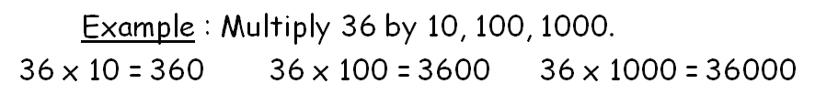

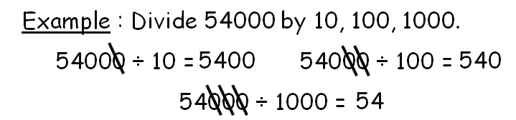

- Multiplication / Divide 20, 300 and 7000

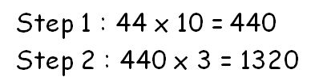

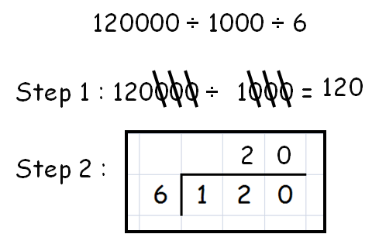

Topic 2 – Decimal Numbers (Chapter 2)

1

2

3

4

- What is a decimal ?


= 1.31

- Decimal scales
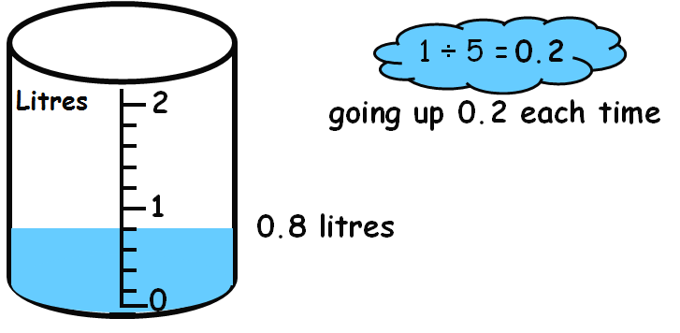

- Rounding
. 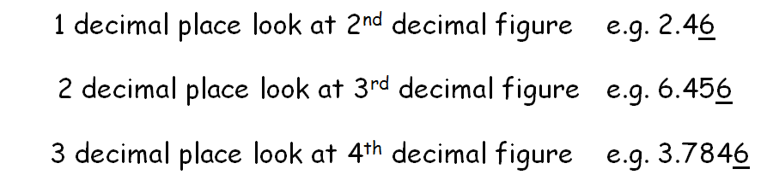

- Addition / Subtract - Layout important

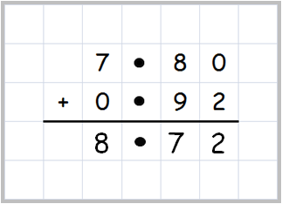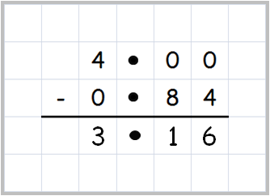

1

2

3

4

- Multiplication by a single digit.

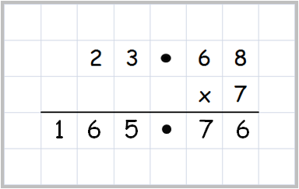

- Divide by a single digit

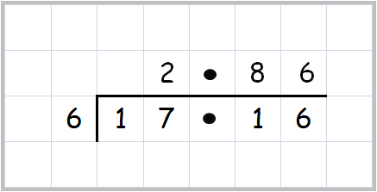

- Multiplication by 10, 100 and 1000

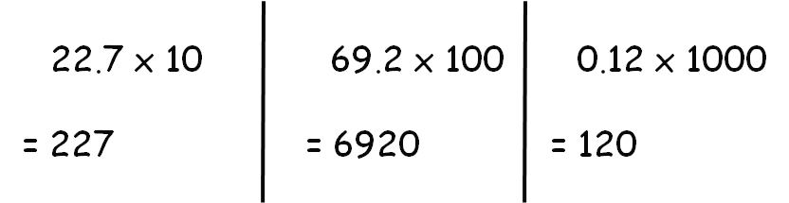

- Division by 10, 100 and 1000

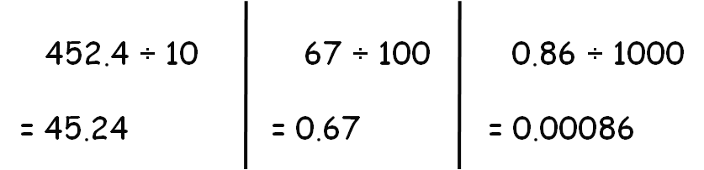

Topic 3 – Fraction & Percentages (Chapter 3)

- Conversion between Fraction Decimal Percentages
1

2

3

4

- Finding a Percentage using a calculator

29% of £250

- Percentage Rise

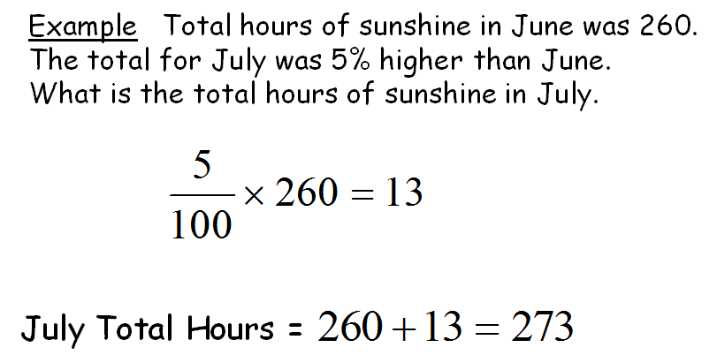

- Percentage Fall

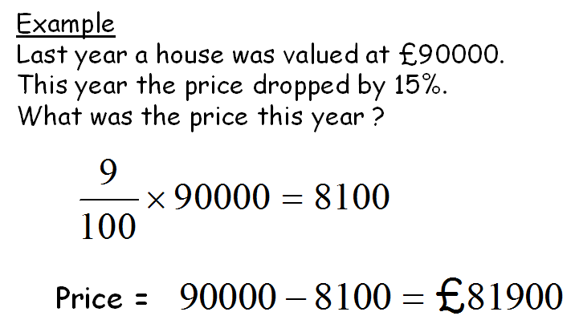

Topic 4 – Fractions (Chapter 4)
- Simplifying a Fraction
1

2

3

4

Find HCF

- Fraction of a Quantity

- Simple Percentages

- More Basic Percentages

Topic 5 – Distance Speed Time (Chapter 5)

1
2

3

4

5

1. Revision of time – conversions and time intervals



2. Distance ( Remember to convert time ! )

$D=\text{ST}$ $\text{15 mins }=0\text{.}\text{25}\text{ hr}$
$\text{30 mins }=0\text{.}5\text{ hr}$ $\text{45 mins }=0\text{.}\text{75}\text{ hr}$

3. Speed ( Remember to convert time ! )

$$S=\frac{D}{T}$$

4. Time

$$T=\frac{D}{S}$$

5. Mixed questions

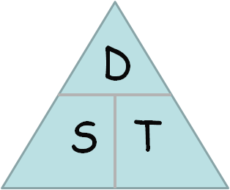

Topic 6 – Area and Perimeter (Chapter 6)

1

2

3

4

5

- Area – Counting Squares

- Area of a Rectangle

B

L

3. Perimeter

The outside of a shape

4. Measuring lengths

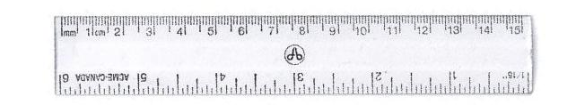

- Measuring Angles

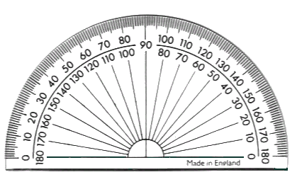

Topic 7 – Integers (Chapter 7)
1

2

3

- Understand – concept of +ve and –ve numbers

Context – Temperature , Bank and Height

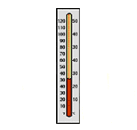
- Use thermometer
– to add / sub integers mentally

- Add / Subtract Mathematically

(-4) + (-8) = -12

(-3) – 7 = -10

6 – 8 = -2

Topic 8 – Ratio and Proportion (Chapter 8)

- Understanding Simple Ratios
1

2

3

4

5

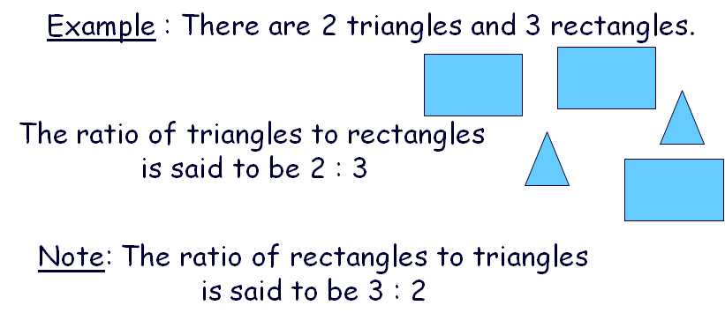

- Simplifying Ratios

6 : 24 is simplified to 1 : 4

- Ratio Calculations

- Unitary (for 1) Proportion

- Direct Proportion

Books £
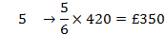

Topic 9 – Conversion (Chapter 9)

1. Length
1

2

3

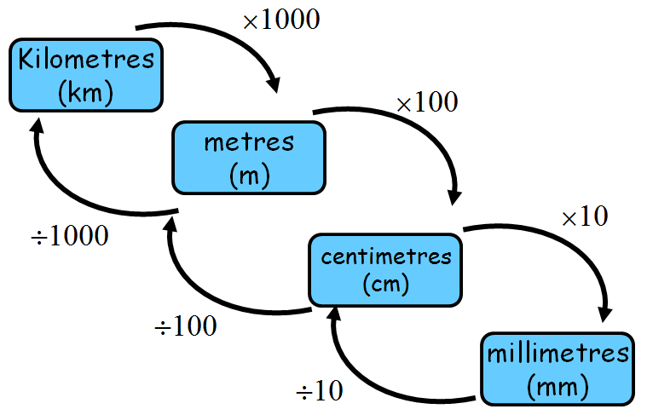

2. Volume

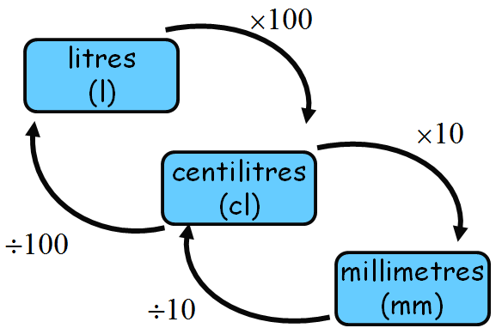

- Weight

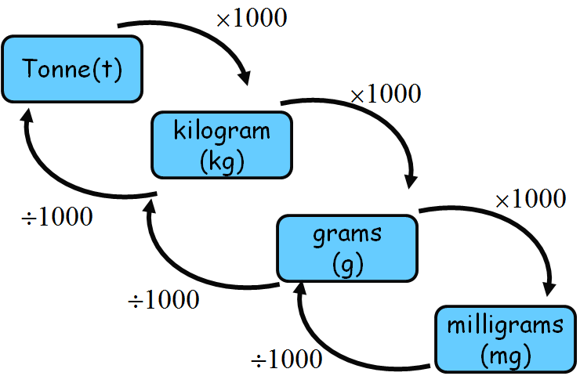

Topic 10 – Volume (Chapter 10)

1

2

3

- Counting Cubes for Volume

- Volume Cuboid

H
B

L

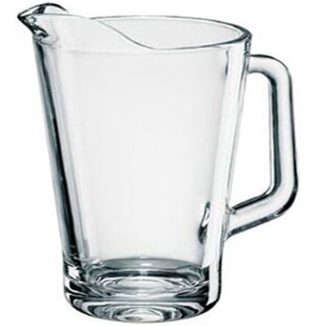
- Liquid Volume

1 litre = 1000 ml = 1000cm³

1ml = 1 cm³

Topic 11 – Graphs Charts and Tables (Chapter 11)

- Interpreting Graphs
1

2

3

4

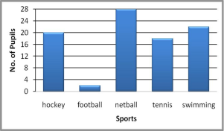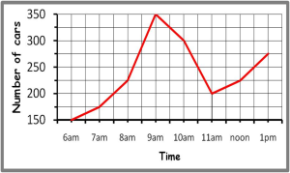
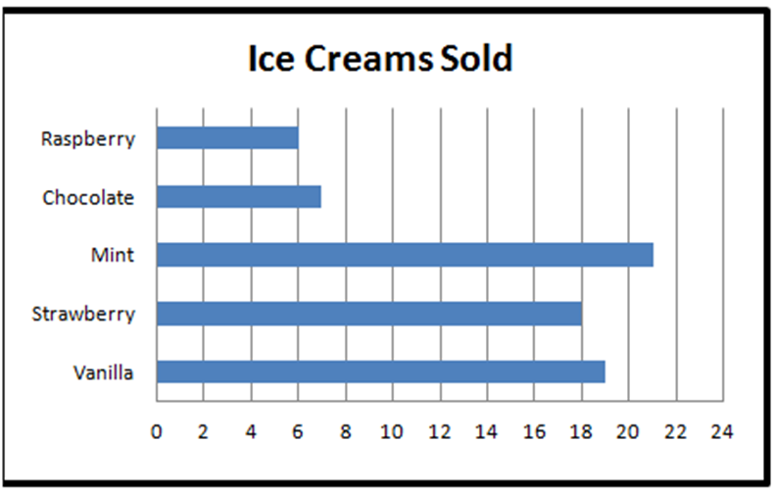
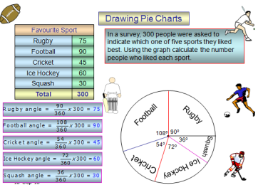

- Scattergraphs
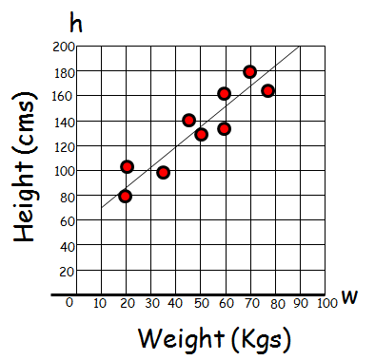

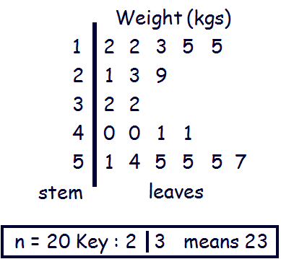
- Stem and leaf Diagrams

- Interpreting Tables

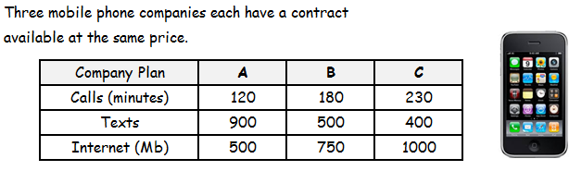

Topic 12 – Probability (Chapter 12)
1

2

- Likelihood Line

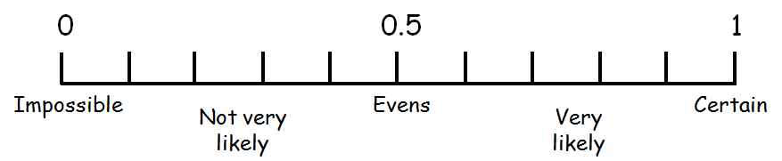

- Simple Probability

To work out probability

Range is between 0 and 1

My Achievements
Skill | Activity | Date & Teacher Signature

My Achievements
Skill | Activity | Date & Teacher Signature

