St Ninian’s High School



Mathematics Department Level 3
TJ Book
Pupil Learning Log


- I understand this part of the course =

- I am unsure of this part of the course =


- I do not understand this part of the course =

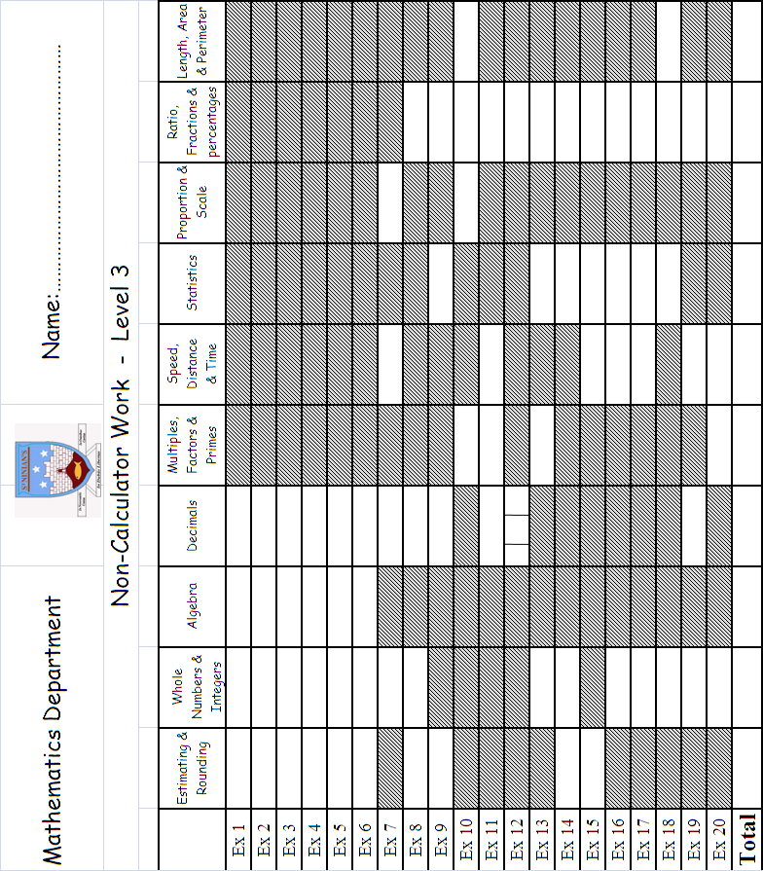
Topic 1 - Integers (Chapter 2)
1

2

3

4

5

- Understand – concept of +ve and –ve numbers

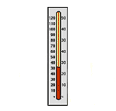
- Use thermometer
– to add / sub integers mentally

- The double negative

(-3) – (-7) = 4

- Multiplication of integers.

(-2) x 5 = -10
(-5) x(-6) = 30

- Division of integers

(-80) 5 = -16
(-16) (-2) = 8

Topic 2 – Type of Numbers (Chapter 5)

1

2

3

- Multiples and L.C.M. ( Lowest Common Multiples)

For 4 and 12 LCM = 12

- Factors and H.C.F. ( Highest Common Factor)

For 4 and 12 HCF = 4

- Prime Numbers and prime decomposition.

12 = 2 x 2 x 3

Topic 3 – Scientific Notation (Chapter 7)

1. Large Numbers – scientific notation
1
2

3

$\text{456000}=4\text{.}\text{56}×{\text{10}}^{5}$

2. Scientific Notation to normal form

$$2\text{.}3×{\text{10}}^{3}→\text{2300}$$

3. Small numbers – scientific notation and vice-versa

$0\text{.}\text{00743}=7\text{.}\text{43}×{\text{10}}^{−3}$

Topic 4 – Decimals (Chapter 13)

1
2
3
4

5

6

7
8
9
- Revision - Level E decimals.

- Addition / Subtraction – decimals.

Decimal point must be under each other.

- Multiplying - decimal by a single digit.

- Division – decimal by a single digit.

$$5\frac{8\text{.}\text{16}}{|\text{40}\text{.}\text{80}}$$

- Multiplying – two simple decimals.

0.2 x 0.2 = 0.04

- Dividing – two simple decimals.

$$0\text{.}8÷0\text{.}2=8÷2=4$$

- Rounding – to any number of decimal places.

$7\text{.}\text{835}→7\text{.}\text{84}$ (to 2 d.p.)

- Rounding – to significant figures.

$\text{6793}→\text{6800}$to 2 sig. fig.

- Money Calculations

Topic 5 – Angles (Chapter 3)

1

2

3

- Revision - Level E angles.

- Interior and exterior angles

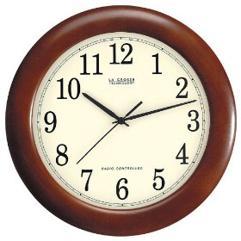
- Clock Face

Topic 6 – Algebra (Chapter 11)

1

2

3

4

5

- Simplifying – expressions

12y + 5m – 3y + 3m = 9y + 8m

- Expanding - brackets

3( p + 7 ) = 3p + 21

- Simplifying – expressions with brackets

8( h + 3) – 8h = 8h + 24 – 8h = 24

- Evaluating – expressions

a = 1 b = (-3) c = 4

abc = 1 x (-3) x 4 = -12

- Factorise - expressions

3y² – 6y = 3y( y – 2 )

Topic 7 – Statistics (Chapter 17)

1. Terminology – Mean, median, mode and range.
1

2

3

4

5

6

7

8

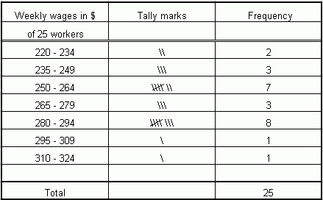

2. Frequency Tables.

3. Mean – from a frequency table.

- Cumulative Frequency tables – median.
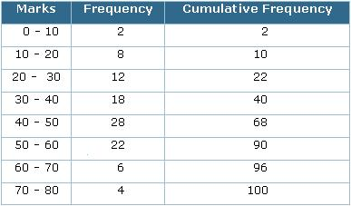
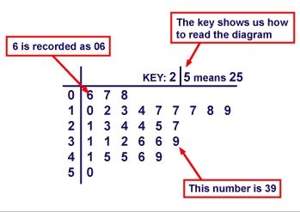

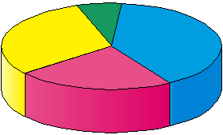
- Construct – Pie Charts

- Stem and Leaf diagrams.

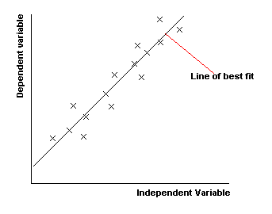
- Scattergraphs

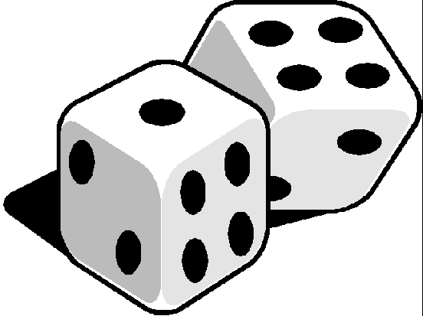
- Probability
The chance of an event happening

F1 – Test (Topics 1-7)

For my F1 test I will

Next Steps

Guardian’s Signature : ___________________________

Topic 8 – Time Distance Speed (Chapter 47)

1
2

3

4

5

6

1. Revision of time – conversions and time intervals


2. Speed ( Remember to convert time ! )

$S=\frac{D}{T}$

3. Distance ( Remember to convert time ! )

$$D=\text{ST}$$

4. Time

$$T=\frac{D}{S}$$

5. Mixed questions

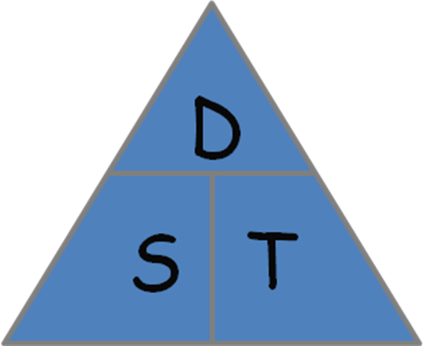

6. Time / Distance / Speed graphs

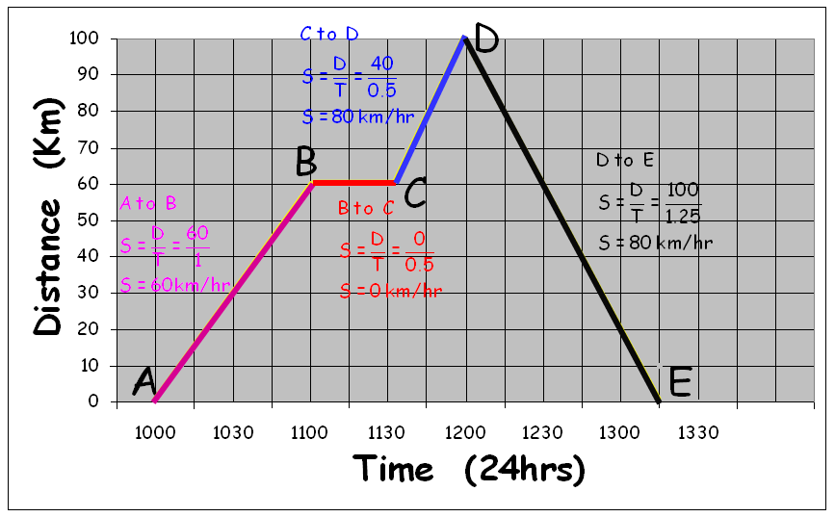
Topic 9 – Scales & Drawing (Chapter 37)

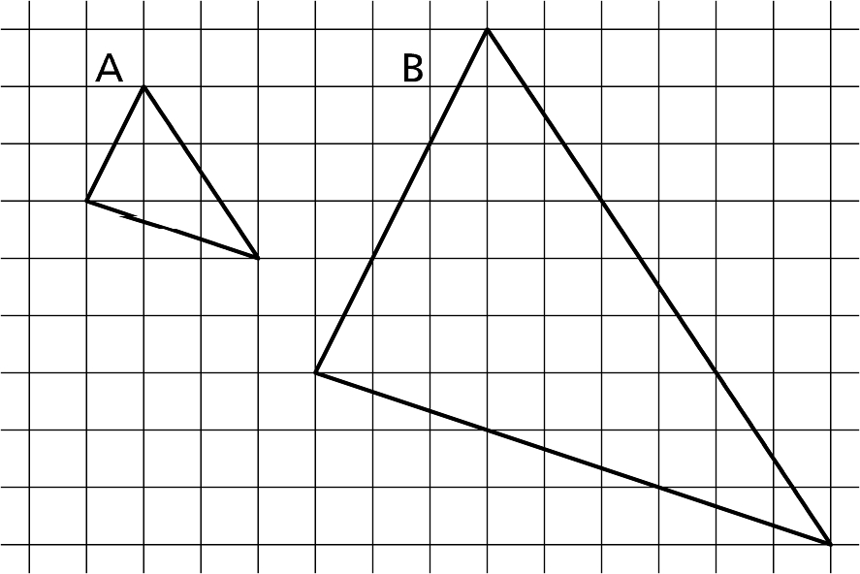
1. Enlargement & Reduced shapes
1

2

3

4

5

2. Revise drawing triangles

3. Drawing Quadrilaterals
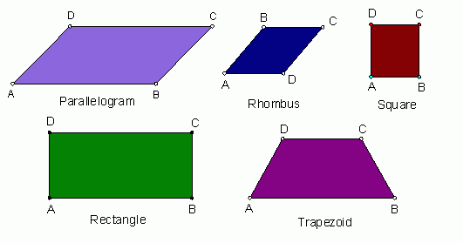

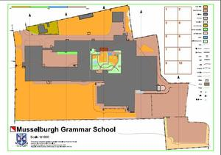
4. Scales - reading maps

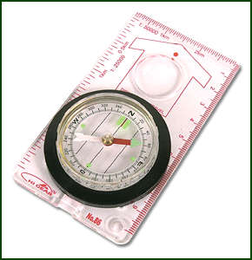

5. Bearings problems

Topic10 – Equations / Inequations (Chapter 43)

- Revision – Level E equations.
1

2

3

4



2. Harder equations – including negatives and brackets.

3. Equations – with fractional coefficients.

4. Inequalities

Topic 11 – Pythagoras Theorem (Chapter 59)

- Squares and roots
1

2

3

4

5

6² = 36

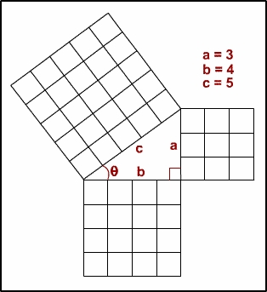
- Pythagoras Theorem

(Right angled triangles ONLY)

Hypotenuse is always the longest side

which is always opposite the right angle.

- Calculating – Hypotenuse.

- Calculating – smaller side.

- Mixed questions

Topic 12 – Percentages (Chapter 19)

1

2

3

4

- Revision – Level E percentages.

15% of 40

- Percentage – Increase / Decrease
(Appreciation / Depreciation)

A jumper increases from £20 to £22.
What is the percentage increase?

- A as a percentage of B

40 out of 50 as a percentage

- Finding Initial Value

In a sale there is 20% off everything.
In the sale a CD cost £8, what was the original cost.

Topic 13 – Fractions (Chapter 31)

- Equivalent fractions
1

2

3

4

5

- Addition & Subtractions of simple fractions

- Addition & Subtractions of harder fractions

- Multiplying fractions

- Division of fractions

F2 Test (Topics 8 – 13)

For my F2 test I will

Next Steps
Guardian’s Signature : ___________________________
Topic 14 – Areas (Chapter 23)

- Revision of Level E
1

2

3

4

5

6

Square Rectangle Right-Angle Triangle

- Any of Triangle

h
b

- Rhombus and Kite

d

D
- Parallelogram

h
b

- Trapezium
a

h
b

- Composite Shapes

Topic 15 – Circle Work (Chapter 29)

- Circumference of a Circle
1

2

3

4

C = πD or C = 2πr

- Finding the Diameter of a Circle

- Area of a Circle

A = πr²

- Mixed Problems

Topic 16 – Ratio / Proportion (Chapter 41)

- Simple Ratios
1

2

3

4

5

6

7

8

2:3

- Simplifying Ratios – Fractional Ratios

- Ratio Calculations

- Proportional Division - Split £60 in ratio 2:3

- Proportion

- Direct Proportion

Books Cost
6 ⇨ £4.20
1 ⇨ 4.20 ÷6 = £0.70
5 ⇨ 5 x 70 = £3.50
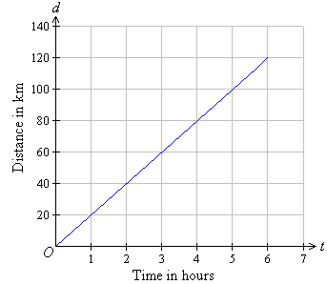
- Linear Graphs of Direct Proportion

- Inverse Proportion – Building a house
Men Months
10 ⇨ 12
1 ⇨ 10 x 12 = 120
8 ⇨ 120 ÷8 = 15

Topic 17 – Linear Patterns (Chapter 53)

- Simple Linear Patterns
1
2

y = ax

- Harder Linear Patterns

Y = ax + b

F3 Test (Topics 14 – 17)

For my F3 test I will

Next Steps

Guardian’s Signature : ___________________________

My Achievements
Skill | Activity | Date & Teacher Signature

My Achievements
Skill | Activity | Date & Teacher Signature

