www.mathsrevision.com
Level F Homework 1

1. Calculate:

2. Calculate the following given that x = 3, y = -5:

3. Calculate:

4. Copy these diagrams and fill in all the angles.
130
80
N
P
S
T
Q
V
R
(a) (b)
E
A
45

70
D
B
C

www.mathsrevision.com
Level F Homework 2

1. Remove the brackets:

(a)
(b)

- Remove the brackets and Simplify:

(a)
(b)

3. Work out:

(a) (b) (c)
(d) (d) (d)

4. A colouring pencil costs £0.09. What is the cost of:-

(a) 8 pencils (b) 300 pencils (c) 2000 pencils ?

5. Find the shaded area in terms of x :

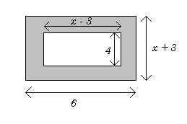

6. Factorise:

(a) (b) (c)
www.mathsrevision.com
Level F Homework 3

1. Find the highest common factor for each of the following: -

(a) 12 and 20 (b) 13 and 26 (c) 24 and 36

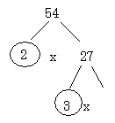
2. (a) Copy and complete the following factor tree:

- Use a similar method to find the prime decomposition of the following:

(i) 36 (ii) 50 (iii) 98

3. Calculate:

4. The area of this rectangle is .
Area =
Its breadth is .
Calculate its length.

5. A music “jingle” on the radio lasted seconds.
The new replacement “jingle” lasts times as long as this.
For how long does the new jingle last?

www.mathsrevision.com
Level F Homework 4

1. Write the following in scientific notation:

2. Write each of the following in full:

3. Copy the following frequency table and add a third column to help you find the mean temperature:

Max. Temp (x) | Frequency (f)
5 | 7
6 | 8
7 | 5
8 | 2
9 | 6

4. Copy the table again, but this time add a cumulative frequency column.

5. The mean age of a group of boys was 15.
One more boy joined the group and the mean age became 14.

How old was the ninth boy?
www.mathsrevision.com
Level F Homework 5

1. Calculate the shaded areas of each of the following:
(Show all your formulae and working)

(a) (b)

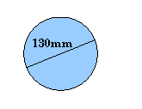
2. A circle has a diameter of 130 mm.

Calculate the Area.

3. A circular trampoline has a circumference of 10.99 m.

- Calculate the diameter
- Calculate the radius
- Using the value for the radius, calculate the Area, to the nearest m².

4. Calculate the shaded area:

www.mathsrevision.com
Level F Homework 6

- A tractor bought for £25000 in 2002 has depreciated in value over the past few years.

It is now worth 32% less than the original value.

What is the tractor worth today?

- From a weekly wage of £280, I pay £67.20 in rent.
What percentage of my wage goes on rent?

- Michael’s annual golf fees have increased by 18% this year.
He now has to pay £590.00

Calculate Michael’s golf fees for last year.

4. Solve each of the following:

www.mathsrevision.com
Level F Homework 7

1. The table shows the results of a survey asking people’s favourite holiday destination.
America | Italy | France | Spain | U.K | Italy
France | France | Italy | Spain | Italy | U.K
Spain | U.K | Italy | U.K | Spain | Italy
France | France | France | Italy | America | Italy
America | America | U.K | U.K | Italy | Spain
Italy | America | Spain | Italy | France | U.K
- Copy and complete the table below:
Destination | Tally Mark | Number
America
Italy
France
U.K
Spain
- Add another column to help you make a pie chart
- Construct an accurate pie chart for this information.

2. Three coins are tossed at the same time,
- List all the possible outcomes. (HHH, HHT, etc..)
- Find:- (i) P(all heads) (ii) P(2 tails)

3. For each of the following tables, determine a formula in the form
x | 2 | 4 | 6 | 8
y | 1 | 5 | 9

x | 10 | 11 | 12 | 13
y | 7 | 8 | 9

x | 2 | 4 | 6 | 8
y | 11 | 23 | 35

www.mathsrevision.com
Level F Homework 8

1. At 10am, 3 delivery vans leave the warehouse to supply supermarkets at A, B and C.

Copy and complete the table:
Journey | A | B | C
Time  (h) |  | 3½h
Distance  (km) | 96km |  | 180km
Average Speed (km/h) | 48km/h | 42km/h | 40km/h

2. The length of the ladder below is 5.4m.
Calculate x to 1 decimal place:
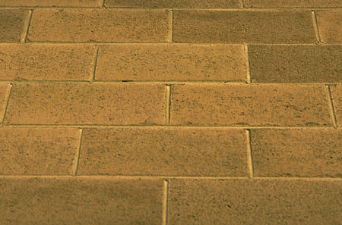
5m

x

3. Plot the following pairs of points and calculate the lengths of the lines joining them:

- A(0, 0) and B(8, 6)
- C(1, 2) and D(9, 8)
- T(-1, -1) and U(2, 3)
www.mathsrevision.com
Level F Homework 9

1. Make enlargement OR a reduction of the following shapes using the given scales:

(a) (b)
3cm

4cm

Make a 3 times enlargement Make a 4 times enlargement

(c) (d)
18cm
3cm
6cm

12cm
6cm
9cm
Reduce this shape to
half its size.

Make this one third of its size

2. It takes 12 workmen 3 hours to repair a roof.

How long will it take 9 workmen, working at the same rate?

3. Five pizzas cost £27.50.
How much will 8 pizzas cost?

