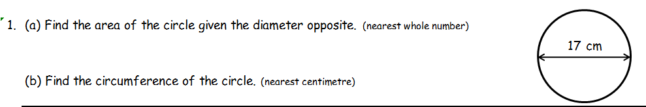

6 marks

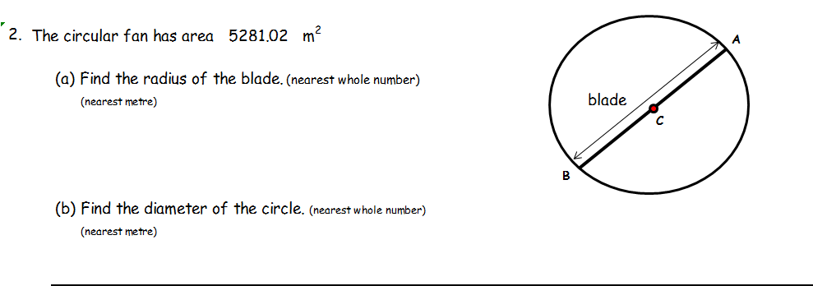

4 marks

* 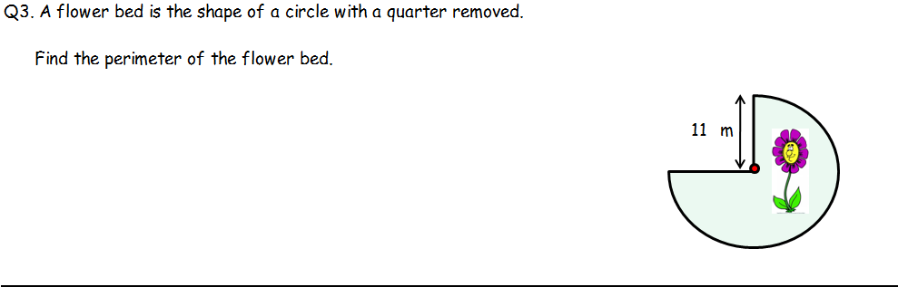

4 marks

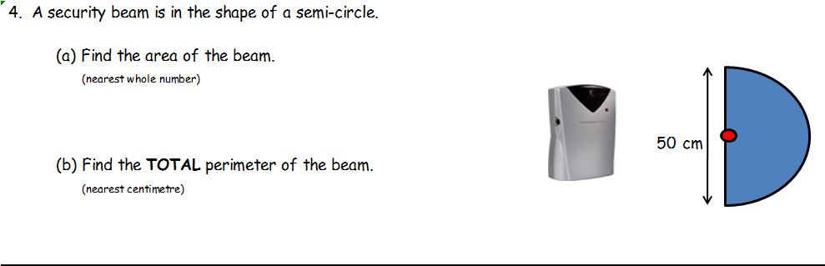

5 marks

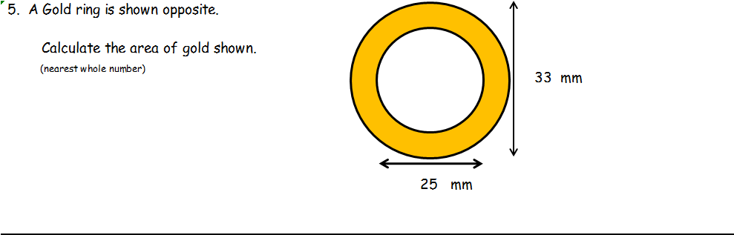

4 marks

Total 23