Q1.

Q2.

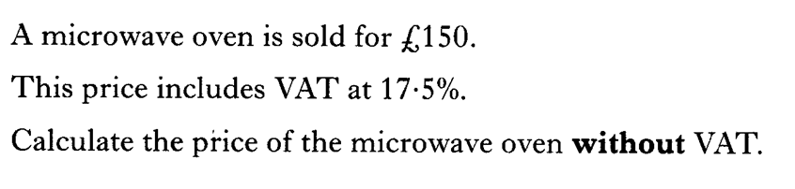

Q3.

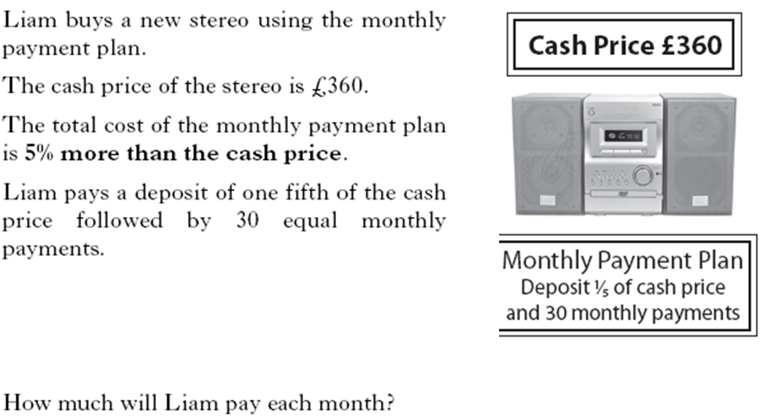

Q4.

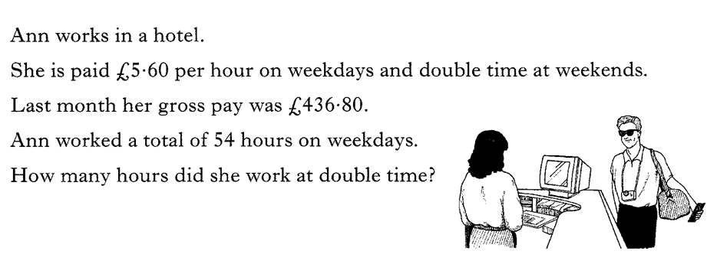Q5.

|  |  |  |
| --- | --- | --- |
| Question | Main points of expected responses | |
| 1(a) |  | •1  •2 |
| 1(b) | Greece | •1 =£46  •2 =£43.50  •3 |
| 2 | £21.46 | •1  •1 |
| 3 | £127.66 | •1  •1 £127.66 |
| 4 | £10.20 | •1  •2  •3  •4 |
| 5 | 12 hours | •1  •2  •3  •4 |

Total 17