Q1. A survey of S3 pupils on how many times they visited the cinema in the last month is given below.

Complete the table below and calculate:

1. Range
2. Mean
3. Mode
4. Median



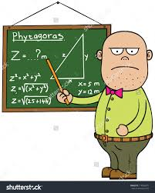Q2. In a school, the average age of three mathematics teachers is 48.

A new mathematics teacher arrives and the new average is 51.

What is the age of the new mathematics teacher ?

Q3. Complete the table below and calculate the median.

