Q1. A survey of S3 pupils on how many times they visited the cinema in the last month is given below.

Complete the table below and calculate:

1. Range
2. Mean
3. Mode
4. Median



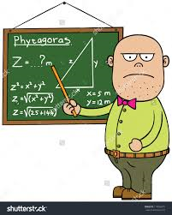Q2. In a school, the average age of three mathematics teachers is 48.

A new mathematics teacher arrives and the new average is 51.

What is the age of the new mathematics teacher ?

Q3. Complete the table below and calculate the median.



Marking Scheme

|  |  |  |
| --- | --- | --- |
| Q1 | $$\left(i\right) Range = 5$$ $$\left(ii\right) Mean = 1.06$$ $$\left(iii\right) Mode = 0$$ $$\left(ii\right) Median = 15$$ | * 5 * Totals + 3rd column correct 2 marks   (2 out of 3 1 mark)     * 1.06 * 0 * 1 |
| Q2 | 60 | * 144 $204$* 204 - 144 = 60 |
| Q3 | 3 books | $Cumulative Frequancy all correct$* 13th number $Median=3 book$ |

Total 12 marks