St Ninian’s High School
Success is 99% Perspiration and 1% Inspiration

Hard Work beats Talent every time when Talent doesn’t Work Hard
MATHS
Level 4+ Course
Pupil Learning Log
Expect to get out what you put in !
Name :
Teacher :


- I understand this part of the course =

- I am unsure of this part of the course =

- I do not understand this part of the course =
St. Ninian’s High School – Mathematics Dept
Rules for Completing Homework
- Always write the date, Page No, Ex No, and a heading.
- Attempt all questions using the method and working shown in class.
- Self correct answers from the back of the booklet.
- Do any corrections.
- Parents must then sign your jotter to ensure that all questions have been attempted.
- If you found any questions difficult – ask in class the next day.

4+ Chapter 1 - Significant Figures & Integers
1

2

3

4

- Significant Figures

In mathematics a figure or digit is significant
if it gives an idea of both:
- Quantity
- Accuracy
ALL TO DO WITH ZERO’S

- Estimating

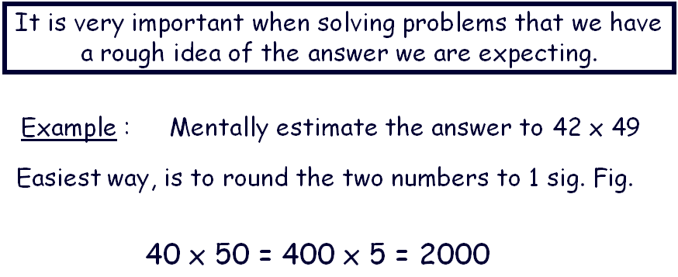

- Order of Operation (BODMAS)
B – Brackets
1 + 3 x 5 = 16
NOT 20
O – Other
D – Division
M – Multiplication
A – Addition
S – Subtraction

- Revision of Integer

1 + (-3) = -2
1 – (-3) = 4
(-6) x (-2) = 12
(-6) x (2) = -12
(-6) ÷ (-2) = 3
(-6) ÷ (2) = -3

Topic Mark : |  | %
4+ Chapter 2 - Angles

1

2

- Revision of Basic Angles.

- Angles in quadrilaterals

Internal angles add up to 360º

Topic Mark : |  | %
4+ Chapter 3 - Fractions Decimals and Percentages
1
2

3

- Finding a Percentage without a calculator

30% of 80
10% ⇨ 8
30% ⇨ 8x3 = 24

- Finding a Percentage using a calculator

29% of £250

- Linking Fraction → Decimals → Percentages

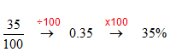

Topic Mark : |  | %

4+ Chapter 4 - Money

- Wages & Salaries including :
1

2

3

4

Commission
Liam sells car. He is paid a commission of 15% on any
Windows he sells. He sold £ 30 000 worth of windows.
How much commission was he paid ?
Overtime
Double time ⇨ Time and a half ⇨

- Wage Slips – Deductions – gross / net pay

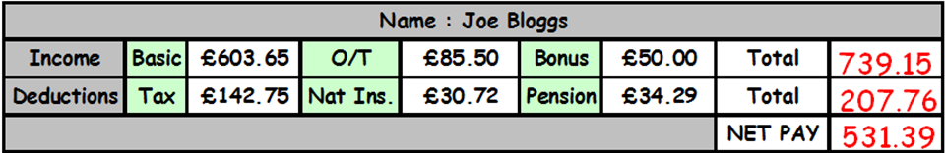

- Income Tax
Income Tax (Tax allowance = Amount of money the government is not allowed to tax. Tax is calculated by taking your annual salary and subtracting your allowance. This is the amount that will be taxed.

- VAT ( Old VAT 17.5% new VAT 20%)

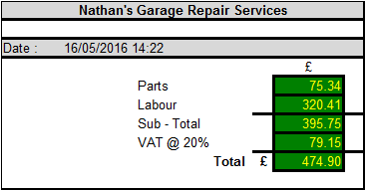
5

6

7

- Hire Purchase

Buying Products
Washing Machine Cash Price £365.50
or
by H.P. £75 deposit + 12 Payment £28.80

- Insurance - Household and Life

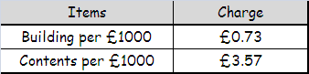

- Foreign Exchange

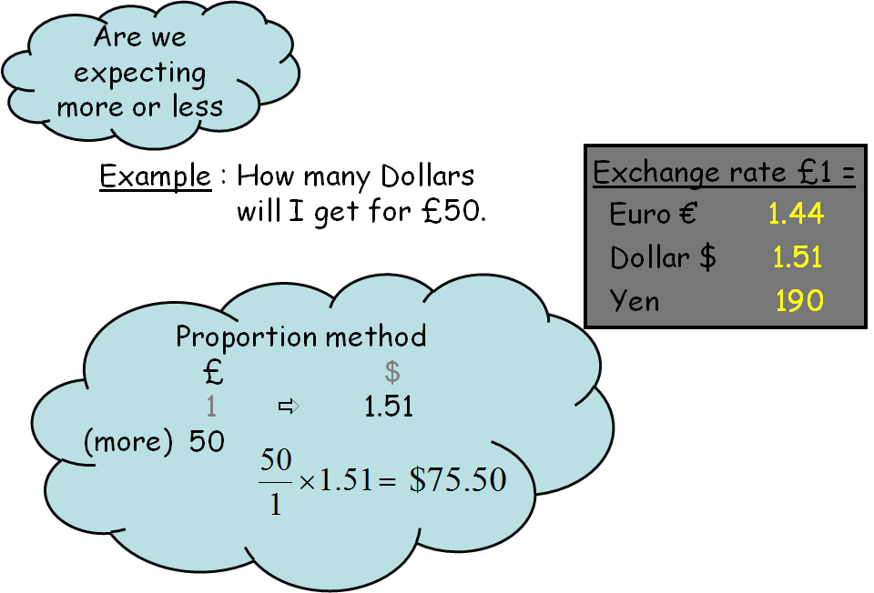

Topic Mark : |  | %

4+ Chapter 5 - Algebraic Operations

- Multiplying Terms
1

2

3

$\begin{aligned}2a×3b \\ =6\text{ab}\end{aligned}$ $\begin{aligned}4y^{2}×8y \\ \text{32}y^{3}\end{aligned}$

2. Multiplying out brackets and tidying up

$\begin{aligned}3(2x+4)−4(x+5) \\ =6x+\text{12}−(4x+\text{20}) \\ 2x−8\end{aligned}$

3. Factorise - expressions

3y² – 6y = 3y( y – 2 )

Topic Mark : |  | %

4+ Chapter 6 - Symmetry

1

2

3

- Line / Reflection
Mirror image

- Rotational / Turn

Half turn, quarter turn etc.....

Order of rotation 1, 2, 3, 4 etc...


3. Translation / Glide / Slide

Wallpaper design etc....

Topic Mark : |  | %

4+ Chapter 7 - Tolerance

- Tolerance
1

2

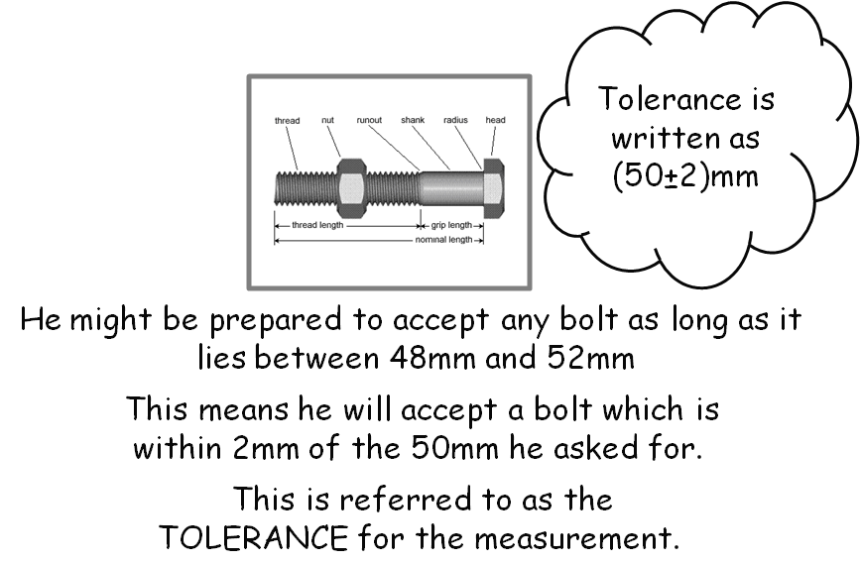

- Tolerance Notation

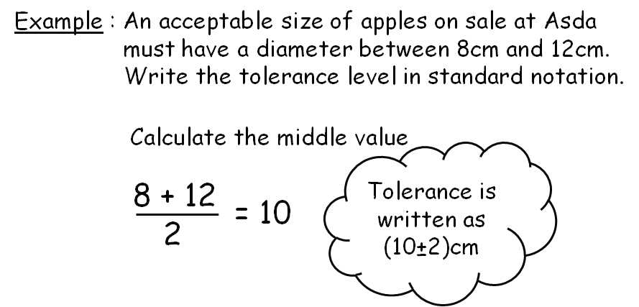

Topic Mark : |  | %

4+ Chapter 8 - Straight Line

1

2

3

4

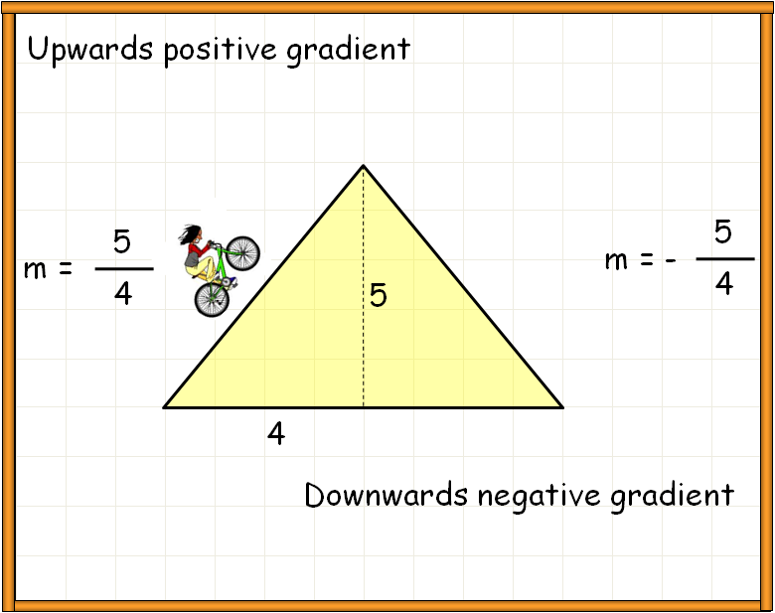
- Gradient

$m=\frac{\text{Vertical}}{\text{Horizontal}}$

- Gradient from Coordinates
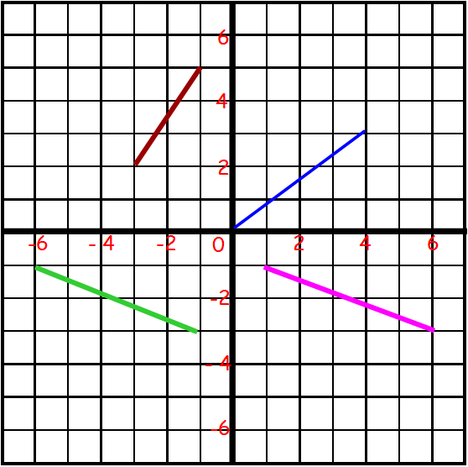
m = $\frac{y_{2}−y_{1}}{x_{2}−x_{1}}$

- Sketching Straight Lines of the form

y=mx y=mx+c
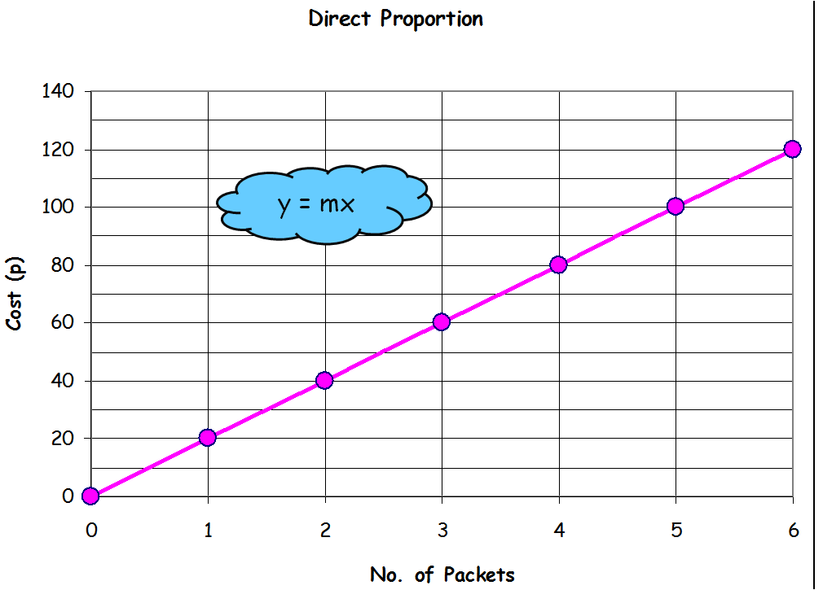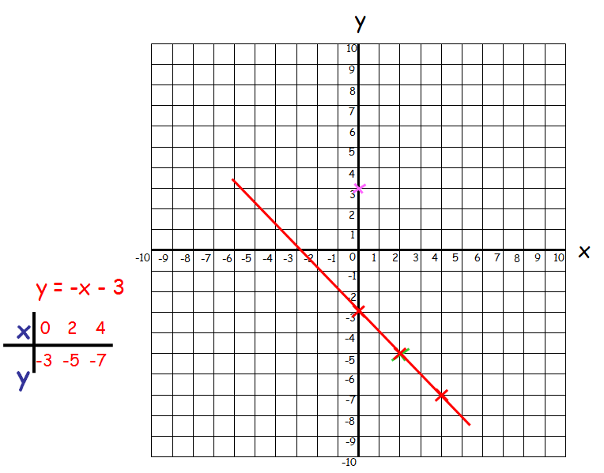

- Finding the Equation of a Straight Line

y=mx+c m = Gradient
c = y - intercept
Topic Mark : |  | %

4+ Chapter 9 - Equations & Inequations

- Revision 2 and 3 Equations
1

2

3

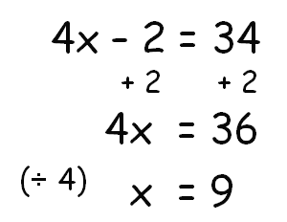

- Harder Equation

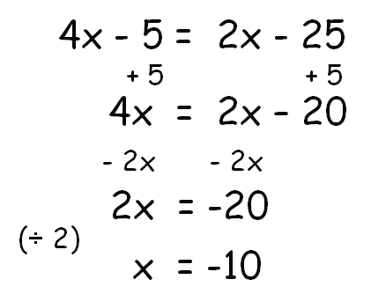

- Equations with Brackets

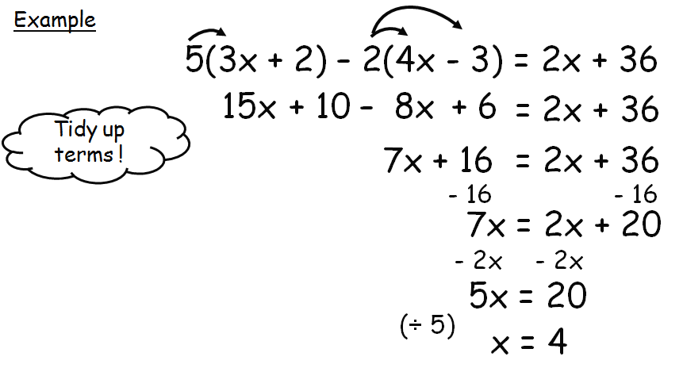

- Equations with Fractions
4

5

6

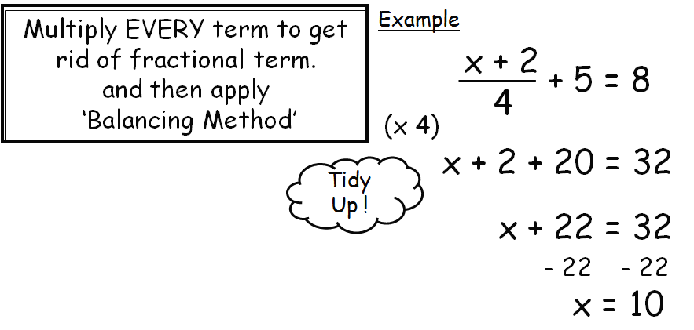

- Equations with Harder Fractions

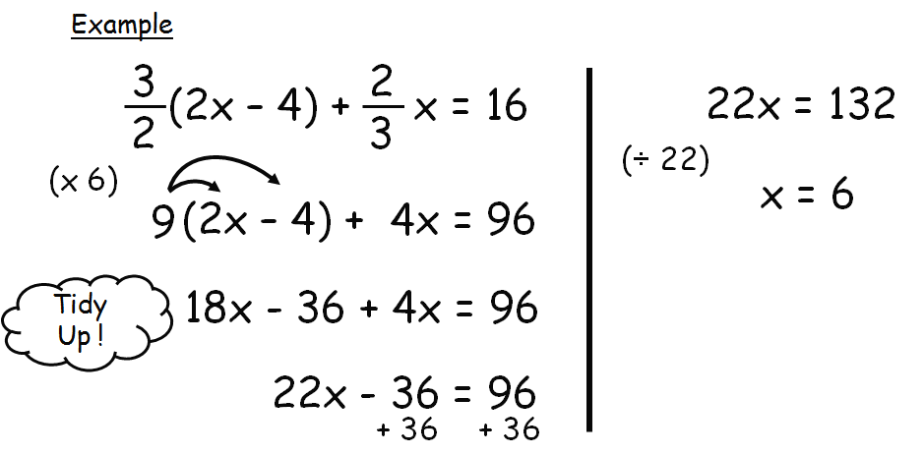

- Solving Inequations (Inequalities)

The same as solving equations EXCEPT when dividing by a negative FLIP sign.
Also NEVER put in an equal sign.

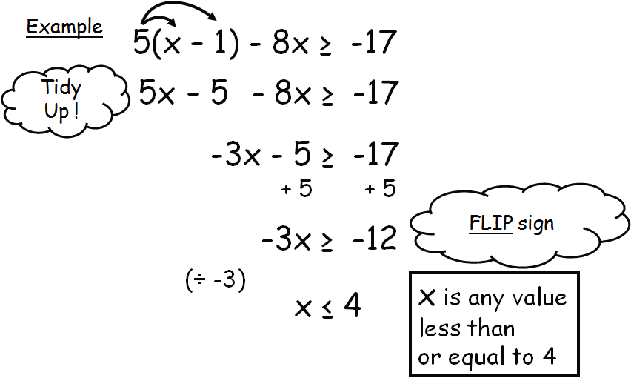

Topic Mark : |  | %
4+ Chapter 10 – Power Roots & Scientific Notation

- Powers
1

2

3

4

$2^{5}=\text{32}$ $5^{6}=\text{15625}$

- Roots

$\sqrt{\text{81}}=9$ $\sqrt[3]{8}=2$

- Scientific Notation Vice-Versa (Large Numbers)

$\text{456000}=4\text{.}\text{56}×{\text{10}}^{5}$ $2\text{.}3×{\text{10}}^{3}→\text{2300}$

4. Small numbers – scientific notation and Vice-Versa

$0\text{.}\text{00743}=7\text{.}\text{43}×{\text{10}}^{−3}$ $2\text{.}5×{\text{10}}^{−2}=0\text{.}\text{025}$

Topic Mark : |  | %
4+ Chapter 11 – The Circle 1

- Circumference of a Circle
1

2

3

4

5

C = πD or C = 2πr

Finding perimeter of Semi and Quarter Circles

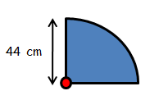
$$\begin{aligned}P=\frac{1}{4}πD+r+r \\ =\frac{1}{4}π(\text{88})+\text{44}+\text{44} \\ =\text{157}\text{.}1\text{cm}\end{aligned}$$

- Finding the Diameter of a Circle

- Area of a Circle

A = πr²

- Fractional Area
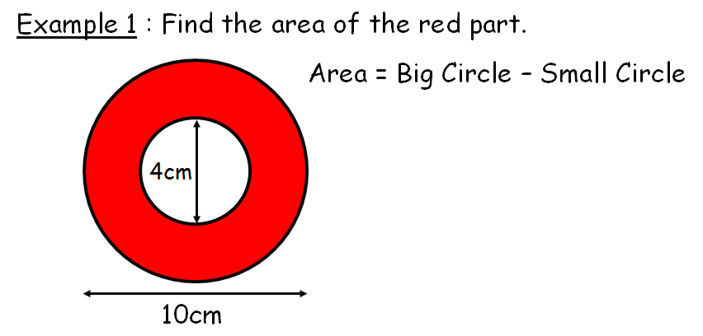$\begin{aligned}A={πr}_{B^{2}}−{πr}_{S^{2}} \\ π(5)^{2}−π(2)^{2} \\ \text{66}{\text{ cm}}^{2}\end{aligned}$

- Mixed Questions

Topic Mark : |  | %

4+ Chapter 12 - Transformation of Shapes

- Transformations – Reflections
1

2

3

4

5

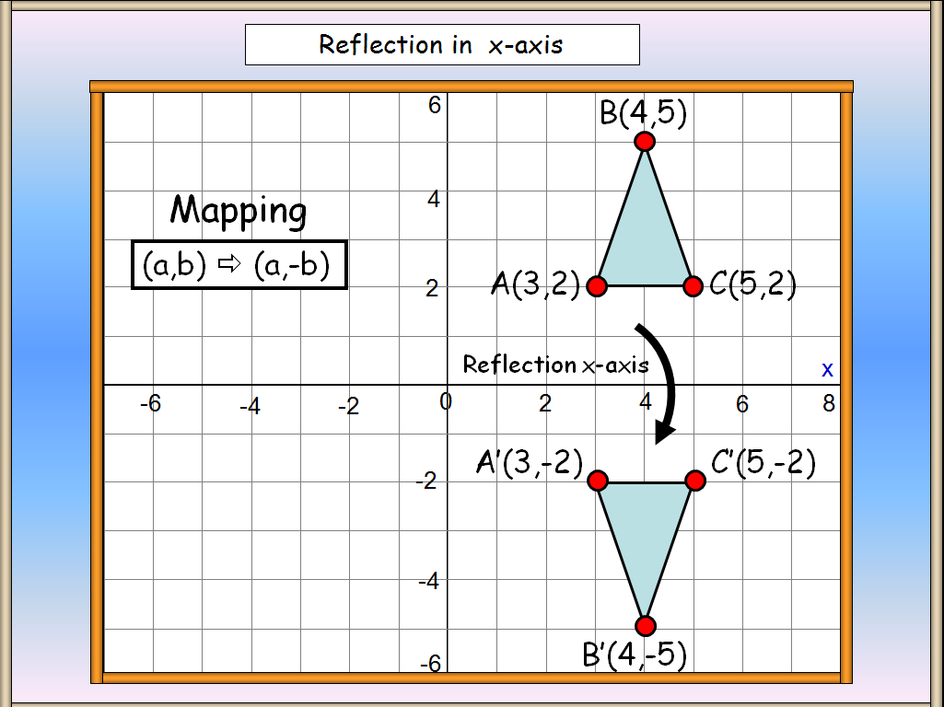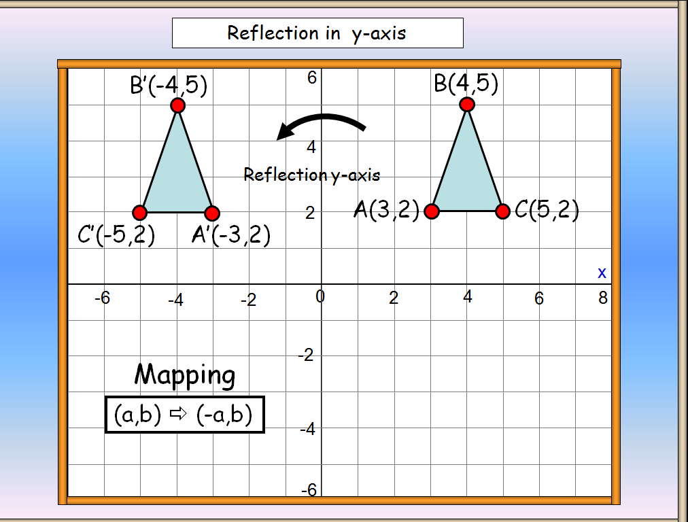

- Transformations - Rotations

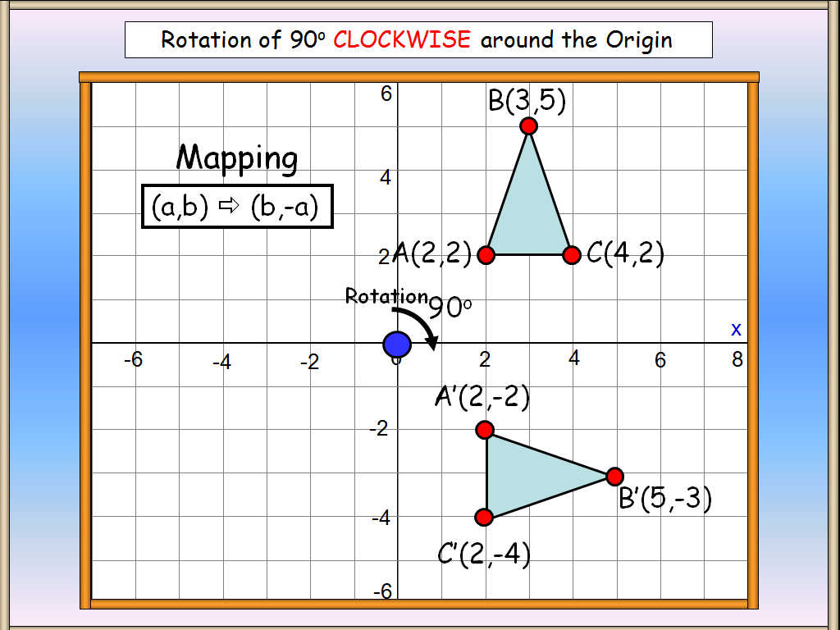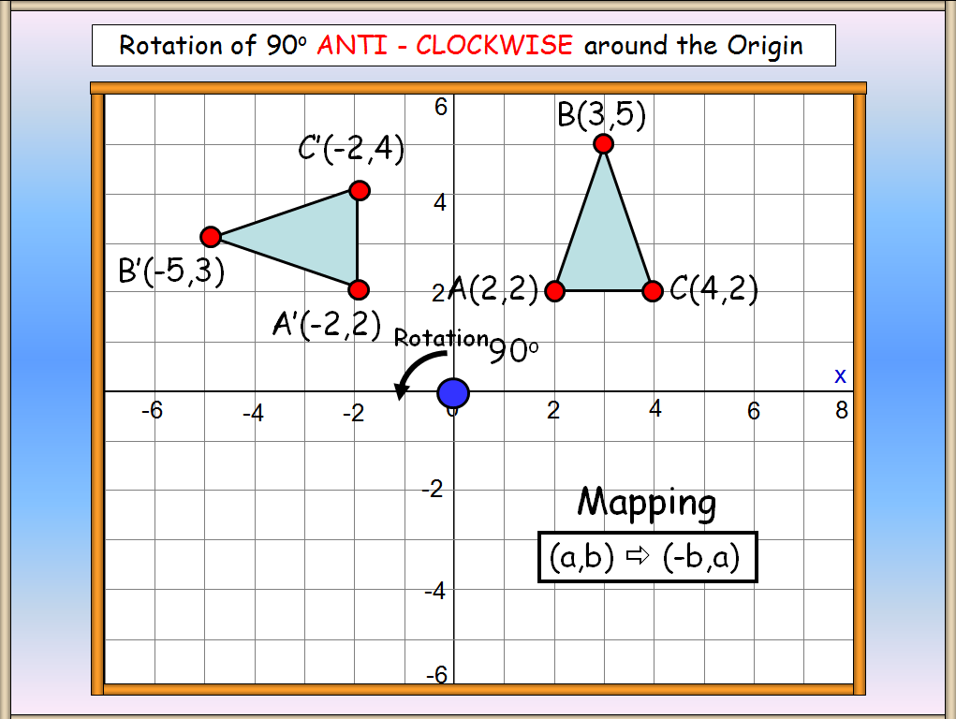

- Transformations – Translation (Moving)

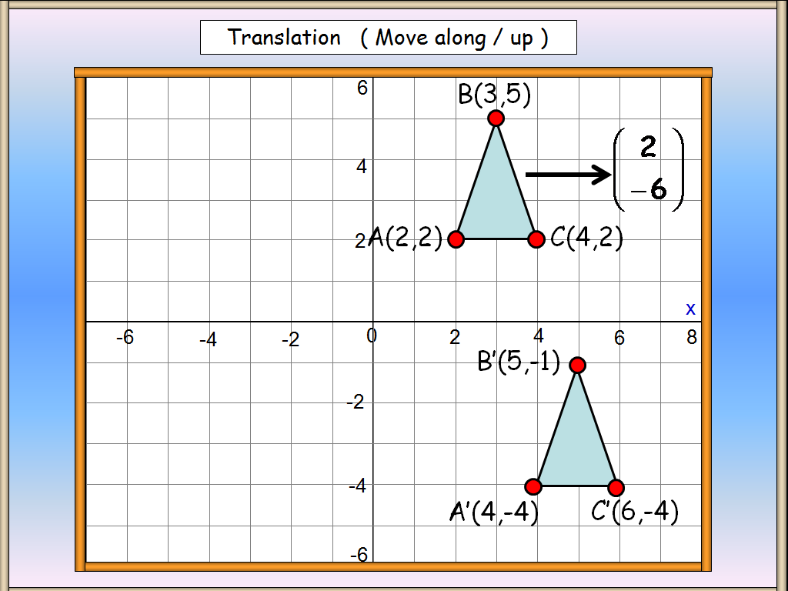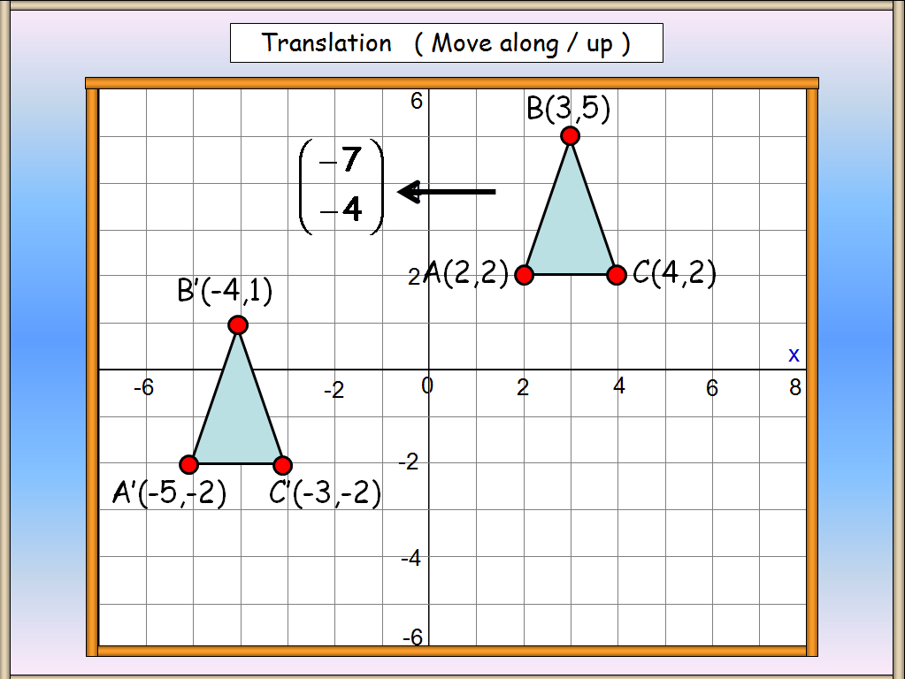

- Transformations – Dilation (Changing Size)

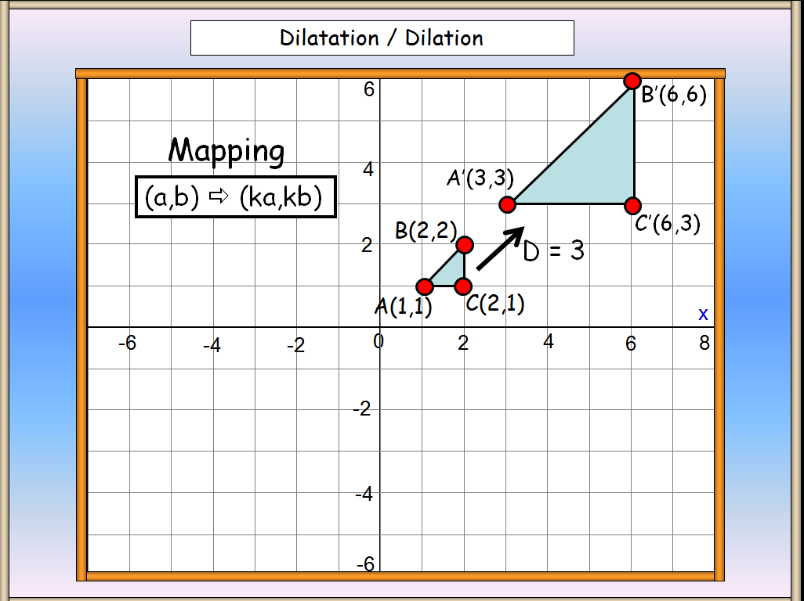

- Transformations – Mixed

4+ Chapter 13 - Pythagoras Theorem
1

2

3

4

5

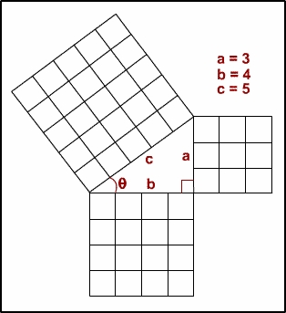
- Pythagoras Theorem

(Right angled triangles ONLY)

Hypotenuse is always the longest side

which is always opposite the right angle.

- Calculating – Hypotenuse.

?

- Calculating – smaller side.

?

?

- Mixed questions

- Distance between two points.

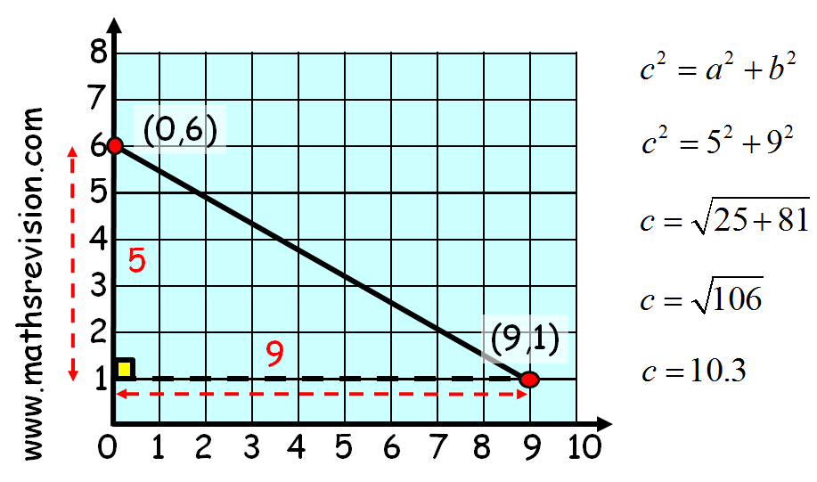

Topic Mark : |  | %

4+ Chapter 14 – Distance Speed Time (DST)

1

2

3

4

5

6

1. Distance
$$D=\text{ST}$$

2. Speed and Time ( Remember to convert Time ! )


$S=\frac{D}{T}$ $T=\frac{D}{S}$

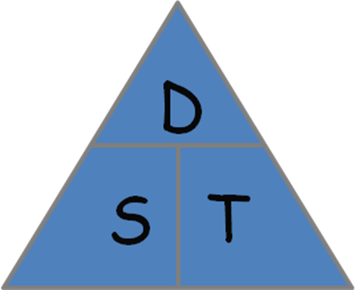
3. Mixed Questions

4. Converting Hours & Minutes to Decimal Time

2 hours 12 minutes → 2.2 hours

5. Decimal Time to Converting Hours & Minutes

3.9 hrs → 3 hours 54 minutes

6. Time / Distance (Speed) graphs

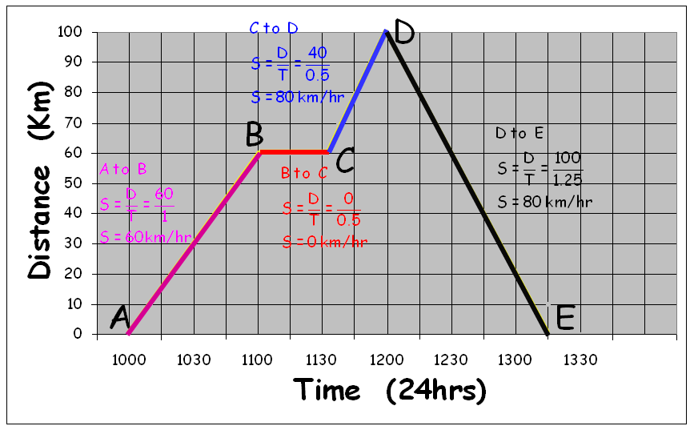

Topic Mark : |  | %
4+ Chapter 15 – Proportion
1

2

3

4

5

- Proportional Division - Split £60 in ratio 2:3

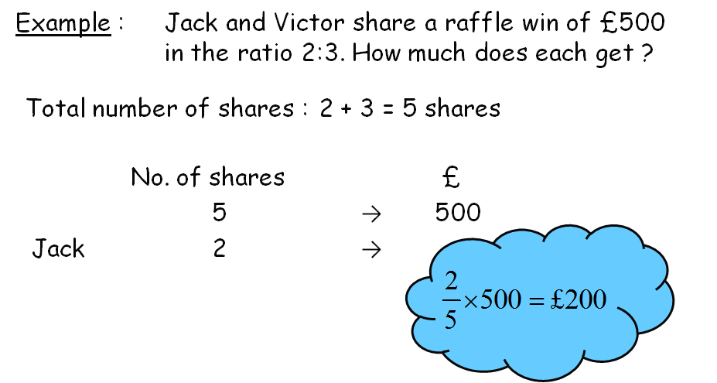

- Proportion per Item

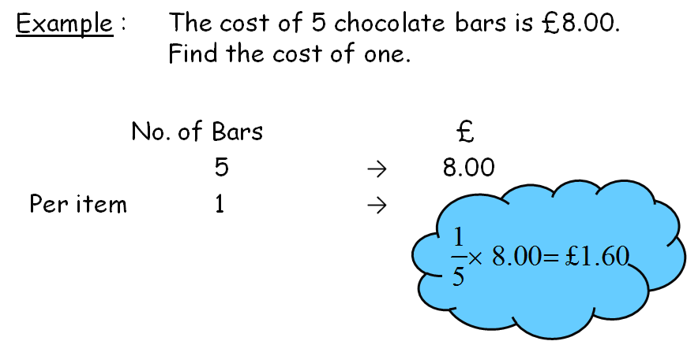

- Direct Proportion

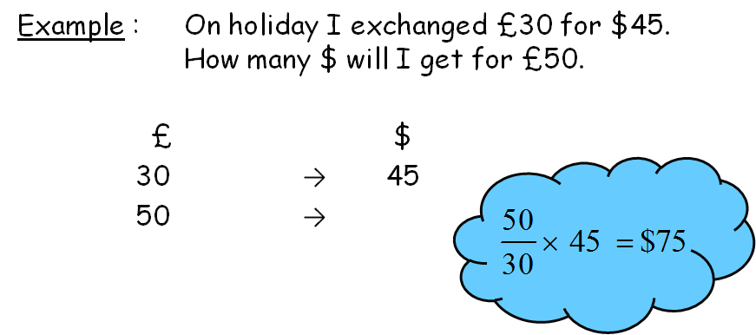
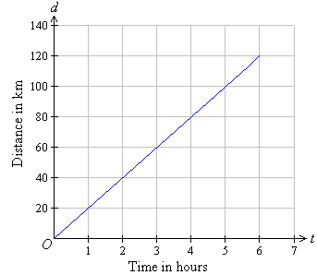
- Linear Graphs of Direct Proportion

- Inverse Proportion

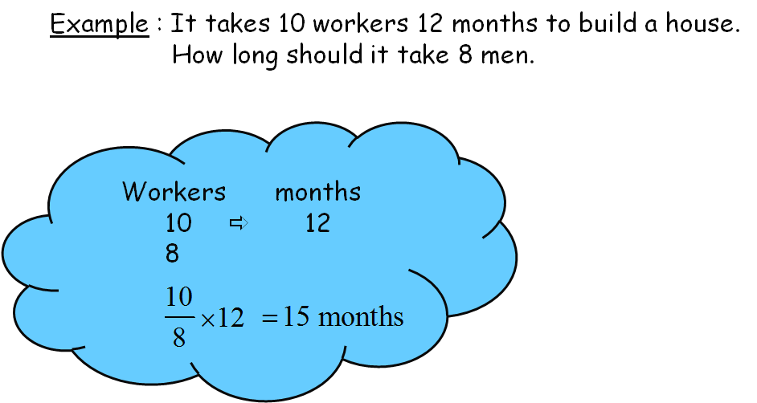

Topic Mark : |  | %

4+ Chapter 16 - Volume

- Sphere
1

2

3

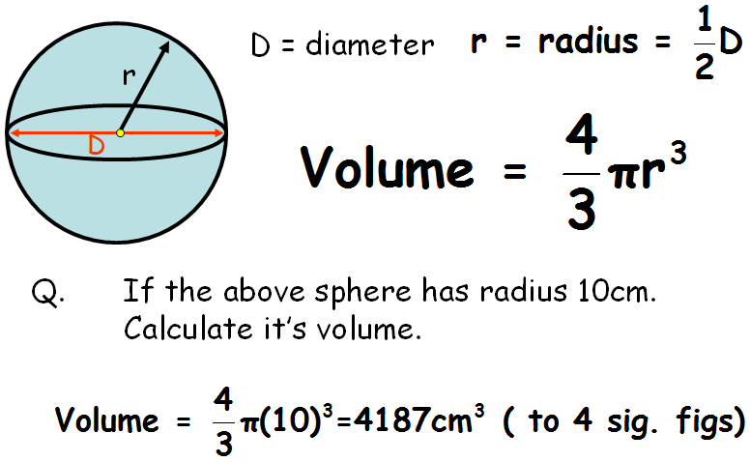

- Cone

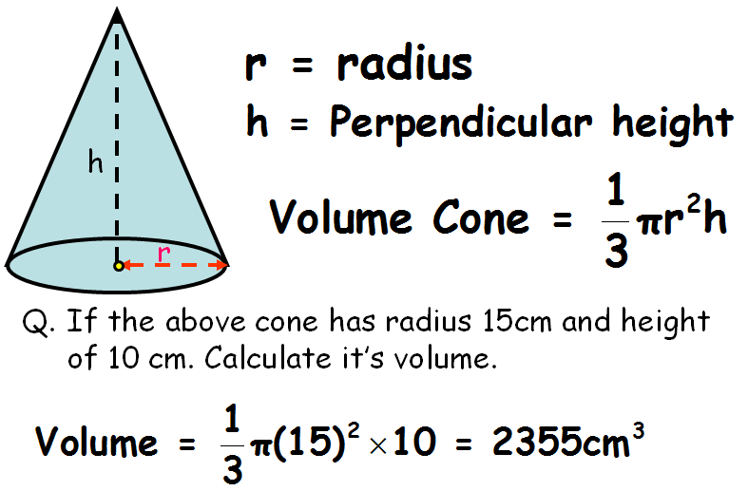

- Pyramid

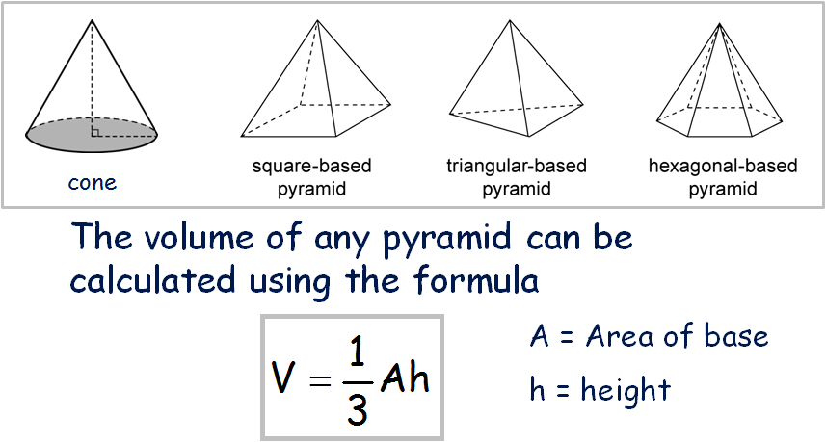

Topic Mark : |  | %

4+ Chapter 17- Patterns
1

2

3

- Simple Linear Patterns

y = mx

- Harder Linear Patterns

y = mx + c

- Non - Linear Patterns

y = x²

Topic Mark : |  | %

4+ Chapter 18 - Angles in Circles

1

2

3

4

5
- Isosceles Triangles

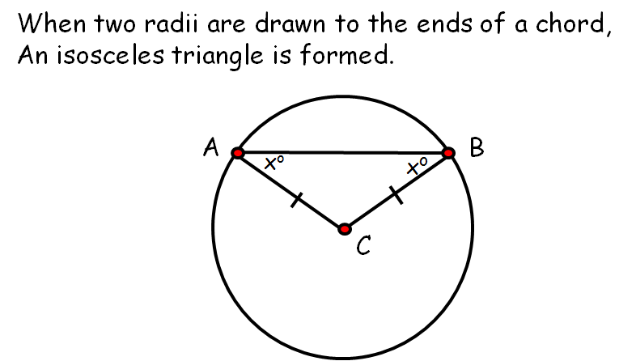

- Angles in a Semi-Circle

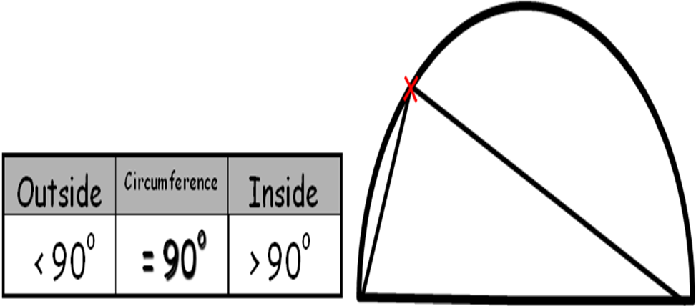

- Tangent Line

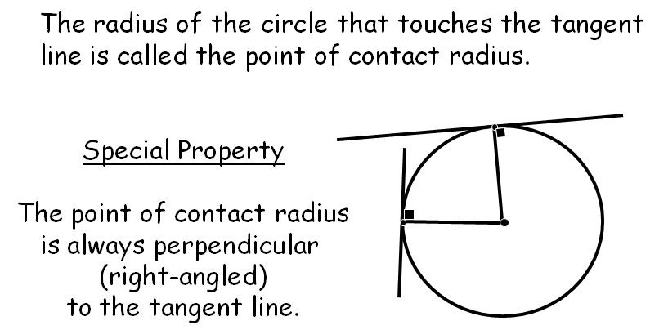

- Tangent Kite
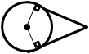

- I have successfully completed past paper questions
on this topic.

Topic Mark : |  | %

4+ Chapter 19 - Trigonometry (S^{O}HC^{A}HT^{O}A)

1

2

3

4

5
- Tangent Ratio (Right-angled triangles ONLY)
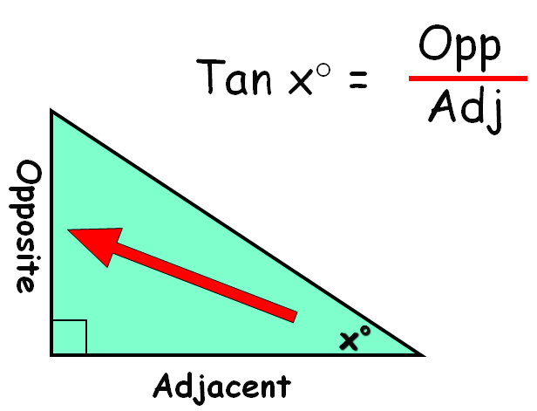
$$\text{tan}x^{o}=\frac{\text{Opp}}{\text{Adj}}$$

Calculating the missing side.

Calculating the missing angle.

- Sine Ratio (Right-angled triangles ONLY)
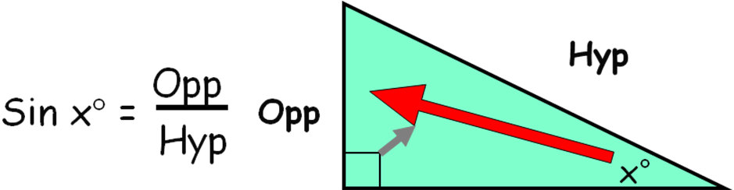
$$\text{sin}x^{o}=\frac{\text{Opp}}{\text{Hyp}}$$

Calculating the missing side.

Calculating the missing angle.

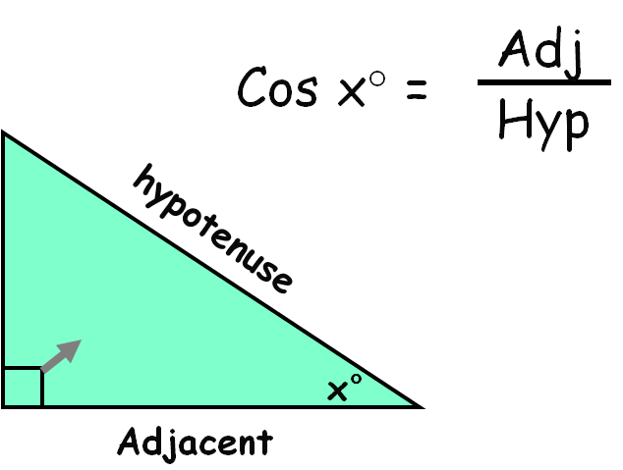
- Cosine Ratio (Right-angled triangles ONLY)

$$\text{cos}x^{o}=\frac{\text{Opp}}{\text{Hyp}}$$

Calculating the missing side.

Calculating the missing angle.

- Mixed Problems (S^{O}H C^{A}H T^{O}A)

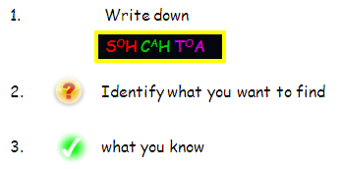

- I have successfully completed past paper questions on this topic.

Topic Mark : |  | %

4+ Chapter 20 - Similarity

- Similar Figures
1

2

3

Enlargement Scale Factor

Reduction Scale Factor

- Similar Triangles

- Parallel Lines

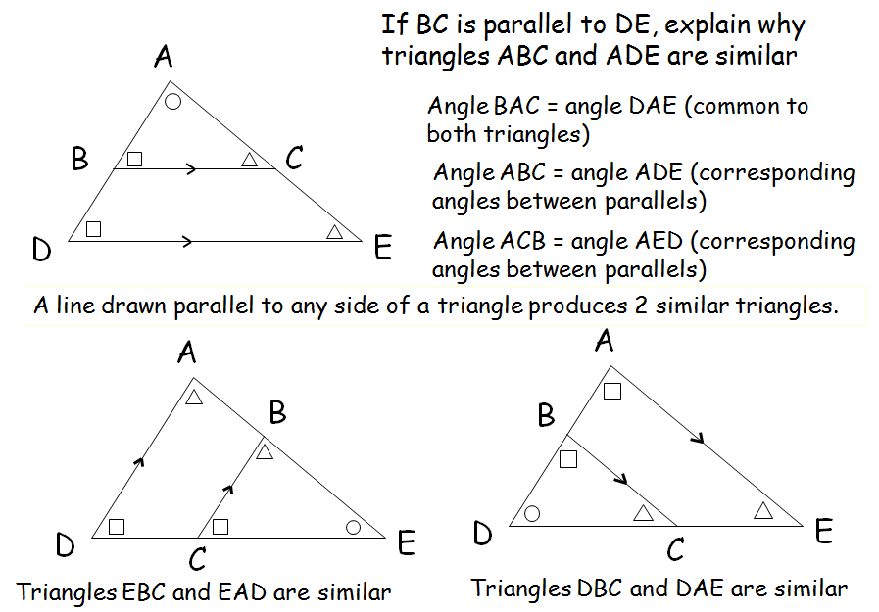
3

4

5

- Area of Similar Figures.

- Volume of Similar Figures.

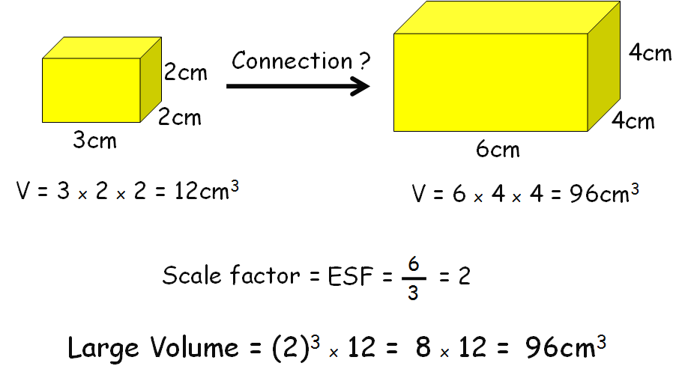

- I have successfully completed past paper questions on this topic.

Topic Mark : |  | %

4+ Chapter 21 - Fractions
1

2

3

4

5

- Equivalent fractions

$2\frac{3}{4}→\frac{\text{11}}{8}$ $\frac{\text{24}}{5}→4\frac{4}{5}$

- Addition & Subtractions of simple fractions

- Addition & Subtractions of harder fractions

Method : “kiss and smile”

- Multiplying fractions

- Division of fractions

Topic Mark : |  | %

4+ Chapter 22 – Simple Statistics
1

2

3

1. Terminology – Mean, median, mode and range.

2. Mean Median and Mode from Frequency Tables.

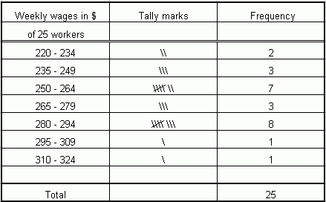

- Mean from Cumulative Frequency Tables.

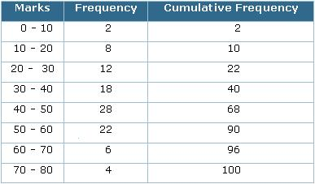

Topic Mark : |  | %

4+ Chapter 23 – Charts & Tables


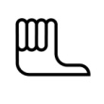
1

2

3

- Bar Graphs and Line Graphs

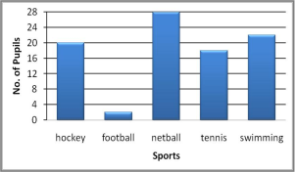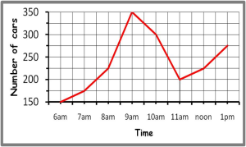

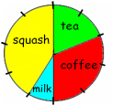
- Interpreting Pie-Charts

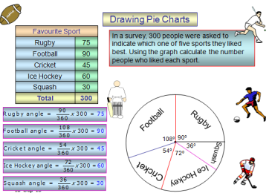
- Constructing Pie Charts

Topic Mark : |  | %
4+ Chapter 24 - Probability

1

- Simple Probability

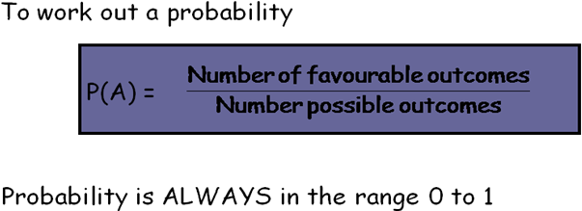

Expressed as a ratio P(A) = 0.4 means 2 in 5 chance

Expressed as a fraction P(A) = 0.4 means

Topic Mark : |  | %

My Achievements
Skill | Activity | Date & Teacher Signature

