Q1. The profit made by Bill and Ben is shared in the ratio of 6 : 7.

How much will Bill get if they make a profit of £91,000 ?

Q2. A cake is made with flour (g), milk (ml) and water (ml) in the ratio of 6 : 5 : 4.

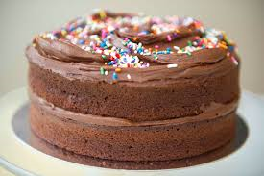 How much milk is needed for a cake weighing 4500 grams ?

Q3. A bag contains 3200 Green, White and Gold coloured balls. 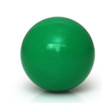

 There are 2000 White balls.

There are 3 times as many Gold balls than Green balls.

How many Gold balls are there ?

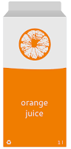

Q4. 7 cartons of orange juice contain 980ml of juice.

How many will 8 cartons of juice hold ?

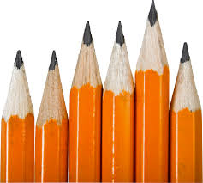

Q5. A teacher needs 6 spare pencils for every 90 pupils taught.

How many pupils does a teacher teach if they have 5 spare pencils ?

Best presentation & working MUST be shown

Remember refer to notes or website if you need help !

or ask your teacher for help !