Scientific notation

1. The circumference of the earth is approximately km.

Calculate, correct to three significant figures, the radius of the
earth, expressing your answer in standard form. 3K

2 Uranium is a radioactive isotope which has a half-life of $4⋅5×{\text{10}}^{9}$ years. This means
that only half of the original mass will be radioactive after $4⋅5×{\text{10}}^{9}$ years.

How long will it take for the radioactivity of a piece of Uranium to reduce to one
eighth of its original level? Give your answer in scientific notation. 3K

3. The speed of light is approximately $8×{\text{10}}^{5}$ times faster than the speed of sound in
air. If the speed of sound in air is 372 metres per second, calculate the speed of
light.
Give your answer in scientific notation correct to 3 significant figures. 2K

4. The population of Scotland in June 2001 was $5\text{.}\text{06}×{\text{10}}^{6}$ people.
The population of China in June 2001was approximately 250 times
larger than that of Scotland .

Calculate, correct to three significant figures, the population of China
in 2001, expressing your answer in standard form. 3K

5. The Blackbird is a two-seater high speed jet.

In December 1964 it broke a world speed record by
travelling at $1⋅\text{02}×{\text{10}}^{4}$metres per second.

Calculate, correct to three significant figures, the distance travelled if the jet were to
maintain this speed for one hour. Express your answer in scientific notation. 3K

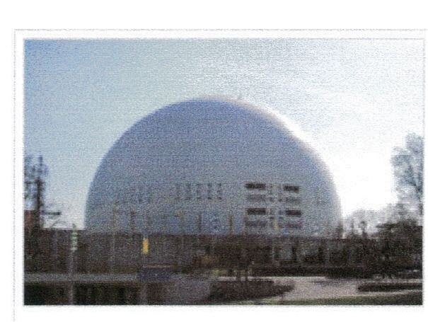
6. The Stockholm Globe Arena is the largest hemispherical
building in the world.
The radius of the building is 110m.
Calculate the volume of the building in cubic metres,
giving your answer in scientific notation correct to 3
significant figures.

[$\text{Volume}(\text{sphere})=\frac{4}{3}π r^{3}$, where r is the radius.] 4K

