St Ninian’s High School


N4 Lifeskills
Logbook
TJ Book


- I understand this part of the course =

- I am unsure of this part of the course =

- I do not understand this part of the course =

Geometry & Measure
Topic 1 - Gradients (Chapter 13)
1

- Gradient

The Gradient is the measure of how steep a slope is.

Topic 2 – Perimeters (Chapter 14)

1

2

3

4

- Perimeter of rectilinear Shapes

The outside of a shape

- Parts of a Circle

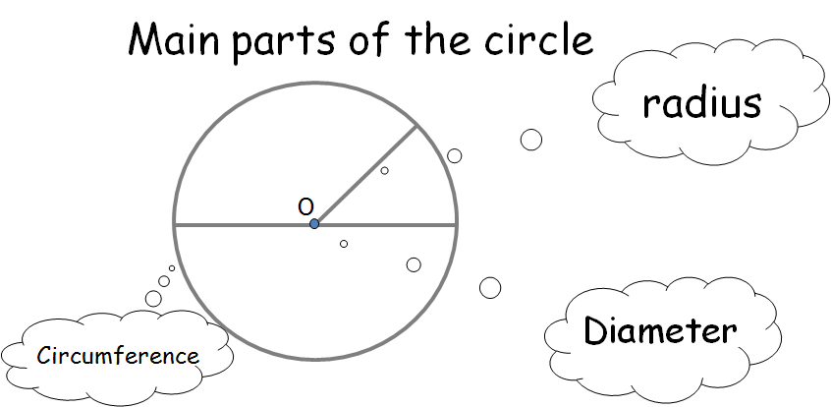

- Circumference of a Circle

- Finding a length given Perimeter

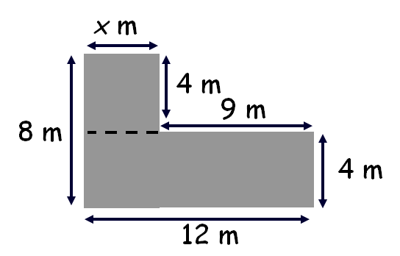

Topic 3 – Area 1 (Chapter 15)

- Area of a Rectangle
1

2

3

4.

B

L

- Area of a RAT (Right-Angled Triangle)

h

b

- Area of ANY Triangle

h
b

- Composite Area

Area that is made up from basic shapes

A₁

A₂

Topic 4 – Scale Drawings 1 (Chapter 16)

- Enlargement & Reduced shapes
1

2

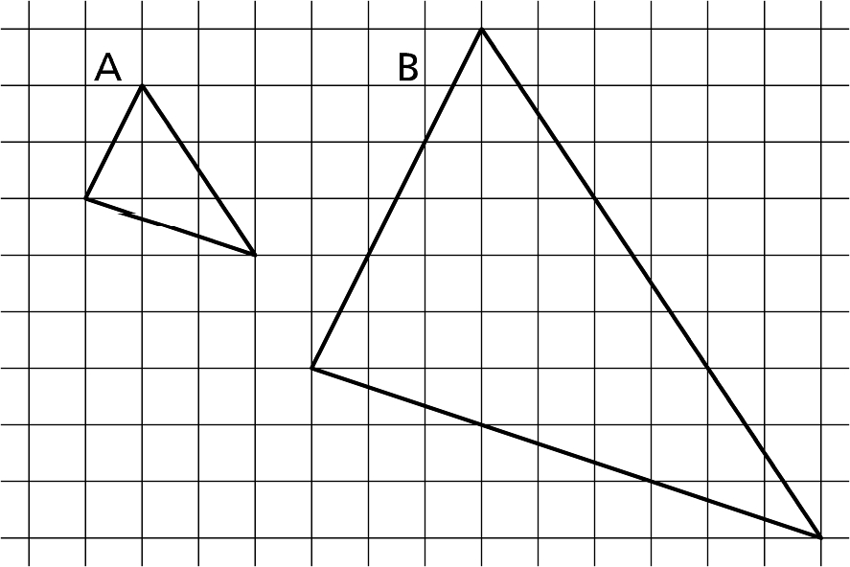

- Scale Drawings to work out real-life values

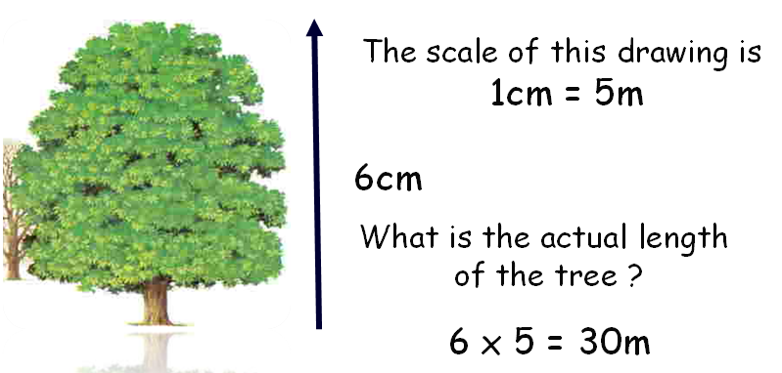

Topic 5 – Area 2 (Chapter 17)
1

2

3

- Parallelogram

h
b

- Rhombus and Kite

d

D

- Area of a Circle

A = πr²

Topic 6 – Volume (Chapter 18)

1

2

3

4

- Volume Cuboid

H
B

L

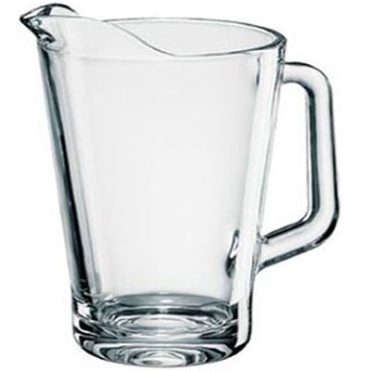
- Liquid Volume

1 litre = 1000 ml = 1000cm³

1ml = 1 cm³

- Volume of Prisms

- Volume of a Cylinder –

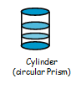
$V={πr}^{2}h$

Topic 7 –Pythagoras (Chapter 19)

- Squares and roots
1

2

3

4

5

6

6² = 36

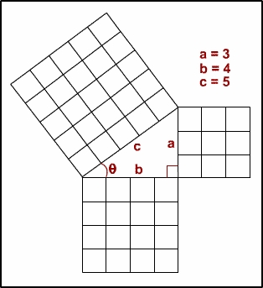
- Pythagoras Theorem

(Right angled triangles ONLY)

Hypotenuse is always the longest side

which is always opposite the right angle.

- Calculating – Hypotenuse.

- Real - Life Problems involving Pythagoras

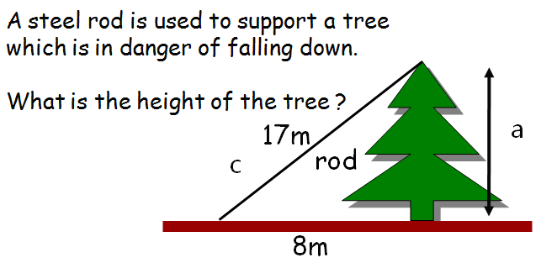

- Calculating – smaller side.

- Mixed questions

Topic 8 – Time & Timetables (Chapter 20)

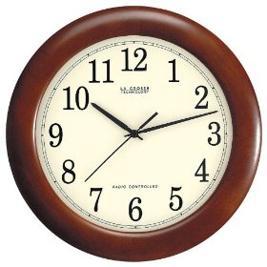
1
2
3
1. Converting between 12 / 24 clock
7.30pm ⇨1930 2215⇨1015pm

- Time Intervals
Counting Method

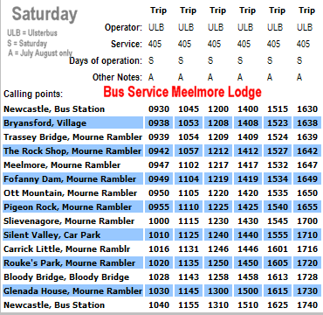
- Interpreting Timetables

Topic 9 – Rules & Formulae (Chapter 21)

1

2

- Formulae expressed in Words

Multiply the temperature in ºC by 1.8 then add 32

- Evaluating Formulae with Symbols

Topic10 –Scale Drawings 2 (Chapter 22)

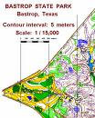
1. Simple Scale Drawing
1

2
3

4

1cm represents 2m etc.....

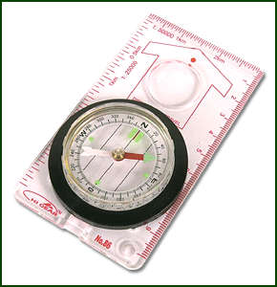
- Compass Points

- Scale Drawing using a protractor

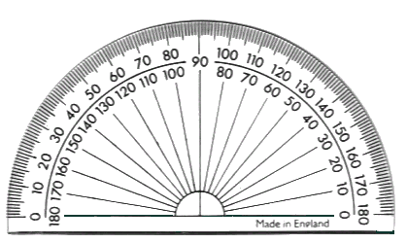

4. Bearings and Scale Drawings

Topic 11 – Problem Solving Area & Volume (Chapter 23)

- The term Fraction
1
2
3
4
5
6
7

- Equivalent Fraction

- Fraction of a Quantity

- The term Percentage

Out of a 100

(80 out of 100)

- Finding a Percentage using a calculator

29% of £250

- Finding a Percentage without a calculator

30% of 80
10% ⇨ 8
30% ⇨ 8x3 = 24

- Common Percentages / Fractions

Topic 12 – Tolerance (Chapter 24)

1

2

- Tolerance
A builder needs 50mm bolts
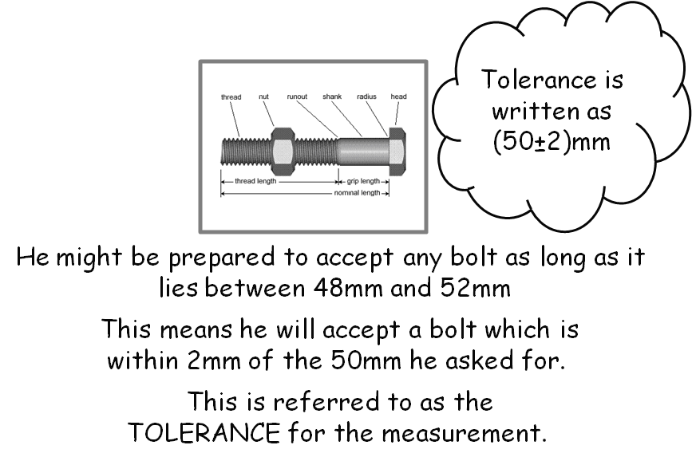

- Tolerance Notation

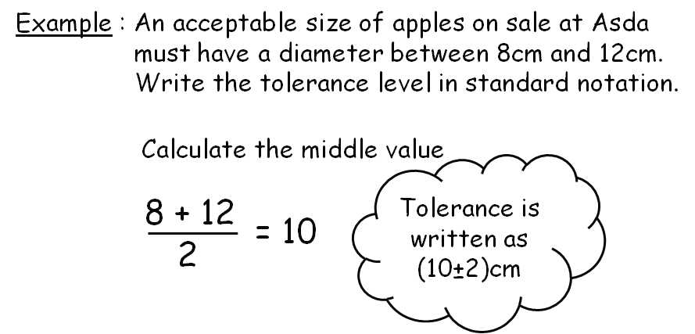

For my Geometry & Measure Assessment I will

Finance & Statistics

Topic 13 – Income (Chapter 25)

- Hourly rate
1

2

3

4

5

6

7

£7.50 ph means £7.50 for every hour worked

- Calculate hourly rate

£10 for 2 hours work ⇨ hourly rate £5 per hour

- Weekly / Monthly Pay

Weekly means ÷ 52 Monthly means ÷ 12

- Wages Increase / Decrease (Percentage)

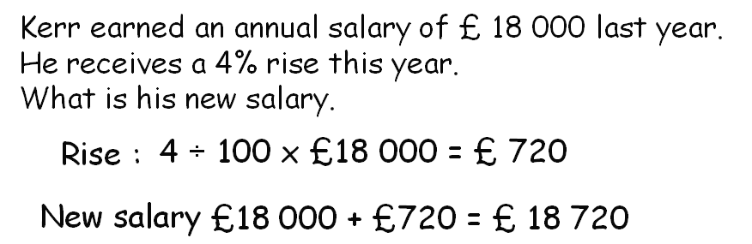

- Commission
Liam sells windows. He is paid a commission of 15% on any
Windows he sells. He sold £ 30 000 worth of windows.
How much commission was he paid ?

- Overtime + Bonuses

Double time ⇨ Time and a half ⇨

- Wage Slips – Deductions – gross / net pay

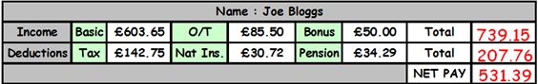

Topic 14 – Foreign Exchange (Chapter 26)
1
2
- Exchanging Pounds for Foreign Currency

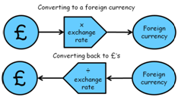

- Exchanging Foreign Currency to Pounds

Topic 15 – Banking (Chapter 27)

- Simple Interest
1
2

3
How much is earned in interest if I have £60 in the bank for a year if annual interest is paid at 2% p/a.

- Credit & Debit Cards

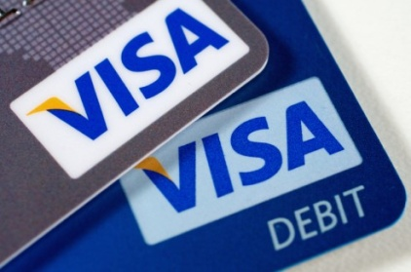

- Borrowing money

- Where to go to for a loan
- Advantages and disadvantages
- Why would you take out a loan

Topic 16 – Comparing Prices (Chapter 28)

- Better Buy
1

2

3

Shop A - 700g of Flakes cost £4.90 100g → 70p
Shop B - 500g of Flakes cost £3.60 100g → 72p

- Paying for Services

- Call – Out Charges & Hourly Rates
- Plumber, Joiner, Mechanic etc.....

- Rates or Contracts

- Mobile phone tariffs
- Foreign Exchange Rates
- Loan Rates

Topic 17 – Budgeting (Chapter 29)

- Budgeting 1 – Individual budgeting for a trip
1

2

3

- Saving by cutting back on non essential
- Extra jobs to earn

- Budgeting 2 – Family Monthly budgeting

- Income and Expenditure
- Spreadsheet can help to calculate budgets

- Budgeting 3 – Needs and Wants

- NEEDS – what you need to survive
- WANTS – nice to have but you don’t need

Topic 18 – Comparing Data Sets (Chapter 30)

- Range = Highest – lowest
1

Mean = (Add up all the data) ÷ the number bits of data

Range = Highest – lowest

Median = Middle number when data arranged in order

Mode = The number that occurs the most

Topic 19 – Graphs Charts & Tables 2 (Chapter 31)




- Drawing Bar Graphs and Line Graphs
1

2

3

4

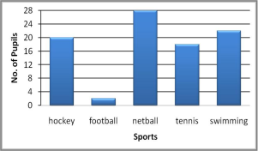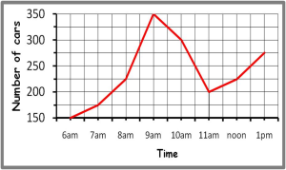

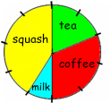
- Constructing Simple Pie-Charts

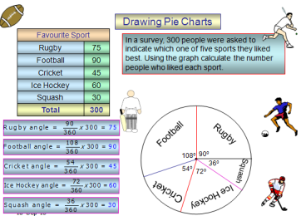
- Constructing Pie Charts

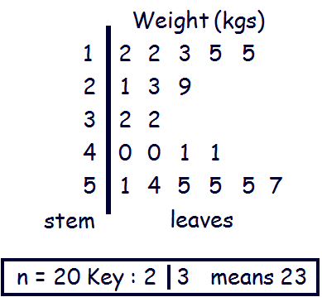
- Constructing Stem-Leaf Diagrams

Topic 20 – Scattergraphs (Chapter 32)

- Scattergraphs
1

2

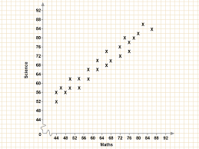

- Best-Fit Line
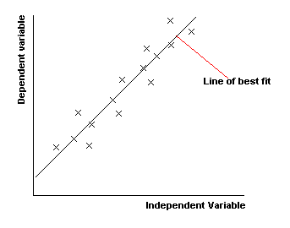

Topic 21 – Statistical Chance (Chapter 33)

1

2

- Simple Probability

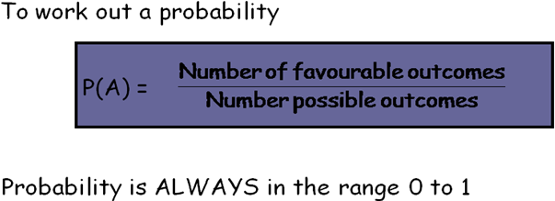

- Harder Probability

Expressed as a ratio P(A) = 0.4 means 2 in 5 chance

Expressed as a fraction P(A) = 0.4 means

For my Finance & Statistics Assessment I will

My Achievements
Skill | Activity | Date & Teacher Signature

My Achievements
Skill | Activity | Date & Teacher Signature

