1. Jane found a small photo-frame and decided to put one of her favourite photographs in it. The diagram below shows the dimensions of the frame.
7cm
10cm
x cm
x cm
The width of the wooden surround is x cm.

Unfortunately the glass in the centre of the frame was cracked and had to be replaced.

- Show that the area of glass needed for the centre of the frame
can be given by the formula
4 marks

(b) If the area of glass needed was 28cm², find a possible value for x. 3 marks

2. Rectangle A, shown opposite, has length (x + 6) units and breadth (x – 1) units.
A
(x + 6)
(x – 1)

Rectangle B has length (x + 3) units and breadth 3 units.
B
(x + 3)
3

a) Write down expressions, in terms of x, for the area of Rectangle A
and the area of Rectangle B. 2 marks
b) Given that both rectangles have the same area for a particular value of x,
form an equation using your answers to part (a) and
solve it to find this value of x. 3 marks

3. A frog is sitting 2 feet to the left of a snake.
The frog then notices a fly sitting on a rock on the other side of the snake.
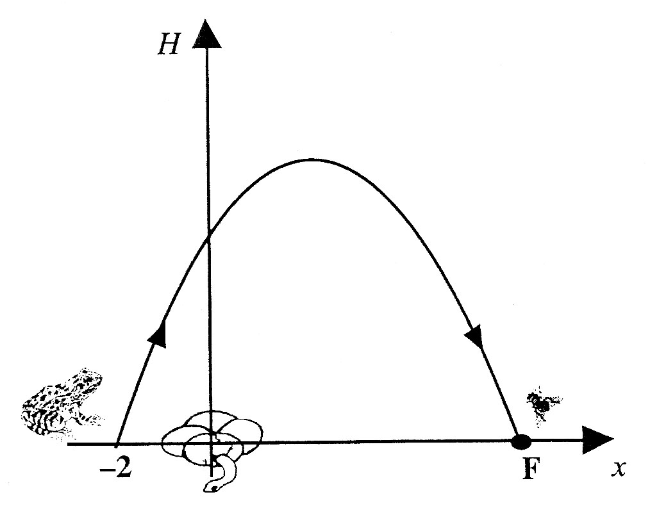
As the frog leaps over the snake to catch the fly,
its path is described by the parabola with equation
where H is the height of the frog above the ground.

a) By considering the quadratic equation:
Find the co-ordinates of the point F, where the fly is sitting,
and hence write down how far away the fly is from the frog. 4 marks

b) How high above the ground does the frog reach on its jump ? 3 marks

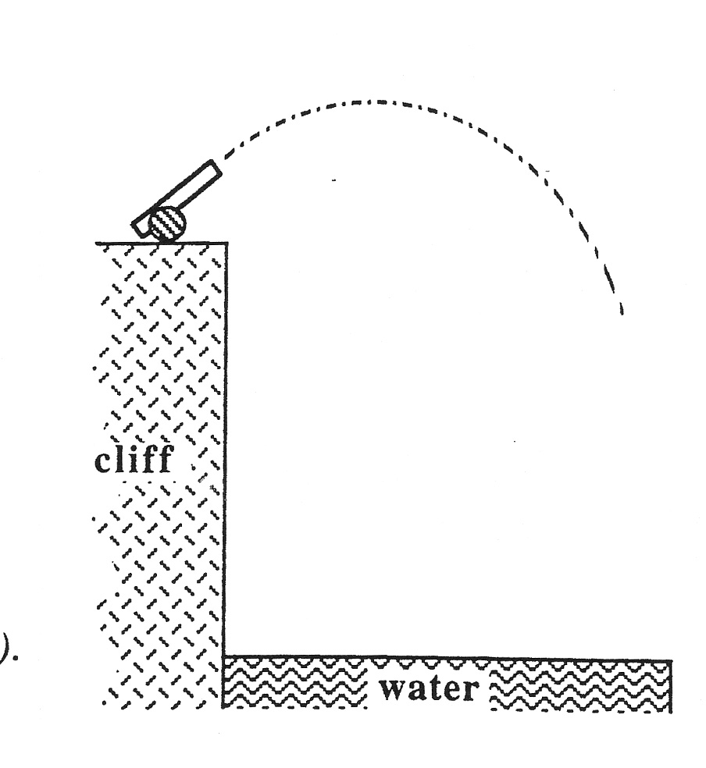
4. When a shell is fired from a cannon on top of a cliff,
the height of the shell above the water surface
is given by the formula:

where t is the time in seconds and H(t) is the height in metres after t seconds.

Calculate the height of the shell after 3 seconds.
Explain what your answer indicates. 2 marks

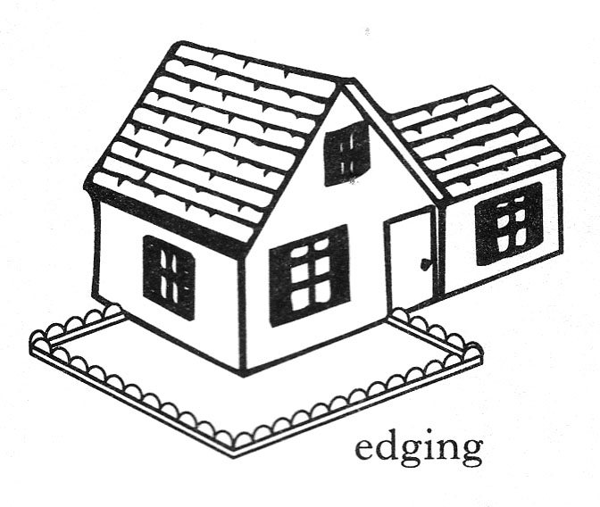
5. A gardener creates an L-shaped flower bed.
He uses the house walls and concrete edging for
the boundary as shown in figure 1 opposite.
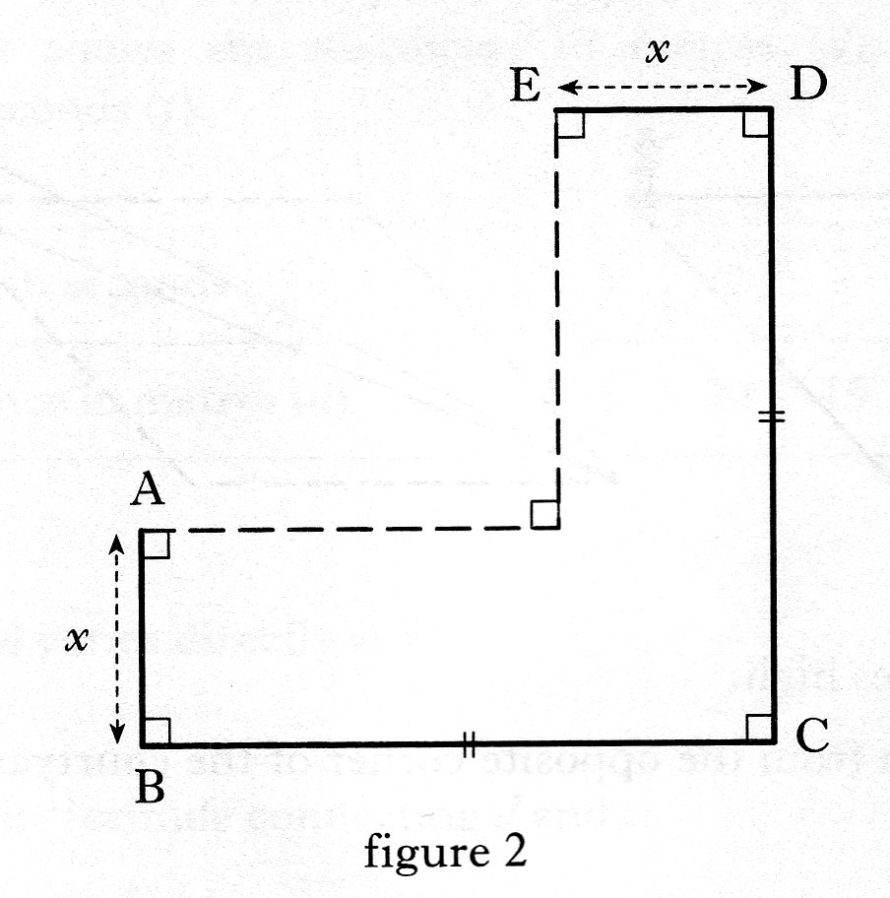

He plans his flower bed as shown in figure 2.

a) He uses a total of 6 meters of edging.
AB = ED = x metres.
BC = DC
Show that the length in metres, of BC,
can be expressed as BC = 3 – x. 2 marks

b) Hence show that the area, A, in square metres, of the flower bed
can be expressed as
3 marks

c) Calculate algebraically
the maximum area of the flower bed. 3 marks

6. A family want to build an extension at the rear of their house.
An architect advises that the extension should have its length 2 metres more
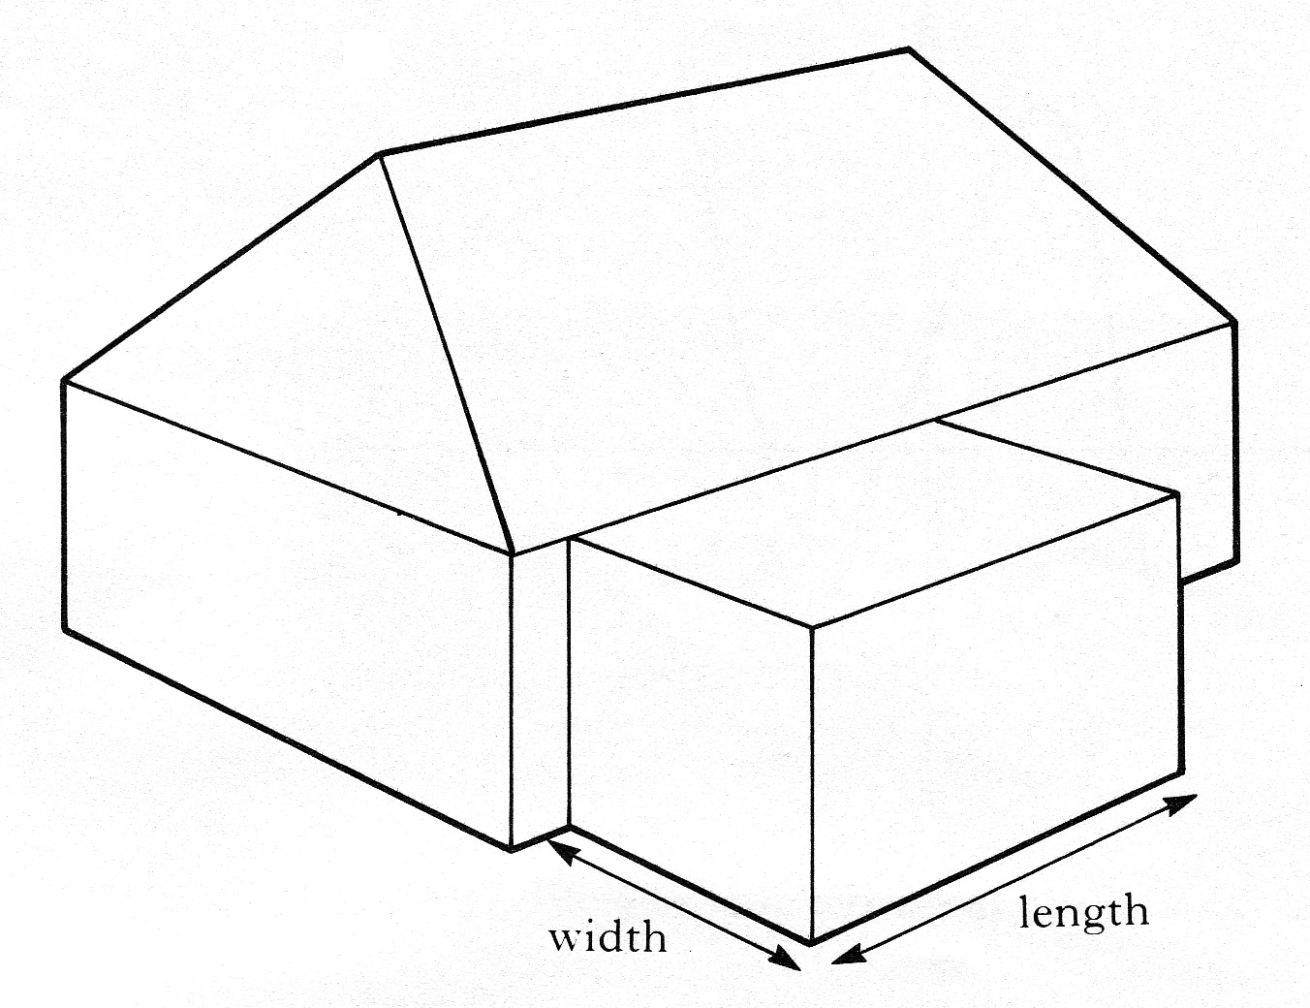
than its width.
a) If the width of the extension is w metres,
write down an expression for its length. 1 mark

Planning regulations state that the area of the ground floor of the extension
must not exceed 40% of the area of the ground floor of the original house.

b) The ground floor of the original house is 12 metres by 10 metres.
Show that, if the largest extension is to be built, . 3 marks

c) Find the dimensions of the largest extension which can be built. 2 marks

7. A rectangular sheet of plastic 18 cm by 100 cm is used to make a gutter for
draining rain water.
The gutter is made by bending the sheet of plastic as shown below in diagram 1.
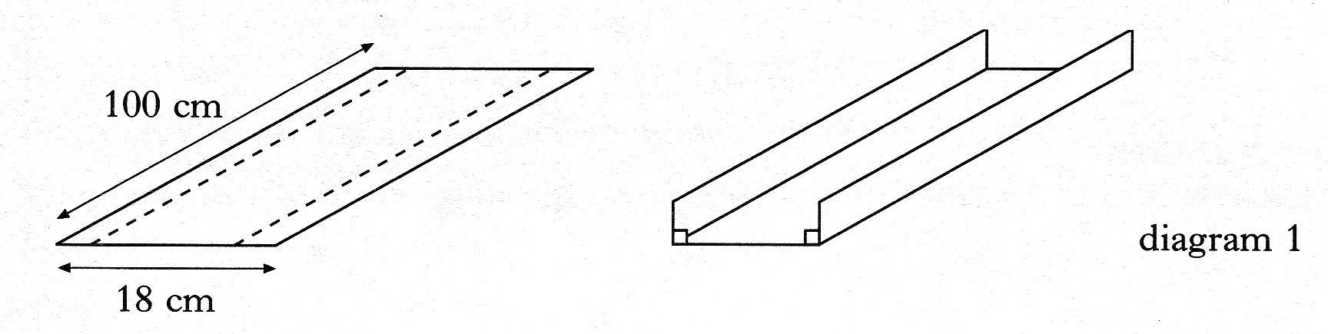

a) The depth of the gutter is x centimetres as shown in diagram 2 below.
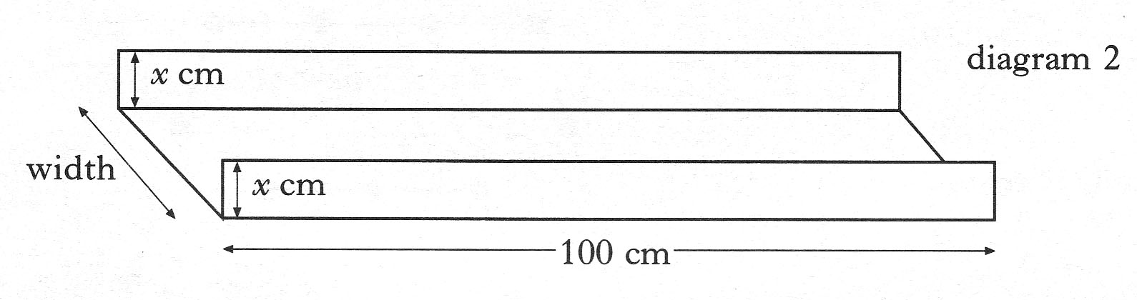
Write down an expression in x for the width of the gutter. 1 mark

b) Show that the volume, V cubic centimetres, of this gutter is given by
2 marks

c) Find the dimensions of the gutter which has the largest volume.
Show clearly all your working. 4 marks

