1. The diagram shows part of the graph of a quadratic function, with equation of the form
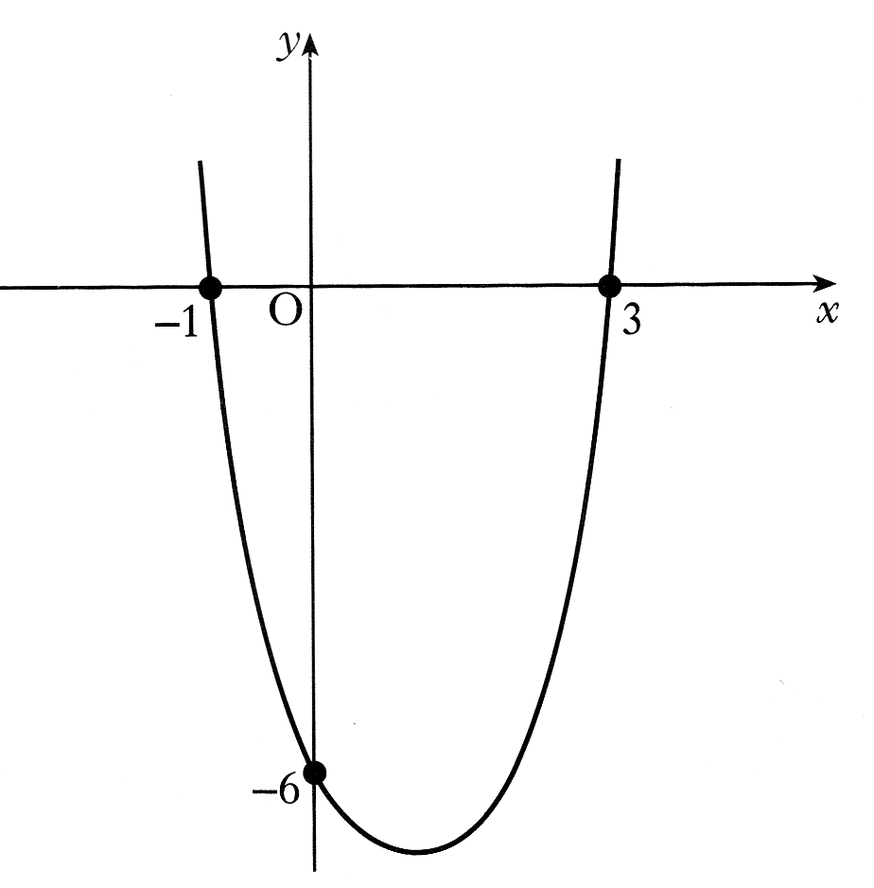
The graph cuts the y-axis at (0, -6) and the x-axis at (-1, 0) and (3, 0)

a) Write down the values of a and b. 2 marks
b) Calculate the value of k. 2 marks
c) Find the coordinates of the minimum turning point of the function 2 marks

y
x
0
A
B
C
2. The graph shown has equation .

(a) Find the coordinates of A, the point where the curve cuts the y – axis. 1 mark
(b) Find the coordinates of B and C, the points where the curve cuts the x – axis. 3 marks

(c) Find the coordinates of the minimum turning point. 2 marks

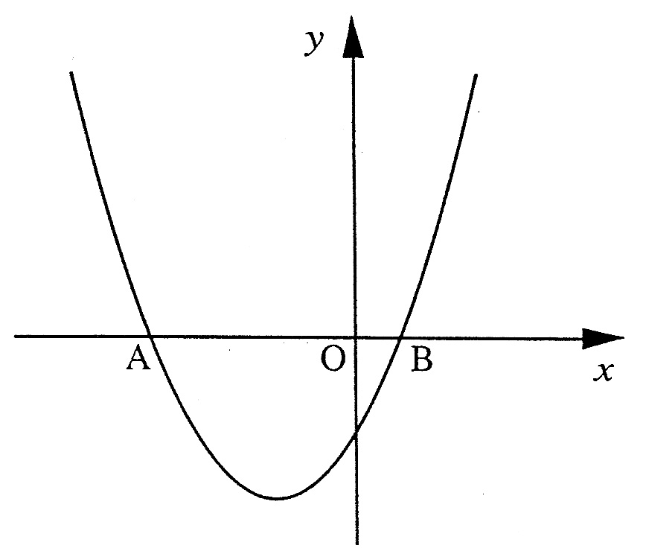
3. The graph shows the parabola

By solving the quadratic equation
Find the coordinates of point A.
Give your answer correct to 2 decimal places. 4 marks

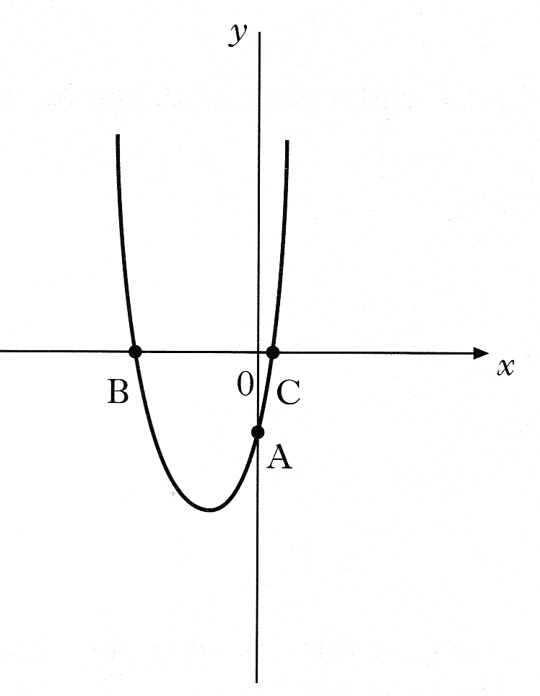

4. The diagram below shows part of the graph of

The graph cuts the y-axis at A and the x-axis at B and C.
a) Write down the coordinates of A 1 mark
b) Find the co-ordinates of B and C. 3 marks
c) Calculate the minimum value of 2 marks

