1. Andrew and Doreen each book in at the Sleepwell Lodge.
a) Andrew stays for 3 nights and has breakfast on 2 mornings. His bill is £145
Write down an algebraic equation to illustrate this. 1 mark
b) Doreen stays for 5 nights and has breakfast on 3 mornings. Her bill is £240.
Write down an equation to illustrate this. 1 mark
c) Find the cost of one breakfast. 3 marks

2. The reception area in a council office block is to be tiled with a mixture of two types of ceramic tile – white and blue. The contractors left two samples, with their cost per square metre, as shown in the diagrams below.
Diagram 1
Diagram 2

Cost: £25.20
Cost: £26.40

(a) Using Diagram 1 write down an equation in b and w, where b is the cost of a
blue tile and w is the cost of a white tile. 1 mark
(b) Using Diagram 2 write down a second equation in b and w. 1 mark
Unfortunately the manager did not like any
of the samples left and decided to use one of his own.
His choice is shown in the diagram on the right.

(c) How much per square metre would this design cost ? 4 marks

3. a) 4 peaches and 3 grapefruit cost £1.30
Write down an algebraic equation to illustrate this. 1 mark
b) 2 peaches and 4 grapefruit cost £1.20.
Write down an algebraic equation to illustrate this. 1 mark
c) Find the cost of 3 peaches and 2 grapefruit. 4 marks

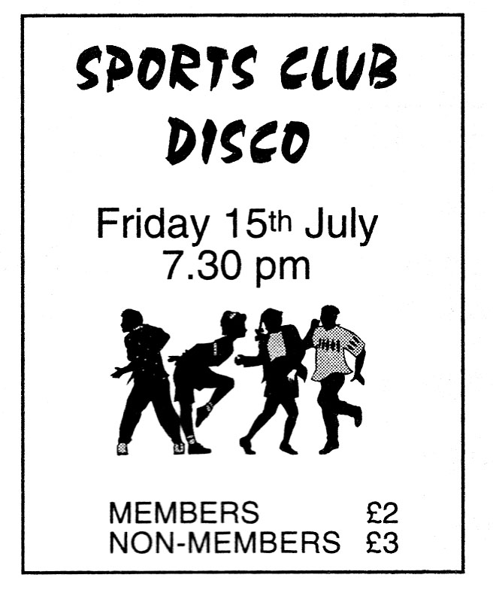
4. The tickets for a Sports Club Disco cost £2 for members and £3 for non-members.
a) The total ticket money collected was £580.
x tickets were sold to members
and y tickets were sold to non-members.
Use this information to write down an equation
involving x and y. 2 marks
b) 250 people bought tickets for the disco.
Write down another equation involving x and y. 1 mark
c) How many tickets were sold to members ? 3 marks

5. A small square patio required nine slabs to cover it.
a) The cost of using 4 patterned slabs and 5 plain ones is £15.50
by letting £x be the cost of 1 patterned slab.
£y be the cost of 1 plain slab. 1
Write down an algebraic equation to illustrate this. 1 mark
b) If 2 patterned slabs and 7 plain ones
are used instead, the cost becomes £14.50.

Write down an algebraic equation to illustrate this. 1 mark

c) Find the cost of this arrangement which is made
up by using 8 patterned slabs and 1 plain one.

(show all your working clearly). 4 marks

6. A water pipe runs between two buildings.
These are represented by the points A and B in the diagram below.
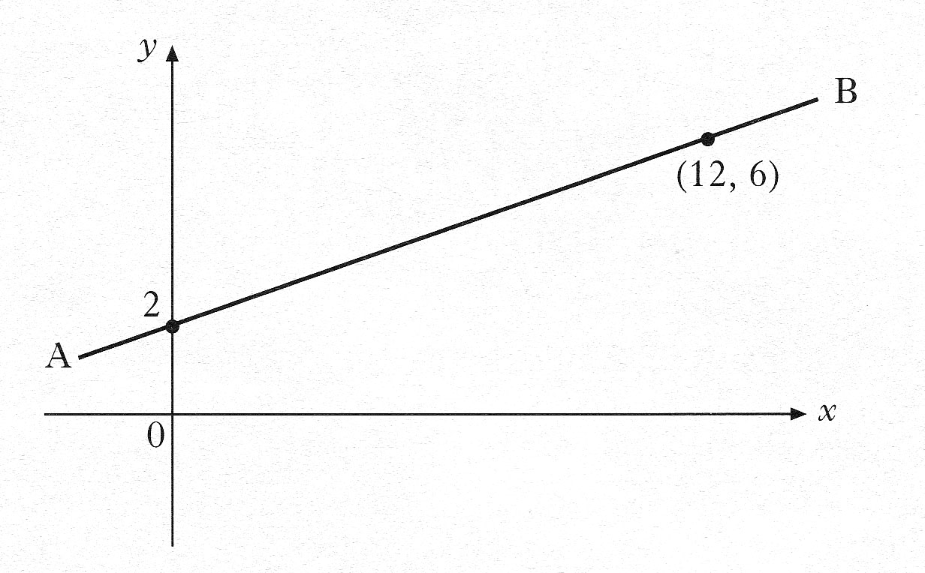

a) Using the information in the diagram, show that the equation
of the line AB is . 3 marks
b) An emergency outlet pipe has to be built across the main pipe.
The line representing this outlet pipe has equation
Calculate the coordinates of the point on the diagram at which
the outlet pipe will cut across the main water pipe. 4 marks

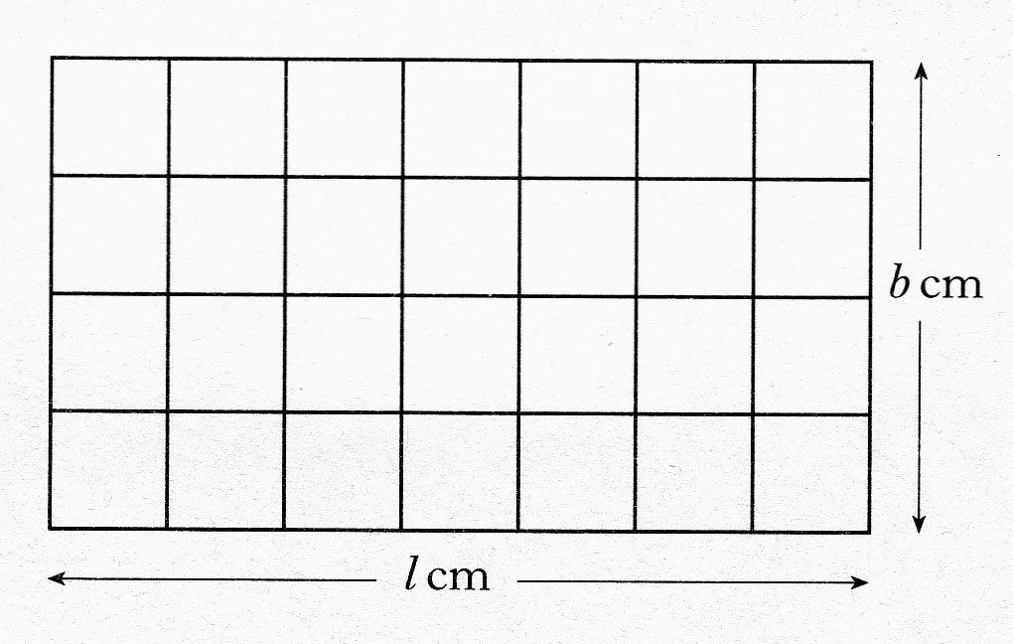
7. A rectangular window has length,
l centimetres and breadth b centimetres
A security grid is made to fit this window.
The grid has 5 horizontal wires and 8 vertical wires.

a) The perimeter of the window is 260 centimetres.
Use this information to write down an equation involving l and b. 1 mark

b) In total, 770 centimetres of wire are used.
Write down another equation involving l and b. 2 marks

c) Find the length and breadth of the window. 3 marks

8. Gillian and Laura took their children to the zoo.
The entrance cost for the zoo was as shown below, but the charges for
children have been torn off.
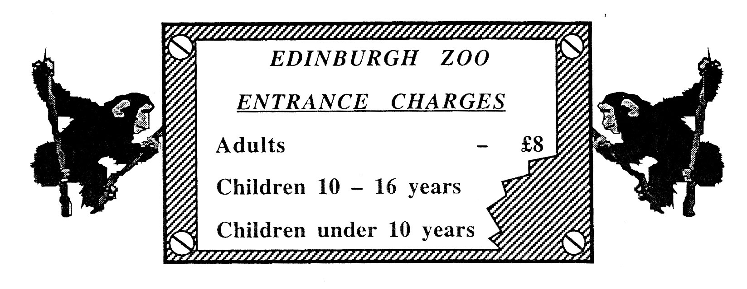

a) Gillian paid for herself and:-
her 2 sons aged 13 and 15, and her 3 daughters all under 10 years of age.
Let the price for each 10 – 16 year old be £ x.
Let the price for each under 10 year old be £ y.
If Gillian paid £19 in total for herself and her own children, explain why
the cost can be expressed in the form.
1 mark
b) Laura paid for herself and:-
her 4 sons aged 10, 12, 13 and 16, and her 1 daughters aged 7. Laura paid £15 in total.
Write down a second equation in x and y to indicate her total cost. 1 mark

c) Calculate the cost of:
(i) a single ticket for a 14 year old child. 3 marks
(ii) a single ticket for a 7 year old child. 1 mark

9. A child has built a tower made of two types of brick.
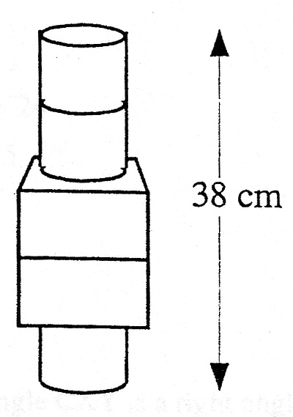
It has three cylinders and two cuboids.
The total height of his tower is 38 centimetres.
Let x cm be the height of one cylinder and
let y cm be the height of one cuboid.

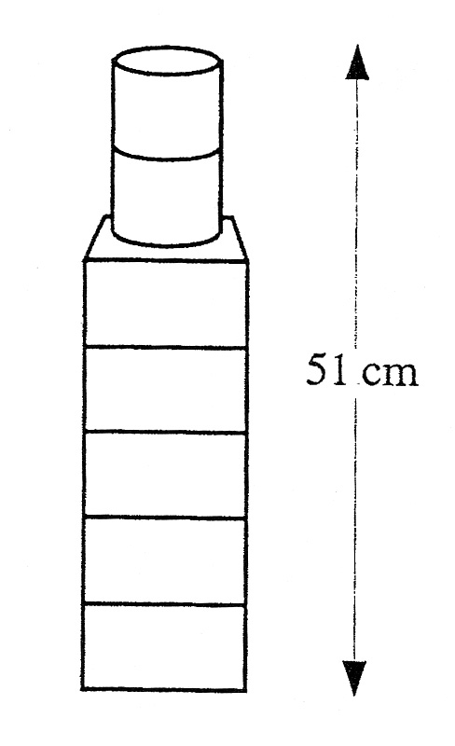
a) Construct an equation connecting x and y 1 mark

He then built this second tower using two cylinders and five
cuboids, and its height was 51 centimetres.

b) Form a second equation in x and y and calculate the height
of both a cylinder and a cuboid. 4 marks

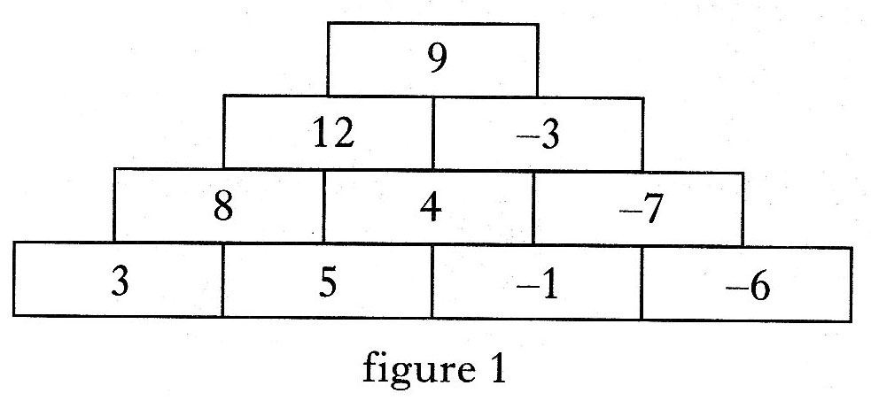
10. A number tower is built from bricks
as shown in figure 1.
The number on the brick above is always equal to the sum of the two numbers below.

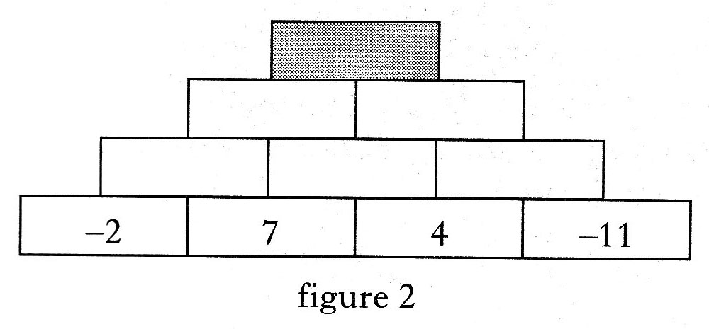
a) Find the number on the shaded brick in figure 2. 1 mark

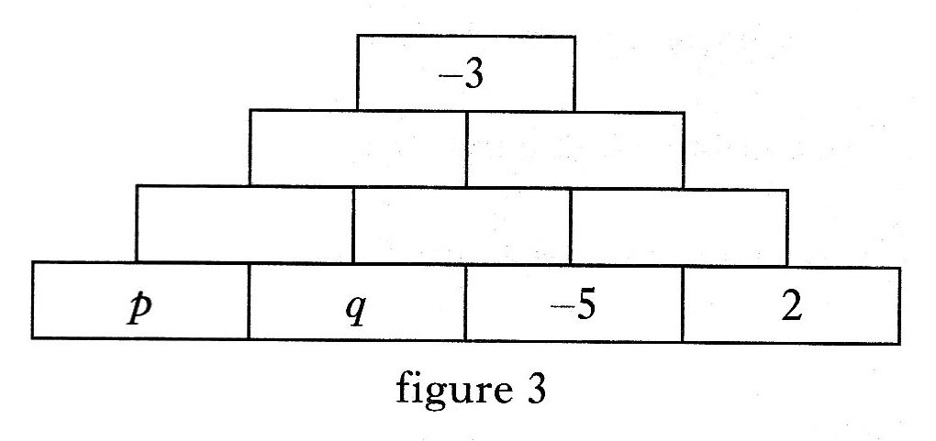
b) In figure 3, two of the numbers on the base bricks are represented by p and q.
Show that 2 marks

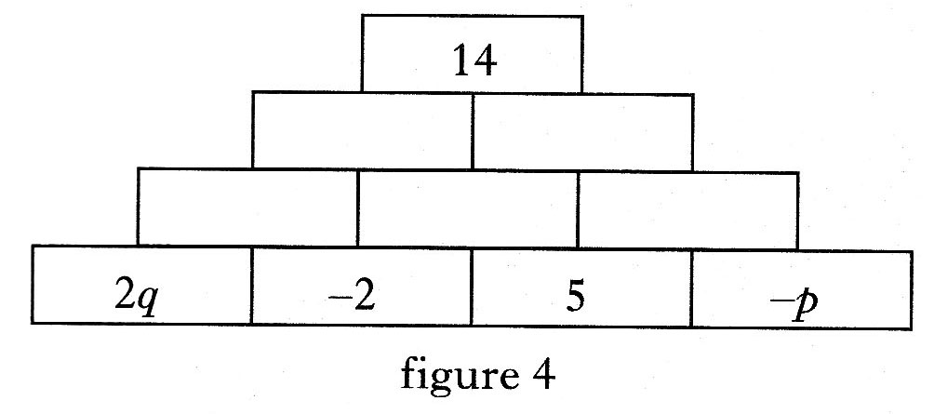
c) Use figure 4 to write down a second equation in p and q. 2 marks

d) Find the values of p and q. 3 marks

11. Alloys are made by mixing metals. Two different alloys are made using iron and lead.
To make the first alloy, 3 cubic centimetres of iron and 4 cubic centimetres of lead are used.
This alloy weighs 65 grams.

- Let x grams be the weight of 1 cubic centimetre of iron and
y grams be the weight of 1 cubic centimetre of lead.
Write down an equation in x and y which satisfies the above condition. 2 marks

To make the second alloy, 5 cubic centimetres of iron and 7 cubic centimetres of lead are used.
This alloy weighs 112 grams.

b) Write down a second equation in x and y which satisfies this condition. 2 marks

c) Find the weight of 1 cubic centimetre of iron and the weight of 1 cubic
centimetre of lead. 3 marks

