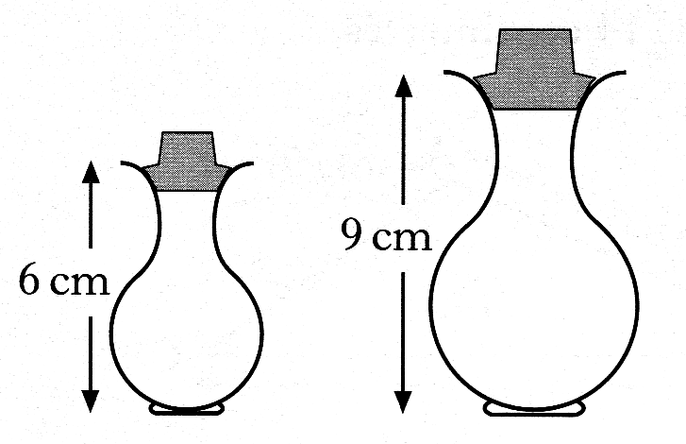
1. Two perfume bottles are mathematically similar in shape.
The smaller one is 6 centimetres high and
holds 30 millilitres of perfume.
The larger one is 9 centimetres high.

What volume of perfume will the larger one hold. 3 marks

2. The two boxes below are mathematically similar and
both have to be wrapped with decorative paper.
50cm
40cm

It requires 3.27 m² of paper to cover the large box.

Calculate the amount of paper needed to cover the smaller box. 3 marks

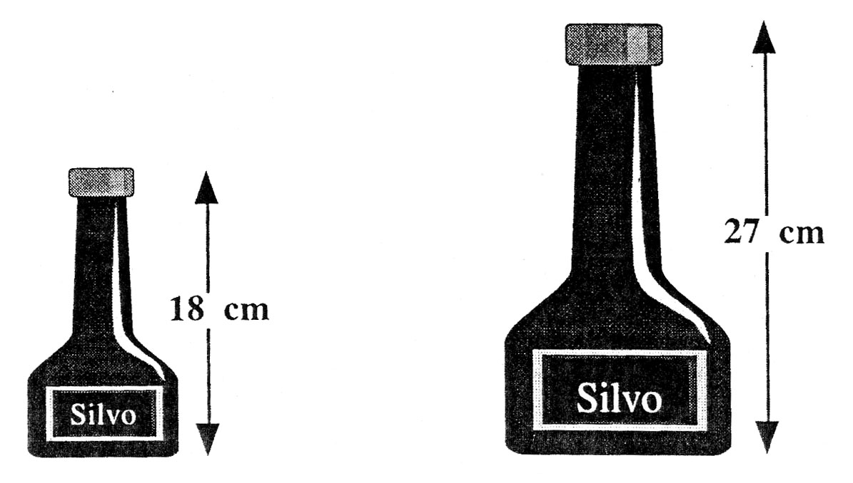
3. The diagram shows two bottles of Silvo Shampoo.
The two bottles are mathematically similar, and the cost of the shampoo
depends only on the volume of liquid in the bottle.

If the small one costs 80p, what should the large one cost ? 3 marks

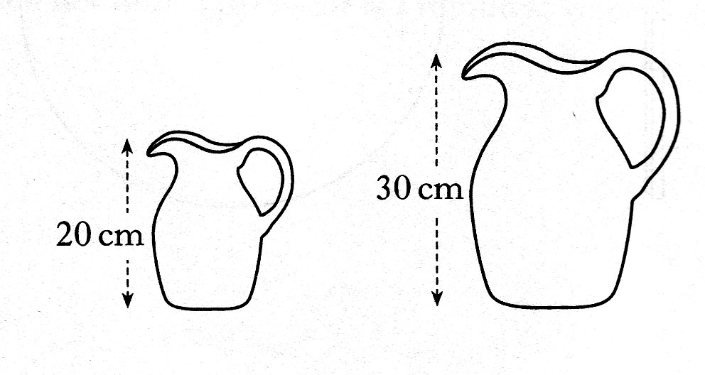
4. The diagram shows two jugs which are mathematically similar.
The volume of the smaller jug is 0.8 litres.

Find the volume of the larger jug. 3 marks

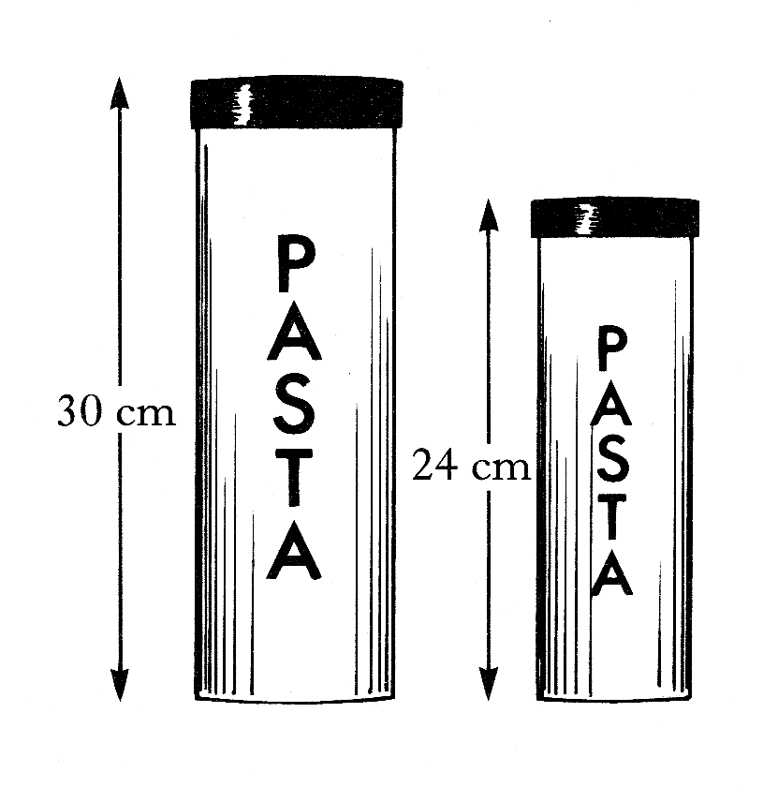
5. The diagram shows two storage jars which are mathematically similar.
The volume of the large jar is 1.2 litres.
Find the volume of the smaller jar.

Give your answer in litres correct to 2 significant figures. 3 marks

6. The diagram shows two tubes of toothpaste.
Assuming that the tubes are mathematically similar,
and that the price of toothpaste depends only on the volume of toothpaste in the tube.
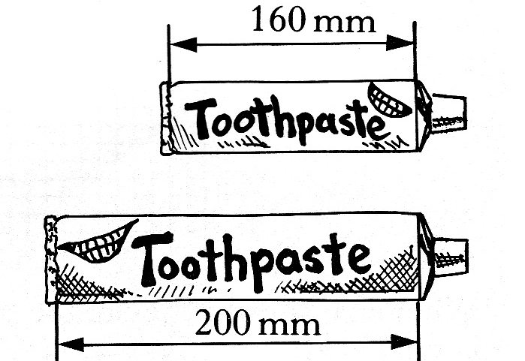

What would be the cost of the large tube when the small one costs £1.12? 3 marks

7. A metal beam, AB, is 6 metres long.
It is hinged at the top, P, of a vertical post 1 metre high.
When B touches the ground, A is 1.5 metres above the ground,
as shown in Figure 1.

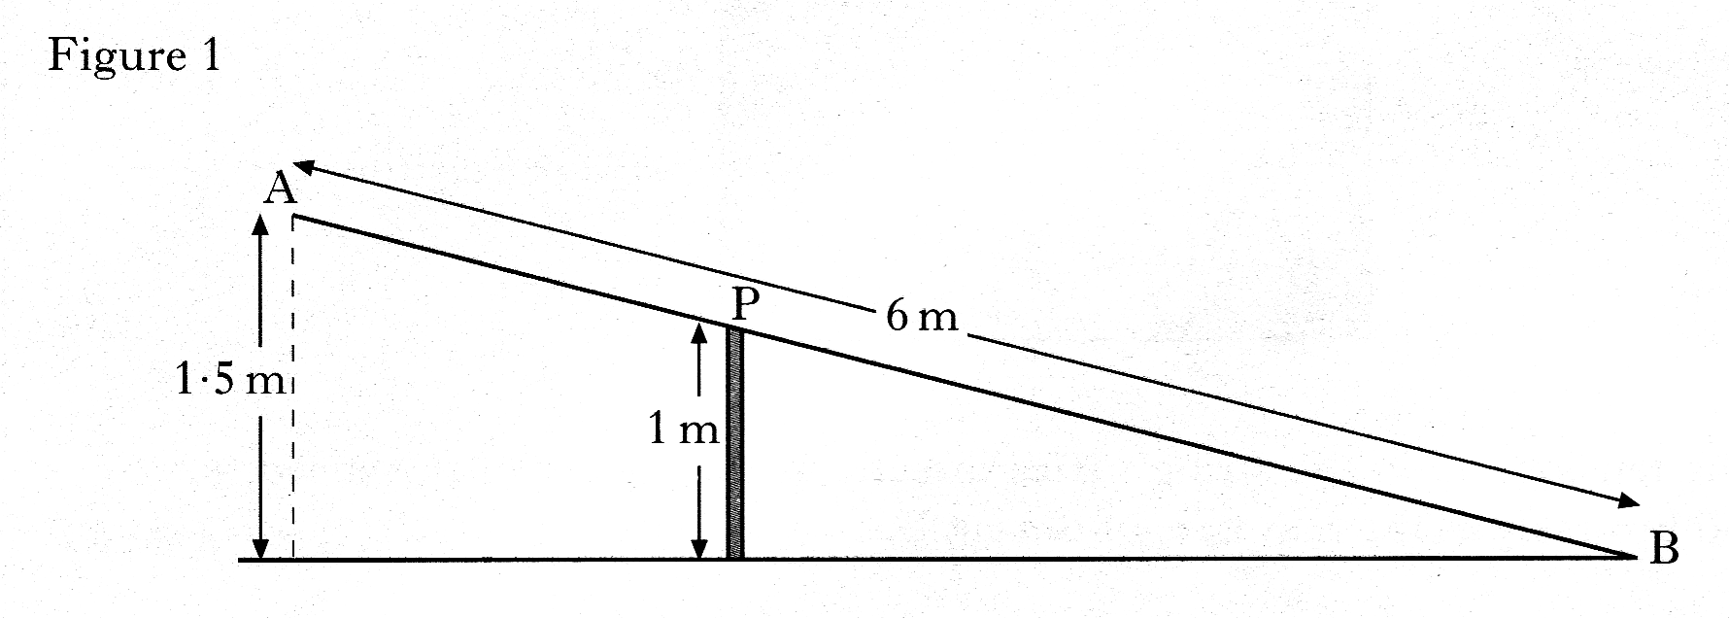

When A comes down to the ground, B rises, as shown in Figure 2.
By calculating the length of AP, or otherwise, find the height of B above the ground.
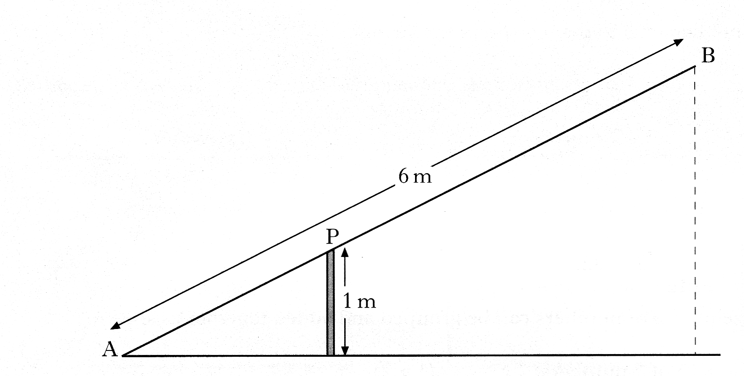
Do not use a scale drawing. 5 marks

8. The road joining A to B is parallel to the road joining C to D in the diagram.
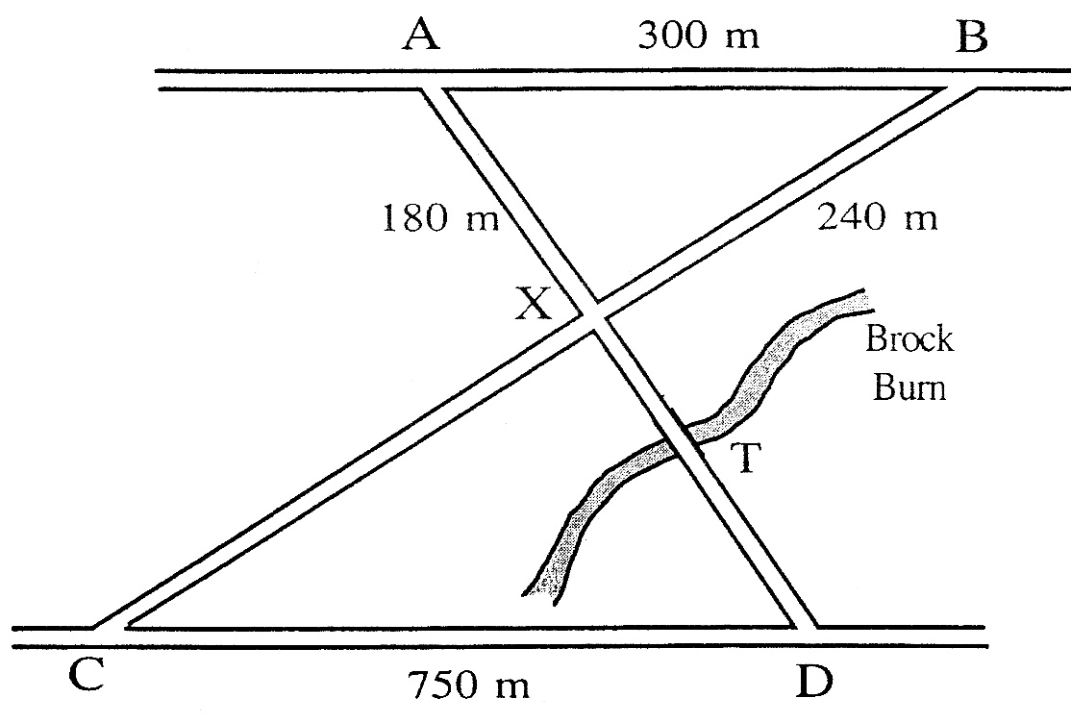
AB = 300 metres, AX = 180 metres, BX = 240 metres and CD = 750 metres.

a) Prove that the two roads AX and BX are at right angles to one another 3 marks
b) The Brock Burn burst its banks at T and the road became impassable.
An alternative route had to be found in order to travel from A to D.
Calculate the length of the shortest route. 3 marks
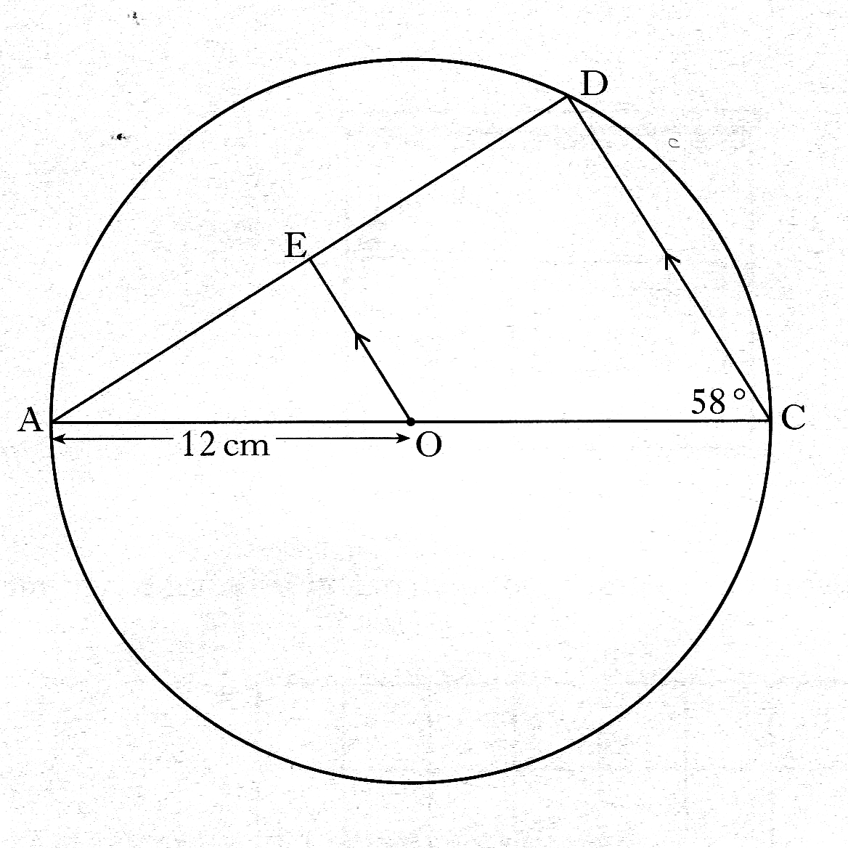
9. AC is the diameter of the circle.
with centre O, and radius 12 centimetres
AD is a chord of the circle.
OE is parallel to CD
Angle ACD is 58°
Calculate the length of ED. 4 marks

11. Study the two triangles shown.
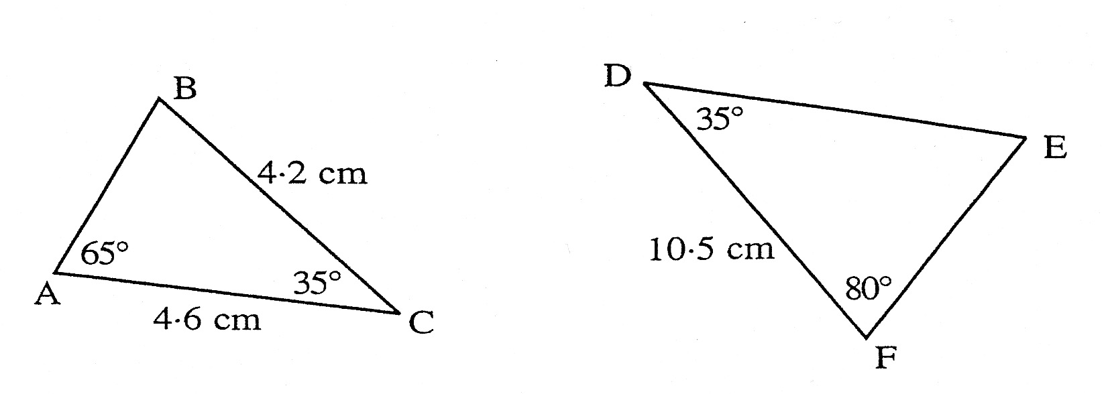

a) Explain clearly why the two triangles must be similar. 1 mark

b) Use the fact that the two triangles are similar to calculate the length of the line DE. 2 marks

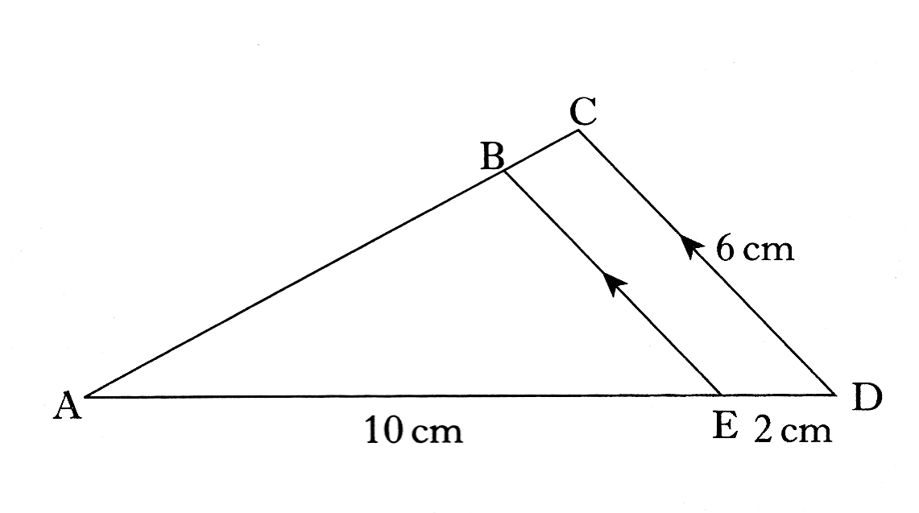
12. Triangles ABE and ACD with some of their measurements are shown opposite.

Triangle ABE is similar to triangle ACD.

Calculate the length of BE.
Do not use a scale drawing. 3 marks

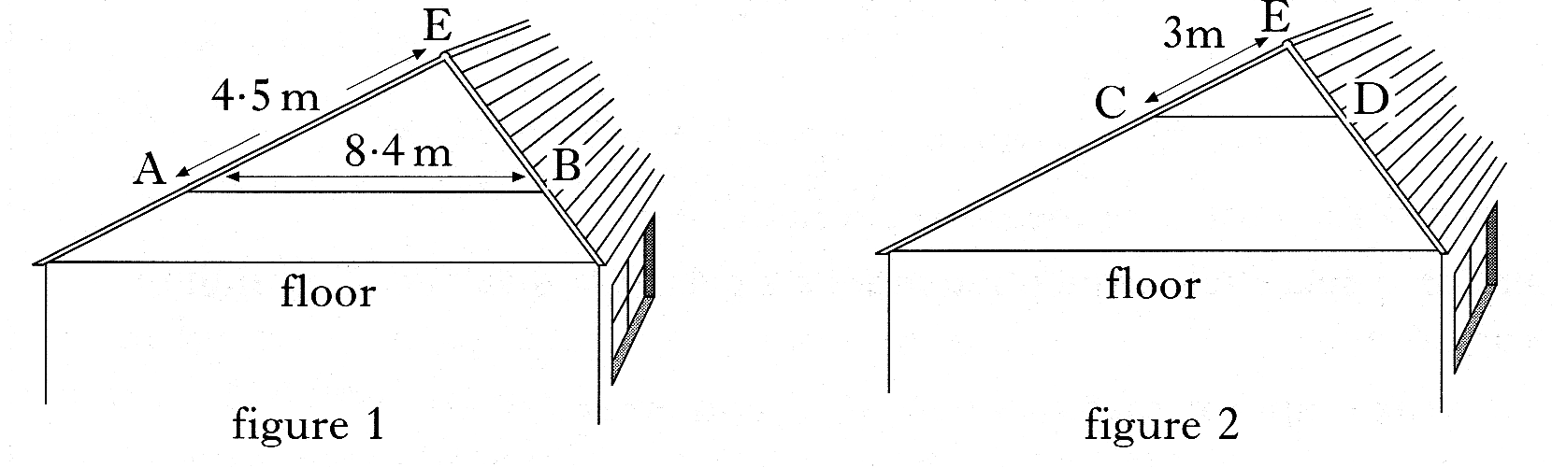
13. The brown family want to convert the roof space in their bungalow
into an extra room.

The position, AB, of the wooden beam must be changed to position CD, as shown in figure 2.
The wooden beam must always be parallel to the floor.
By considering the similar triangles EAB and ECD, calculate the length of the
wooden beam in position CD.
Do not use a scale drawing. 3 marks

14. By holding a 10 pence coin at arms’ length, it is possible to cover exactly
the face of a person standing a distance away.
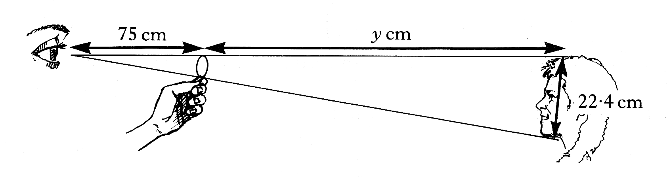

The diameter of the 10 pence coin is 2.8 cm and the length from the top to the
bottom of the person’s face is 22.4 cm.
The distance from the observer’s eye to the top of the coin is 75 cm.
Find the distance from the top of the 10 pence coin to the top of the person’s head.
4 marks

