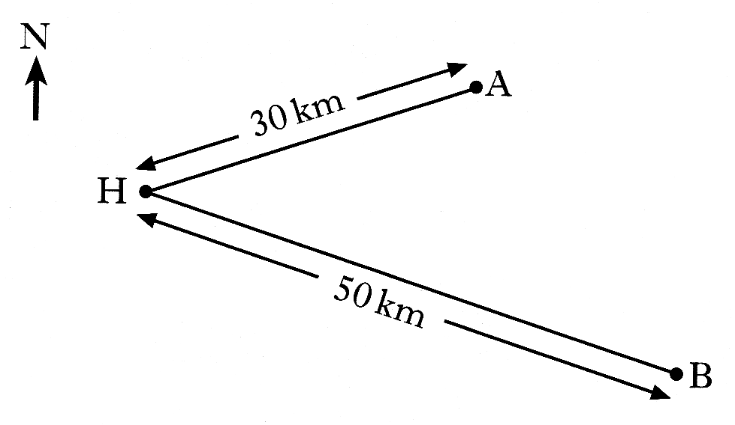
1. Two yachts leave from harbour H.
Yacht A sails on a bearing of 072°
for 30 kilometres and stops.
Yacht B sails on a bearing of 140°
for 50 kilometres and stops.

How far apart are the two yachts when they have both stopped?
Do not use a scale drawing. 4 marks

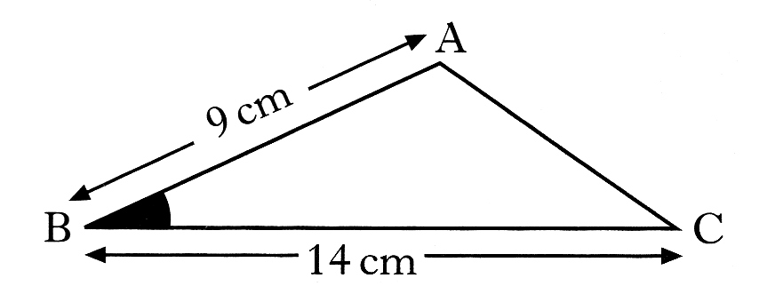
2. The area of triangle is 38 square centimetres.
AB is 9 centimetres and BC is 14 centimetres.

Calculate the size of the acute angle ABC 3 marks

3. Two boats leave port together.
D
E
Port
North
Boat D sails on a course of 057º
at 13 miles per hour.
Boat E sails on a bearing of 104º
at 15 miles per hour.
After 45 minutes Boat D receives
a distress call from Boat E requesting
their help as soon as possible.

How far, to the nearest mile, would Boat D have to travel to reach Boat E? 4 marks
P
Q
R
6cm
16cm

4. The area of the triangle shown is 36 cm².

Show that . 4 marks

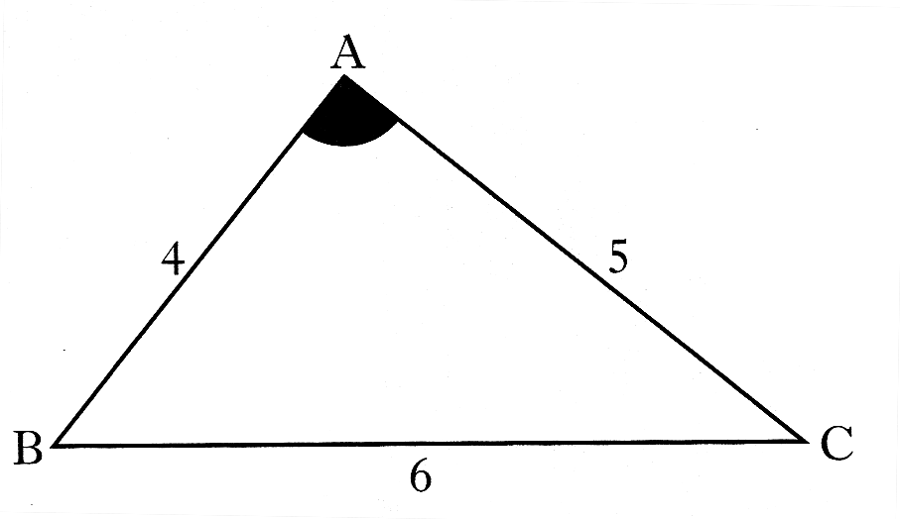
5. In triangle ABC
AB = 4 units
AC = 5 units
BC = 6 units
Show that 3 marks

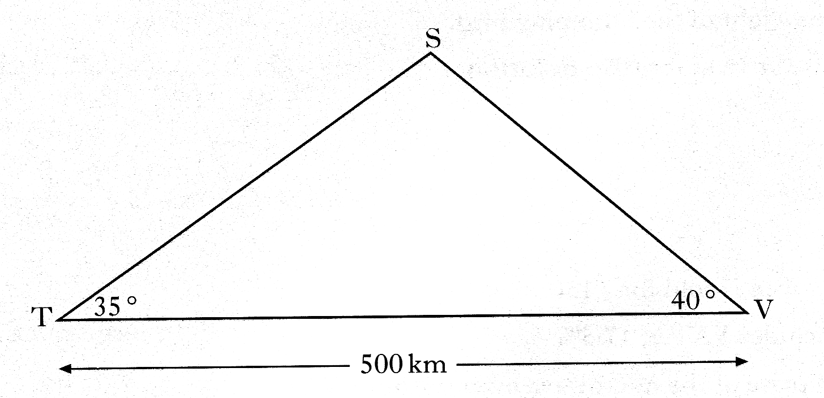
6. A TV signal is sent from a transmitter T,
via a satellite S, to a village V,
as shown in the diagram.

The village is 500 kilometres from the transmitter.

The signal is sent out at an angle of 35° and is received in the village at an angle of 40°.

Calculate the height of the satellite above the ground. 5 marks

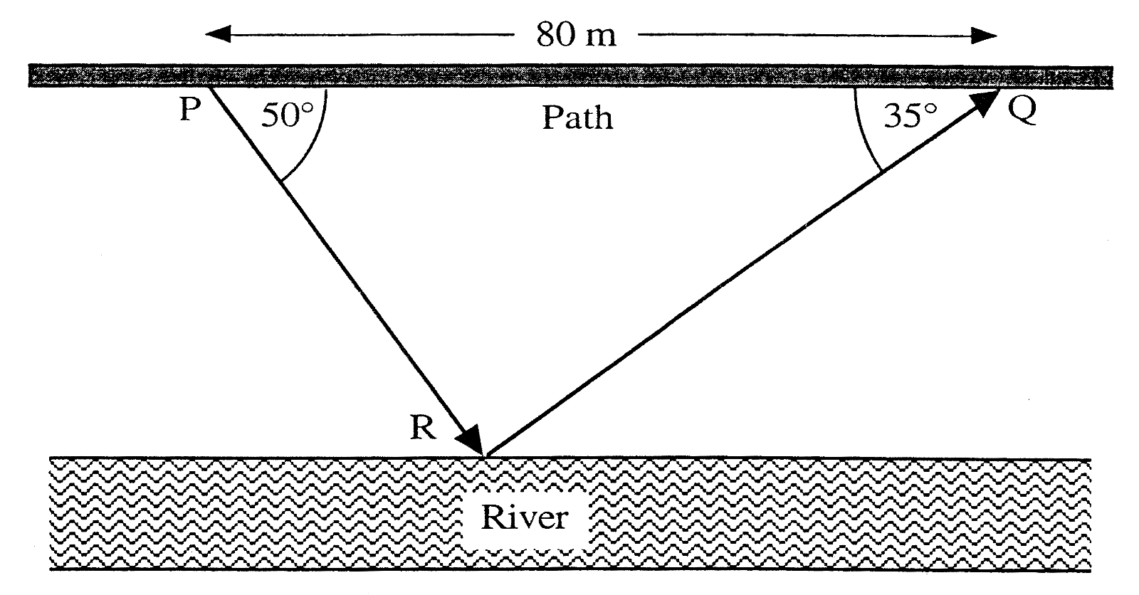
7. The path in the diagram
opposite runs parallel
to the river.
Jennifer leaves the path
at P, walks to the river to bathe her feet at R and rejoins the path further on at Q.

Calculate the distance between the river and the path. 5 marks
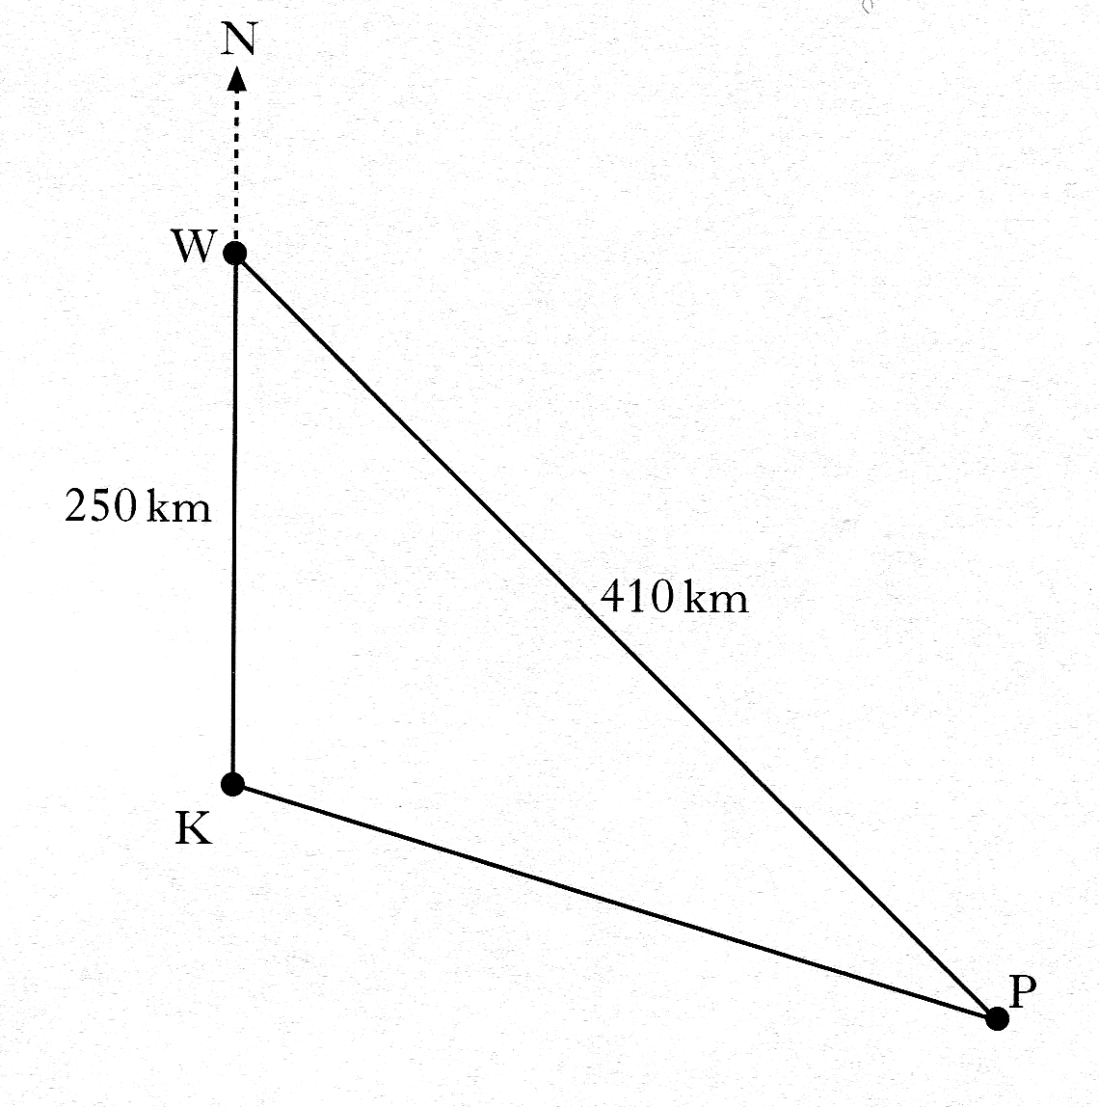
8. The radio masts, Kangaroo (K), Wallaby (W)
and Possum (P) are situated
in the Australian outback.
Kangaroo is 250 kilometres due south of Wallaby.
Wallaby is 410 kilometres from Possum
Possum is on a bearing of 130° from Kangaroo.

Calculate the bearing of Possum from Wallaby.
Do not use a scale drawing. 4 marks

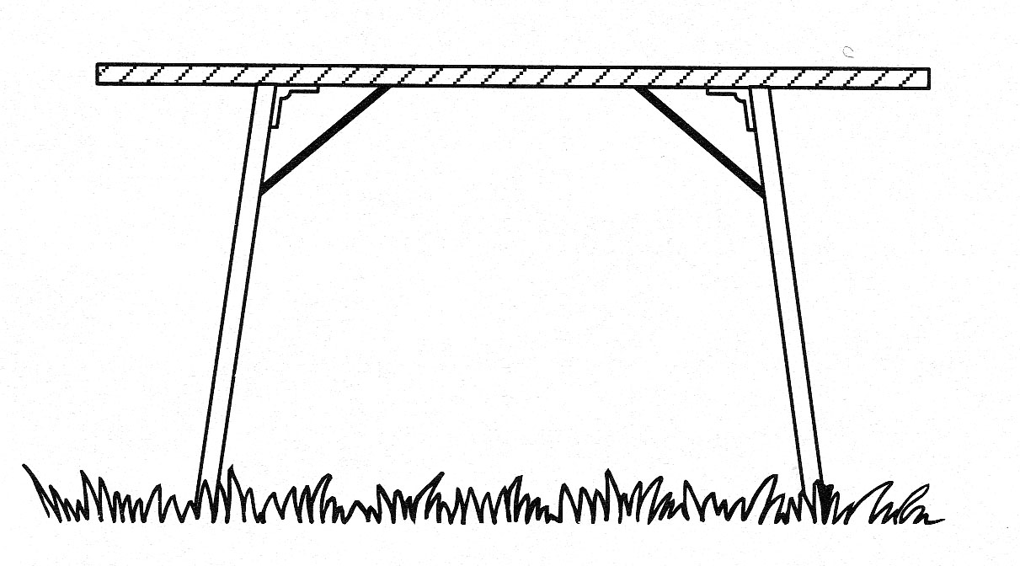
9. Each leg of a folding table is prevented
from opening too far by a metal bar.

The metal bar is 21 centimetres long.
It is fixed to the table top 14 centimetres from the hinge and to the table leg
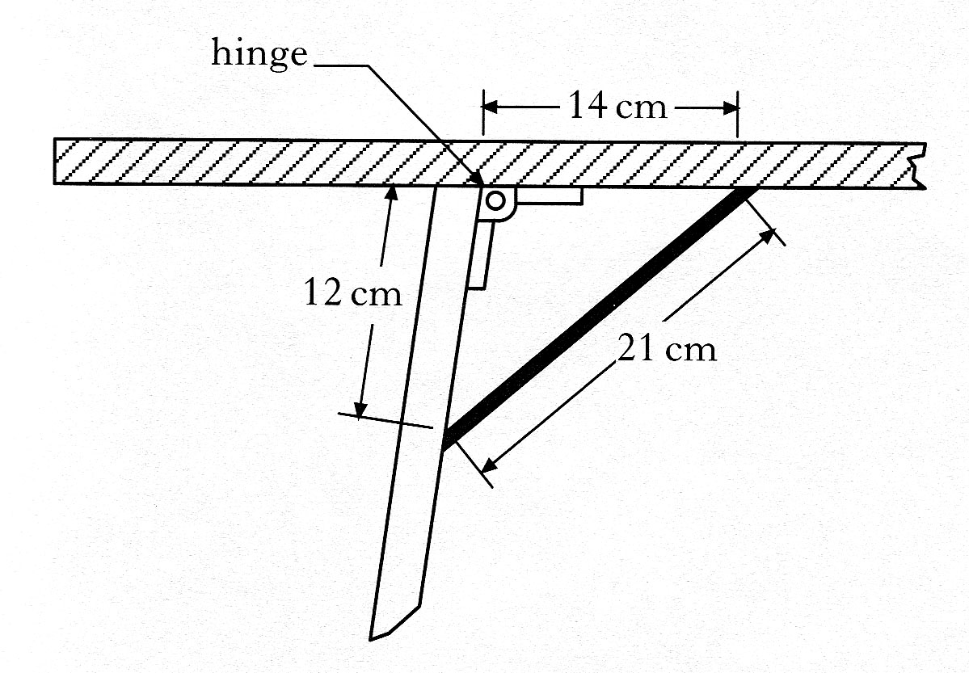
12 centimetres from the hinge.

a) Calculate the size of the obtuse
angle which the table top makes
with the leg. 3 marks
b) Given that the table leg is 70 centimetres long,
calculate the height of the table. 3 marks

10. A newspaper group advertises
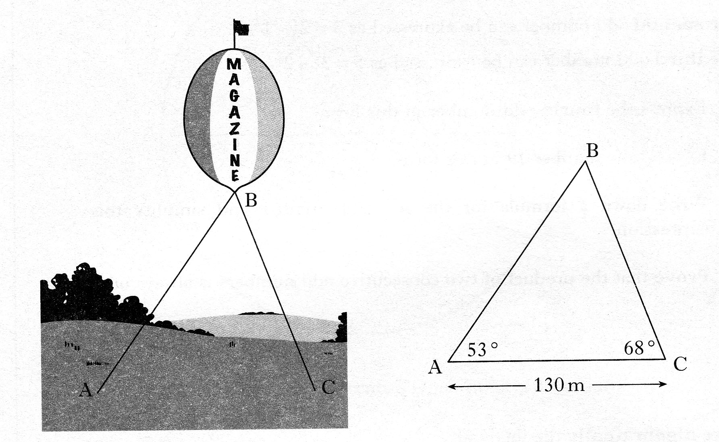
a new magazine on a helium balloon.
53°
68°
130 m
A
B
C
From the base of the balloon, B, two holding wires
are attached to the ground at A and C.
The distance from A to C is 130 metres.
From A, the angle of elevation of B is 53°.
From C, the angle of elevation of B is 68°
Calculate the height of point B above the ground.
Do not use a scale drawing 5 marks

11. The bonnet of a car is held open, at an angle of 57°, by a metal rod.
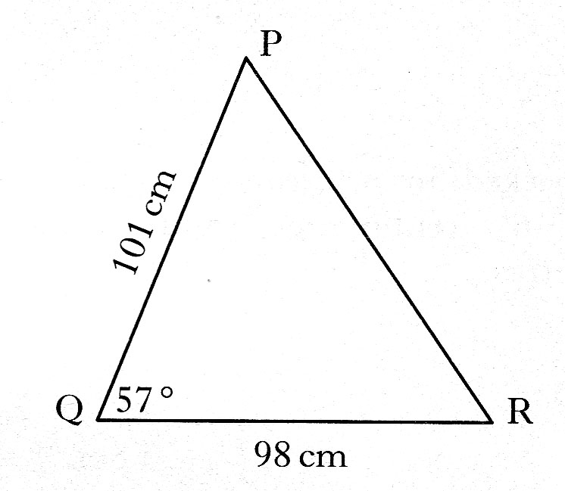
In the diagram,
PQ represents the bonnet
PR represents the metal rod.
QR represents the distance from
the base of the bonnet to the front of the car.
PQ is 101 centimetres
QR is 98 centimetres
Calculate the length of the metal rod, PR.
Do not use a scale drawing. 4 marks

12. Triangle ABC has an area of 14 square centimetres.
AB is 6 centimetres and AC is 7 centimetres.
Calculate the possible sizes of angle BAC 4 marks
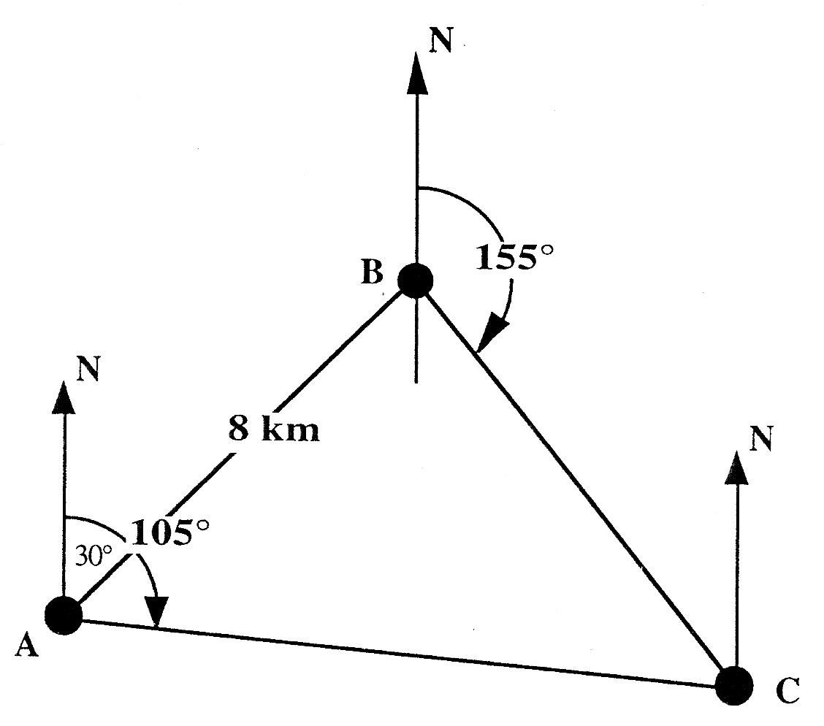
13. An orienteering course has 3 checkpoints – A, B and C.
B is on a bearing of 030°
and a distance of 8 km from A.
C is on a bearing of 155° from B
and a bearing of 105° from A.
a) Explain clearly why ∠ABC = 55° 2 marks
b) Calculate the distance between points B and C.
Do not use a scale drawing. 4 marks

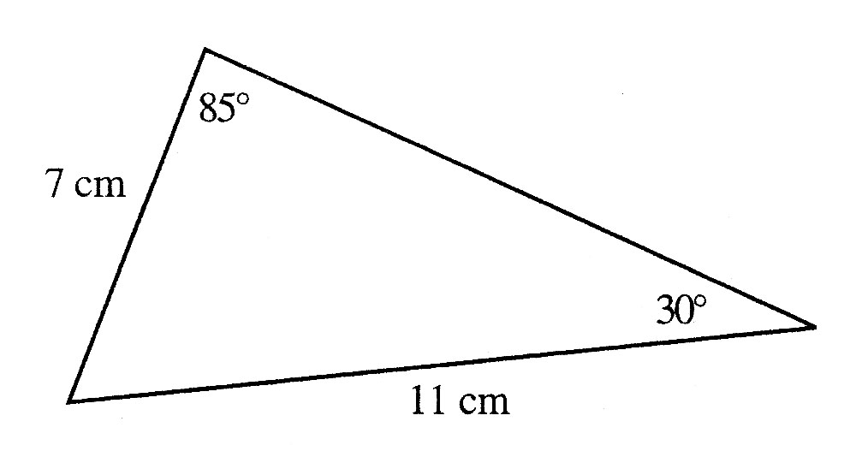

14. Calculate the area of the triangle. 3 marks

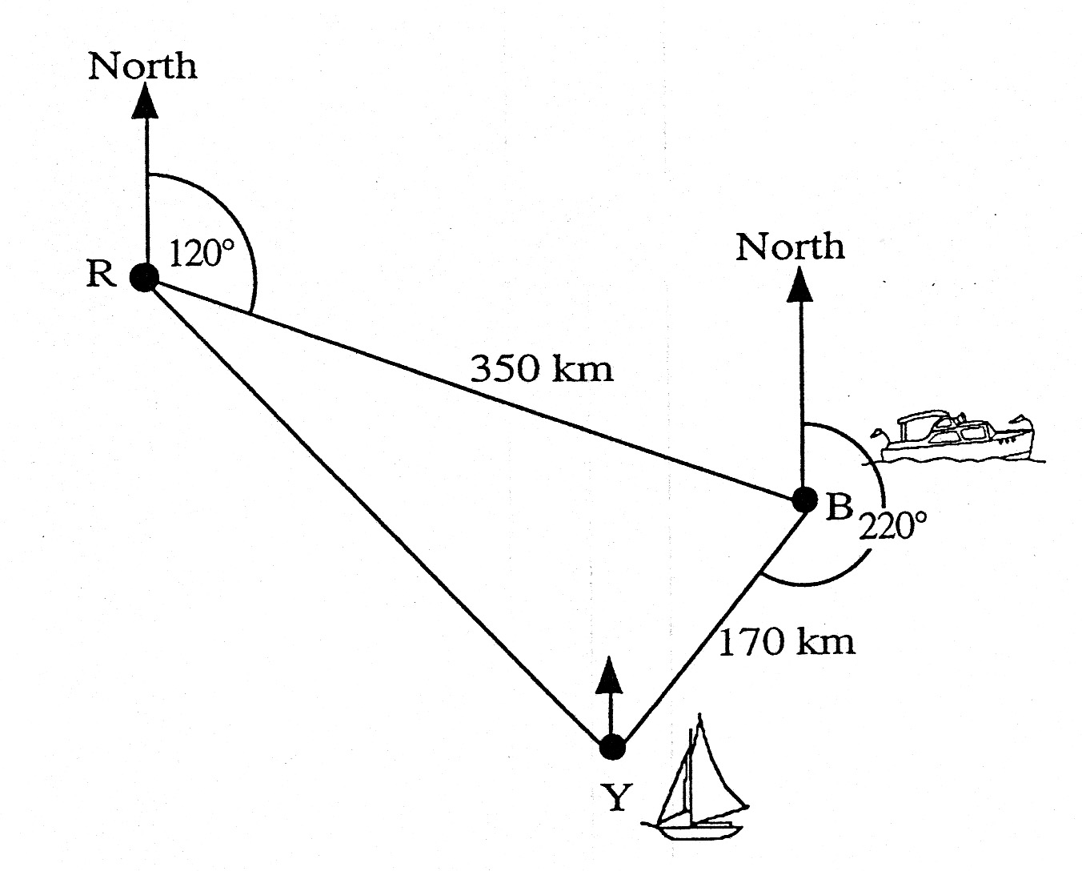
15. A rescue boat, at R, picks up a distress call
from a boat B, 350 km away, on a bearing of 120°.
At the same time another distress
call comes from a yacht Y, which is 170 km away
from B and on a bearing of 220° from B.

a) Prove that ∠RBY = 80° 2 marks
b) The rescue boat is obliged to respond to the nearest distress call first.
Will the people on the boat or those on the yacht be rescued first ?
(You must support your answer by showing working). 4 marks
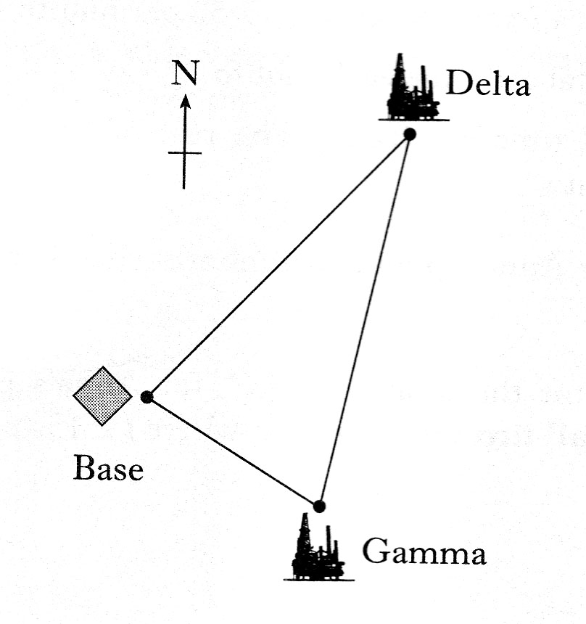

16. The diagram shows the position
of a helicopter base and two oil rigs, Delta and Gamma.
From the helicopter base, the oil rig Delta
is 35 kilometres away on a bearing of 050°.
From the same base, the oil rig Gamma is 20 kilometres away on a bearing of 125°.

Calculate the distance between Delta and Gamma.
Do not use a scale drawing. 5 marks

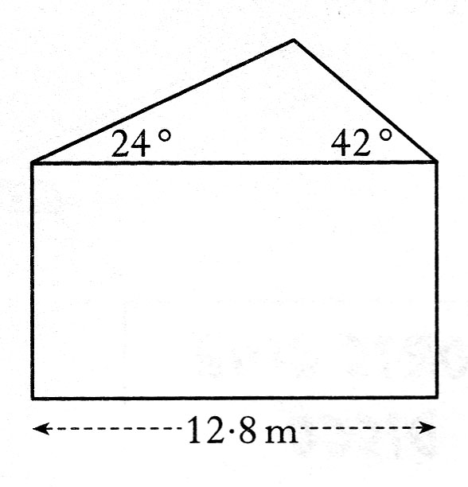
17. The end wall of a bungalow is in the shape of a
rectangle and a triangle as shown in the diagram.
The roof has one edge inclined at an angle of 24°
to the horizontal and the other edge inclined
at 42° to the horizontal.
The width of the house is 12.8 metres.
Calculate the length of the longer sloping edge of the roof.
Do not use a scale drawing. 4 marks

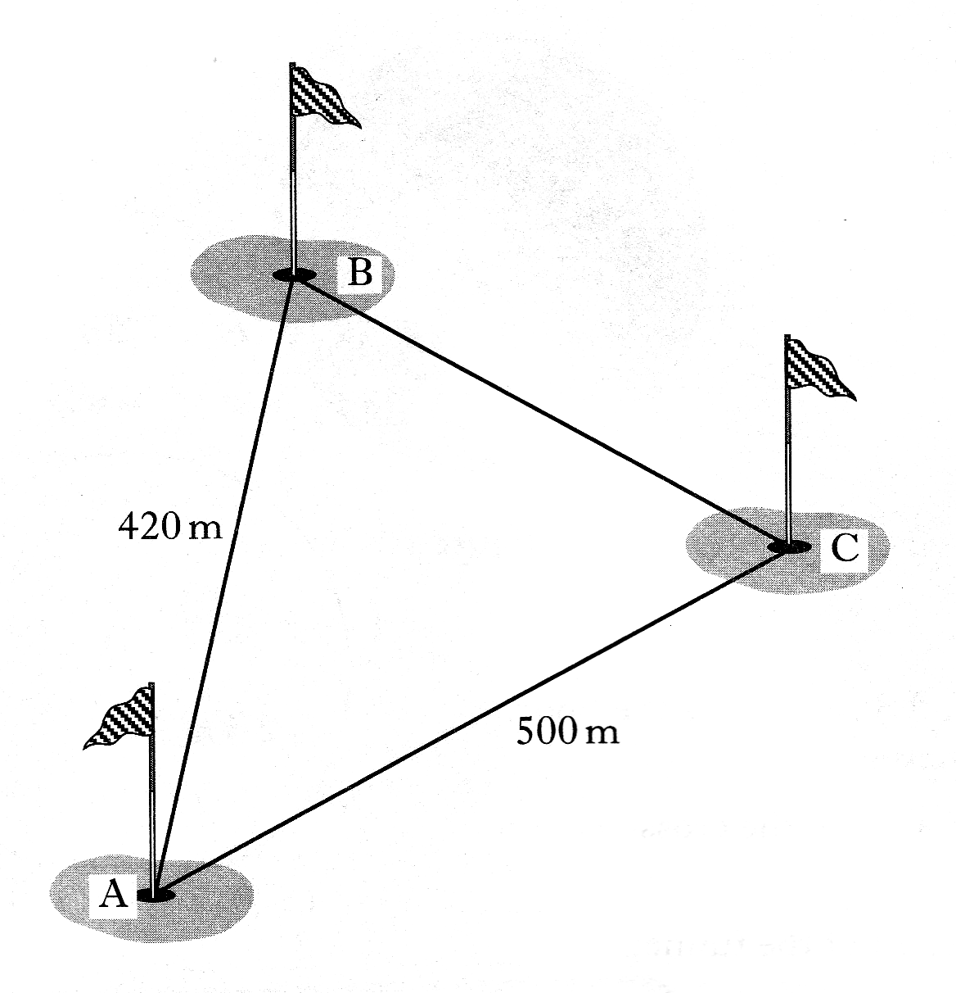

18. The diagram shows part of a golf course.
The distance AB is 420 metres,
the distance AC is 500 metres and angle BAC = 52°.

Calculate the distance BC.
Do not use a scale drawing. 3 marks

19. An aeroplane is flying parallel to the ground.
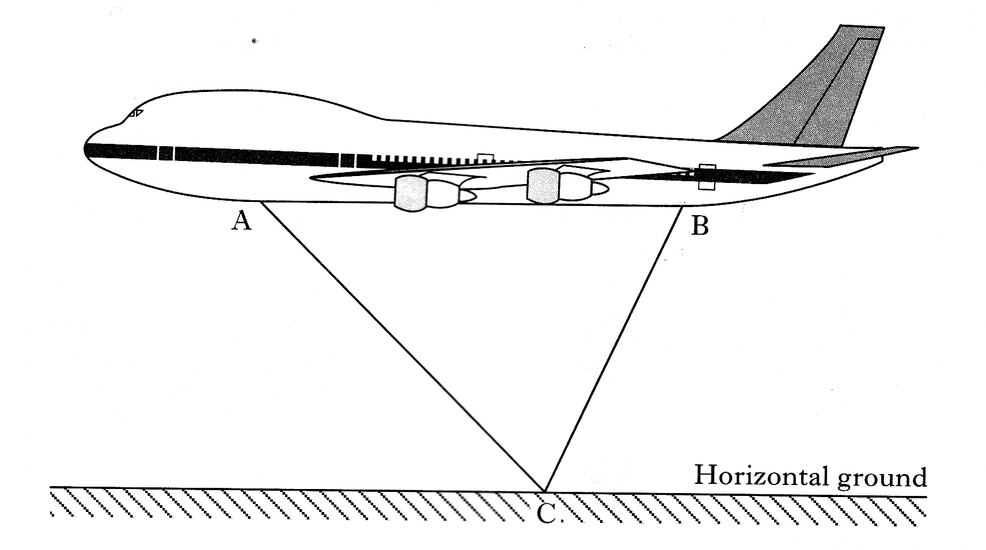

Lights have been fitted at A and B
as shown in the diagram.
When the aeroplane is flying at a certain height,
the beams from these lights
meet exactly on the ground at C.

The angle of depression of the beam of light from A to C is 50°.
The angle of depression of the beam of light from B to C is 70°.
The distance AB is 20 metres.

Find the height of the aeroplane above C. 6 marks

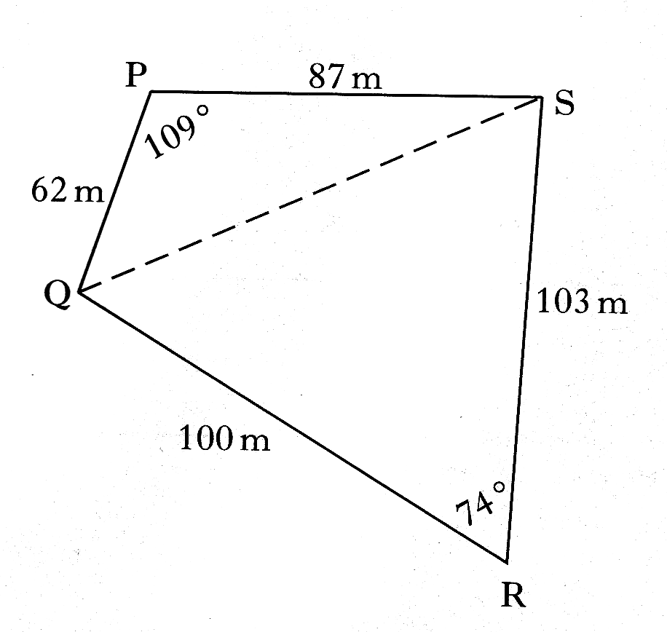

20. The sketch shows a plot of ground,
PQRS, split into two triangles.
Calculate the area of the plot of ground. 4 marks

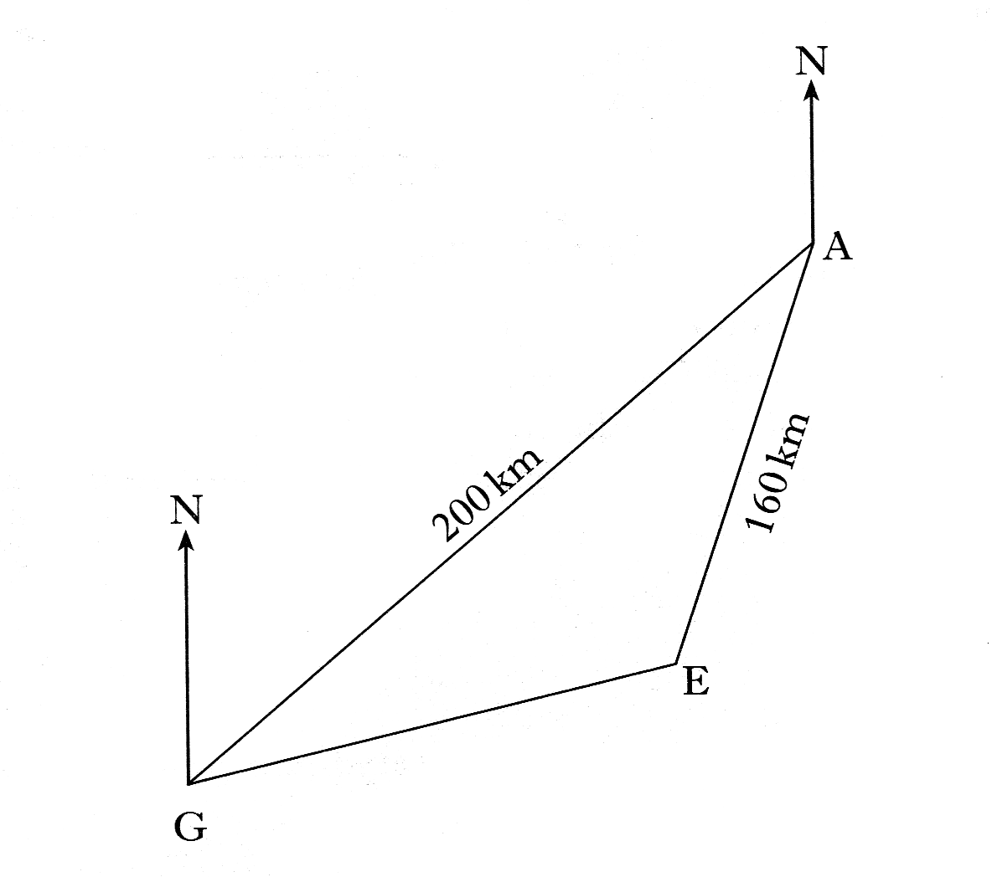
21. The diagram shows the position of three airports, A, E and G.

G is 200 kilometres from A
E is 160 kilometres from A
From G the bearing of A is 052°
From A the bearing of E is 216°
How far apart are airports G and E ? 6 marks

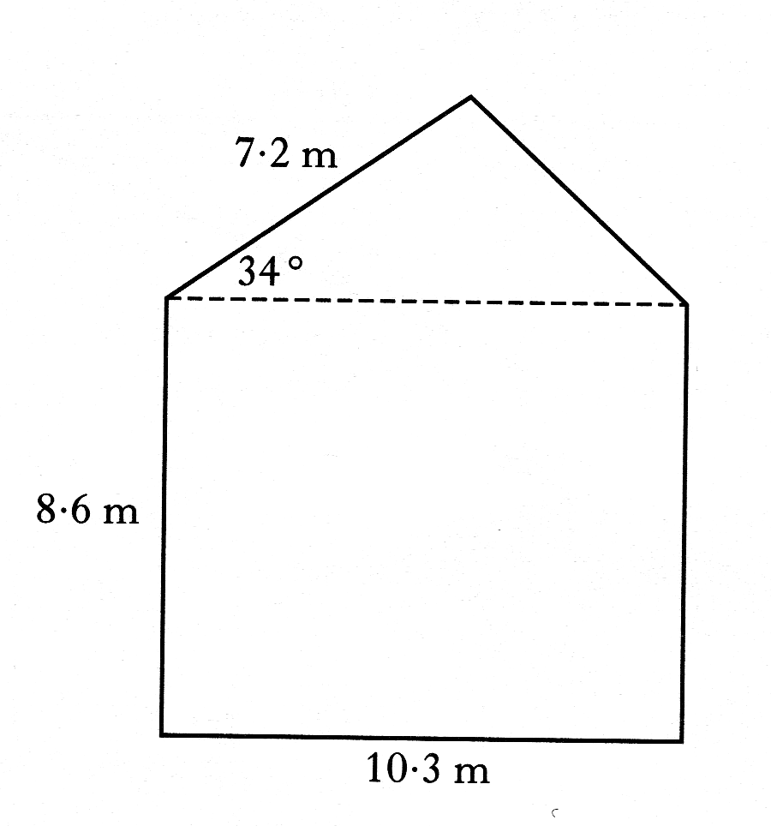

22. The side wall of a house, with measurements
as shown in the diagram, requires painting.
The wall is in the shape of a rectangle and a triangle.
On average, a litre of paint will cover 8 square metres.
A painter estimates that he will require 12 litres of paint.
Will this be enough paint?
Justify your answer. 4 marks

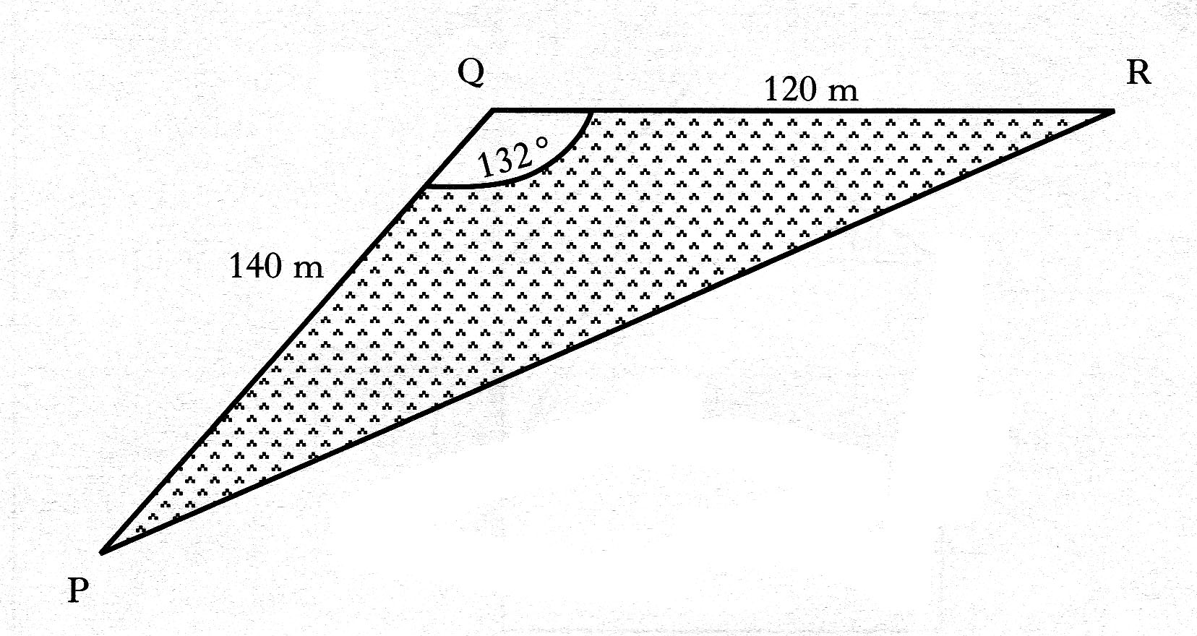
23. A triangular field, PQR is shown in the diagram.
PQ = 140 metres,
QR = 120 metres
and angle PQR =132°
Calculate the length of PR.
Do not use a scale drawing. 4 marks
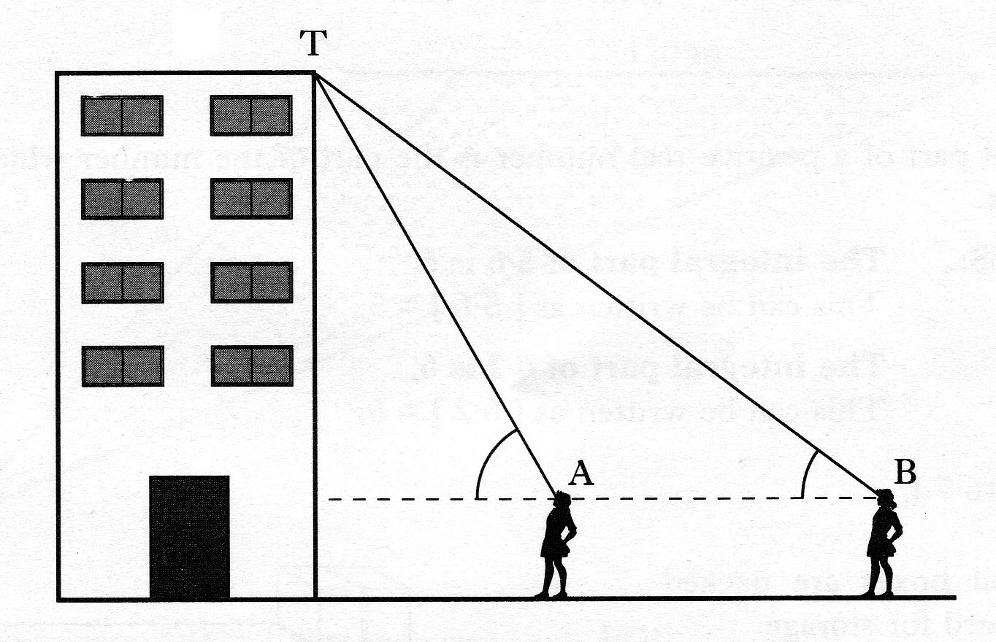
24. The diagram shows two positions of a student
as she views the top of a tower.
From position B, the angle of elevation to T
at the top of the tower is 64°.
From position A, the angle of elevation to T
at the top of the tower is 69°.
The distance AB is 4.8 metres and the height of the student to eye level is 1.5 metres.

Find the height of the tower. 6 marks
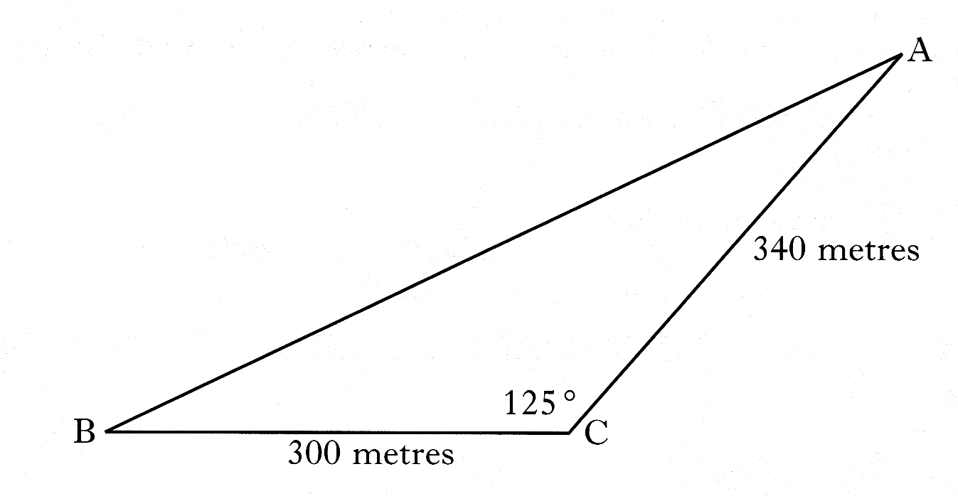

25. A field, ABC, is shown in the diagram.

Find the area of the field. 2 marks

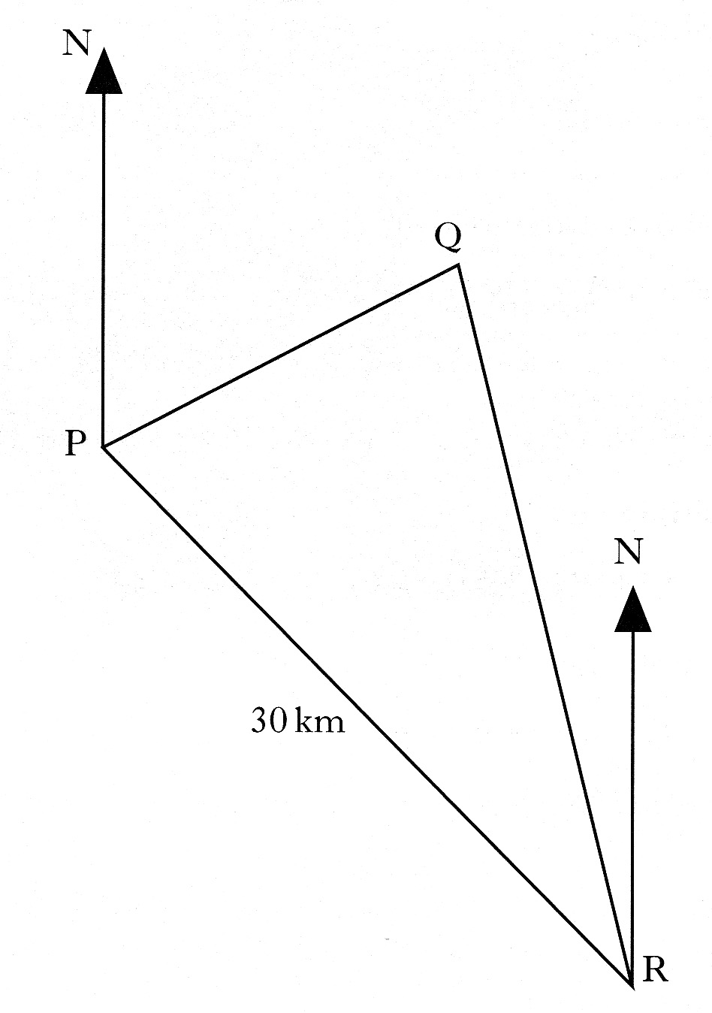
26. A ship, at position P, observes a lighthouse at position Q on a bearing of 040°.

The ship travels 30 kilometres
on a bearing of 125° to position R.

From position R, the ship observes
the lighthouse on a bearing of 340°.

When the ship is at position R, how far is it from the lighthouse? 6 marks

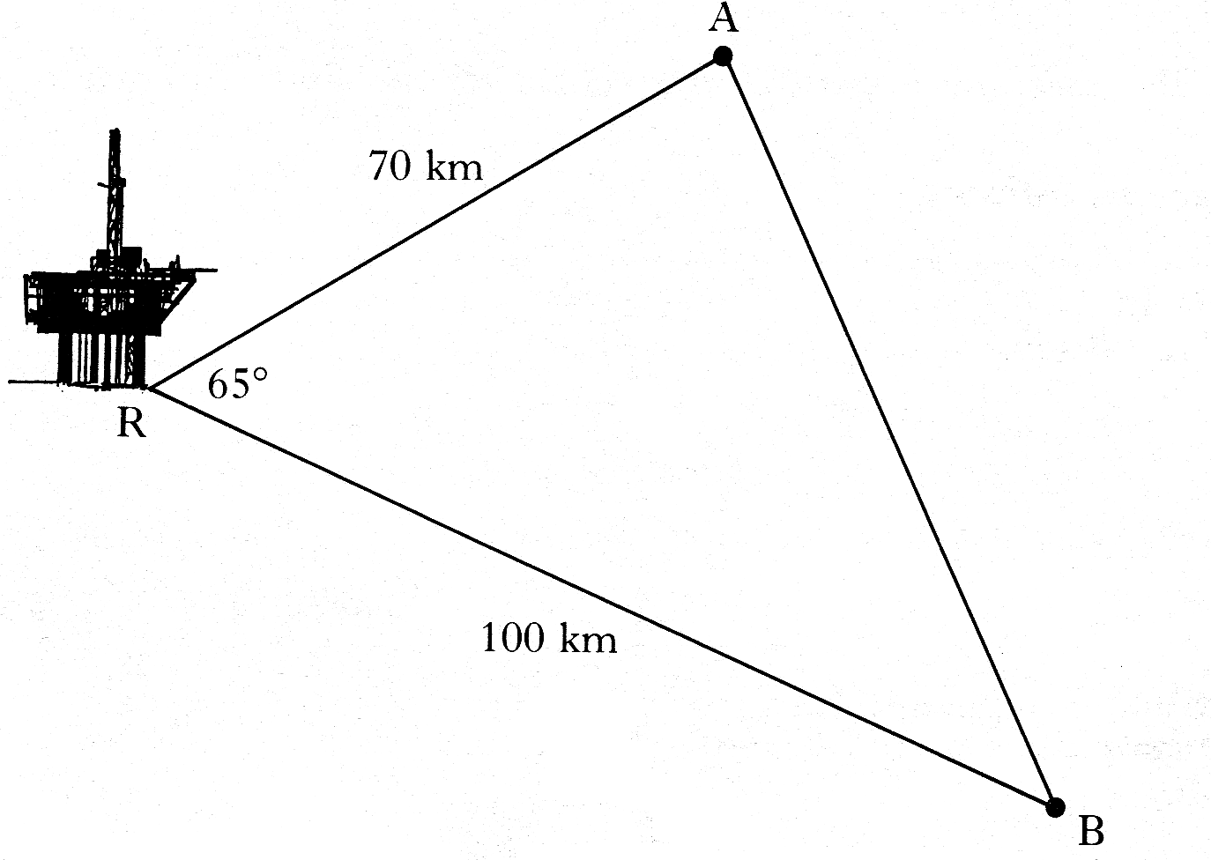
27. The diagram shows the positions
of an oilrig and two ships.
The oilrig at R is 70 kilometres from a ship at A
and 100 kilometres from a ship at B. Angle ARB = 65°.

Calculate the distance AB.
Do not use a scale drawing. 4 marks

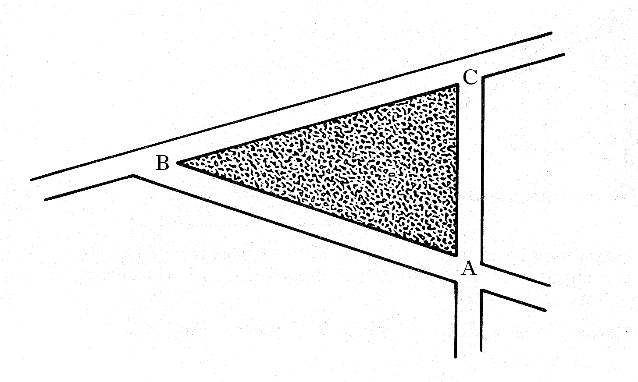
28. A traffic island, ABC, is shown in the diagram.

Find the area of the traffic island if
AB = 12.6 metres, AC = 10 metres and angle BAC = 72° 2 marks

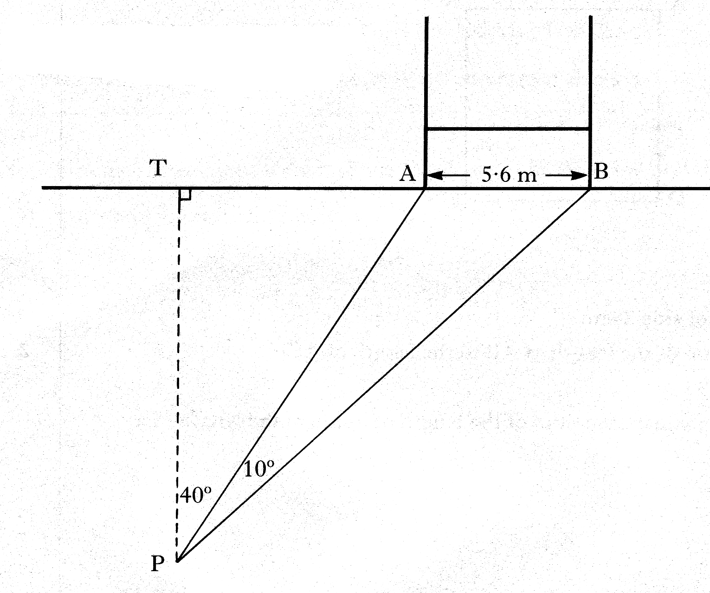
29. The diagram shows the goalposts on a rugby field.
To take a kick at goal,
a player moves from T to position P.
TP is perpendicular to TB.
Angle TPA =40° and angle APB = 10°

The distance AB between the goal posts is 5.6 metres.

Find the distance from T to P. 6 marks

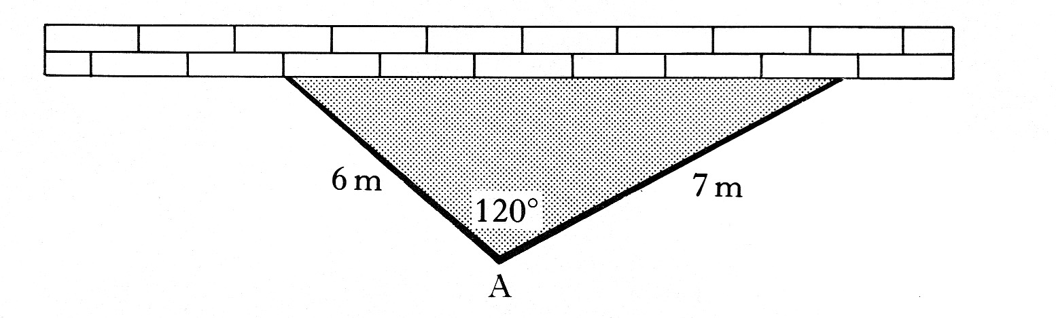
30. A family wants to fence
off a triangular part of their garden
for their pet rabbits.

They have a long straight wall available and two straight pieces of fencing 6 metres
and 7 metres in length. They first erect the fencing as shown in the diagram.
- Find the area of garden enclosed by the wall and the two pieces of fencing.
2 marks
b) What size should they make the angle at A so that the greatest area of garden
is enclosed? Give a reason for your answer. 2 marks

31. A ship is first spotted at position R, which is on a bearing of 315° from a
lighthouse, L. The distance between R and L is 10 kilometres. After the ship has
travelled due West to position T, its bearing from the lighthouse is 300°.
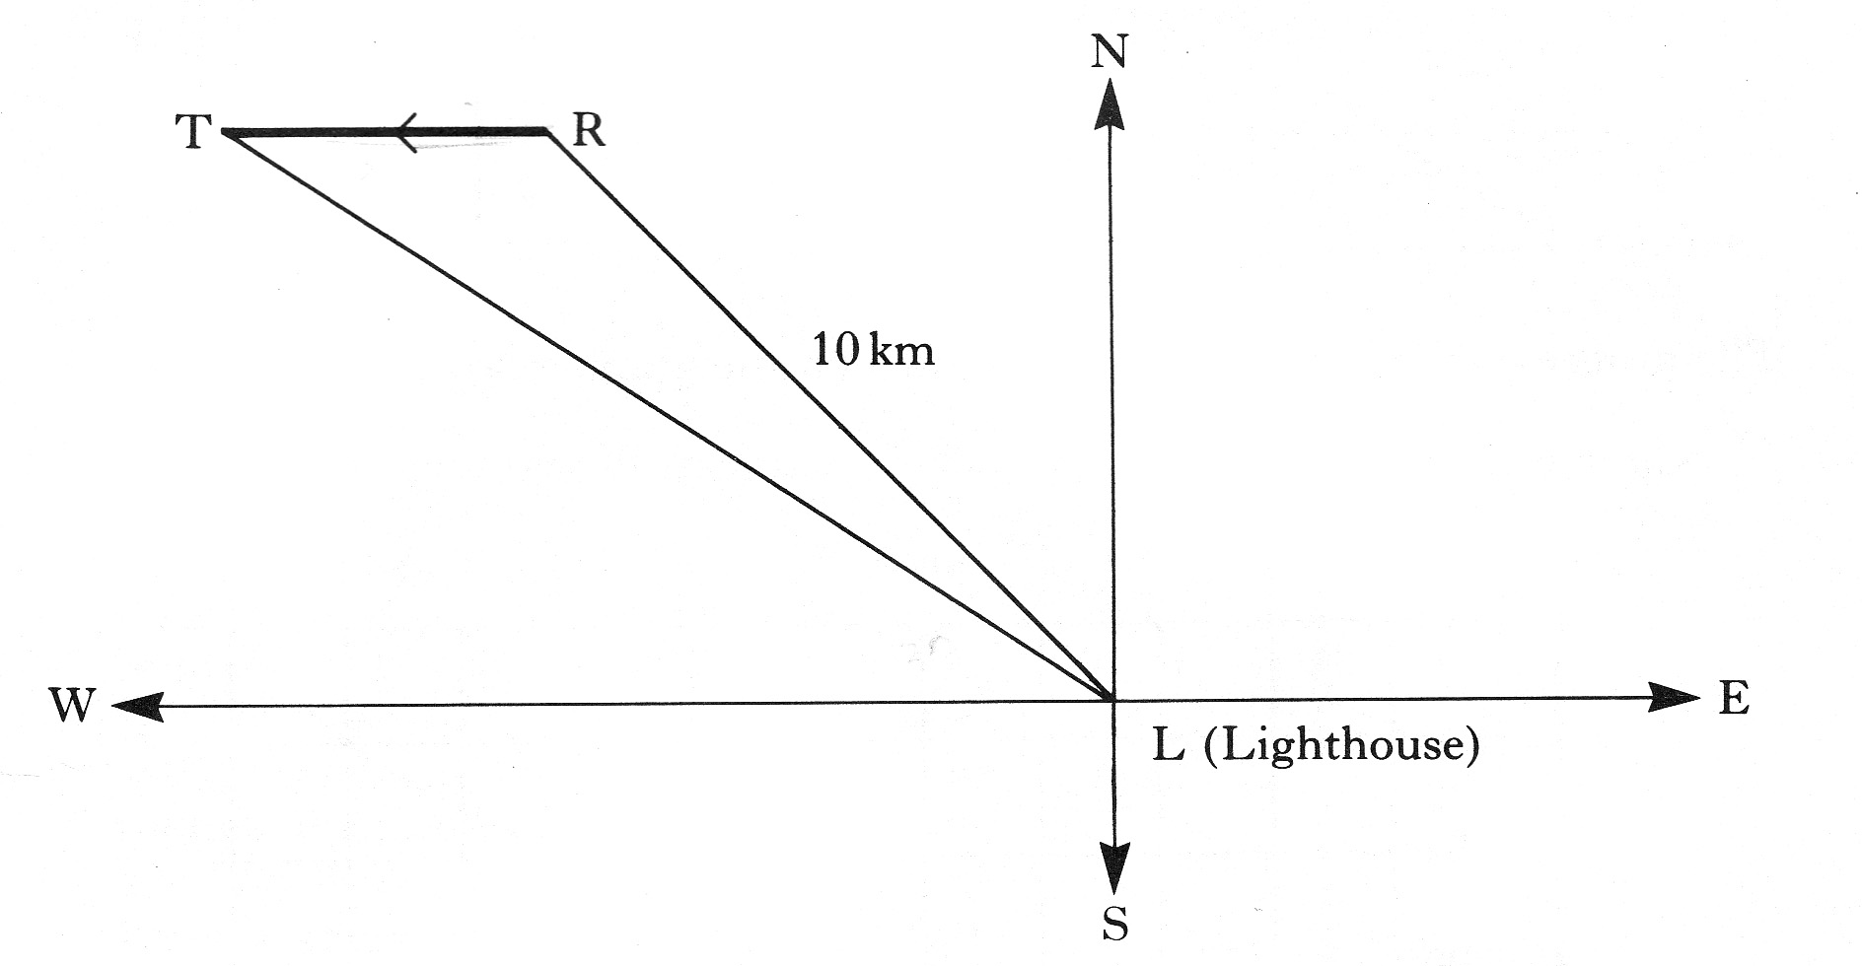

How far has the ship travelled from R to T ? 5 marks

