1. A random check is carried out on the contents of a number of matchboxes.
A summary of the results is shown in the boxplot below.
47
50
51
53
54

What percentage of matchboxes contains fewer than 50 matches ? 1 mark

2. The ages of the male members of staff in a school were recorded and a box
plot was drawn to show the results.
18
34
44
50
60
Ages of male members of staff

When the same study was carried out for the female members of staff in the
same school, another box plot was drawn.
It was found that:
  - the range of the ladies’ ages was half that of the range of the mens’.
  - the ladies’ median age was 15 years less than the men’s median age.
  - the semi-interquartile range of the ladies’ was three quarters that of the men’s.
22
A
B
37
C
Ages of female members of staff

Make a copy of the above females’ box plot and complete it to show
which ages are represented by the letters A, B and C. 3 marks

3. Fifteen medical centres each handed out a questionnaire to fifty patients.
The numbers who replied to each centre are shown below.

11 | 19 | 22 | 25 | 25
29 | 31 | 34 | 36 | 38
40 | 46 | 49 | 50 | 50
Also, they each posted the questionnaires to another fifty patients.
The numbers who replied to each centre are shown below.
15 | 15 | 21 | 22 | 23
25 | 26 | 31 | 33 | 34
37 | 39 | 41 | 46 | 46
Draw an appropriate statistical diagram to compare these two sets of data. 3 marks

4. A furniture maker investigates the delivery times, in days, of two local wood companies
and obtains the following data.
Company | Minimum | Maximum | Lower  Quartile | Median | Upper  Quartile
Timberplan | 16 | 56 | 34 | 38 | 45
Allwoods | 18 | 53 | 22 | 36 | 49
a) Draw an appropriate statistical diagram to illustrate these two sets of data. 3 marks
b) Given that consistency of delivery is the most important factor, which
company should the furniture maker use? Give a reason for your answer. 1 mark

5. Jamie conducted a survey.
He asked his classmates how they had travelled to school that day.
Here are their replies.
Walk 13
Bus 9
Car 6
Cycle 2
Draw an appropriate statistical diagram to illustrate this information 4 marks

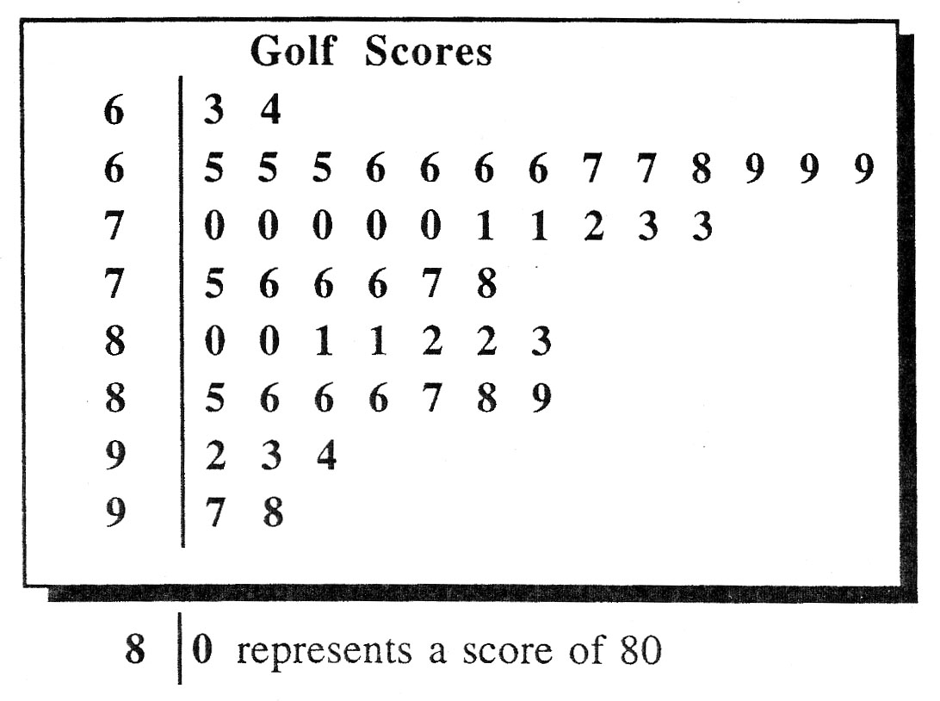
6. The stem and leaf diagram
shows a sample of 50 scores
in a boy’s golf tournament.

a) Write down the median golf score. 1 mark

b) Calculate the semi-interquartile range for these scores. 3 marks

c) Sketch this boxplot and fill in the correct values to illustrate the golf scores
in this sample.

2 marks

7. In a tournament, 13 men throw one dart each at a dart board and their scores are noted.
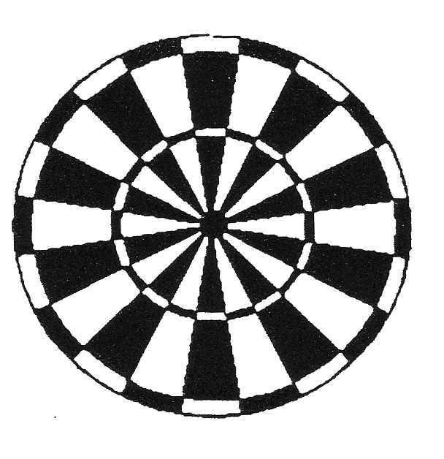
Alex | 16 |  | Nick | 20 |  | Steve | 28
Norrie | 6 |  | George | 9 |  | Brian | 18
Ted | 24 |  | James | 22 |  | Graeme | 18
Tom | 12 |  | John | 13 |  | Tony | 7
George | 9

a) Find the median and the upper and lower quartiles. 3 marks

b) Make a neat sketch of the following box plot and fill in all the missing values.
2 marks
6
?
?
?
?

