1. In the diagram, A is the point (-1, 7) and B is the point (4, 3).
a) Find the gradient of the line AB. 1 mark
y
x
O
B(4, 3)
A(-1, -7)
b) AB cuts the y-axis at the point (0, -5).
Write down the equation of the line AB 1 mark
c) The point (3k, k) lies on AB
Find the value of k. 2 marks

2. A is the point (a², a)
T is the point (t², t) a ≠ t
Find the gradient of the line AT
Give your answer in its simplest form. 3 marks

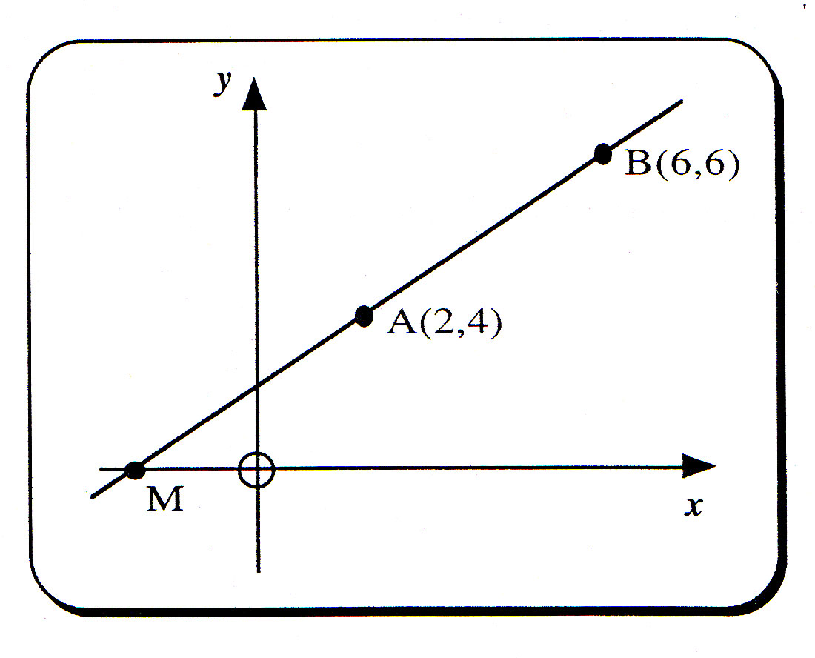
3. The straight line through the points A(2, 4) and B(6, 6) is shown in the diagram.
The point M is where the line AB cuts the x-axis.

a) Find the equation of the straight line AB. 4 marks
b) Use this equation to find the coordinates of the point M. 2 marks

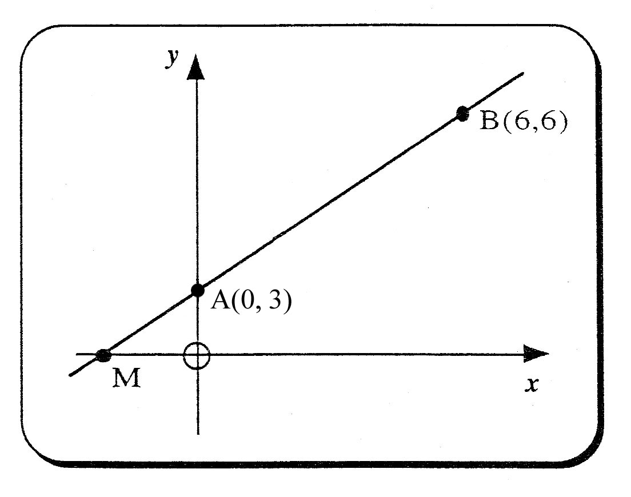
4. The straight line through the points A(0, 3) and B(6, 6) is shown in the diagram.
The point M is where the line AB cuts the x-axis.

a) Find the equation of the straight line AB. 4 marks
b) Use this equation to find the coordinates of the point M. 2 marks

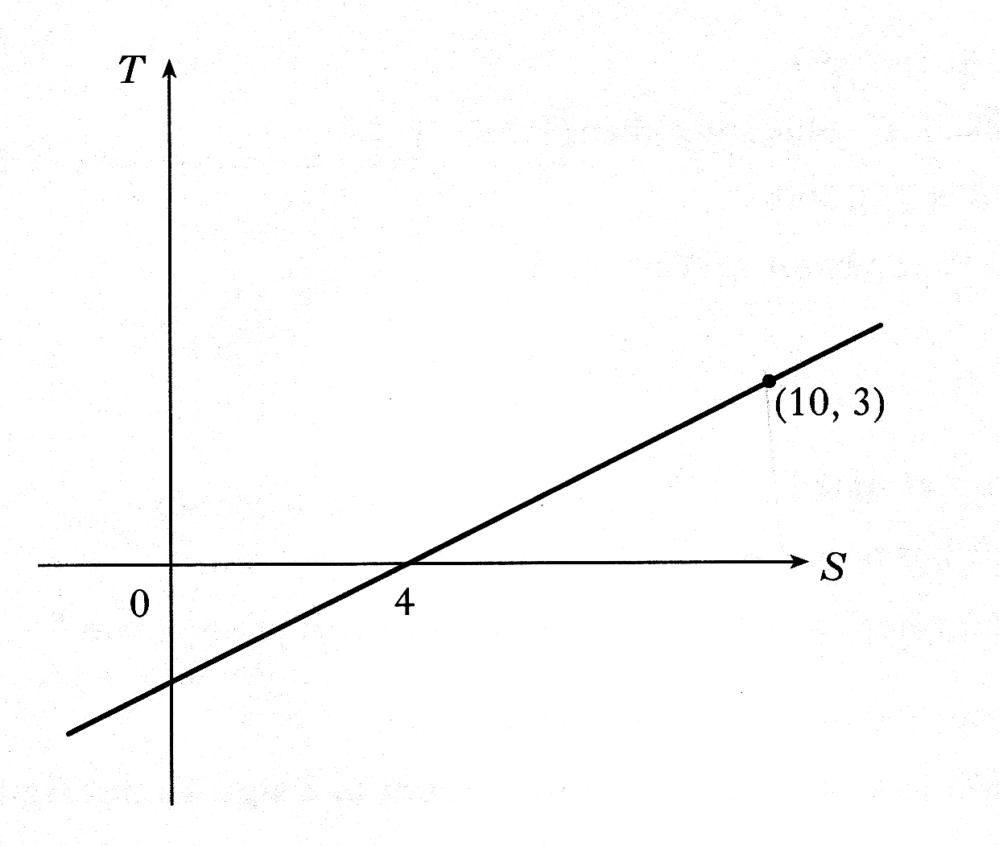
5. Find the equation of the given straight line in terms of S and T. 4 marks

6. Find the equation of the straight line. 3 marks
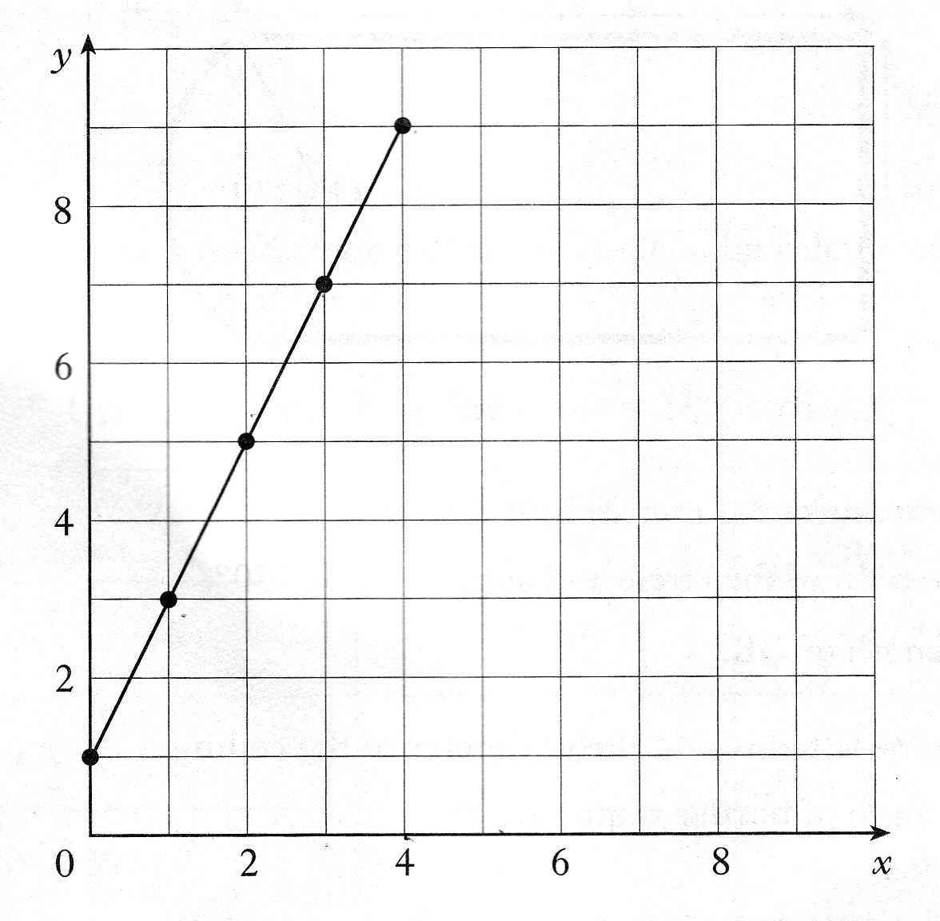

7. Find the equation of the straight line in terms of p and t. 4 marks

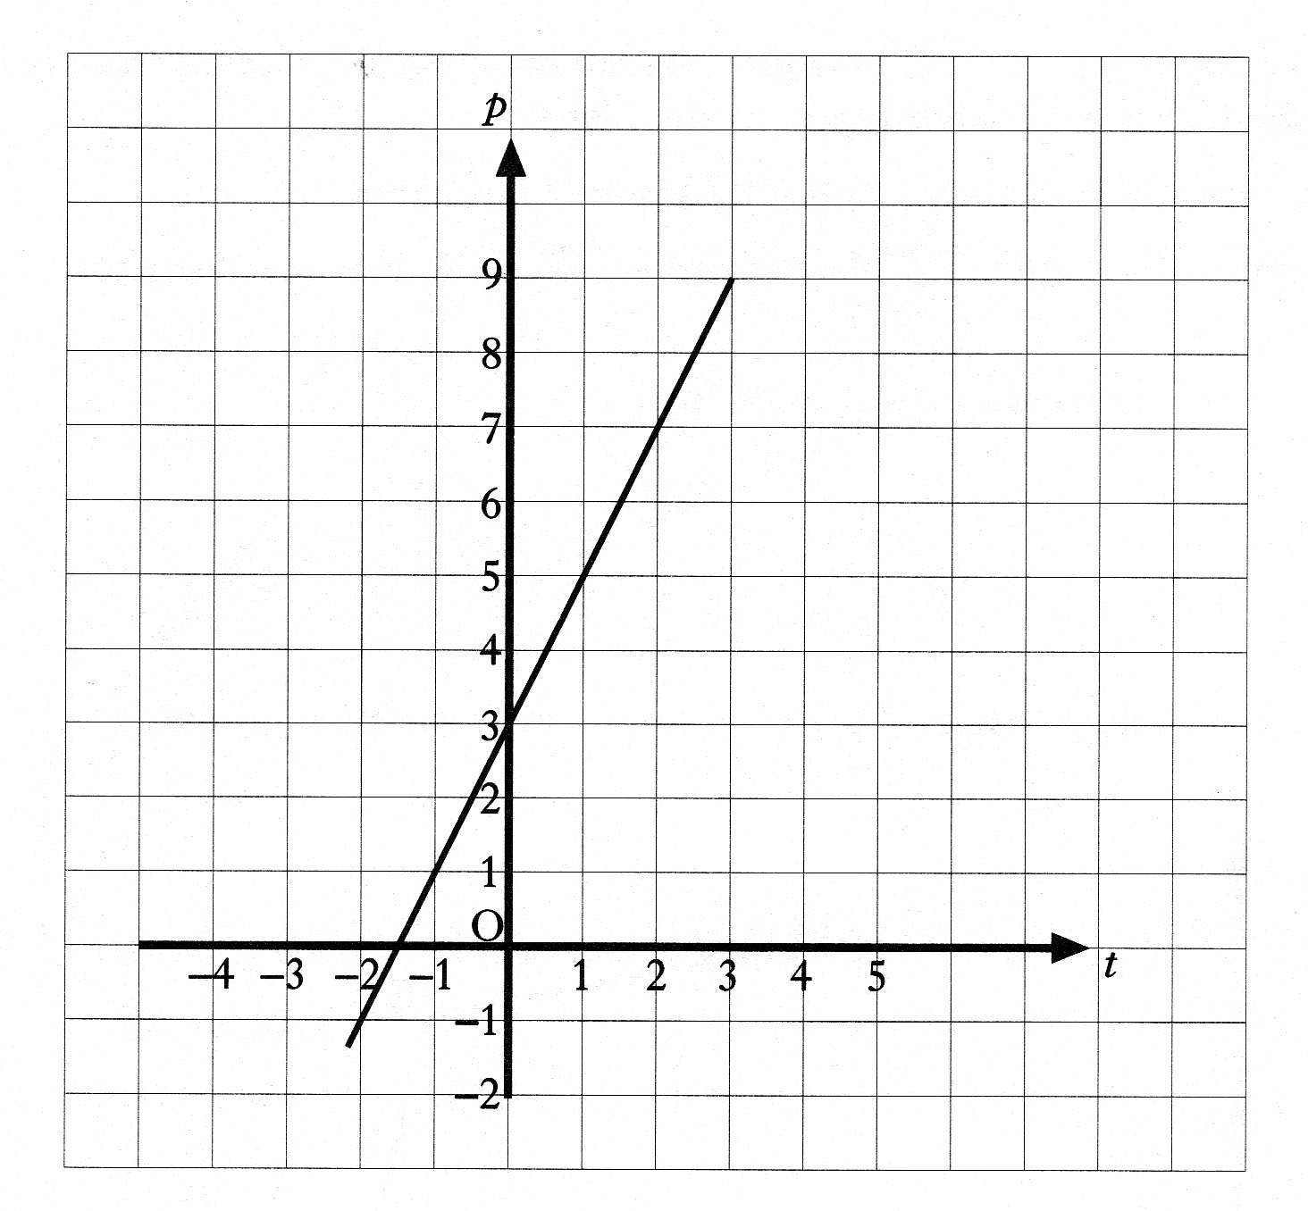

8. The tank of a car contains 5 litres of petrol.
The graph below shows how the volume of petrol in this tank changes
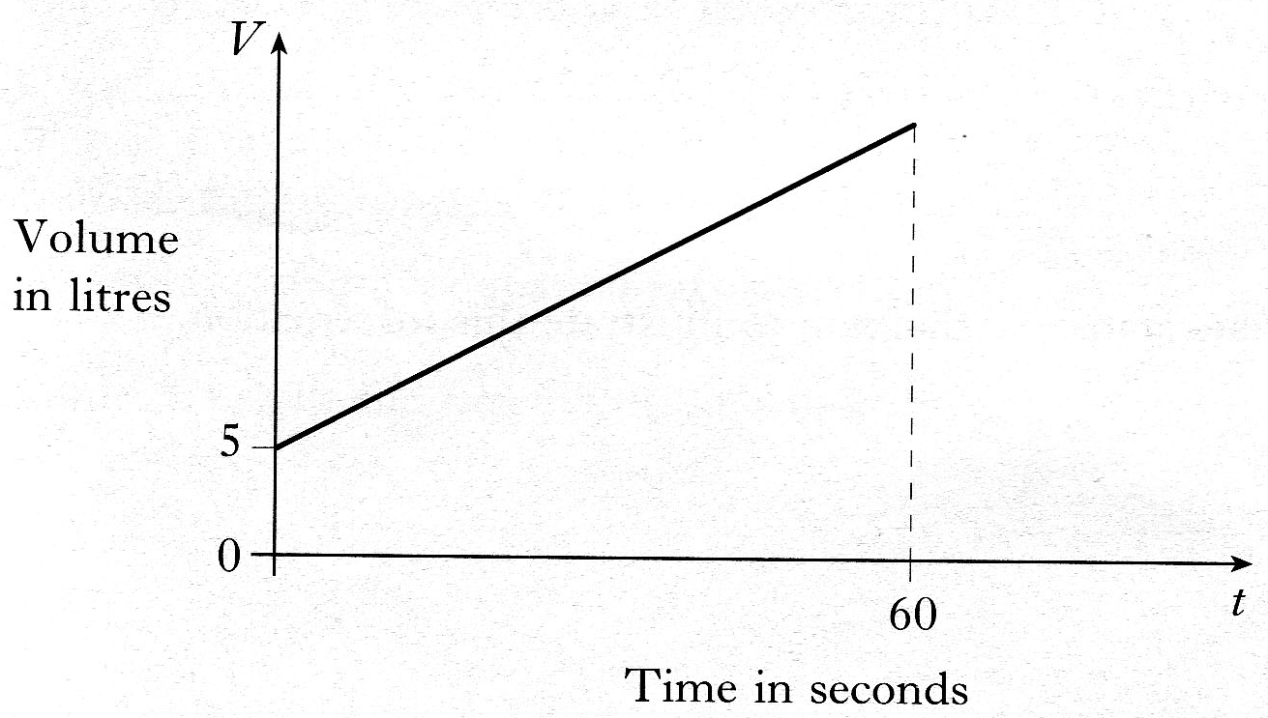
as a further 45 litres of petrol is pumped in at a steady rate for 60 seconds.

Find the equation of the straight line in terms of V and t. 4 marks

9. A tank contains 10 litres of water.
A further 30 litres of water is poured into
the tank at a steady rate of 5 litres per minute.
a) On the 2mm square ruled graph paper
provided, draw a graph of the volume,
V litres, of water in the tank against the time, t minutes. 4 marks

b) Write down an equation connecting V and t. 2 marks

Applications of the Equation of a Straight Line

1. The graph shows the relationship between the number of hours (h) an athlete trains per
week and the number of Championship medals (m) they have won.
A
B
m
h
•
•
•
•
•
•
•
•
•
•
•
•
•
•
•
Number of medals
(m)
Number of hours training per week
(h)

A best fitting straight line AB has been drawn.
Athlete A does not train but has won 4 medals this year.
Athlete B who trains for 12 hours per week has won 40 medals this year.

(a) Find the equation of the straight line AB in terms of m and h. 4 marks
(b) How many medals would you expect an athlete who trains 8 hours per week to have won ? 1 marks

2. A boy sets of a rocket from the top of a 40 metre high block of flats.
The diagram shows the path of the rocket over the first 4 seconds.
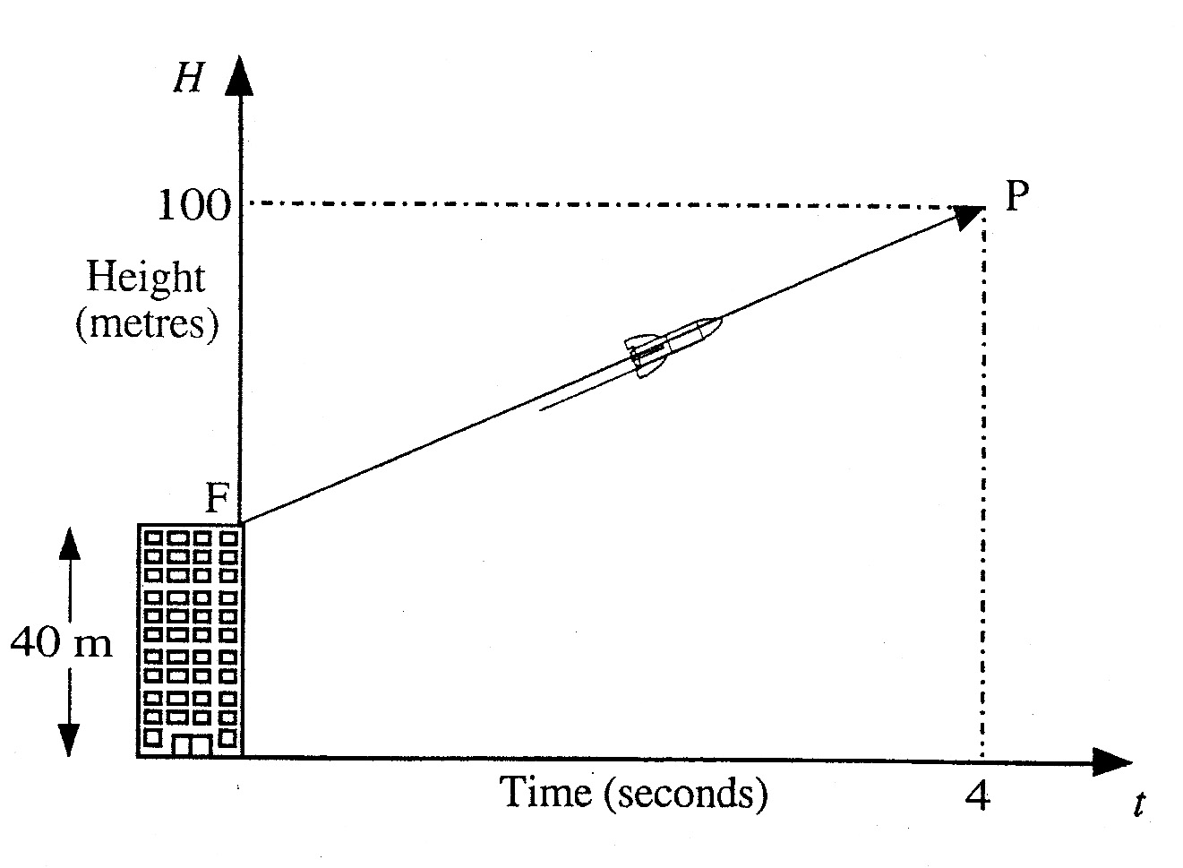
It is represented by the straight line in the graph.

After 4 seconds, the rocket has reached a point 100 metres above the ground.
Find the equation of the straight line FP in terms of H and t. 4 marks

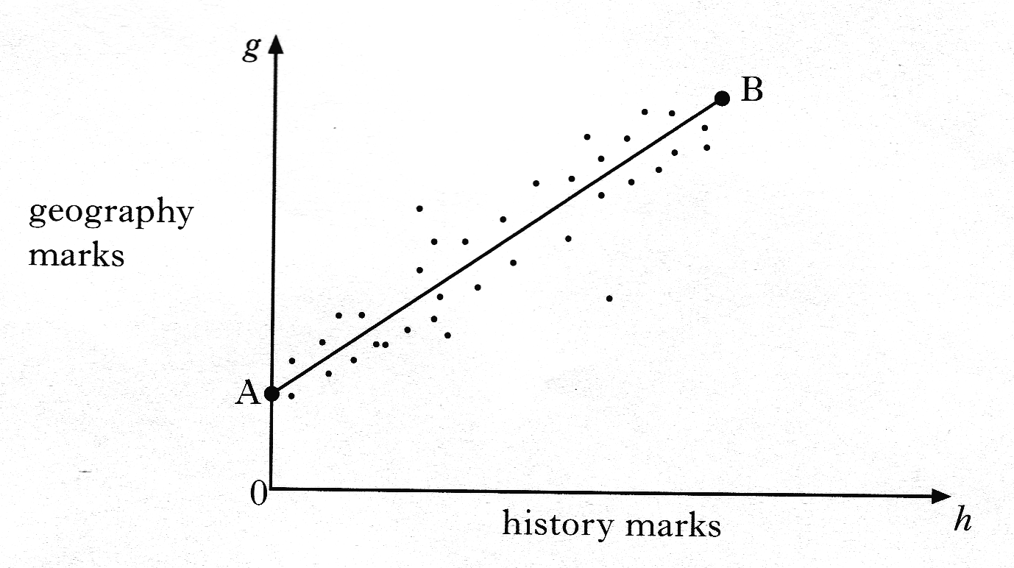
3. The graph below shows the relationship between the history and geography marks
of a class of students

A best fitting straight line, AB has been drawn.
Point A represents 0 marks for history and 12 marks for geography.
Point B represents 90 marks for history and 82 marks for geography.
Find the equation of the straight line AB in terms of h and g. 4 marks

4. A water pipe runs between two buildings.
These are represented by the points A and B in the diagram below.
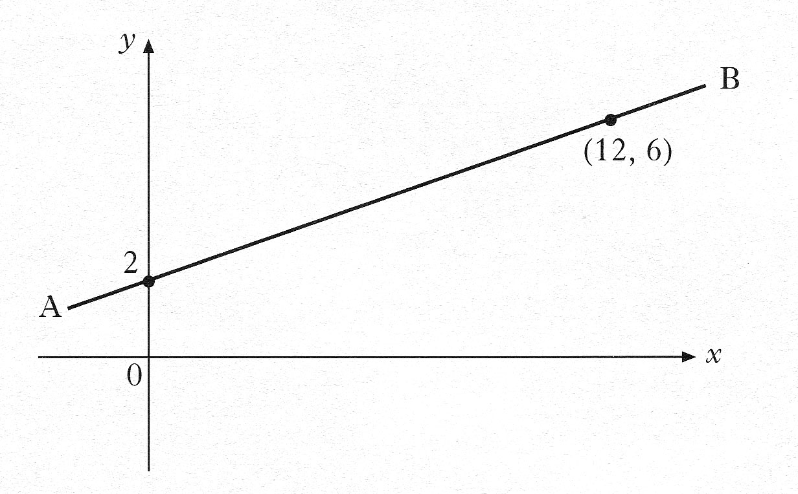

a) Using the information in the diagram, show that the equation
of the line AB is . 3 marks
b) An emergency outlet pipe has to be built across the main pipe.
The line representing this outlet pipe has equation
Calculate the coordinates of the point on the diagram at which
the outlet pipe will cut across the main water pipe. 4 marks

5. When a patient’s blood pressue (B.P.), is taken,
two measurements are made.
For example, in “160 over 70” ( or ),
⇒ the 160 is the reading when the heart is pumping.
⇒ the 70 is the reading when the heart is at rest.
David has a heart problem, and has his blood pressure taken every hour.
The first number of these two measurements is monitored very carefully
and the nurse plots a graph, showing the changes from 8 am.
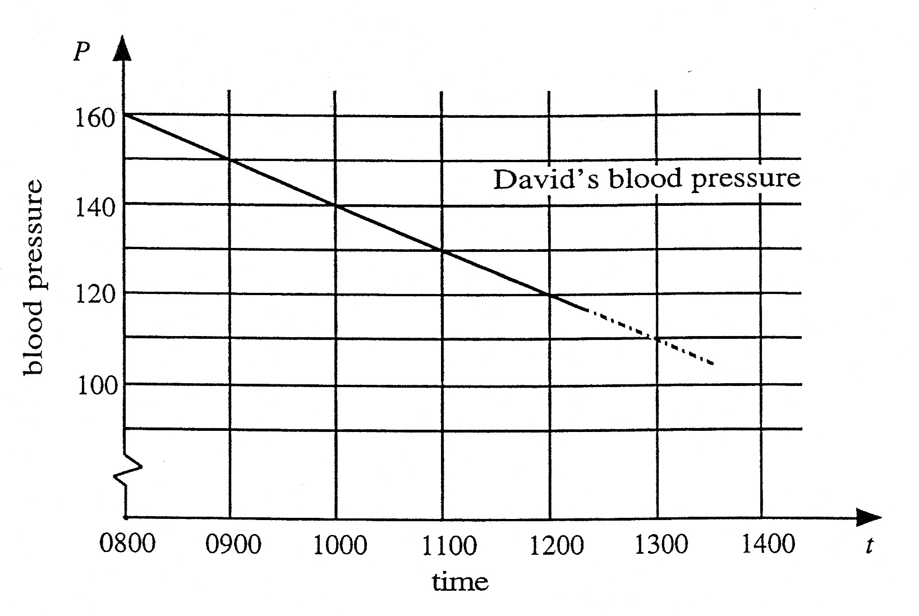

a) Find the gradient of the line shown above. 2 marks
b) Write down the equation of the line in the form
P = ………….. 2 marks
c) It is known that if the blood pressure drops below 70, the patient will be
in danger of losing consciousness.
If David’s blood pressure continues to drop in the way indicated, when
might he be expected to become unconscious. 3 marks

6. A tank contains 240 litres of water.
When the tap is opened, water flows from
the tank at a steady rate of 20 litres
per minute.
a) On the 2mm square-ruled paper provided, draw a graph of the volume V litres,
of water in the tank against the time, t minutes.
3 marks
b) Write down an equation connecting V and t. 2 marks

7. The graph below shows the number of grams, s, of a substance that can be dissolved
in a fixed quantity of water when the temperature of the water is t °C. 4 marks

Find the equation of this straight line in terms of s and t.
