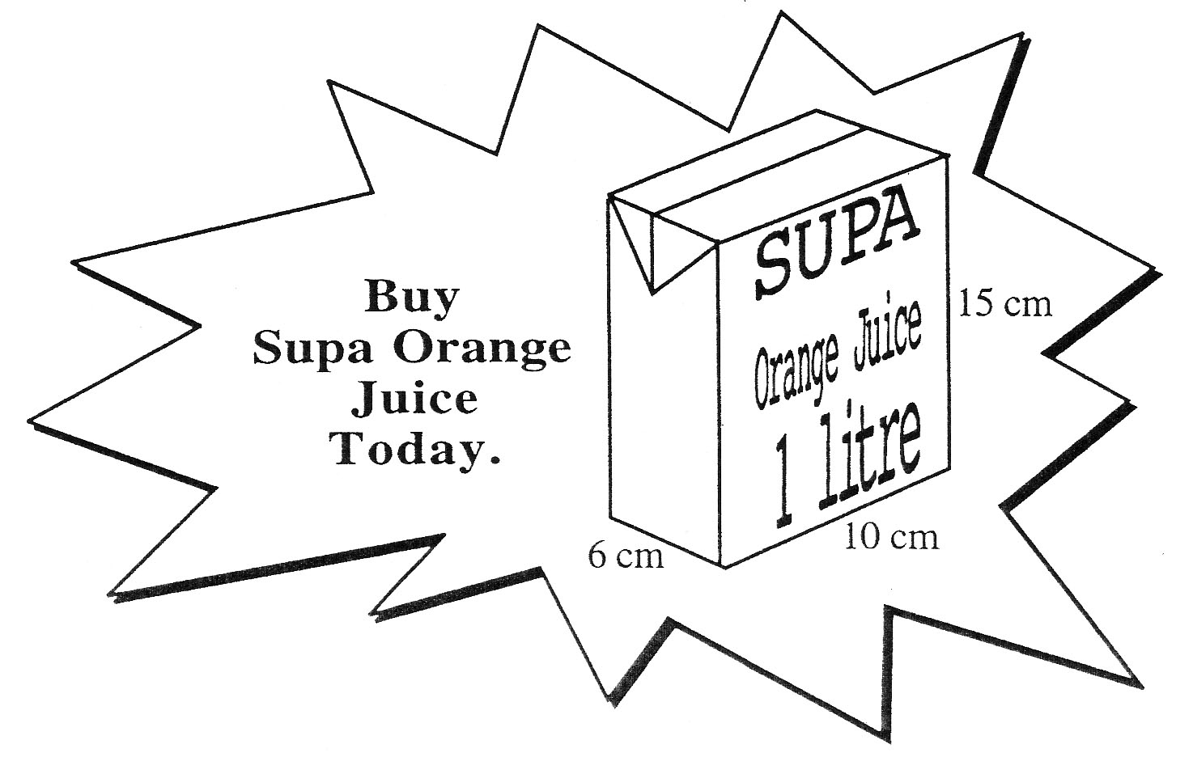

Q1. a) Explain what is wrong

with this advert for a

1 litre carton of

Orange Juice.

1 mark

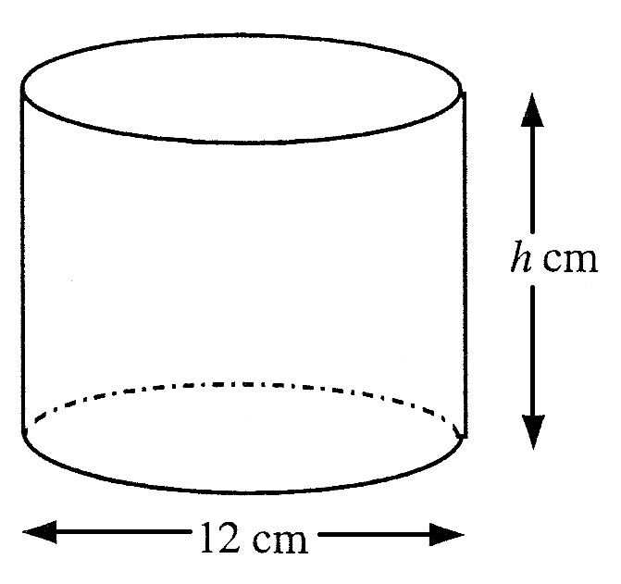 b) The measurements 10 cm, 6 cm and 15 cm

are correct.

All of the juice is poured into this

cylindrical container with base

diameter 12 cm and it is found to

**exactly** half fill it.

Calculate the height of the container. 4 marks

Q2. A wooden toy box is prism-shaped

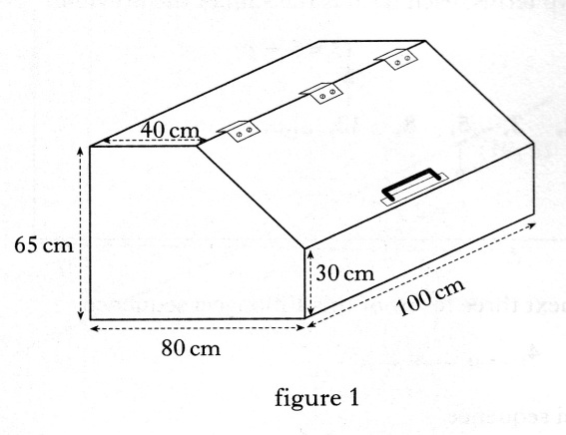 as shown in figure 1.

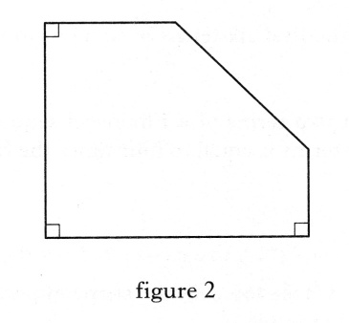 The uniform cross-section of the box

is as shown in figure 2.

Calculate the volume of the box

in **cubic metres**. 4 marks

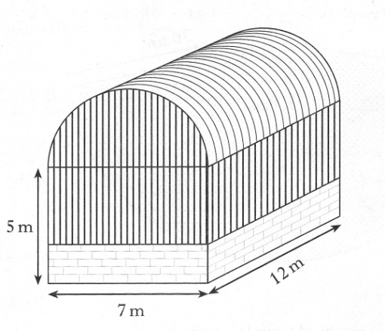

Q3. A storage barn is prism shaped, as shown.

The cross-section of the storage barn

consists of a rectangle measuring

7 metres by 5 metres and a semi-circle

of radius 3.5 metres.

a) Find the volume of the storage barn.

Give your answers in cubic metres,

**correct to 2 significant figures**. 4 marks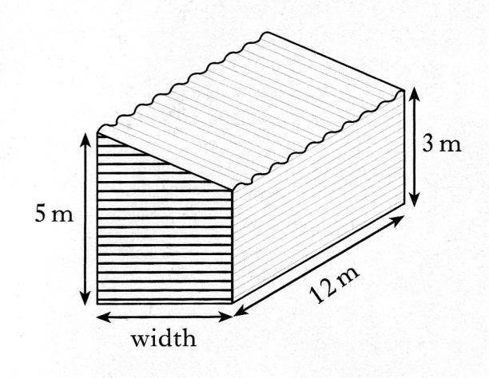

b) An extension to the barn is planned

to increase the volume by

200 cubic metres.

The uniform cross-section of the

extension consists of a rectangle

and a right angled triangle.

Find the width of the extension. 3 marks

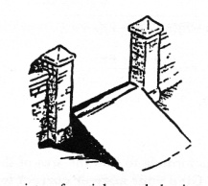

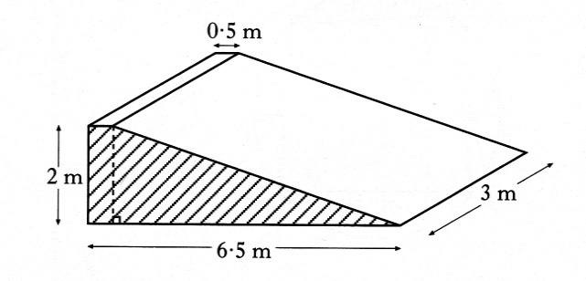Q4. A ramp is being made from concrete.

The uniform cross section of the ramp

consists of a right angled triangle and

a rectangle as shaded in the diagram.

Find the volume of concrete required

to make the ramp. 2 marks