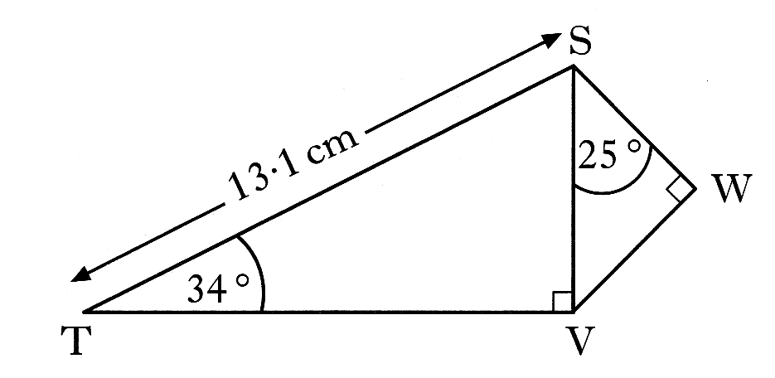1. In the diagram

Angle STV = 34°

Angle VSW = 25°

Angle SVT = Angle SWV = 90°

ST = 13.1 centimetres

Calculate the length of SW 4 marks

2. A cat is trapped in a tree and a ladder is placed against the tree in an attempt to rescue it.

14m

60o

The ladder rests against the tree making an angle of

60o with the horizontal and reaching 14 metres up

the tree, allowing the rescuer to reach the cat.

1m

Just as the cat is about to be rescued, it jumps to a

branch 1 metre above its original resting place.

Calculate the size of the angle, to the nearest degree,

that the ladder now has to make with the horizontal

to allow the rescuer to reach the cat. 5 marks

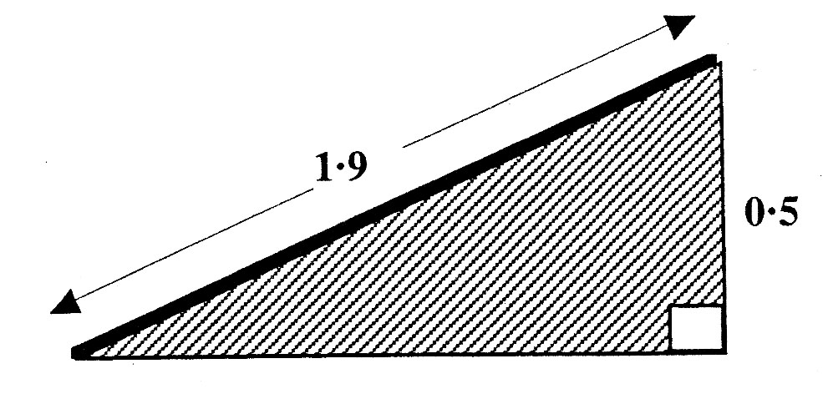3. The owners of Stately Hall Manor erected an entrance ramp

for disabled people at the main front entrance.

Local building regulations state that ramps

must be built at an angle of **not more than** 15°

to the horizontal ground.

A side view of the ramp which was actually

erected is shown above.

Does this ramp satisfy the local building regulations?

**You must explain your answer with mathematical reasoning.**  4 marks

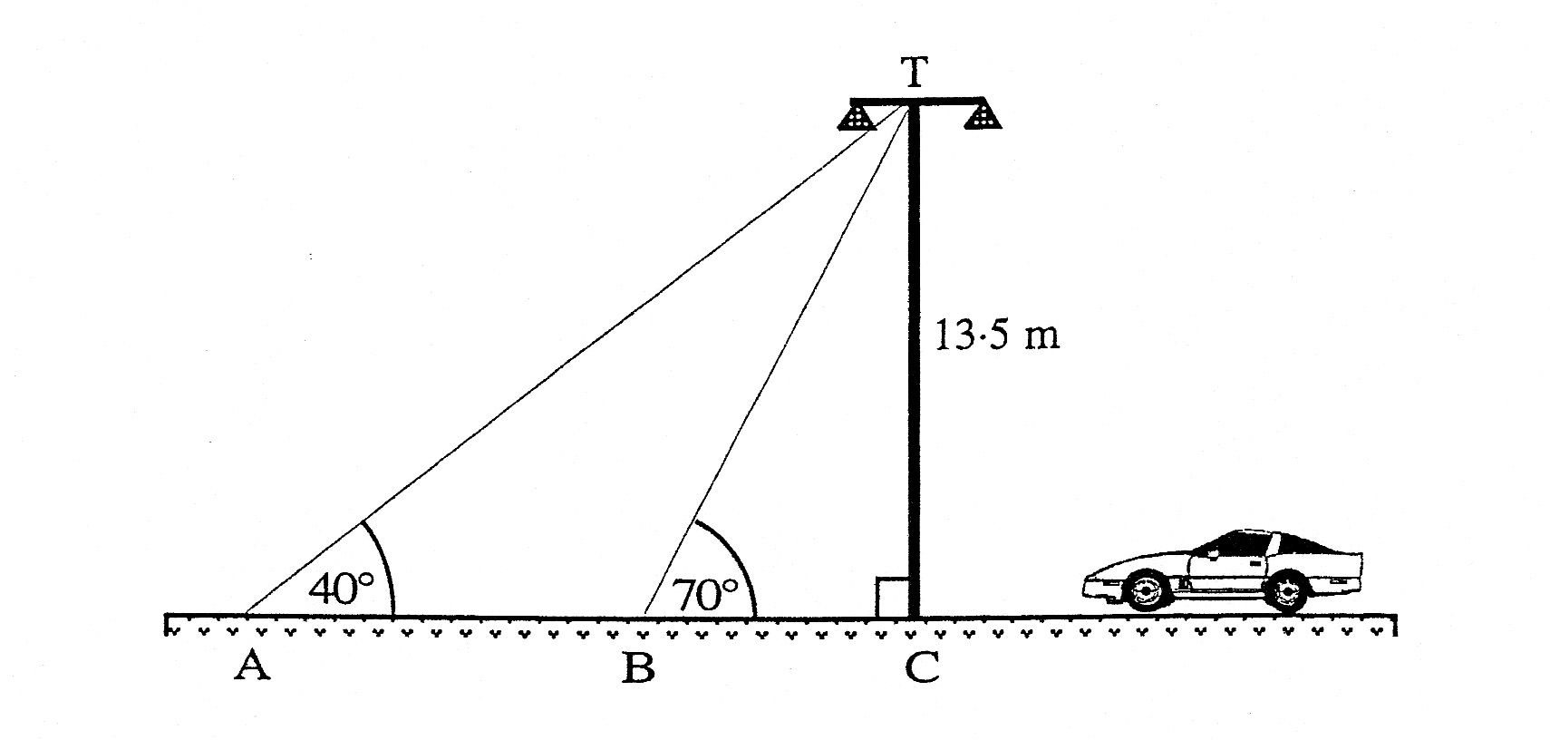

4. Two support cables, from the

top (T) of a motorway light,

are attached to a pair of points,

A and B, on the ground,

as shown in the diagram.

a) Calculate the distance

from B to C. 2 marks

b) Calculate the distance

from A to B. 3 marks