5. A statue stands at the corner of a square courtyard.

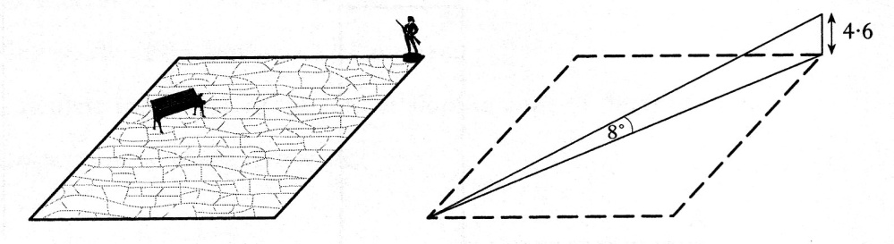

The statue is 4.6 metres high.

The angle of elevation from the opposite corner of the courtyard to the top

of the statue is 8°.

1. Find the distance from the base of the statue to the opposite corner of the courtyard.

2 marks

1. Find the length of the side of the courtyard to the nearest whole number.

2 marks

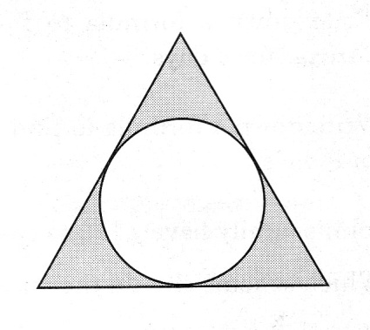

6. The diagram shows the design of an earring.

The earring consists of a circle

inside an equilateral triangle.

The sides of the triangle are tangents to the circle.

The radius of the circle is 8 mm

The distance from the centre of the circle

to **each** vertex of the triangle is 17mm.

Calculate the perimeter of the triangle. 4 marks

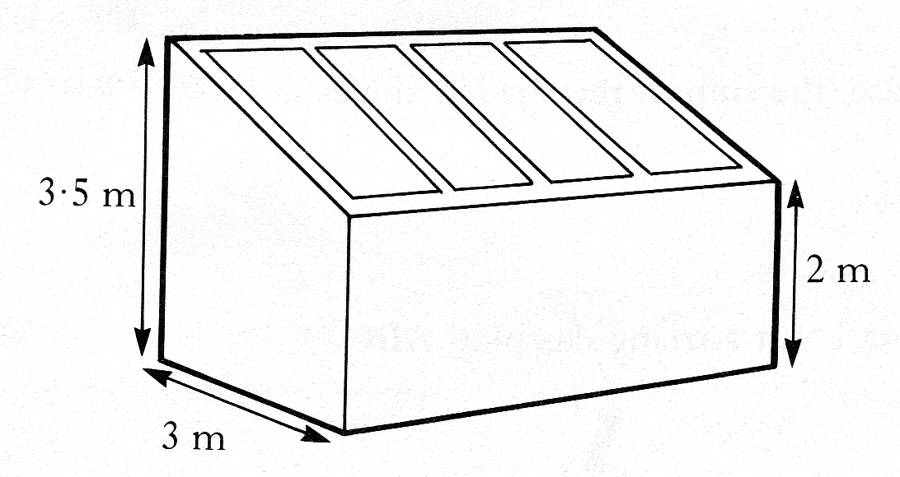

7. The Scott family want to build a

conservatory as shown in the diagram.

The conservatory is to be 3 metres wide.

The height of the conservatory at the lower end is to be

2 metres and at the higher end 3.5 metres.

To obtain planning permission, the roof

must slope at an angle of (25 ± 2) degrees to the horizontal.

Should planning permission be granted.

**Justify your answer.** 4 marks

8. The diagram shows the design

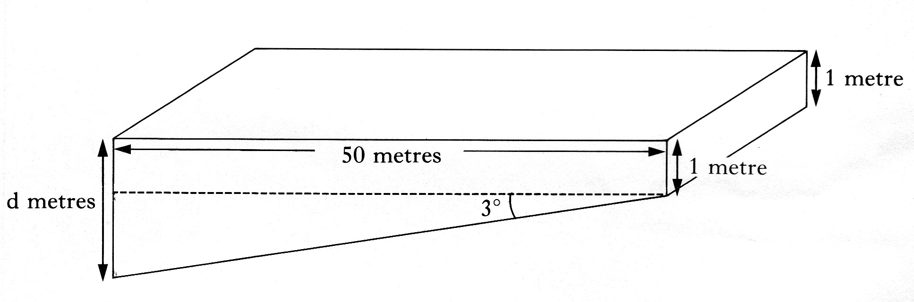 of a swimming pool 50 metres in length.

The pool is 1 metre deep at one end

and its base slopes downwards

at an angle of 3° to the horizontal.

Calculate the depth, *d* metres, of

the other end of the pool, giving

your answer to 2 significant figures.

**Do not use a scale drawing.** 5 marks