1. Two perfume bottles are mathematically similar in shape.

The smaller one is 6 centimetres high and

holds 30 millilitres of perfume.

The larger one is 9 centimetres high.

What volume of perfume will the larger one hold. 3 marks

50cm

40cm

2. The two boxes below are

mathematically similar

and both have to be wrapped

with decorative paper.

If it requires 3.27 m2 of paper to cover

the large box, calculate the amount of paper needed to cover the smaller box. 3 marks

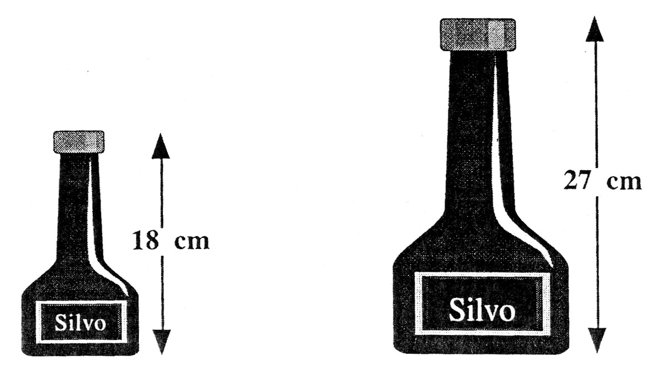

3. The diagram shows two bottles of

Silvo Shampoo.

The two bottles are **mathematically**

**similar**, and the cost of the shampoo

depends only on the volume of liquid

in the bottle.

If the small one costs 80p, what should the large one cost ? 3 marks

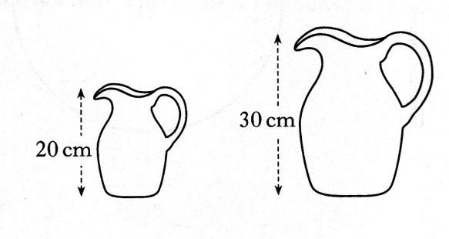

4. The diagram shows two jugs

which are mathematically similar.

The volume of the smaller jug is 0.8 litres.

Find the volume of the larger jug. 3 marks

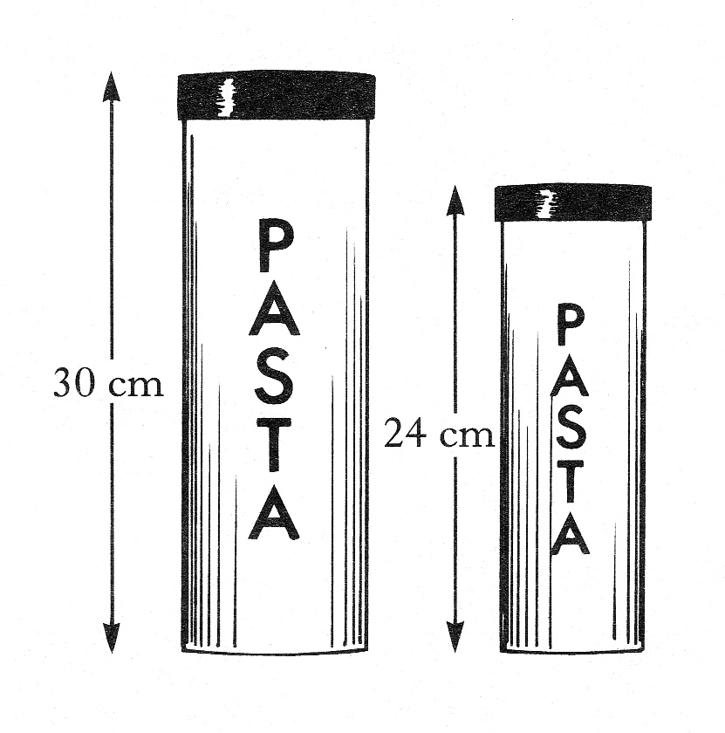

5. The diagram shows two storage jars which are mathematically similar.

The volume of the large jar is 1.2 litres.

Find the volume of the smaller jar.

**Give your answer in litres**

**correct to 2 significant figures.** 4 marks

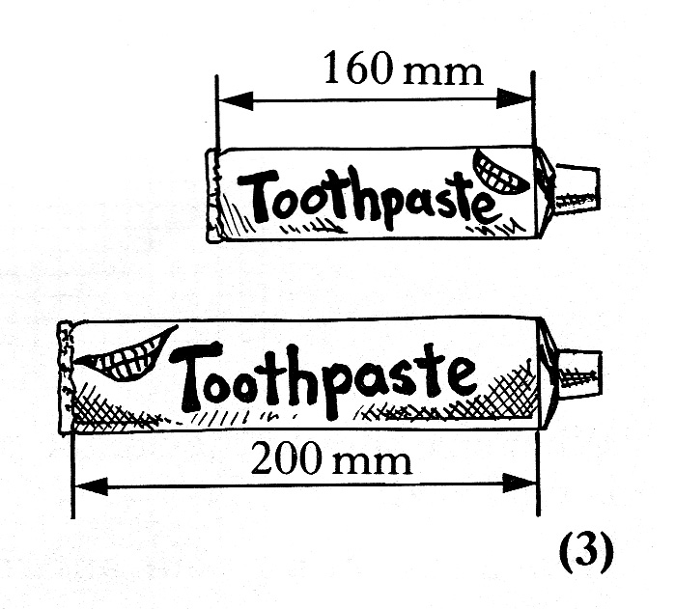6. The diagram shows two tubes of toothpaste.

Assuming that the tubes are mathematically

similar, and that the price of toothpaste depends

only on the volume of toothpaste in the tube,

what would be the cost of the large tube when

the small one costs £1.12? 3 marks