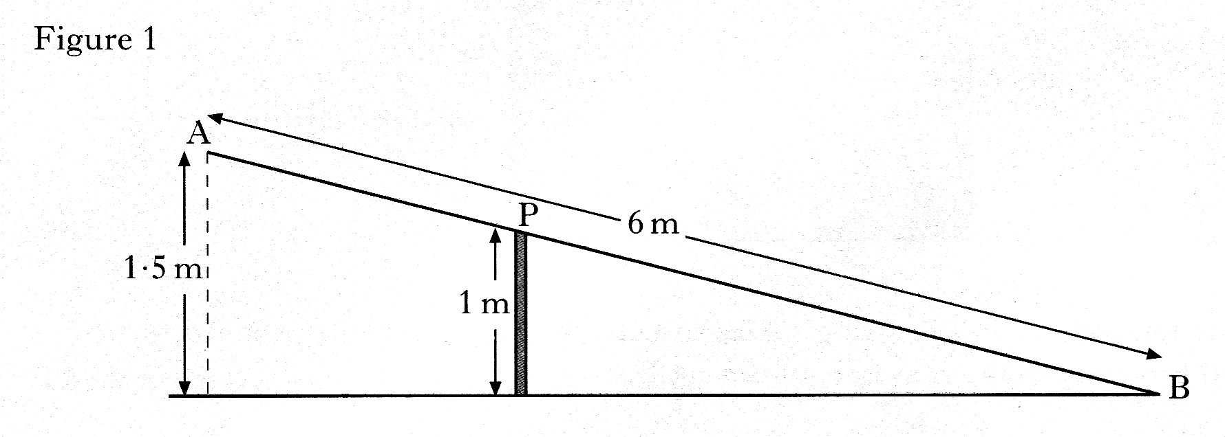1. A metal beam, AB, is 6 metres long.

It is hinged at the top, P,

of a vertical post 1 metre high.

When B touches the ground,

A is 1.5 metres above the ground,

as shown in Figure 1.

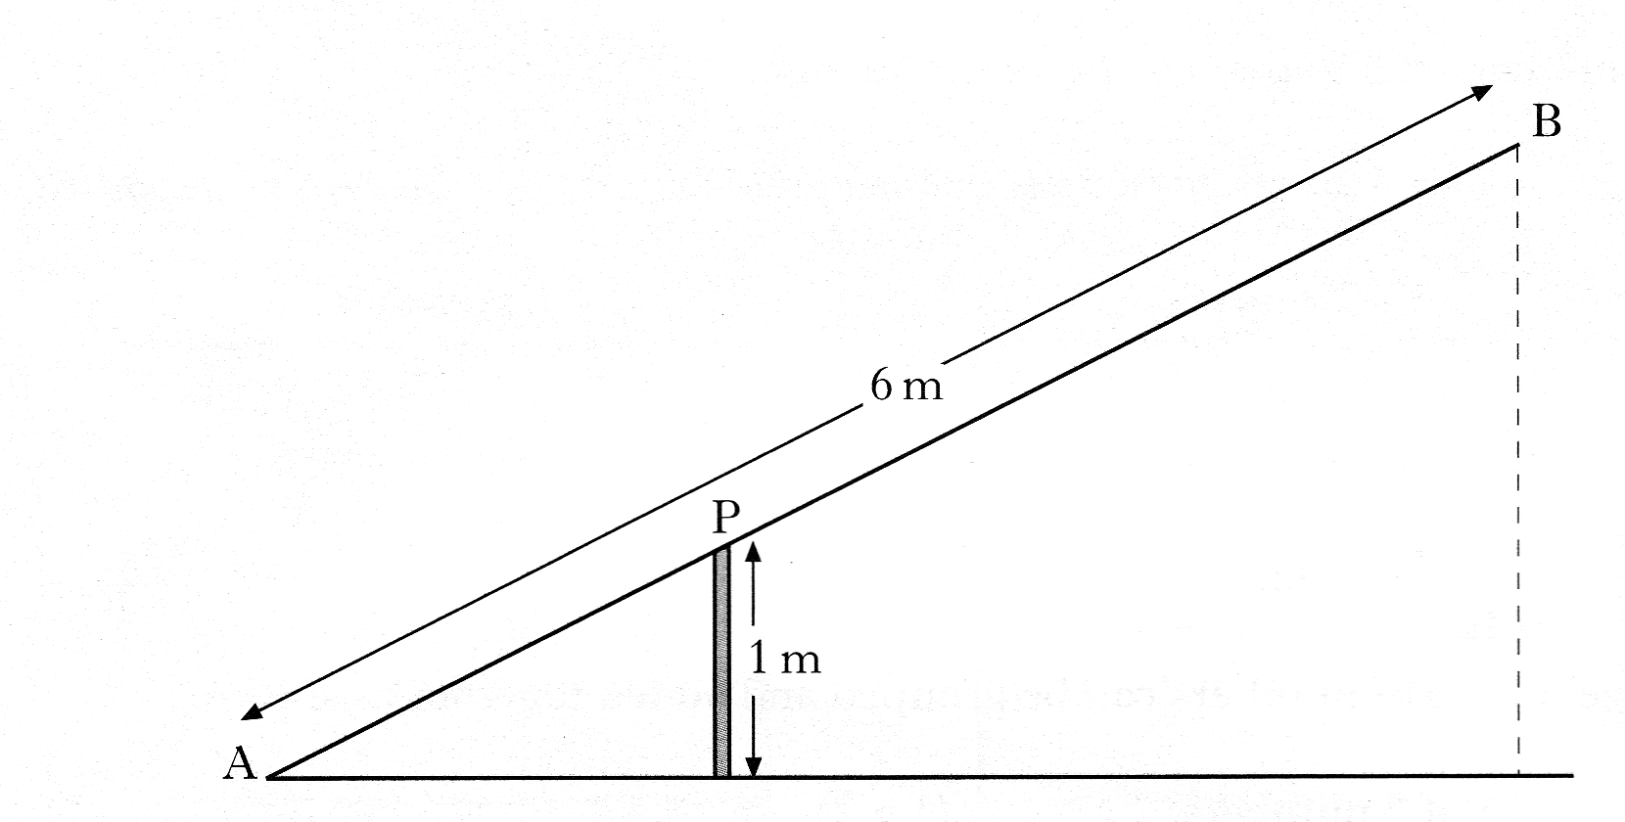

When A comes down to the ground,

B rises, as shown in Figure 2.

By calculating the length of AP,

or otherwise, find the height of B

above the ground.

**Do not use a scale drawing.**

5 marks

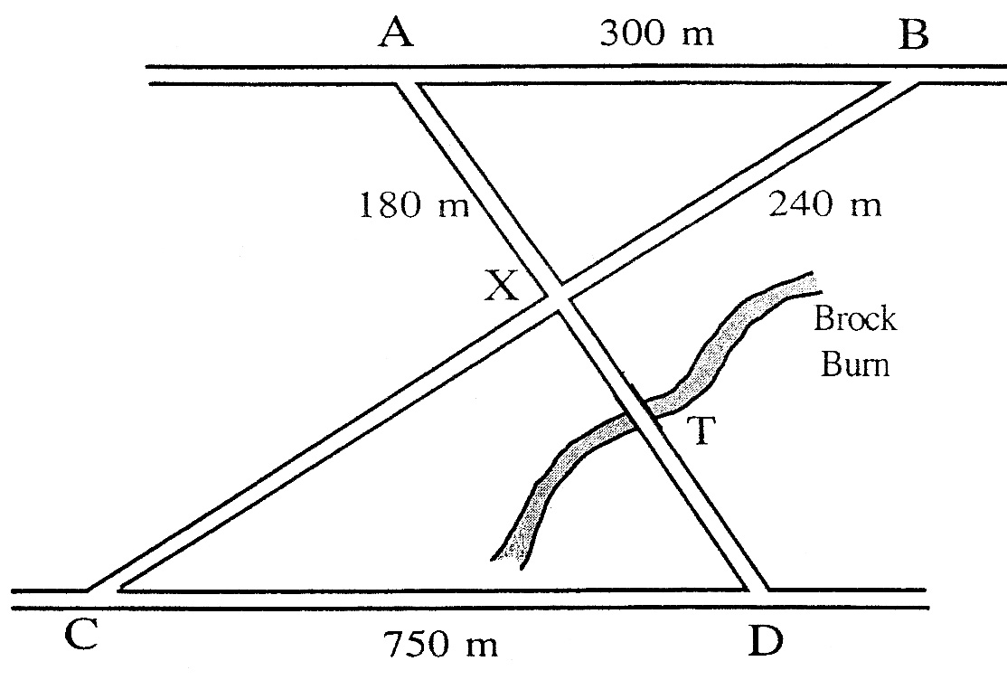

2. The road joining A to B is parallel

to the road joining C to D in the diagram.

AB = 300 metres,

AX = 180 metres,

BX = 240 metres

and CD = 750 metres.

a) Prove that the two roads AX and BX are at right angles to one another 3 marks

b) The Brock Burn burst its banks at T and the road became impassable.

An alternative route had to be found in order to travel from A to D.

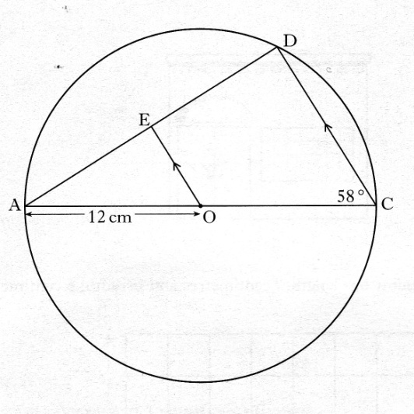 Calculate the length of the shortest route. 3 marks

3. AC is the diameter of the circle.

with centre O, and radius 12 centimetres

AD is a chord of the circle.

OE is parallel to CD

Angle ACD is 58°

Calculate the length of ED. 4 marks

4. Study the two triangles shown.

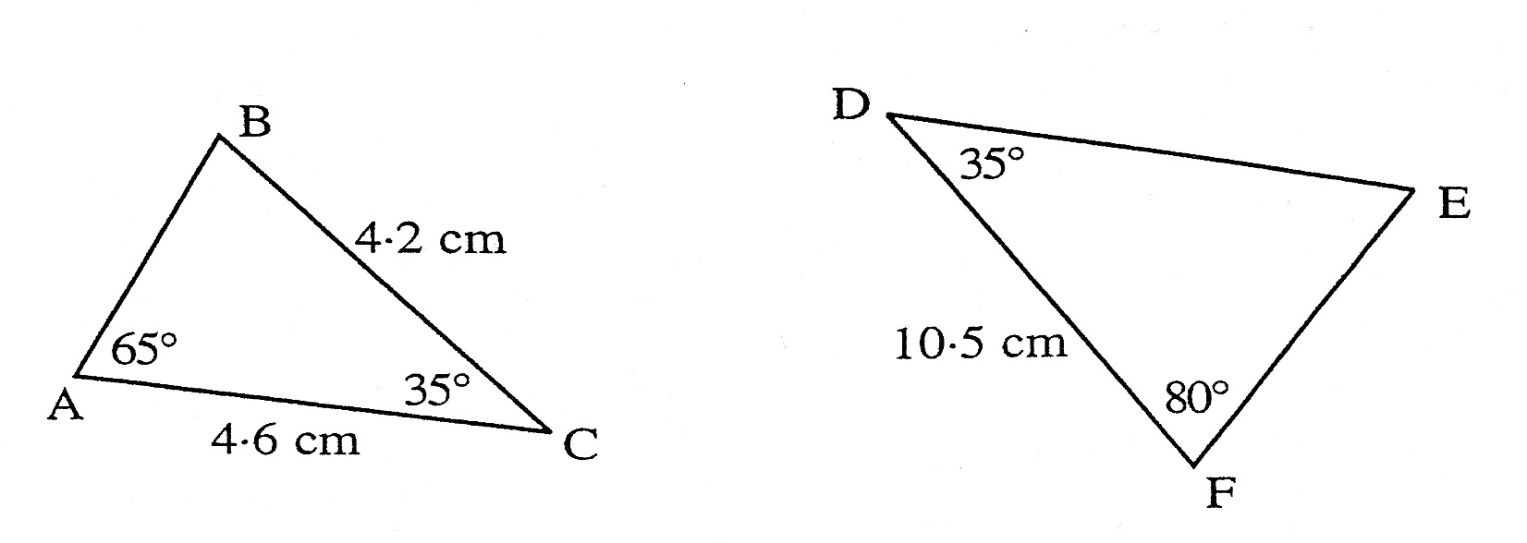

a) Explain clearly why the two triangles must be similar. 1 marks

b) Use the fact that the two triangles are similar to calculate the length of the line DE. 2 marks

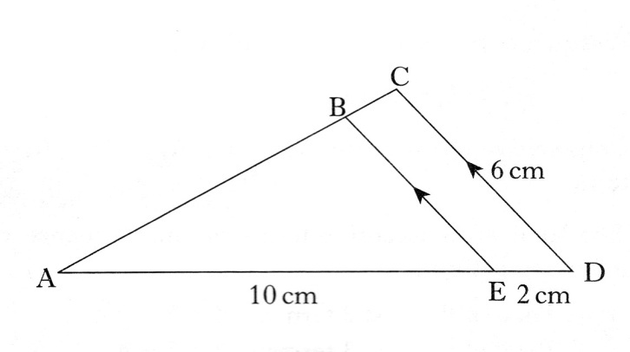5. Triangles ABE and ACD with

some of their measurements are

shown opposite.

Triangle ABE is similar to

triangle ACD.

Calculate the length of BE.

**Do not use a scale drawing.** 3 marks

6. The brown family want to convert the roof space in their bungalow

into an extra room.

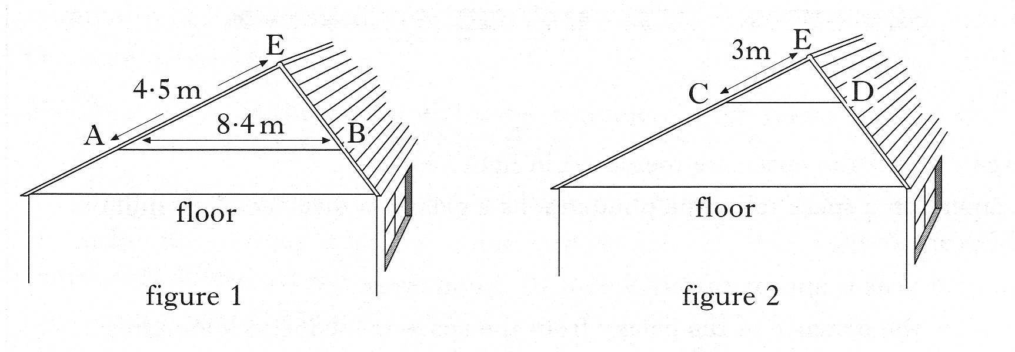

The position, AB, of the wooden beam must be changed to position CD,

as shown in figure 2.

The wooden beam must always be parallel to the floor.

By considering the similar triangles EAB and ECD, calculate the length of the

wooden beam in position CD.

**Do not use a scale drawing.** 3 marks

7. By holding a 10 pence coin at arms’ length, it is possible to cover exactly

the face of a person standing a distance away.

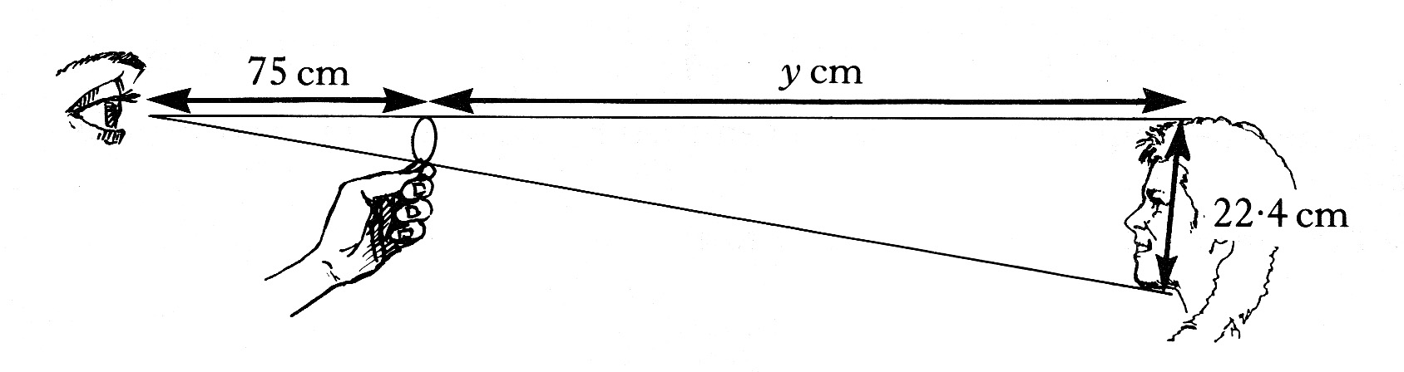

The diameter of the 10 pence coin is 2.8 cm and the length from the top to the

bottom of the person’s face is 22.4 cm.

If the distance from the observer’s eye to the top of the coin is 75 cm, find the

distance from the top of the 10 pence coin to the top of the person’s head. 4 marks