C1
^{S4 Credit}
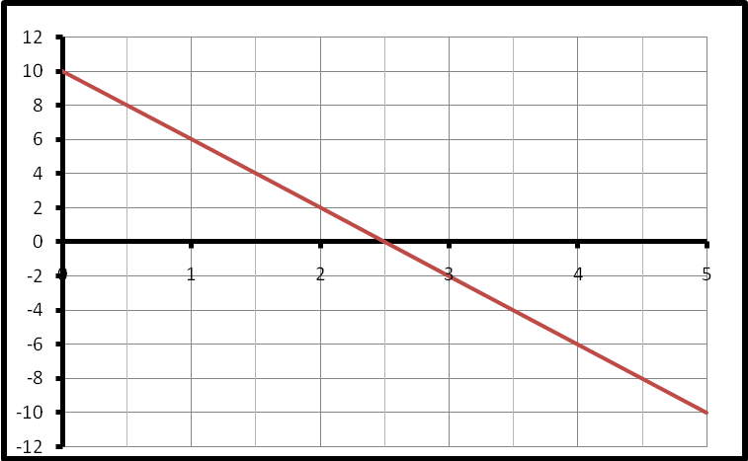
Q1. Find the equation of the straight line. (3 marks)

Q2. Find the equation of the given
straight line in terms of S and T. (3 marks)

Q3. When a patient’s blood pressue (B.P.), is taken, two measurements are made.
For example, in “160 over 70”

the 160 is the reading when the heart is pumping.
the 70 is the reading when the heart is at rest.

David has a heart problem, and has his blood pressure taken every hour. The first number of these two measurements is monitored very carefully and the nurse plots a graph, showing the changes from 8 am.
a) Find the gradient of the line shown above. (2 marks)

b) Write down the equation of the line in the form (2 marks)
P = …………..

c) It is known that if the blood pressure drops below 70, the patient will be in danger of losing consciousness. If David’s blood pressure continues to drop in the way indicated, when might he be expected to become unconscious. (3 marks)
C1
^{S4 Credit}
Q4. Solve
- 49p² – 9 = 0 2 marks
- 2y² – 9y – 35 = 0 4 marks

Q5. a) f(x) = x³ – 4x evaluate f (-2) 2 marks

b) f(k) = 11k– 3k² evaluate f (-3) 2 marks

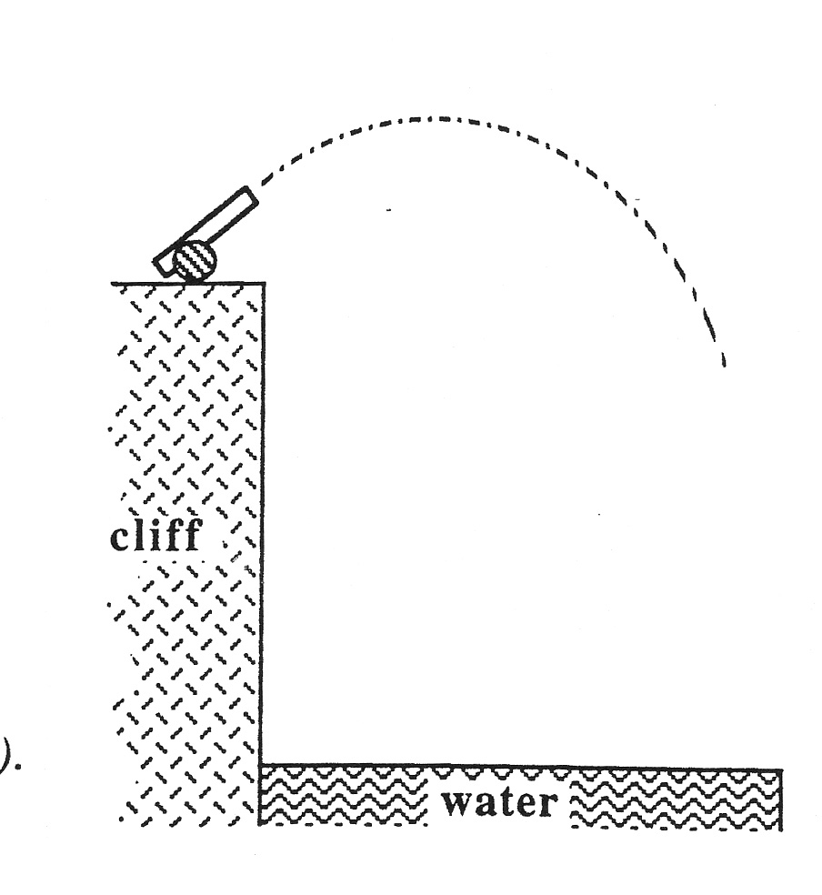
Q6. When a shell is fired from a cannon on top of a cliff,
the height of the shell above the water surface
is given by the formula:
where t is the time in seconds and H(t) is the
height in metres after t seconds.
Calculate the height of the shell after 3 seconds.
Explain what your answer indicates. 2 KU

C1
^{S4 Credit}

Q7. Solve the equation
Give your answers correct to 2 significant figures. (5 marks)

Q8. A frog is sitting 2 feet to the left of a snake.
The frog then notices a fly sitting on a rock on the other side of the snake.
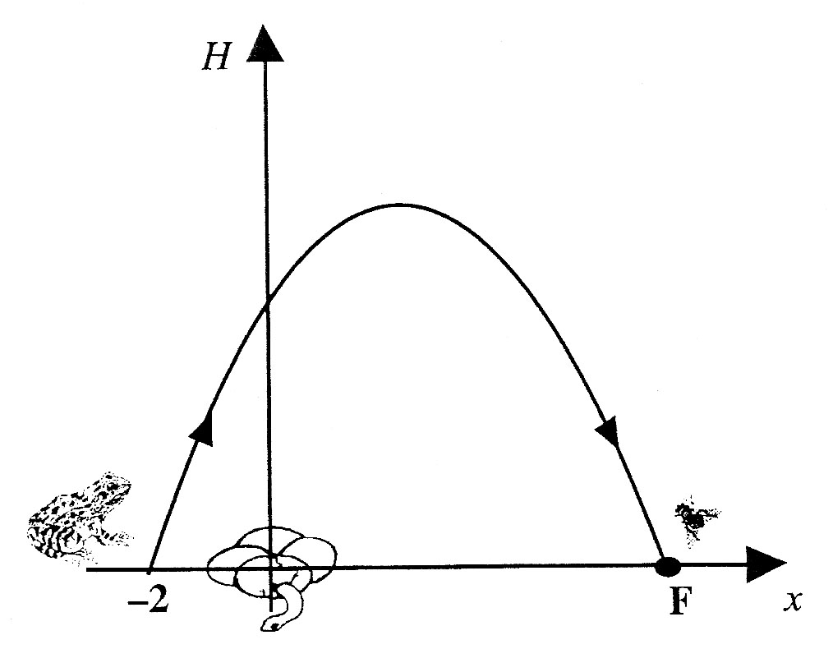
As the frog leaps over the snake to catch the fly,
its path is described by the parabola with equation
where H is the height of the frog above the ground.
a) By considering the quadratic equation:
find the co-ordinates of the point F,
where the fly is sitting, and hence write
down how far away the fly is from the frog. (4 marks)

b) How high above the ground does the frog reach on its jump ? (3 marks)

C1
^{S4 Credit}
Q10. A rectangular sheet of plastic 18 cm by 100 cm is used to make a gutter
for draining rain water.
The gutter is made by bending the sheet of plastic as shown below in diagram 1.
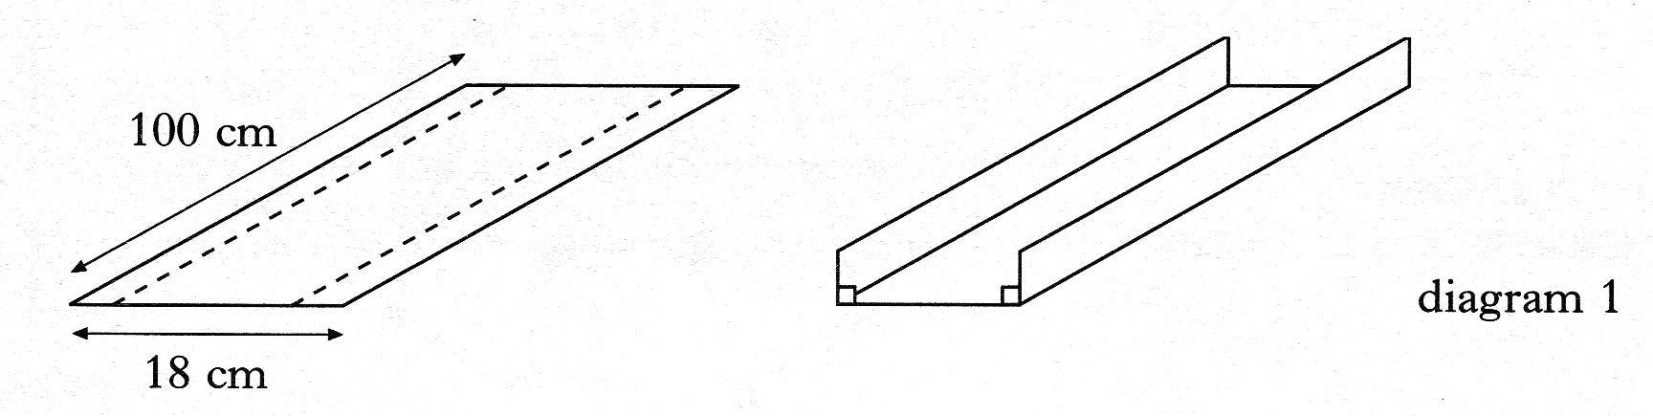

a) The depth of the gutter is x centimetres as shown in diagram 2 below.
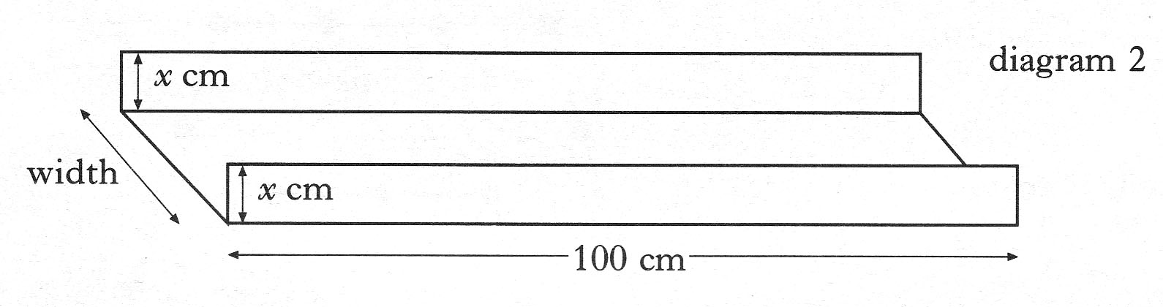
Write down an expression in x for the width of the gutter. (1 mark)

b) Show that the volume, V cubic centimetres, of this gutter is given by
(2 marks)

c) Find the dimensions of the gutter which has the largest volume.
Show clearly all your working. (4 marks)

