St Ninian’s High School


MATHS
S4 Credit Course CHECKLIST


- I understand this part of the course =
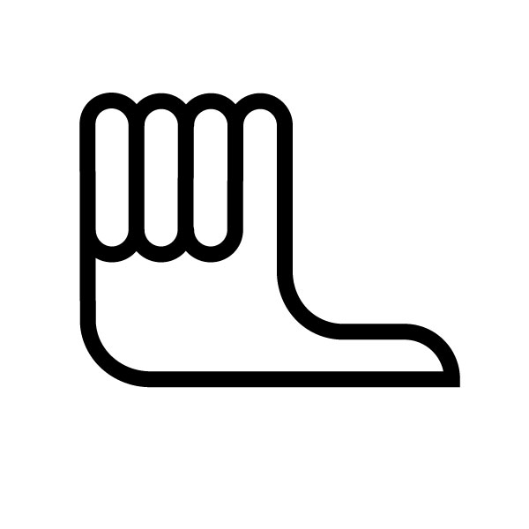
- I am unsure of this part of the course =

- I do not understand this part of the course =

Chapter 1 - Area and Volume
1
2
3
4
5
6
7

- Revision ( Conversion litres - millilitres, Area of Rectangle / Square. Surface Area etc.)

- The Area of a triangle. (A = $\frac{1}{2}b$ase x height )

- The Area of a Parallelogram ( A = Base x Altitude )

- The Rhombus and Kite ( Area of a Kite = Half the product of the diagonals, A = $\frac{1}{2}d_{1}×d_{2}$)
a
- The trapezium ( A = $\frac{1}{2}h(a+b)$ )
h
b

- The Area of Composite Shapes ( Split shape up into smaller shapes. Calculate individual areas and then add together. )

- The Volume and Surface Area of a Prism. ( Volume = Cross Section Area x Length or Height. Surface Area = Area of faces added together.)

Chapter 2 - Money

- Money Calculations ( £566.23 + £432.56 etc)
1
2
3
4
5
6
7
8
9
10

- Wages and Salaries ( Weekly wage = £200, How much does this person earn in a month? How much does this person earn in a year? £7 per hour, How much do you earn in one week if you work 30 hours etc)

- Time Sheets and Overtime ( Overtime – Time and a half, Double Time, time and a quarter.

- Piecework and Commission ( Piecework – Person gets paid £20 for one maths lesson, how much for 10 lessons? Commission – Sales person get 3% of the sales he makes. etc)

- Payslips ( Gross pay = Total amount earned before any deductions, Deductions = Tax, National Insurance, Pension, Net Pay = Total pay received after deductions)

- National Insurance Contributions ( This is a government tax on earnings, intended to contribute towards unemployment, ill health and retirement payments.)

- Income Tax (Tax allowance = Amount of money the government is not allowed to tax. Tax is calculated by taking your annual salary and subtracting your allowance. This is the amount that will be taxed.

- Bank and Building Society Accounts ( Check book, cash card, credit card, bank statement.

- Savings and Interest ( Simple Interest eg £500 is deposited in a bank for 3 years. Work out interest gained for 1 year and multiply by 3. Compound Interest – The interest carries over onto the next year, thus building up in the bank account over the required term.)

- Appreciation and Depreciation ( Appreciation means an increase in value, Depreciation means a decrease in value. eg Appreciation – House is worth £120000 and in 3 years it is worth £145000, How much has it appreciated by? Depreciation – A Car is worth £6000, find out how much it has depreciated by in 3 years if the rate is 8%.)

Chapter 3 – Similarity

1
2
3
4
5
6
7
8
- Representative Fractions ( 1cm Represents 10m, 1cm:1000cm or 1:1000)

- Scale Drawings ( Choose a suitable scale, Start all Movement points with a north line, Make sure all measurements are accurate.

- Working out Scales ( 2cm : 5 km, therefore 2cm : 500000cm = 1 : 250000)

- Similar Triangles
(Enlargement Scale Factor$=\frac{L\text{arg}e_{\text{Measurement}}}{{\text{Small}}_{\text{Measurement}}}$)
(Reduction Scale Factor $=\frac{{\text{Small}}_{\text{Measurement}}}{L\text{arg}e_{\text{Measurement}}}$)

- Other Similar Triangles ( The Corresponding Sides are in proportion)
4
6
3
x

- Ratios of Areas ( The scale factor for the area is the square of the scale factor for the length )

- Surface Areas of similar solids ( If two solids are similar, then the scale factor for the surface area is the square of the scale factor for the length )

- Volumes of Similar Solids ( The scale factor for volume is the cube of the scale factor for length)

Chapter 4 – Formulae

- Review of BODMAS, removing brackets, Squaring numbers, substitution.( eg 2(x + 1) = 2x + 2, -3y = 33)
1
2
3
4
5

- Using Formulae (Substituting various answers into formulae eg A = , where h = 1.8, w = 70kg)

- Making Formulae ( I buy a CD £m and Sell it for £n, making a profit £p. Formula would be P = n – m)

- Change the subject of the Formula ( A = , Change subject to r, r = )

- Understanding Formulae ( C = d, What happens if we double d?

Chapter 5 - Equations and Inequations

- Revision ( Solving Equations, Foil, Lowest Common Multiple)
1
2
3
4
5

- Solving Harder Equations ( )

- Equations with fractions ( Solve )

- Inequalities ( )

- Solving Inequalities ( Can you solve this Equation? 10m – 3 > 2x + 9, Remember by a –ve number will flip the symbol round the opposite way. )

Chapter 6 – Algebraic Fractions

- Revision of Fractions ( Adding, Subtracting, Multiplying, Dividing Fractions)
1
2
3
4
5
6

- Equivalent Fractions ( Find three fractions equivalent to = )

- Multiplying Fractions ( )

- Dividing Fractions ( )

- Adding Fractions ( )

- Subtracting Fractions ($\frac{7}{8}−\frac{3}{7}=\frac{7×7}{8×7}−\frac{3×8}{7×8}=\frac{\text{49}}{\text{56}}−\frac{\text{24}}{\text{56}}=\frac{\text{25}}{\text{56}}$ )

Chapter 7 – The Straight Line

- Plotting Coordinates ( )
1
2
3
4
5
6

- Naming Grid Lines ( x = 4, y = 3 etc)

- Gradient ( Is the measure of how steep a slope is.
M = $\frac{{\text{Vertical}}_{\text{Height}}}{{\text{Horizontal}}_{\text{Dis}}\text{tan}\text{ce}}$

- Gradients on a coordinate grid ( m = $\frac{y_{2}−y_{1}}{x_{2}−x_{1}}$)

- The Equation of a Line ( y = mx + c, m = Gradient, c = y intercept)

- The best fitting line ( Scatter graph containing a best fitting line )

Chapter 8 - Quadratic Equations

- Revision ( Solving Equations, Factorising, Difference of two squares, Quadratics)
1
2
3
4
5
6
7
8

- Introducing Quadratic functions / Equations ()

- Using Factors to solve Quadratic Equations ( $x^{2}−4x$= 0, x ( x – 4) = 0, therefore the solutions are x = 0 and x = 4 )

- More Quadratic equations : Trinomials ($x^{2}+5x+6=0$, (x + 3)(x + 2) = 0, (x + 3) = 0 , (x + 2) = 0, Therefore x = -3, x = -2

- Manipulation ( (x + 4)${}^{2}$ = 36 )

- Problems involving quadratic equations ( Use Pythagoras to show that $x^{2}+x−\text{12}=0$)
(x + 1) m
x m
5m

- A formula for solving quadratics ( $x=\frac{−b±\sqrt{b^{2}−4\text{ac}}}{2a}$)
- Iteration ( Find a solution between two numbers. Using trial and error)

Chapter 9 – Surds and Indices

- Indices - Multiplication ($x^{2}×x^{3}=x^{2+3}=x^{5}$)
1
2
3
4
5
6
7
8

- Indices – Division ($x^{8}÷x^{3}=x^{8−3}=x^{5}$)

- Negative Indices ( $\frac{1}{x}=x^{−1},4x^{−3}=\frac{4}{x^{3}}$)

- Powers of powers ($(x^{2})^{4}=x^{2×4}=x^{8}$)

- Fractional Indices ( $\sqrt{x}=x^{\frac{1}{2}}$)

- Surds ( $\sqrt{\text{ab}}=\sqrt{a}×\sqrt{b}$)

- Further Simplification ( $\sqrt{\frac{a}{b}}=\frac{\sqrt{a}}{\sqrt{b}}$)

- Rationalising the denominator ($\frac{1}{\sqrt{3}}=\frac{1}{\sqrt{3}}×\frac{\sqrt{3}}{\sqrt{3}}=\frac{\sqrt{3}}{\sqrt{9}}=\frac{\sqrt{3}}{3}$)

Chapter 10 - Functions

- Illustrating a function ( )
1
2
3
4
5
6

- Notation ( f(x) = x + 4, Find (f6) = 6 + 4 = 10)

- Graphs of linear and quadratic functions ( )

- Sketching Quadratic functions ( 4 steps – (1) Find where (f(x) = 0, (2) Find the equation of its axis of symmetry (3) Find Turning point – Max or Min (4) Find where the curve cuts the y axis, x = 0.)

- The function f(x) = $\frac{a}{x},x≠0$( The function $\frac{a}{x}$ is the simplest form of a reciprocal function.

- The function f(x) = a${}^{x}$, for a = 1,2,3……

Chapter 11 – Trigonometric graphs and equations

- Revision ( Soh Cah Toa)
1
2
3
4
5
6

- Exact Values
 | 0${}^{o}$ | 30${}^{o}$ | 45${}^{o}$ | 60${}^{o}$ | 90${}^{o}$
Sin | 0 | $$\frac{1}{2}$$ | $$\frac{1}{\sqrt{2}}$$ | $$\frac{\sqrt{3}}{2}$$ | 1
Cos | 1 | $$\frac{\sqrt{3}}{2}$$ | $$\frac{1}{\sqrt{2}}$$ | $$\frac{1}{2}$$ | 0
Tan | 0 | $$\frac{1}{\sqrt{3}}$$ | 1 | $$\sqrt{3}$$ | ---

- Sines, Cosines and Tangents of angles > 90${}^{o}$
0 < A < 90
1st Quadrant
270 < A < 360
4th Quadrant
90 < A < 180
2nd Quadrant
180 < A < 270
3rd Quadrant

- Trig Functions and their graphs (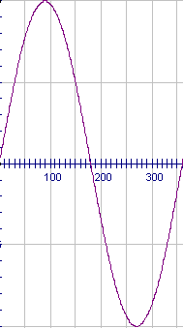)

- Solving Trigonometric Equations ( Sin x${}^{o}$= 0.2, Using Quadrants shown above)

- Related Ratios ( $\frac{\text{SinA}}{\text{CosA}}=\text{TanA}$)

Chapter 12 – Trigonometry and triangle calculations

- The Sine Rule – Calculating Lengths and Angles ( $\frac{a}{\text{SinA}}=\frac{b}{\text{SinB}}=\frac{c}{\text{SinC}}$)
1
2
3
4

- The Cosine Rule – Calculating Lengths and Angles ($a^{2}=b^{2}+c^{2}−2\text{bcCosA}$, Cos A = $\frac{b^{2}+c^{2}−a^{2}}{2\text{bc}}$)

- The Area of a Triangle ( A = $\frac{1}{2}$ab Sin C)

- Which Formula to use? (3 sides – Cosine rule, 2 sides + angle between – Cosine Rule, 2 Sides + angle not between – Sin Rule, 1 side and 2 angles – Sin Rule)

