Higher Mathematics Booklet
CONTENTS

Item |  | Pages
Formula List
The Straight Line | Homework 1
The Straight Line | Homework 2
Functions | Homework 3
Functions | Homework 4
Recurrence Relations | Homework 5
Differentiation | Homework 6
Differentiation | Homework 7
Polynomials | Homework 8
Quadratics | Homework 9
Integration | Homework 10
Integration | Homework 11
Further Trigonometry | Homework 12
Further Trigonometry | Homework 13
The Circle | Homework 14
The Circle | Homework 15
Vectors | Homework 16
Vectors | Homework 17
Further Calculus | Homework 18
Further Calculus | Homework 19
Logarithms and Exponentials | Homework 20
Logarithms and Exponentials | Homework 21
The Wave Function | Homework 22
The Wave Function | Homework 23
Revising Unit 1 (including A/B questions)
Revising Unit 2 (including A/B questions)
Revising Unit 3 (including A/B questions)
Unit 1 Practice Assessments (NABS)
Unit 2 Practice Assessments (NABS)
Unit 3 Practice Assessments (NABS)
Higher Exam Technique Modules
Past Paper Question Map
Topic Checklist

The following items will be issued throughout the year in separate booklets.
Please keep them safe and return them to you teacher at the end of the year.

- Higher Objective Test Booklet
- Additional Practice Papers
- Revision Booklets

Higher Mathematics Booklet
DETAILS

Homework

All questions in the homework should be attempted.
The questions in the box contain important revision of previous topics.

Care of booklet

- Please keep these booklets in good condition and return at the end of the year
- Please do not mark the copies with pen

The Straight Line
Homework 1

1. Find the angles which the lines joining the following pairs of points make with the
positive direction of the x-axes (OX)

(a) (0, 0), (1, 1) (b) (0, 0), ($\sqrt{3}$ , 1) (c) (-3, 6), (5, 4) (6)

2. Find the equations of the lines through the following points, with the given
gradients. Give your answers in the form $y−b=m(x−a)$

(a) (2, 3), 4 (b) (0, 4), -2 (c) (-4, 2), ½ (3)

3. Find the equation of the line through (-3, 2) and parallel to the line
$2x+3y+4=0$. (3)

4. Find the equation of the line connecting points (1, -4) and (3, -6). (2)

5. P is the point (4, 0), Q is (0, -3) and R is (-5, -1). Given that PQRS is a
parallelogram, obtain the equation of RS. (3)

6. Prove that the points A(-2, 1), B(-1, 0) and C(7, -8) are collinear. (3)

7. Solve the equation $x(x+\text{29})−9(x−2)=4x+3$ (3)

8. Solve the following simultaneous equations

$\begin{aligned}4x+2y=8 \\ x+3y=2\end{aligned}$ (4)

TOTAL 27
The Straight Line
Homework 2

1. Find the equation of the median AD of triangle ABC where the coordinates of
A, B and C are (-2, 3), (-3, -4) and (5, 2) respectively. (3)

2. Find the equation of the altitude PR of triangle OPQ where the coordinates
of O, P and Q are (-2, 3), (-3, -4) and (5, 2) respectively. (3)

- Find the equation of the perpendicular bisector of the line joining A(2, -1) and
B(8, 3). (3)

4. A triangle ABC has vertices A( -4, -3), B(-2, 1) and C(6, -3)
C
A
B
x
0
y

- Show that the triangle ABC is right angled at B. (3)
- The medians AD and BE intersect at M.
  - Find the equations of AD and BE. (6)
  - Find the coordinates of M (2)

5. Solve $x\left(x−5\right)+2(x−\text{14})=0$ (3)

6. Simplify each expression
(a) $4b^{9}×2b^{−6}$ (b) $(6h^{5})^{3}$ (c) $\frac{\text{48}f^{\text{10}}}{6f^{−4}}$ (3)

TOTAL 26
Functions
Homework 3

1. Convert to radians (simplify where possible)

(a) 60º (b) 225º (c) 330º (3)

2. Express 160º in radians correct to 2 decimal places. (1)

3. Convert to degrees

(a) $\frac{π}{4}$ radians (b) $\frac{4π}{3}$ radians (c) $\frac{9π}{5}$ radians (3)

4. Sketch the graph of $y=2\text{sin}(3x+\text{60})^{o}$, $0^{o}<x<{\text{180}}^{o}$ (3)

5. $f(x)=2x−1$, $g(x)=\frac{x^{2}+1}{x^{2}−1}$ and $h(x)=g(f(x))$

(a) Find a formula for h(x). (2)
(b) For what values of x is h undefined? (2)

6. $f(x)=x^{2}+x$ and $g(x)=3x−1$
Evaluate $g(f(2))$ and $f(g(−1))$ (4)

7. Express the following as exact values

(a) sin225º (b) –tan150º (2)

8. Solve $2\text{cos}3x=1$, for $0^{o}≤x≤{\text{360}}^{o}$ (4)

TOTAL 24
Functions
Homework 4

1. The following sketch shows the graph of f(x).
2
-1
-6

Make separate sketches of the following graphs:
(a) $y=−f(x)$
(b) $y=f(−x)$
(c) $y=3f(x)$ (3)

2. $g(x)=2^{x}$. Make separate sketches of the following graphs:
(a) $y=g(x)$
(b) $y=2^{x}+3$
(c) $y=2^{(x−4)}$ (3)

3. (a) Show that the function $f(x)=2x^{2}+8x−3$ can be written in the form
$f(x)=a(x+b)^{2}+c$, where a, b and c are constants. (3)

(b) Hence, or otherwise, find the coordinates of the turning point of the
function f. (1)

4. (a) Express $7−2x−x^{2}$ in the form $a−(x+b)^{2}$ and write down the values of
a and b. (3)

(b) State the minimum value of $\frac{1}{7−2x−x^{2}}$and justify your answer. (2)

5. Find the coordinates of the points of intersection of the curve
$y=3x^{2}−5x+2$ and the line $y=4x+2$. (4)

6. Evaluate ${\text{64}}^{43}$ (2)

TOTAL 21
Recurrence Relations
Homework 5

1. (a)Write down the next 3 terms of the sequence given by the recurrence relation

$T_{n+1}=0\text{.}9T_{n}+2$, $T_{0}=\text{40}$ (2)

(b) What is the limit of this sequence? (2)

2. A car designer has calculated that water escapes from an engine’s cooling
system at a rate of 20% per month. The system was initially filled with 36 litres
of coolant and each month she adds 4 litres of coolant to the system.

(a) Find a recurrence relation to describe this. (2)
(b) Calculate the volume of coolant in the system after 6 months. (2)
(c) If the coolant drops below 18 litres the engine will overheat.
Is the engine in danger of overheating? (explain fully) (2)

3. A recurrence relation is defined by $U_{n+1}={\text{aU}}_{n}+b$ for some constants a and b.

(a) If $U_{2}=\text{190},U_{3}=\text{430}$ and $U_{4}=\text{910}$ calculate the values of a and b. (3)
(b) What is the initial value, $U_{0},$of this sequence? (2)

4. (a) Given that $f(x)=x^{2}−2$ and $g(x)=3x+1$, find functions
$k(x)=f(g(x))$and $h(x)=g(f(x))$.
(b) If $f(g(p))=f(g(p))+\text{16}$ for some number p, find the value(s) of p. (6)

TOTAL 21
Differentiation
Homework 6

1. Differentiate the following functions with respect to x.

(a) $f(x)=3x^{2}−6x$ (b) $f(x)=(2x+3)^{2}$ (3)

2. Differentiate each of the following functions with respect to the relevant variable

(a) $f(x)=x^{3}(x−x^{2})$ (b) $f(t)=t^{\frac{1}{2}}(t^{2}+t^{\frac{3}{2}})$ (c) $g(p)=\frac{x^{5}+2x^{2}}{x^{4}}$ (6)

3. Calculate the rate of change of $f(x)=x^{3}−2x^{2}$ at $x=2$. (2)

4. Find the equation of the tangent to the curve with equation $y=4x^{2}+3$ at the
at the point where $x=1$. (4)

5. The gradient of the tangent to the curve $y={\text{ax}}^{2}+b$ is equal to 30 at the point
point (3, 1). Find the values of a and b. (4)

6. Triangle PQR has vertices (2, 3), (-3, -2) and (3, 0) respectively.

(a) Find the equations of the perpendicular bisectors of sides RQ and PR.
(b) Find the coordinates of the point T, the point of intersection of these two
lines. (6)

TOTAL 25
Differentiation
Homework 7

1. Differentiate the following functions with respect to x.

(a) $y=\frac{5x^{4}−3x^{2}−\text{14}}{x^{2}}$ (b) $y=\frac{(x−3)^{2}}{3\sqrt{x}}$ (6)

2. For the following graph of $f(x)$, sketch the graph of $f^{'}(x)$.
(2)
3
0
(1, 5)
x
y

3. For what values of x is the function $h(x)=2x^{3}+3x^{2}−\text{12}x+1$ decreasing? (4)

4. The diagram shows a sketch of the parabola $y=6x−x^{2}$ and the line $y=x$.
x
y
0

- Find the gradient of the tangent to the parabola at the point (0, 0). (2)
- Hence or otherwise calculate the size of the angle between the line
$y=x$and the tangent to the parabola at the point (0, 0). (3)

5. Sketch the graph of the curve $y=2x(x−4)^{2}$, indicating all important points. (5)

6. Sketch the graph of $y=3\text{cos}(2x−\text{30})^{o}$, $0^{o}<x<{\text{360}}^{o}$ (3)

TOTAL 25
Polynomials
Homework 8

1. (a) Show that $x=2$ is a root of the equation $2x^{3}+x^{2}−\text{13}x+6=0$ (1)
(b) Hence find the other roots. (3)

2. Given that $\left(x−4\right)$is a factor of $h(x)=x^{3}−5x^{2}−\text{ax}+\text{80}$, find
(a) The value of a (2)
(b) Hence solve the equation $x^{3}−5x^{2}−\text{ax}+\text{80}=0$ when a takes this value. (2)

- When $x^{4}−x^{3}+x^{2}+\text{ax}+b$is divided by $x−1$the remainder is 0, and when divided by$x−2$the remainder is 11. Find $a$and $b$. (6)

4. Find the equation of the perpendicular bisector of CD where the coordinates of C
and D are (4,3) and (2,-3) respectively. (4)

5. Find the equation of the tangent to the curve $y=x^{3}−3x+1$, at the point $x=−1\text{.}$ (4)

TOTAL 22
Quadratics
Homework 9

1. Decide the nature of the roots in the following equation:

$9x^{2}+8x−1=0$ (2)

2. Prove that $y=6+2x$ is a tangent to $y=5−x^{2}$ and find the point of contact. (4)

3. Find $p$ if the roots of $(p+1)x^{2}+2\text{px}+(p−2)=0$are equal. (3)

4. Express $x+2x+7$in the form $(x+a)^{2}+b$
(a) Hence state the minimum value of $x+2x+7$.
(b) State the maximum value of $\frac{1}{x^{2}+2x+7}$and the
corresponding value of x. (5)

5. A statistician claims that purchasing 15 new street cleaners will reduce the
amount of litter by 65% after cleaning. However, after testing it is found that a
further 1400kg of litter are dropped between cleaning times. What is the
minimum weight of litter found at any point after cleaning? (5)

6. Differentiate $\frac{x^{3}−4x}{\sqrt{x}}$ (2)

TOTAL 21
Integration
Homework 10

1. Integrate the following:

a) $\int{}\frac{\text{dx}}{3x^{2}}$ b)$\int{(4−3x)^{2}\text{dx}}$ (5)

2. Evaluate $\int_{1}^{9}{\frac{r+1}{\sqrt{r}}}\text{dr}$ (4)

3. If $\int_{0}^{k}{x^{{}^{\frac{1}{3}}}}\text{dx}=\text{12}$, find the value of k. (4)

4. The function g, defined on a suitable domain, is given by $g(x)=\frac{5}{2x+1}$.
(a) Describe any restriction on the domain of $g$. (1)

(b) Find an expression for $h(x)$where $h(x)=g(g(x))$, giving your answer as a
fraction in its simplest form. (3)

5. Find the rate of change of the function $f(t)=5t(3t−4)$, when $t=−2$ (3)

TOTAL 20

Integration
Homework 11

1. Find the area between the curve $y=6x−5−x^{2}$ and the x axis, between the
limits$x=2$ and $x=4$. (3)

2. Find the area between the curves $y=x^{2}+1$ and $y=3x+1$ (5)

3. Given that $\frac{\text{dy}}{\text{dx}}=4x^{3}+1$ and that $y=2$ when $x=−1$ find $y$in terms of $x$. (4)

4.
x
y
1
2
3
-1
-2
1

Sketch the graph of (a) $f(−x)$
(b) $−f(x)$ (2)

5. Find the equation of the curve from question 4 in the form
$y=k(x−a)(x−b)(x−c)$ (4)

6. Given that $y=5\sqrt{x}−\frac{3}{x}$, find $\frac{\text{dy}}{\text{dx}}$. (3)

TOTAL 21
Further Trigonometry
Homework 12

1. Sketch the graph of the function $f(x)=2\text{sin}(x−\text{30})$. (2)

2. If $\text{tan}x^{o}=\frac{1}{3}$, find the exact value of $\text{sin}x^{o}$ . (2)

3. (a)Write $\text{cos}\frac{π}{6}\text{cos}x−\text{sin}\frac{π}{6}\text{sin}x$ in the form $\text{cos}(A+B)$ (1)
(b) Hence solve the equation $\text{cos}\frac{π}{6}\text{cos}x−\text{sin}\frac{π}{6}\text{sin}x=\frac{\sqrt{3}}{2}$,
for $0≤x≤2π$ (3)

4. The diagram shows the cross-section of an adjustable ramp which is made from
two right-angled triangles, PQR and RQS. Angle RQS = aº and PQR = bº .

Find the exact value of sin(a+b)º.

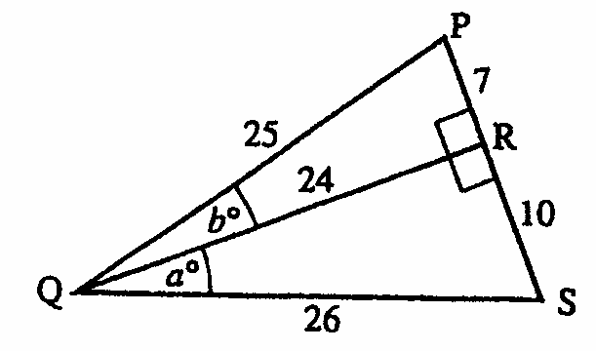

(4)

5. (a) Given that (-1,0) is a point of intersection of the curve$y=3x^{3}+3x^{2}+x+1$
on the x-axis. Find the other points of intersection on this axis.
(b) State the point of intersection on the y-axis.
(c) Find the coordinates of the stationary point(s) and justify the(ir) nature.
(d) Sketch the graph of the function. (9)

TOTAL 21
Further Trigonometry
Homework 13

1. Solve the following equations:

a) $\text{sin}2x−\text{sin}x=0$ $(0≤x≤2p)$
b) $4\text{cos}2x^{o}−6\text{cos}x^{o}−1=0$ $(0≤x≤\text{360})$. (10)

2. The diagram shows two curves $y=\text{cos}2x^{o}$ and$y=1+\text{sin}x^{o}$where0$x≤\text{360}\text{.}$
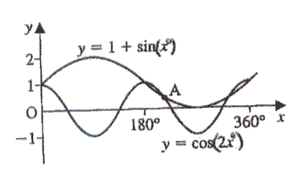
Find the x-coordinate of the point of intersection at A.

(5)

3. A rectangular sheet of cardboard is to be folded to form a closed cuboid with a
length of $2x$cm, breadth $x$cm and a volume of 72cm²
- Show that the height is $\frac{\text{36}}{x^{2}}$.
- Show that the total surface area $A$ is given by the formula $A(x)=4x^{2}+\frac{\text{216}}{x}$cm²
- Find the dimensions of the cuboid so that the total surface area is minimum.
(7)

TOTAL 22
The Circle
Homework 14

1. Find the equations of the following circles with:
(a) centre (0,0) and radius 3
(b) centre (-2,3) and radius 5 (2)

2. State the centre and radius of each of the following circles
(a) $x^{2}+y^{2}+4x+8y+\text{16}=0$
(b) $x^{2}+y^{2}−6y+2=0$
(c) $2x^{2}+2y^{2}+6x−4y−3=0$ (4)

3. Prove whether point (-2, 1) lies inside or outside the circle
$x^{2}+y^{2}+4x+5y−8=0$ (2)

4. The end points of the diameter of a circle are A(-6, 4) and B(2, -2). Find the
equation of the circle. (3)

5. Find the value of k if point (-2, k) lies on the circle
$x^{2}+y^{2}+2x−5y−6=0$ (3)

6. $Δ\text{ABC}$ has vertices A(-1, -6), B(3, 4) and C(-3, 7). Find the:
(a) Equation of the altitude from A
(b) Equation of the median from C
(c) Coordinates of the point of intersection between the altitude and
median above. (11)

TOTAL 25
The Circle
Homework 15

1. Prove that T(5, 1) lies on the circle $(x−1)^{2}+(y+2)^{2}=\text{25}$, and find the equation
of the tangent at T. (5)

2. Show that $y=x+1$is a tangent to the circle $x^{2}+y^{2}+8x−2y+9=0$and find the
point of contact. (4)

3. The diagram shows two identically sized circles that have line AB as a common
tangent with T as the point of contact. The equation of AB is x = -2.
One of the circles has equation $x^{2}+y^{2}−2x+2y−7=0\text{.}$ Find the equation of the
other circle.
T
A
B

(3)

4. Calculate the length of the tangent from A(11,-4) to the circle with
equation $(x−5)^{2}+(y−4)^{2}=\text{51}$. (6)

5. If $f$and g are functions defined on set R by $f(x)=3−2x$ and $g(x)=4x^{2}−3$
(a) Find $g(f(x))$
(b) Find $f(f(x))$ (4)

TOTAL 22

Vectors
Homework 16

1. R divides $\vec{\text{EF}}$ in the ratio 3:2. Find the coordinates of R given that the coordinates
of $E$and $F$are (5, 0, 10) and (0, 10, -5) respectively. (4)

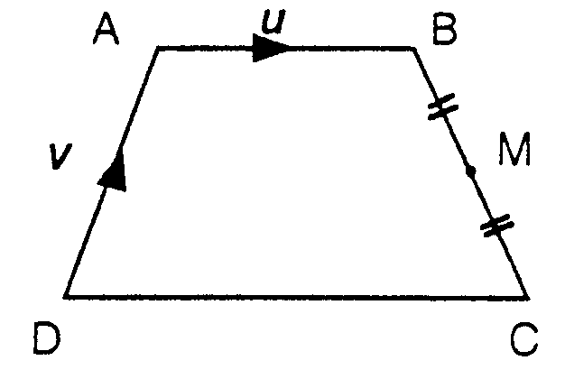
2. In this diagram $\vec{\text{AB}}=u$and $\vec{\text{DA}}=v$.
$\text{DC}=2\text{AB}$, and $\text{DC}$is parallel to$\text{AB}$.
Write down, in terms of u and v, the vectors:
(a) $\vec{\text{DC}}$ (b) $\vec{\text{BC}}$ (c) $\vec{\text{BM}}$ (d) $\vec{\text{DM}}$

(5)

3. A(1,3,-2), B(5,4,1) and C(-2,6,3) are vertices of a parallelogram ABCD.
Find the coordinates of the point D.
(3)

4. A, B, and C are the points (3, -4, 4), (5, 2, 0) and (8, 11, -6) respectively. Show that
A, B and C are collinear and find the ratio in which C divides AB.
(5)

5. Find the value of k if $(x+3)$is a factor of $2x^{3}−5x^{2}+\text{kx}+\text{18}$. (3)

6. Evaluate $\int_{1}^{8}{\sqrt[3]{x^{2}}}\text{dx}$ (4)

TOTAL 24
Vectors
Homework 17

1. The position vectors of the points P and Q are $p=3i+4j$and $q=−3i−4j+5k$
respectively. Calculate the size of angle POQ, where O is the origin.
(9)

2. (a) Show that $(a+b)\text{.}(a−b)={\left|a\right|}^{2}−{\left|b\right|}^{2}$.
(b) Hence evaluate this expression when $a=\begin{aligned}\left(3 | \right)\left(−1 | \right) \\ \end{aligned}$ and $b=\begin{aligned}\left(−5 | \right)\left(3 | \right) \\ \end{aligned}$.
(5)

3. If $a=\begin{aligned}\left(2 | \right)\left(−3 | \right) \\ \end{aligned}$ and $b=\begin{aligned}\left(p | \right)\left(6 | \right) \\ \end{aligned}$
Find the value of $p$given that a and b are perpendicular.
(3)

4. For what real values of $c$will the equation $3x^{2}−5x+c=0$ have real roots. (2)

5. Evaluate $\int_{1}^{2}{\frac{u^{2}+2}{2u^{4}}}\text{du}$ (4)

TOTAL 23
Further Calculus
Homework 18

1. Differentiate (a) $2x−\text{cos}x$
(b) $4p^{2}−3\text{sin}p$ (2)

2. Find
(a) $\int{(5x^{3}}+x+\text{sin}x)\text{dx}$
(b) $\int{(2\text{cos}y−\frac{4}{5y^{2}}})\text{dy}$ (3)

3. Let $f(x)=(2x−3)^{4}$. Find $f'(x)$. (2)

4. Find the area between the curve $y=4\text{sin}x$and the x axis from $x=\frac{π}{4}$ and
$x=\frac{2π}{3}$. (4)

5. Find the equation of the tangent to the curve $y=\frac{5}{(1−x)^{2}}$, at the point $x=−2$.
(6)

6. If $\text{tan}(A)=\frac{3}{4}$and $\text{tan}(B)=\frac{1}{7}$, where A and B are acute angles, show
without a calculator that $A+B=\frac{π}{4}$. (4)

7. Prove that $\frac{1−\text{cos}2A}{1+\text{cos}2A}={\text{tan}}^{2}A$ (2)

TOTAL 23
Further Calculus
Homework 19

1. Find $f'(x)$given that $f(x)=\text{sin}(2x+3)$ (1)

2. Differentiate the following
(a) $f(x)={\text{cos}}^{2}x$ (b) $f(x)=\frac{1}{\text{sin}x}$ (6)

3. Find the derivative with respect to x of :-

$f(x)=\frac{1}{\sqrt{(3x−1)}}+\text{cos}(3x−1)$ (4)

4. Find $\int{\sqrt{(1+3x)}}\text{dx}$ and hence find the exact value of $\int_{0}^{1}{\sqrt{(1+3x)}}\text{dx}$ (4)

5. Integrate $\int{6\text{sin}(2x−1)\text{dx}}$ (2)

6. (a) Show that $3x^{3}−2x+5$ has a root between -2 and -1.
(b) Find this root correct to 1 decimal place. (4)

7. Find the equation of the tangent to the circle $x^{2}+y^{2}=\text{25}$ at the point (-4, 3).
(4)

TOTAL 25
Logarithms and Exponentials
Homework 20

1. Make sketches to show $y={\text{log}}_{3}x$ and $y={\text{log}}_{3}(x−2)$ (2)

2. Find a) ${\text{log}}_{3}\text{27}$ b)${\text{log}}_{9}1$ c)${\text{log}}_{5}\frac{1}{\text{25}}$ (3)

3. Simplify ${\text{log}}_{4}\text{32}−{\text{log}}_{4}2$ (3)

4. Solve for x:- $\text{log}(2x−3)−\text{log}x=0$ (4)

5. Find x, if $7^{x}=\text{65}$ (3)

6. The diagram shows a sketch of part of the graph of $y={\text{log}}_{5}x\text{.}$
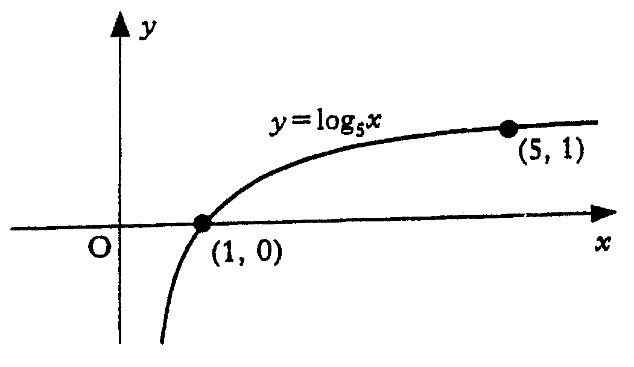

a) Make a copy of the graph of $y={\text{log}}_{5}x\text{.}$
On your copy, sketch the graph of $y=1+{\text{log}}_{5}x$ (2)
b) Find the coordinates of the point where it crosses the x-axis. (2)

7. Solve ${\text{tan}}^{2}2x^{o}=1$, given $0≤x≤\text{180}$ (4)

TOTAL 23

Logarithms and Exponentials
Homework 21

1. A medical technician obtains this print-out of a wave generated by an oscilloscope.
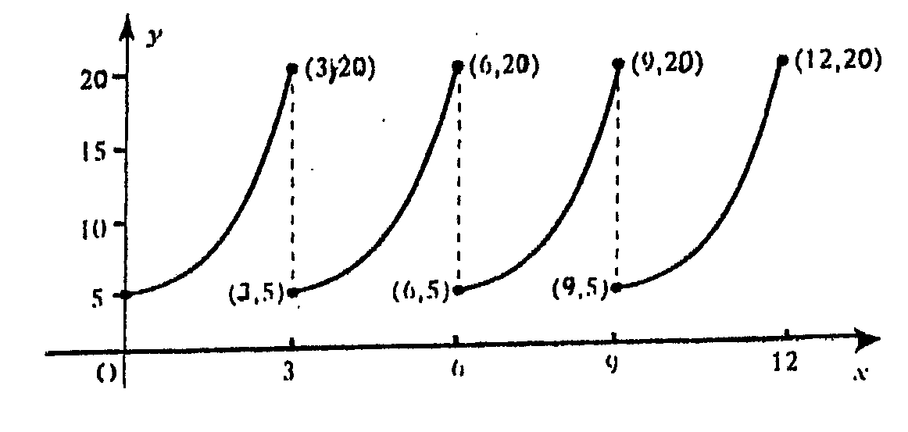

The technician knows that the equation of the first branch of the graph for $0≤x≤3$ should be of the form $y={\text{ae}}^{\text{kx}}\text{.}$
(a) Find the values of $a$ and $k$. (4)
(b) Find the equation of the second branch of the curve (i.e. for $3≤x≤6)\text{.}$ (1)

2. A lake is polluted by a cleaning agent from a dye-works. Every day, the pollutant
is broken down by natural processes, (rain, the fish in the lake etc.)
The formula for the percentage of the pollutant is :-

P(d)=100$e^{−0\text{.}\text{02}d}$

where P(d)=the percentage of pollutant after d days.

(a) What percentage of the pollutant will remain in the lake after 10 days? (2)
(b) How long will it take for half the pollutant to be removed from the lake? (4)

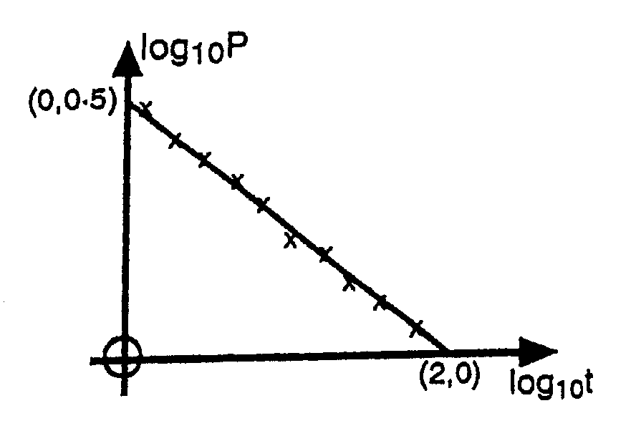
3. A scientific experiment is carried out to
find a connection between two variables P and t.
Results are recorded, and when the graph of
${\text{log}}_{\text{10}}P$ against ${\text{log}}_{\text{10}}t$is plotted, the best
fitting line is drawn in as shown in the diagram.

It is thought that the relationship between $P$and $t$ is of the form$P={\text{kt}}^{n}$
(a) Show that ${\text{log}}_{\text{10}}P=n{\text{log}}_{\text{10}}t+{\text{log}}_{\text{10}}k$
(b) Find k and n. (5)

4. Find the points of intersection of the line $3y+x=−1$ and the circle
$x^{2}+y^{2}+\text{10}x+4y+\text{19}=0$. (5)

TOTAL 21
The Wave Function
Homework 22

1. Express $3\text{sin}x−3\text{cos}x$ in the form $k\text{cos}(x−α)$where $k>0$ and $0≤α≤\text{360}$.
(4)

2. Express $\sqrt{3}\text{cos}x−\text{sin}x$ in the form $k\text{sin}(x+α)$where $k>0$ and $0≤α≤\text{360}\text{.}$
(4)

3. Express $5\text{cos}8x+\text{sin}8x$ in the form $r\text{sin}(8x+α)$ where $r>0$ and $0≤α≤2p$. (4)

4. (a)Write down the maximum value of $f(x)=3\text{cos}x+4\text{sin}x$. (5)

(b) Find the value of $x$ for which this maximum occurs, for$0≤x≤\text{360}$. (1)

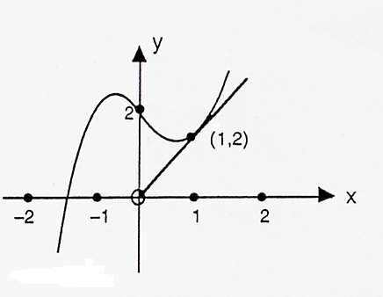
5. The straight line OA is a tangent to the curve $y=x^{3}−x+2$ at point A(1,2)

A

O

(a) Find the equation of the line OA.
(b) Calculate the finite area bounded by the curve, y axis and the line OA. (6)

TOTAL 24
The Wave Function
Homework 23

1. Solve this equation algebraically for $0≤q≤2p\text{.}$ (4)
$$\sqrt{3}\text{sin}θ−\text{cos}θ=1$$

2. (a) Find the minimum value of $7+3\text{sin}x+4\text{cos}x$. (5)

(b) Hence or otherwise find the maximum value of $f(x)=\frac{6}{7+3\text{sin}x+4\text{cos}x}$
and the value of x at which this occurs. (2)

3. The expression $\text{20}\text{sin}\text{10}T+\text{40}\text{cos}\text{10}T$ represents the displacement of a wave after $T$ seconds and can be written in the form $\text{20}\sqrt{5}\text{sin}(\text{10}T+\text{63}\text{.}4^{o})$.

a) Write down the amplitude and period of the wave. (2)
b) Use your values of $R$ and $α$ to sketch the graph of $R\text{sin}(\text{10}T+α)$against $T$ for $0≤T≤\text{36}$, showing clearly the points where the graph cuts the x-axis and any stationary points. (6)

4. For what values of $x$ is function $f(x)=2x^{3}−\text{24}x−9$ decreasing? (4)

TOTAL 23

