Further Trigonometry
Homework 12

1. Sketch the graph of the function $f(x)=2\text{sin}(x−\text{30})$. (2)

2. If $\text{tan}x^{o}=\frac{1}{3}$, find the exact value of $\text{sin}x^{o}$ . (2)

3. (a)Write $\text{cos}\frac{π}{6}\text{cos}x−\text{sin}\frac{π}{6}\text{sin}x$ in the form $\text{cos}(A+B)$ (1)
(b) Hence solve the equation $\text{cos}\frac{π}{6}\text{cos}x−\text{sin}\frac{π}{6}\text{sin}x=\frac{\sqrt{3}}{2}$,
for $0≤x≤2π$ (3)

4. The diagram shows the cross-section of an adjustable ramp which is made from
two right-angled triangles, PQR and RQS. Angle RQS = aº and PQR = bº .

Find the exact value of sin(a+b)º.

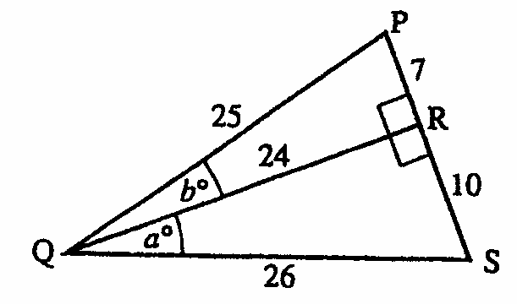

(4)

5. (a) Given that (-1,0) is a point of intersection of the curve$y=3x^{3}+3x^{2}+x+1$
on the x-axis. Find the other points of intersection on this axis.
(b) State the point of intersection on the y-axis.
(c) Find the coordinates of the stationary point(s) and justify the(ir) nature.
(d) Sketch the graph of the function. (9)

TOTAL 21

