Logarithms and Exponentials
Homework 21

1. A medical technician obtains this print-out of a wave generated by an oscilloscope.
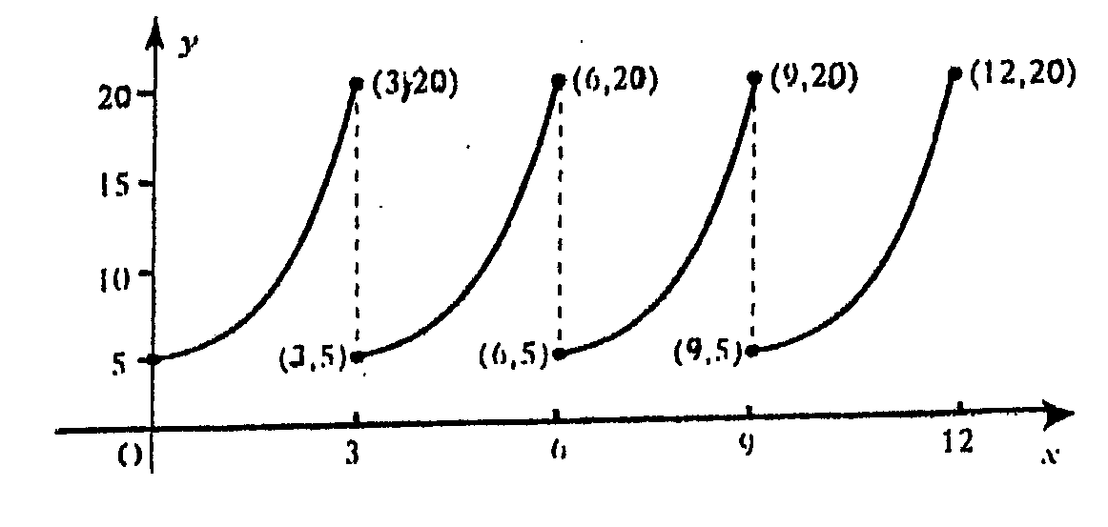

The technician knows that the equation of the first branch of the graph for $0≤x≤3$ should be of the form $y={\text{ae}}^{\text{kx}}\text{.}$
(a) Find the values of $a$ and $k$. (4)
(b) Find the equation of the second branch of the curve (i.e. for $3≤x≤6)\text{.}$ (1)

2. A lake is polluted by a cleaning agent from a dye-works. Every day, the pollutant
is broken down by natural processes, (rain, the fish in the lake etc.)
The formula for the percentage of the pollutant is :-

P(d)=100$e^{−0\text{.}\text{02}d}$

where P(d)=the percentage of pollutant after d days.

(a) What percentage of the pollutant will remain in the lake after 10 days? (2)
(b) How long will it take for half the pollutant to be removed from the lake? (4)

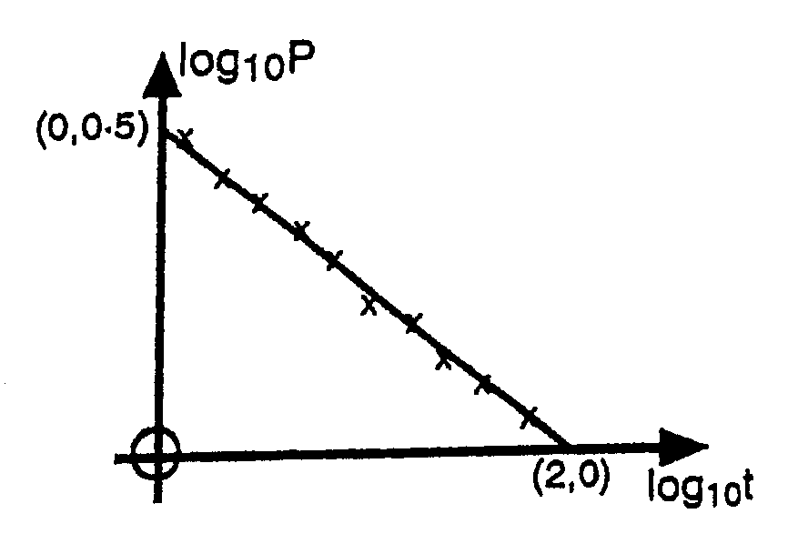
3. A scientific experiment is carried out to
find a connection between two variables P and t.
Results are recorded, and when the graph of
${\text{log}}_{\text{10}}P$ against ${\text{log}}_{\text{10}}t$is plotted, the best
fitting line is drawn in as shown in the diagram.

It is thought that the relationship between $P$and $t$ is of the form$P={\text{kt}}^{n}$
(a) Show that ${\text{log}}_{\text{10}}P=n{\text{log}}_{\text{10}}t+{\text{log}}_{\text{10}}k$
(b) Find k and n. (5)

4. Find the points of intersection of the line $3y+x=−1$ and the circle
$x^{2}+y^{2}+\text{10}x+4y+\text{19}=0$. (5)

TOTAL 21

