Higher Homework: The Circle

1) Find the equation of the circle with centre ( -1, 5 ) and Passing through

the point ( 5, 13 )

2) State the centre and radius of the circle



3)

4)

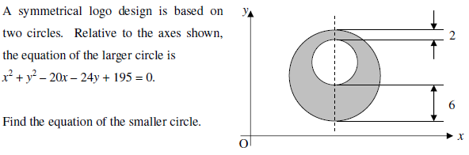

5)

6) Triangle ABC has vertices A(-1, -6), B(3, 4) and C(-3, 7).

Find the:

(a) Equation of the altitude from A

(b) Equation of the median from C

(c) Coordinates of the point of intersection between the altitude and median above.