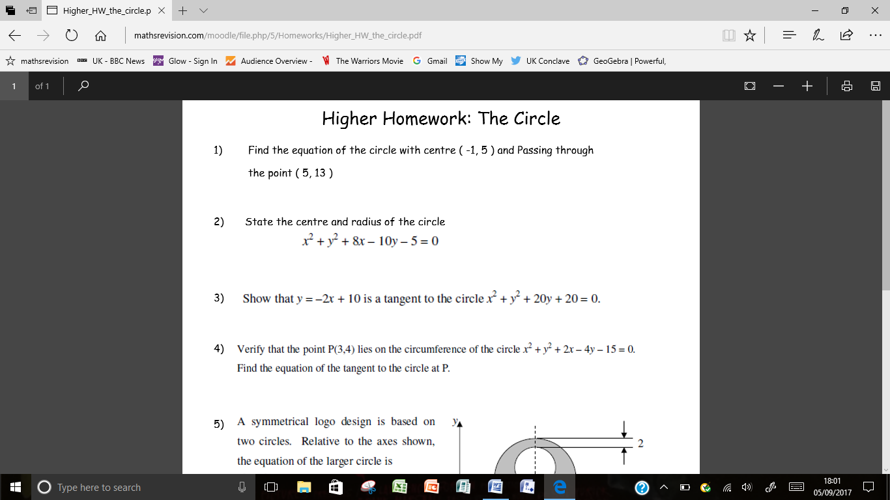

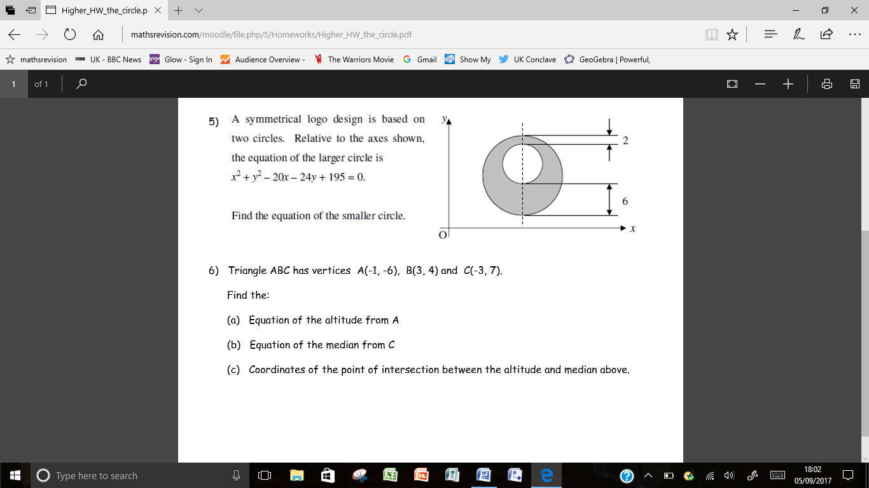

|  |  |  |
| --- | --- | --- |
| Q1 | $${(x+1)}^{2}+{(y-5)}^{2}=100$$ | $r^{2}=100$ ${(x+1)}^{2}+{(y-5)}^{2}=100$ |
| Q2 | Centre (-4,5) and radius $\sqrt{46}$ | * Centre (-4,5) $r=\sqrt{46}$ |
| Q3 | Proof | $x^{2}+{(10-2x)}^{2}+20\left(10-2x\right)+20=0$ ${5x}^{2}-80x+320=0 or x^{2}-16x+64=0$ $\left(x-8\right)\left(x-8\right)=0 or b^{2}-4ac$* Repeated root / $b^{2}-4ac-0$  hence tangency |
| Q4 | $$2x+y-10=0$$ | $LHS=3^{2}+4^{2}+2\left(3\right)-4\left(4\right)-15$ = 0  = RHS Hence lies on the circle $m_{CP}=\frac{1}{2}$ $m_{⊥}=-2$ $2x+y-10=0$ |
| Q5 | $${(x-10)}^{2}+{(y-14)}^{2}=9$$ | * Centre big circle (10,12) $r_{B}=7$ $r_{s}=3$* Centre small circle (10,14) |

|  |  |  |
| --- | --- | --- |
| Q6 | a) $y=2x-4$ | $m_{BC}=-\frac{1}{2}$ $m_{⊥}=2$ $y=2x-4$ |
|  | b) $y=-2x+1$ | ${Midpoint}_{AB}=(1,-1)$ $m_{AB}=-2$ $y=-2x+1$ |
|  | c) $y=\left(\frac{5}{4},-\frac{3}{2}\right)$ | $Evidence of Sim.Equations$ $x=\frac{5}{4}$ $y=-\frac{3}{2}$ |

Total 26