Higher Maths – Homework 2 - September

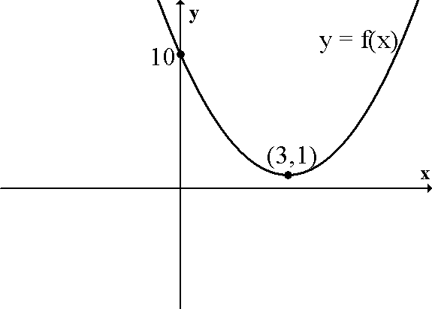
1. The diagram opposite show the graph of y = f(x).

Which of the following shows the graph of y = f(-x).
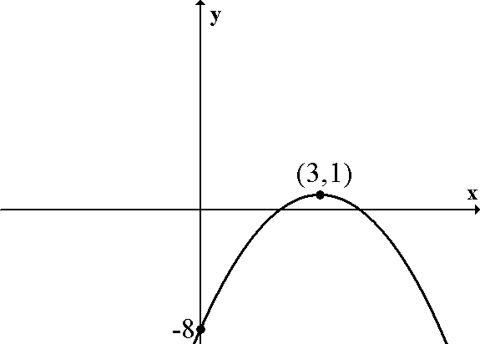
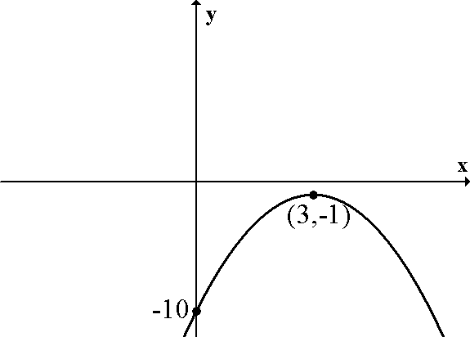
A B

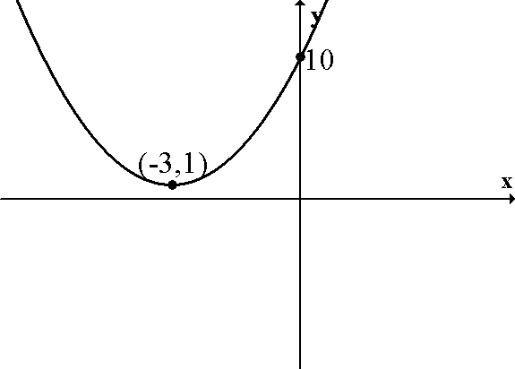
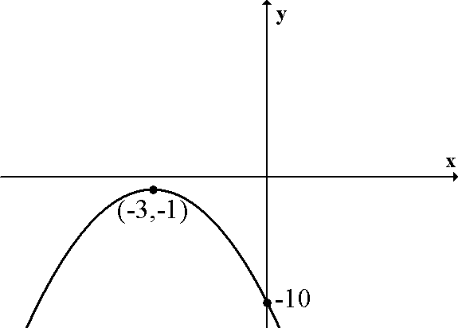
C D

2. A function f is defined as f(x) = $\frac{x}{x^{2}\text{ - 3x - 4}}$

An acceptable domain for this function would be

A {x: x ≠ 4, $x∈\text{ R}$} B {x: x ≠ -1,3, $x∈\text{ R}$} C {x: x ≠ -3,1, $x∈\text{ R}$} D {x: x ≠ -1,4, $x∈\text{ R}$}

3. The points A(5,-2), B(2,2) and C(14,k) are collinear. The value of k is

A -14 B 14 C 18 D -18

4. Find the equation of the line passing through the point (-2,3) which is
perpendicular to the line with equation 4x + 2y – 5 = 0.

$\sqrt{3}y\text{ - x }+\sqrt{3}=\text{ 0 }$$\sqrt{3}y\text{ - x }+\sqrt{3}=\text{ 0 }$
5. The diagram shows the line
$a^{0}$
(a) Find the coordinates of the point where
this line crosses the y-axis.

(b) Calculate the size of angle a⁰.

6. The diagram shows the graph of y = f(x),
where –2 ≤ x ≤ 3.

Sketch the graph of y = 3 – f(x)

- f(x) = 3 – x and .

  - Find p(x) where p(x) = f(g(x)).
  - If, find p(q(x)) in its simplest form.
  - State the connection between p(x) and q(x).

- A triangle has vertices A(1,1), B(3,5) and C(11,1).

  - Show that triangle ABC is right angled at B.
  - The medians AD and BE intersect at M. Find the equations of
AD and BE.
  - Find the coordinates of M.

- An endangered species of snake living on a small island off the coast of Africa is
decreasing in numbers at a rate of 15% each year. Scientists are breeding snakes
in an effort to rescue the species.
It is planned to release 180 snakes into the wild each year and scientists estimate
that the safety of the species will be guaranteed if the population eventually settles
at somewhere between 1000 and 1500.

- Set up a recurrence relation to describe this situation.
- Will the safety of the population be guaranteed?

