St Ninian’s High School



Nelson Textbook
INTERMEDIATE 1
CHECKLIST
S5/6


- I understand this part of the course =
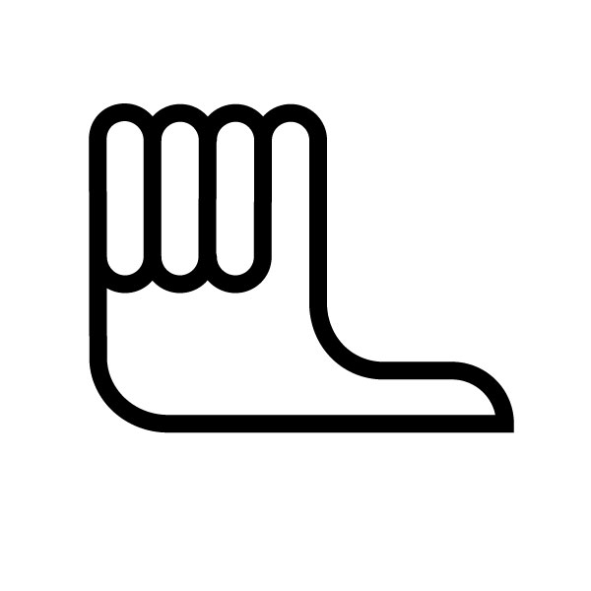
- I am unsure of this part of the course =

- I do not understand this part of the course =

Unit 1 Chapter 2 | Basic Calculations
1 | Round to the nearest 10, 100, 1000
2 | Round to 1 and 2 decimal places
3 | Be able to identify when we should add, subtract, multiply or divide and recognise the language involved in these questions
4 | Write a percentage as a common fraction  Eg. 6% = $\frac{6}{\text{100}}=\frac{3}{\text{50}}$
5 | Calculate a percentage of a quantity without a calculator  Eg. 17.5% of 300  10% is 30  5% is 15  2.5% is 7.5  17.5% is 52.5
6 | Calculate a percentage with a calculator  Eg. 19% of 450  = 19 ÷ 100 × 450  = 85.5
7 | Understand how to calculate VAT
8 | Express one quantity as a percentage of another including percentage loss and profit eg. 3 out of 20  = $\frac{3}{\text{20}}×\text{100}\text{\%}$=15%  eg2. John buys a CD for £3 and sells it for £5. Calculate percentage profit.  = $\frac{5−3}{3}×\text{100}\text{\%}$= 66.7%
9 | Calculate simple interest
10 | Calculate interest for part of a year  Eg. if for 7 months then multiply annual interest by $\frac{7}{\text{12}}$
11 | Calculations involving direct proportion

Unit 1  Chapter 3 | Basic Geometry
1 | Measure area in mm², cm², m², km²
2 | Area of rectangle = length × breadth  = lb
3 | Area of triangle = $\frac{1}{2}×\text{base}×\text{height}$  = $\frac{1}{2}\text{bh}$
4 | Area of composite shapes by adding two or more areas
5 | Area of composite shapes by subtracting areas
6 | Measure volume in mm³, cm³, m³, km³
7 | Calculate volume  Volume of cuboid = $\text{length}×\text{breadth}×\text{height}$  = lbh
8 | Label parts of a circle including radius, diameter and circumference
9 | Know that D = 2r
10 | Calculate the area of a circle using the formula A = ${πr}^{2}$
11 | Calculate the circumference of a circle using the formula C = $πD$
12 | Calculate areas of composite shapes including semi and quarter circles.

Unit 1  Chapter 4 | Formulae
1 | Evaluate formulae written in words
2 | Evaluate two step formulae  Eg. multiply/divide them add/subtract
3 | Substitution  Eg. Calculate 3a – b² + 1 when a = 4, b = 2  = $3×4−2×2+1$  = 12 – 4 +1 = 9
4 | Priority of operations  Brackets  Off  Multiply  Divide  Add  Subtract
5 | Evaluate formula in symbols  Eg. Calculate s where s = ut + v and u = 2, t = 3, v = 5

Unit 1  Chapter 5 | Calculations in Context
1 | Earning money – Piecework Calculations  People are paid a set amount each time they make or do something
2 | Earning money – Commission Calculations  People are paid a percentage of the value of the goods they sell
3 | Calculations involving bonuses
4 | Be able to perform calculations involving double time and time and a half
5 | Calculations involving pay rises
6 | Foreign Exchange calculations  Converting from £ to other currency and from other currency back to £
7 | Understand what is meant by insurance premium
8 | Calculations involving Buildings Insurance
9 | Calcuations involving Household contents insurance
10 | Calculations involving Holiday and Travel Insurance
11 | Calculations involving Motor Insurance
12 | Understand the meaning of Hire Purchase and be able to perform calculations  Eg. TV for £30 deposit plus 12 equal monthly instalments of £25  = 12× 25 + 30 = £330

Unit 2  Chapter 8 | Graphs, Charts and Tables
1 | Create and interpret bar graphs and line graphs
2 | Create and interpret stem and leaf diagrams and understand the levels-Remember a key.  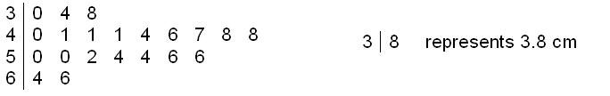
3 | Interpret back to back stem and leaf diagrams
4 | Reading piecharts  Measure angle at centre and perform calculation
5 | Interpret composite bar graphs and line graphs
6 | Construct frequency tables
7 | Draw a bar graph from a frequency table
8 | Draw a scatter graph
9 | Draw a line of best fit

Unit 2  Chapter 9 | Time, Distance and Speed
1 | Calculate time intervals accurately in hours and minutes and in minutes and seconds
2 | Analyse Distance-Time Graphs
3 | Steeper line means faster speed
4 | Meeting point is where the two lines intersect (cross)
5 | Slope down from left to right – changed direction
6 | Calculating speed using the formula  $$\text{speed}=\frac{\text{dis}\text{tan}\text{ce}}{\text{time}}$$
7 | Write minutes as a fraction of an hour.  Write seconds as a fraction of a minute
8 | Calculate distance using the formula  $$\text{dis}\text{tan}\text{ce}=\text{speed}×\text{time}$$
9 | Calculate the time using the formula  $$\text{Time}=\frac{\text{Dis}\text{tan}\text{ce}}{\text{Speed}}$$

Unit 2  Chapter 10 | The Theorem of Pythagoras
1 | Be able to use the x² and √ buttons on calculator  Know that Pythagoras can only be used in right angled triangles
2 | Label the Hypotenuse correctly
3 | Calculate the hypotenuse given the other two sides (square, add, square root)
4 | Calculate a shorter side of a right angled triangle given the other two sides (square, subtract, square root)
5 | Finding any side
6 | Problems involving Pythagoras

Unit 2  Chapter 11 | Integers
1 | Understand the scale on a thermometer
2 | Draw a Cartesian Coordinate diagram accurately, labelling the x, y axes and the origin
3 | Plotting negative coordinates
4 | Number lines in context eg.profit and loss
5 | Adding integers using the number line  -3 + 5 = 2  -4 + (-5) = -4 – 5 = -9
6 | Subtracting integers using the number line  4 – 6 = -2  -2 – (-3) = -2 + 3 = 1
7 | Multiplying and Dividing integers  -ve×-ve = +ve  +ve×+ve=+ve  -ve×+ve = -ve  +ve×-ve = -ve

Unit 2  Chapter 12 | Statistics
1 | Calculate the mean of a data sample.  Mean = total ÷ number of items  Eg. The mean of 4, 7, 9, 12  = (4+7+9+12)÷4  = 32 ÷ 4  = 8
2 | Calculate the range of a data sample.  Range = greatest – least  Eg. Range of 6, 8, 9, 15  = 15-6  =9
3 | State the mode of a data sample  The mode is the most frequent value  Eg. The mode of 5, 7, 8, 8, 9, 9, 9  Is 9
4 | Find the median of a data sample.  The median is the middle of an ordered list.  Eg1. The median of 3, 4, 7, 12, 15 is 7  Eg2. The median of 3, 4, 7, 8, 12, 15 is  $\frac{7+8}{2}=7\text{.}5$
5 | Calculate the mean from a frequency table  Eg  Mean = 97 ÷ 12 = 8.1cm
  Height (cm) | Frequency | Height × Frequency
  7 | 3 | 7×3=21
  8 | 5 | 8×5=40
  9 | 4 | 9×4=36
  TOTAL | 12 | 97
6 | Describe probability in words using  ‘Impossible, Unlikely, Even, Very Likely, Certain’
7 | O stands for Improssible  0.5 stands for even chance  1 stands for certain
8 | State probability using the formula  Probablility(event)=$\frac{\text{Number of favourable outcomes}}{\text{Number of possible outcomes}}$

Unit 3 | Basic Algebra
1 | Evaluate expressions  Eg. Evaluate 3a² + 1 when a = 2  =3(2)²+1  =3(4)+1  =12+1  =13  Or  $$\begin{aligned}3×2×2+1 \\ =\text{12}+1 \\ =\text{13}\end{aligned}$$
2 | Evaluate formulae correctly  Eg. Find volume of a cylinder with radius of 3cm and height 10cm, using the formula $V={πr}^{2}h$  =$\begin{aligned}=π×3×3×\text{10} \\ =\text{282}\text{.}6{\text{cm}}^{3}\end{aligned}$
3 | Simplify expressions/collect/gather like terms  Eg1. Simplify $2x×3x=6x^{2}$  Eg2. Simplify 3x + 2y – x + 3y  = 2x + 5y
4 | Removing brackets  Eg. 3(2x + 5) = 6x + 15
5 | Remove brackets and simplify  Eg. x(x+3) + 2x = x²+3x+2x=x²+5x  Eg2. 2(x-1)+3(x-4)=2x-2+3x-12=5x-14
6 | Factorising using common factor  Eg. Factorise 10m+25=5(2m+5)
7 | Solving Equations  Eg. Solve 3n + 2 = 17  3n = 15 -2  n = 5 ÷ 3
8 | Solving equations by first removing brackets  Eg. Solve 9(n + 5) = 63  9n + 45 =63 -45  9n = 18 ÷ 9  n = 2
9 | Know the meaning of the inequality signs  > greater than < less than  ≥ greater than or equal to  ≤ less than or equal to
10 | Solve simple inequalities  $x≥3x−8$  $0≥2x−8$ -x  $8≥2x$ +8  $4≥x$ ÷2  $$x≤4$$

Unit 3  Chapter 15 | Graphical Relationships
1 | Plotting points and naming lines in the form y= a and x = b
2 | Graphed Relations  Eg. Draw y = 2x  Plot coordinates (0, 0), (1, 2), (2, 4) and join and extend line
  x | 0 | 1 | 2
  y | 0 | 2 | 4
3 | Lines not passing through the origin  Eg. Draw y = 2x + 3  Plot coordinates (-2, -1), (-1, 1), (0, 3), (1, 5) and (2, 7) and join and extend lines
  x | -2 | -1 | 0 | 1 | 2
  y | -1 | 1 | 3 | 5 | 7
4 | *********Find equation of a line********

Unit 3  Chapter 16 | Basic Trigonometry
1 | Label the sides of a right angled triangle correctly: Hypotenuse, Opposite and Adjacent
2 | Using tangent to find the size of an angle in a right angled triangle.  $${\text{Tanx}}^{o}=\frac{\text{Opposite}}{\text{Adjacent}}$$
3 | The sine of an angle  $${\text{Sinx}}^{o}=\frac{\text{Opposite}}{\text{Hypotenuse}}$$
4 | The cosine of an angle  $${\text{Cosx}}^{o}=\frac{\text{Adjacent}}{\text{Hypotenuse}}$$
5 | Picking the ratio  Be able to select the correct ratio to find angle
6 | Finding the lenth of a side: using tan  $$\begin{aligned}\text{opposite}=\text{tan}x^{o}×\text{adjacent} \\ \text{Adjacent}=\frac{\text{opposite}}{\text{tan}x^{o}}\end{aligned}$$
7 | Finding the length of a side: using sine  $$\begin{aligned}\text{Opposite}=\text{sin}x^{o}×\text{Hypotenuse} \\ \text{Hypotenuse}=\frac{\text{Opposite}}{{\text{Sinx}}^{o}}\end{aligned}$$
8 | Finding the length of a side: using cosine  $$\begin{aligned}\text{Adjacent}=\text{cos}x^{o}×\text{hypotenuse} \\ \text{Hypotenuse}=\frac{\text{Adjacent}}{{\text{Cosx}}^{o}}\end{aligned}$$
9 | Finding the length of a side: mixed examples  Be able to select the correct ratio to find the side

Unit 3  Chapter 17 | Standard Form
1 | Be able to convert between normal form to standard form  Eg1. 3700000=3.7 × 10⁶  Eg2. 0.00005 = 5 × 10⁻⁵
2 | Be able to convert between standard form and normal form  Eg1. 6 × 10⁴ = 60 000  Eg2. 3 × 10⁻² = 0.03
3 | Be able to enter scientific notation on calculator
4 | Use scientific notation in context

