St Luke’s High School

TEEJAY Books 1 + 2
INTERMEDIATE 2 CHECKLIST
S3 and S4


- I understand this part of the course =
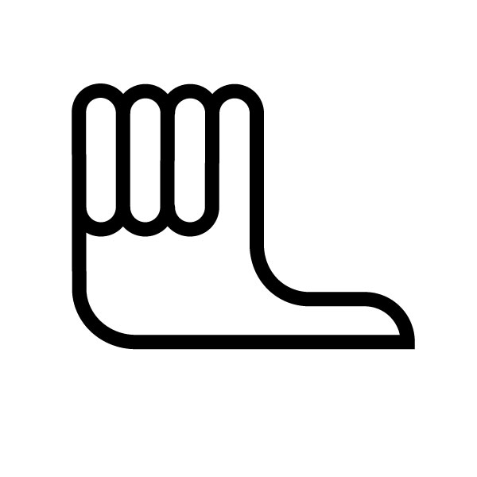
- I am unsure of this part of the course =

- I do not understand this part of the course =

Book 1 Chapter 1 | Perform Calculations involving Percentages
1 | Basic percentage of a quantity  (find 84% of 22 = 84 ÷ 100 × 22)
2 | Simple interest (Interest that is calculated on a sum that does not include previous interest gains/charges)
3 | Compound interest (interest on £2000 over 3 years at 5% p.a. = (1.05)³ × 2000 – 2000)
4 | Appreciation (value increases)  Buy house for £80000, appreciates by 7.5% p.a.  After 2 years, value of house= (1.075)²×80000
5 | Depreciation (value decreases)  Value of car worth £6000 depreciates by 32% annually  Value of car after 4 years = 0.68⁴ × 6000
6 | Mixed examples including appreciation and depreciation
7 | Significant figures (use to express accuracy of measurement)  Eg 4269 = 4000 to 1 sig. fig  3450 = 3500 to 2sig. figs

Book 1  Chapter 6 | Linear Relationships
1 | Plotting Coordinates (x, y)
2 | Gradient ( Is the measure of how steep a slope is)  gradient = $\frac{{\text{Vertical}}_{\text{Dis}}\text{tan}\text{ce}}{{\text{Horizontal}}_{\text{Dis}}\text{tan}\text{ce}}$
3 | Positive and negative gradients
4 | Gradients on a coordinate grid ( m = $\frac{y_{2}−y_{1}}{x_{2}−x_{1}}$)
5 | The Equation of a Line ( y = mx + c, m = Gradient, c = y intercept)

Book 1  Chapter 8 | Volumes of Solids
1 | Volume_{prism}=Area_{base} × height  V = Ah
2 | Volume of triangular prism  Area of end face = ½ bh  Volume = Area of end face × height
3 | Volume of cylinder = ${πr}^{2}h$
4 | Volume of pyramids and the cone  Volume of cone = $13{πr}^{2}h$
5 | Volume of a sphere = $43{πr}^{3}$
6 | Volume of composite solids (more than one solid)
7 | Working out the radius or height given the volume.

Book 1  Chapter 9 | Algebraic Operations
1 | Simplify/Gather like terms  - 7m + 2 – m + 3 = 6m + 5  - 3y × 2 × 4y = 24y²
2 | Multiply/Simplify simple brackets  - 2(3a + 5)=6a + 10  - 3(b – 4) + 2 = 3b-12+2 = 3b – 10  - 5x + 2x(x – 3) = 5x + 2x² – 6x = 2x² – x  - 3(m+2) – 4(m-4) = 3m+6-4m+16= 22 – m
3 | Multiply and simplify using the box method  (2x + 3)(x – 5)  = 2x² – 10x + 3x -15  =2x² – 7x - 15
   | x | -5
  2x | 2x² | -10x
  3 | 3x | -15
4 | Square brackets using the box method  ^{(x – 5)}2  = x² – 5x – 5x + 25  = x² – 10x + 25
   | x | -5
  x | x² | -5x
  -5 | -5x | +25
5 | Multiplying bracket with 3 terms using box method  (x +2)(x² – 3x + 5)  =x³ + 2x² – 3x² – 6x + 5x + 10  =x³ – x² – x + 10
   | x² | -3x | +5
  x | x³ | -3x² | 5x
  2 | 2x² | -6x | 10
6 | Priority of factorisation:  - Common Factor  - Difference of two squares  - Trinomial (Type 1 or Type 2)
7 | Common Factor  Factorise 4x² – 2x  = 2x (2x – 1)
8 | Difference of two squares  Factorise 16a² – 25  =(4a + 5)(4a – 5)
9 | Trinomial Factorisation (Type 1, coefficient of x² is 1)  Factorise  x² + 8x + 15  =(x + 5)(x + 3)
   | x | +3
  x | x² | +3x
  +5 | +5x | +15
10 | Trinomial Factorisation (Type 2, coefficient of x² >1)  2x² – 7x – 15  =(2x +3)(x - 5)
   | x | -5
  2x | 2x² | -10x
  +3 | +3x | -15
11 | Fully factorise (first remove common factor)  2t² – 18  =2(t² – 9)  =2(t+3)(t – 3)

Book 1  Chapter 10 | The Circle 2
1 | Be able to identify the parts of a circle including:  Centre, radius, diameter, circumference, area, chord, arc and sector, tangent  Know that D = 2r, r = D/2
2 | Be able to calculate the Circumference of a circle using the formulae:  C = πD, C = 2πr
3 | Be able to calculate the area of a circle using the formula  A = πr²
4 | Find the length of a major or minor arc using the formula  Arc length = $\frac{x}{\text{360}}×πD$
5 | Find the area of a sector of a circle using the formula  Area of sector = $\frac{x}{\text{360}}×{πr}^{2}$
6 | Find the angle at the centre, given the arc length, using the formula  Angle (xº) = $\frac{\text{Arc length}}{\text{Circumference}}×{\text{360}}^{o}$
7 | Find the angle at the centre, given the area of the sector, using the formula  Angle (xº) = $\frac{\text{Area of sector}}{\text{Area of circle}}×{\text{360}}^{o}$
8 | Symmetry in a circle (isosceles triangle)
9 | Symmetry and chords in a circle (radius that bisects a chord makes an angle of 90º)
10 | Angle in a semicircle (right angled triangle in a semi-circl eif one side is a diameter)
11 | Tangent meets the radius at right angles

Book 1  Chapter 13 | Use Graphs, Charts and Tables
1 | Interpret composite bar and line graphs
2 | Relative frequency (max value of 1)
3 | Construct and Interpret Piecharts
4 | Scattergraphs and correlation  Finding the equation of the line of best fit I the form  y = mx + c. Choose two points and find gradient using m = $\frac{y_{2}−y_{1}}{x_{2}−x_{1}}$, state y-intercept c, then state equation
5 | Use the equation of the line of best fit to estimate further values of y
6 | Construct and Interpret Stem and leaf diagrams, rememeber a key  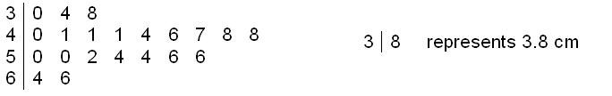
7 | Construct and Interpret dotplots  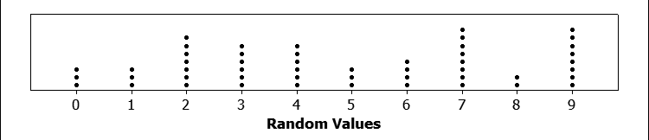

Book 1  Chapter 15 | Solve Simultaneous Linear Equations
1 | Sketch a line in the form y = mx + c  Draw a table of values  Eg. y = 2x + 1  Plot (0,1), (1,3) and (2, 5). Join points and extend line in both directions
  x | 0 | 1 | 2
  y | 1 | 3 | 5
2 | Solve simultaneous equations graphically by drawing both lines on the same set of axis then stating point of intersection.
3 | Solve simultaneous equations algebraically using substitution or elimination
4 | Formulate simultaneous equations and solve algebraically

Book 1  Chapter 17 | Using Simple Statistics
1 | Finding the mean, mode,median and range of a data sample
2 | Finding the quartiles of a data sample
3 | Finding the quartiles from a frequency table
4 | Find the mean from a frequency table
5 | Find the quartiles from a cumulative frequency curve (polygon-S-shaped curve)
6 | Draw and Interpret Cumulative frequency tables  State the median form a cumulative frequency table
7 | Stating a five-figure summary of data  L = lowest, Q₁, Q₂=median, Q₃, H=highest
8 | Draw a boxplot from five-figure summary  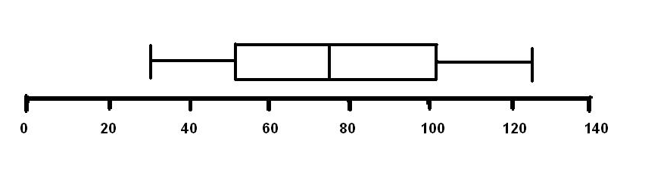
9 | Calculate the semi-interquartile ramge  SIQR = $\frac{Q_{3}−Q_{1}}{2}$
10 | Calculate the standard deviation of a sample using the formula  $$s=\sqrt{\frac{\sum{x^{2}}−(\sum{x{)^{2}}/n}}{n−1}}$$
11 | Comparing two data samples by making valid comments regarding the average and variability (spread) of the data
12 | Understand how changes in the data effect the mean and standard deviation
13 | State/Calculate simple probabilities  P(event) = $\frac{\text{possible}}{\text{favourable}}$
14 | Assign probabilities to events

Book 1  Chapter 18 | Using Trigonometry
1 | Revision ( SOH CAH TOA)  Label sides of a right angled triangle: hypotenuse, opposite and adjacent  Calculate an angle or side of a right angled triangle
2 | The Area of a Triangle ( A = $\frac{1}{2}$ab Sin C)
3 | The Sine Rule – Calculating Lengths and Angles ( $\frac{a}{\text{SinA}}=\frac{b}{\text{SinB}}=\frac{c}{\text{SinC}}$)
4 | The Cosine Rule – Calculating Lengths and Angles ($a^{2}=b^{2}+c^{2}−2\text{bcCosA}$, Cos A = $\frac{b^{2}+c^{2}−a^{2}}{2\text{bc}}$)
5 | Which Formula to use? (3 sides – Cosine rule, 2 sides + angle between – Cosine Rule, 2 Sides + angle not between – Sin Rule, 1 side and 2 angles – Sin Rule)

Book 2  Chapter 2 | Perform Algebraic Operations
1 | Revision of Fractions ( Adding, Subtracting, Multiplying, Dividing Fractions)
2 | Equivalent Fractions ( Find three fractions equivalent to = )
3 | Adding Fractions ( )
4 | Subtracting Fractions ($\frac{7}{8}−\frac{3}{7}=\frac{7×7}{8×7}−\frac{3×8}{7×8}=\frac{\text{49}}{\text{56}}−\frac{\text{24}}{\text{56}}=\frac{\text{25}}{\text{56}}$ )
5 | Multiplying Fractions  ( )
6 | Dividing Fractions  ( )
7 | Review of BODMAS, removing brackets, Squaring numbers, substitution.( eg 2(x + 1) = 2x + 2, -3y = 33)
8 | Using Formulae (Substituting various answers into formulae eg A = , where h = 1.8, w = 70kg)
9 | Change the subject of the Formula ( A = , Change subject to r, r = )

Book 2  Chapter 6 | Quadratic Function 1
1 | Sketching parabolas associated with quadratic functions ( 4 steps – (1) Find where (f(x) = 0 ie y = 0, (2) Find the equation of its axis of symmetry (3) Find Turning point – Max or Min (4) Find where the curve cuts the y axis, x = 0.)
2 | Solve quadratic equations graphically
3 | Revision ( Solving Equations, Factorising, Difference of two squares, Quadratics)
4 | Using Factors to solve Quadratic Equations ( $x^{2}−4x$= 0, x ( x – 4) = 0, therefore the solutions are x = 0 and x = 4 )
5 | More Quadratic equations : Trinomials ($x^{2}+5x+6=0$, (x + 3)(x + 2) = 0, (x + 3) = 0 , (x + 2) = 0, Therefore x = -3, x = -2

Book 2  Chapter 7 | Trigonometric Graphs
1 | Recognise and draw basic sine graphs (period/amplitude, etc)
2 | Recognise and draw basic cosine graphs (period/amplitude, etc)
3 | Recognise and draw basic tangent graphs (period, etc)
4 | Trig functions of the form y = asinxº and y=acosxº
5 | Trig functions of the fom y=sinaxº and y=cosaxº
6 | Trig functions of the form y=sinaxº+b and y=cosaxº+b
7 | Trig functions of the form y=sin(x-a)º and y=cos(x-a)º

Book 2  Chapter 8 | Surds and Indices
1 | Surds ( $\sqrt{\text{ab}}=\sqrt{a}×\sqrt{b}$)
2 | Further Simplification ( $\sqrt{\frac{a}{b}}=\frac{\sqrt{a}}{\sqrt{b}}$)
3 | Rationalising the denominator ($\frac{1}{\sqrt{3}}=\frac{1}{\sqrt{3}}×\frac{\sqrt{3}}{\sqrt{3}}=\frac{\sqrt{3}}{\sqrt{9}}=\frac{\sqrt{3}}{3}$)
4 | Indices - Multiplication ($x^{2}×x^{3}=x^{2+3}=x^{5}$)
5 | Indices – Division ($x^{8}÷x^{3}=x^{8−3}=x^{5}$)
6 | Negative Indices ( $\frac{1}{x}=x^{−1},4x^{−3}=\frac{4}{x^{3}}$)
7 | Powers of powers ($(x^{2})^{4}=x^{2×4}=x^{8}$)
8 | Fractional Indices ( $\sqrt{x}=x^{\frac{1}{2}}$)
9 | Evaluating with fractional indices  Eg. $8^{23}=(\sqrt[3]{8})^{2}=2^{2}=4$

Book 2  Chapter 9 | Quadratic Function 2
1 | Completed square form and minimum turning point  Eg. (x – 2)² + 3  Happy curve, minTP (2, 3)
2 | Completed square form and maximum turning point  Eg. 5 – (x+3)²  Sad curve, max TP(-3, 5)
3 | Quadratics of the form y=kx²
4 | Use the quadratic formula for solving quadratics, particularly those to 1 or 2 decimal places  ( $x=\frac{−b±\sqrt{b^{2}−4\text{ac}}}{2a}$)

Book 2  Chapter 11 | Trigonometric Graphs
1 | Exact Values
   | 0${}^{o}$ | 30${}^{o}$ | 45${}^{o}$ | 60${}^{o}$ | 90${}^{o}$
  Sin | 0 | $$\frac{1}{2}$$ | $$\frac{1}{\sqrt{2}}$$ | $$\frac{\sqrt{3}}{2}$$ | 1
  Cos | 1 | $$\frac{\sqrt{3}}{2}$$ | $$\frac{1}{\sqrt{2}}$$ | $$\frac{1}{2}$$ | 0
  Tan | 0 | $$\frac{1}{\sqrt{3}}$$ | 1 | $$\sqrt{3}$$ | ---
2 | Sines, Cosines and Tangents of angles > 90${}^{o}$  0 < A < 90  1st Quadrant  270 < A < 360  4th Quadrant  90 < A < 180  2nd Quadrant  180 < A < 270  3rd Quadrant
3 | Solving Trigonometric Equations ( Sin x${}^{o}$= 0.2, Using Quadrants shown above)
4 | Trig Identities  ( $\frac{\text{SinA}}{\text{CosA}}=\text{TanA}$ and sin²A + cos²A = 1)

