|  |
| --- |
| www.mathsrevision.com |
| Advanced Higher Maths |
| Advanced Higher - Unit 2.4 Properties of Functions - Solutions |

|  |
| --- |
| Mr. Lafferty BSC (Hons) Open MathSci & Mrs Bissett BSC (Hons) Glasgow |

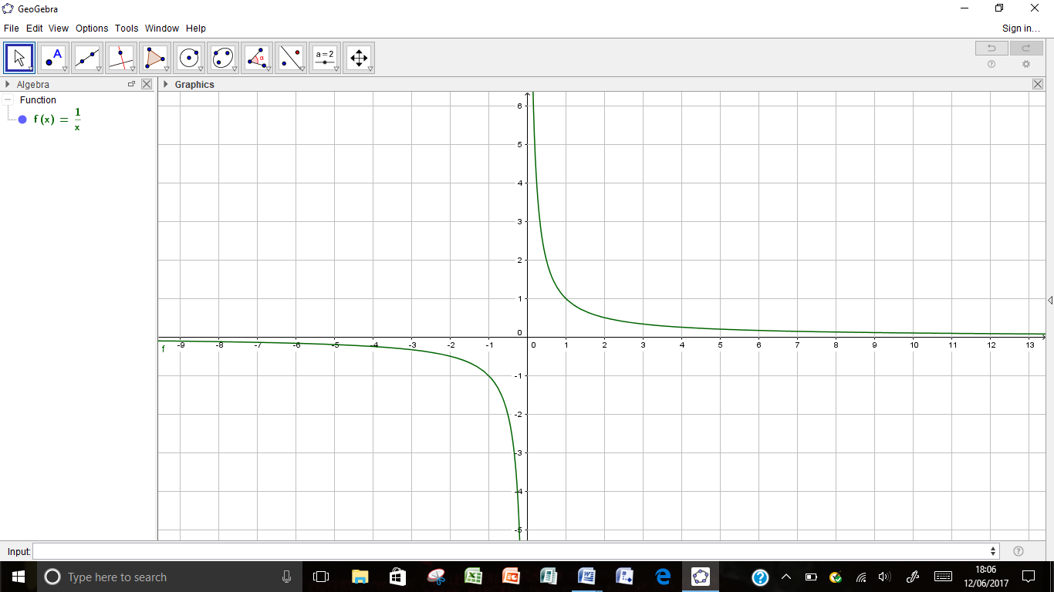Computer Task -



$f\left(x\right)=\frac{1}{x} Vertical Asymptote x=0$

$f\left(x\right)=\frac{1}{x-3} Vertical Asymptote x=3$

___________________________________________________________________________



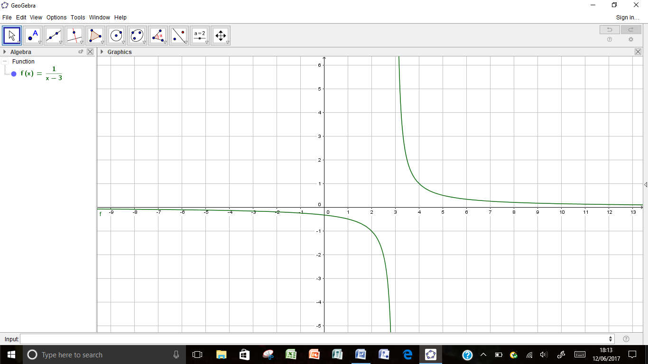



$f\left(x\right)=\frac{1}{x+2} Vertical Asymptote x=-2$

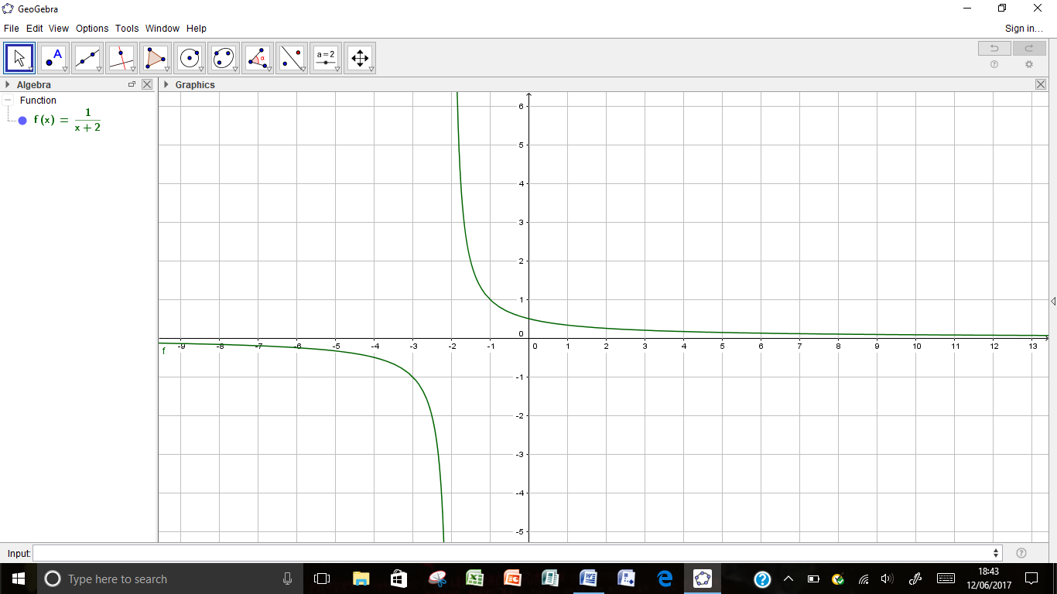



$f\left(x\right)=\frac{2x+3}{3-x} Vertical Asymptote x=3$

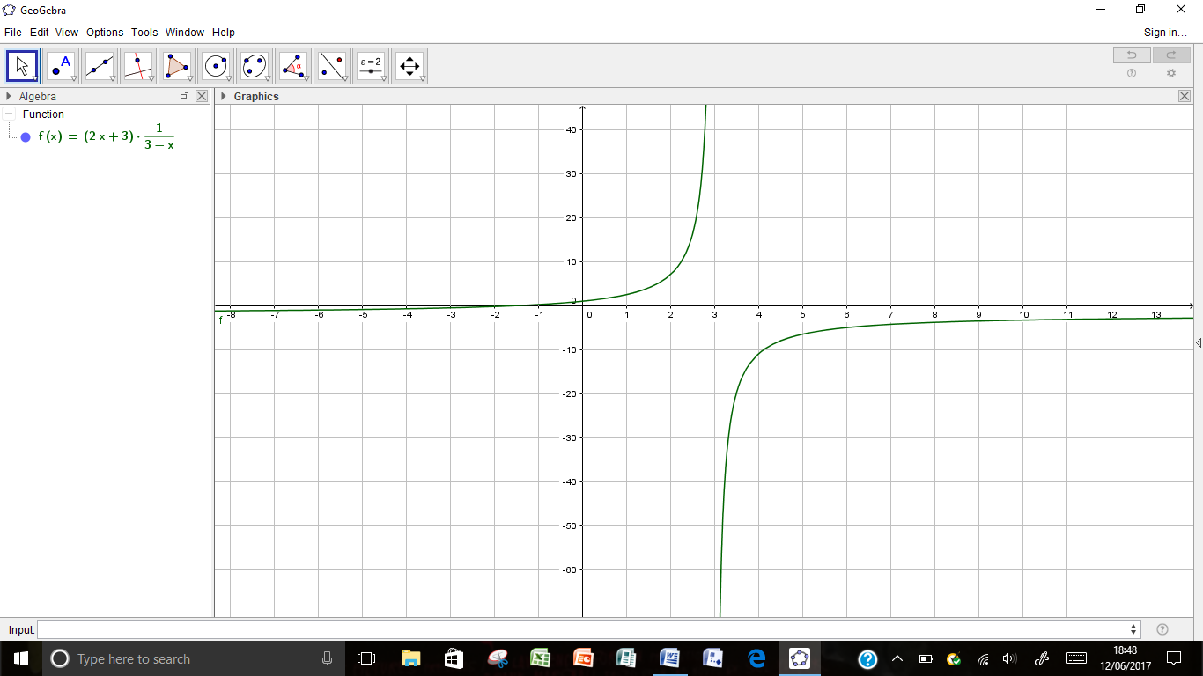



$f\left(x\right)=\frac{1}{\left(x-1\right)(x+3)} Vertical Asymptotes x=-3 and x=1$

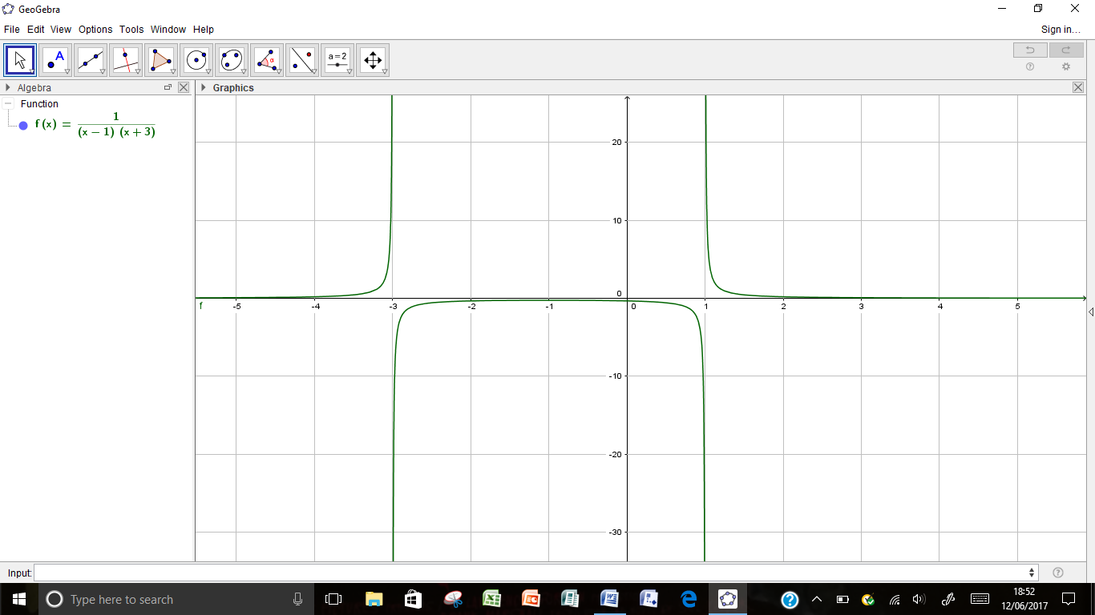



$f\left(x\right)=\frac{x}{\left(x-1\right)} Vertical Asymptote x=1$

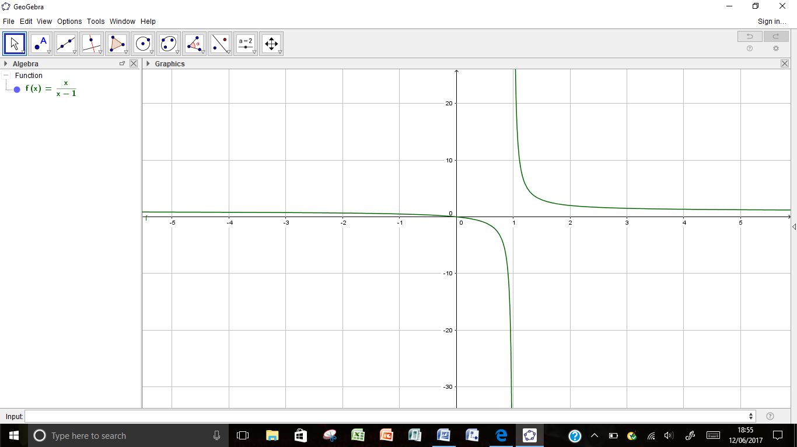



$f\left(x\right)=\frac{x}{\left(x+2\right)(x-3)} Vertical Asymptotes x=-2 and x=3$

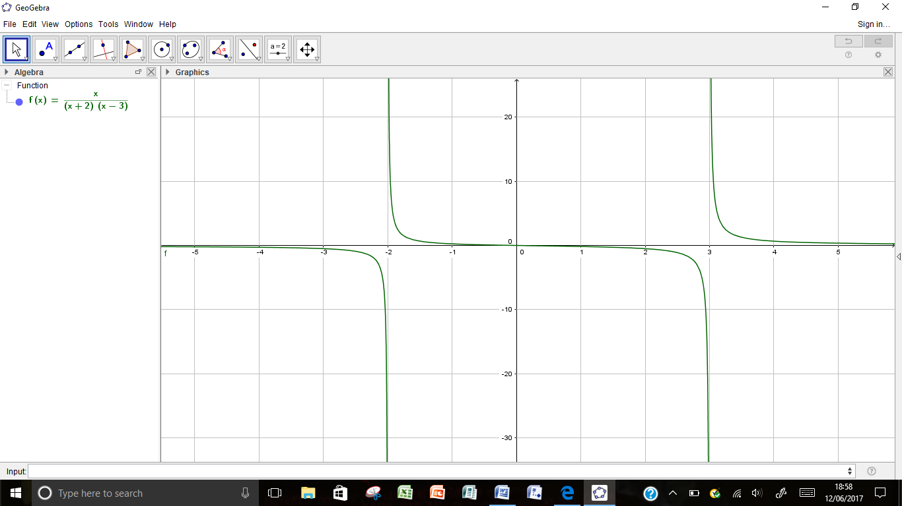



$f\left(x\right)=\frac{x^{2}}{\left(x+2\right)(x-3)} Vertical Asymptotes x=-2 and x=3$

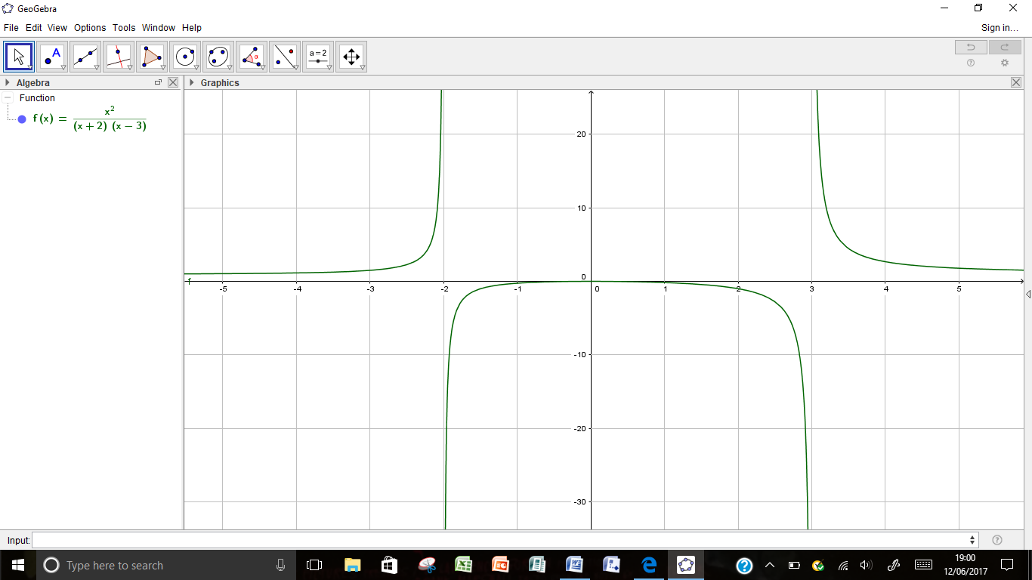



$f\left(x\right)=\frac{x-1}{x^{2}} Vertical Asymptote x=0$

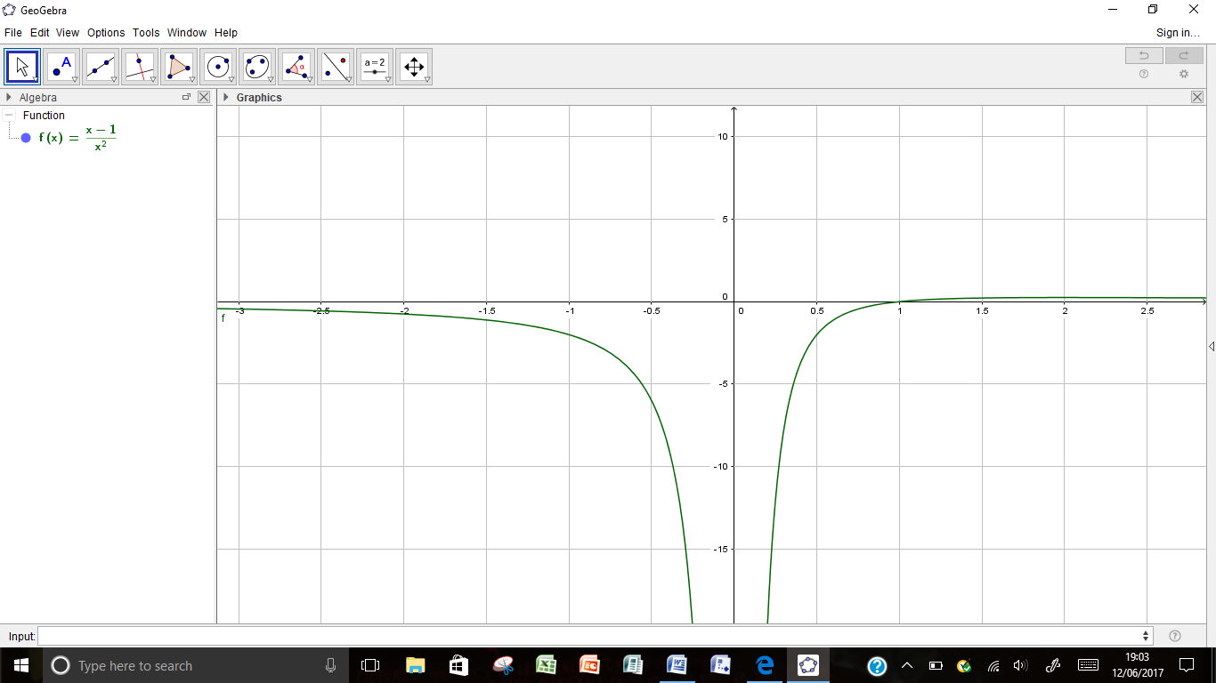



$f\left(x\right)=\frac{x^{2}}{x-1} Vertical Asymptote x=1$

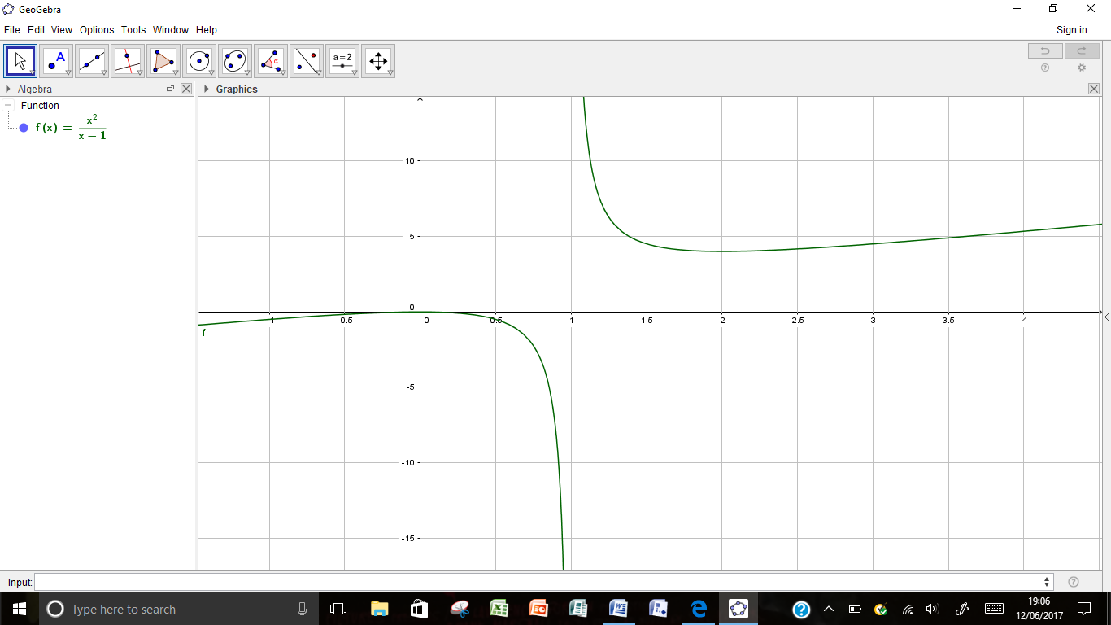



$f\left(x\right)=\frac{x^{3}}{x^{2}-1} Vertical Asymptote x=-1 and x=1$

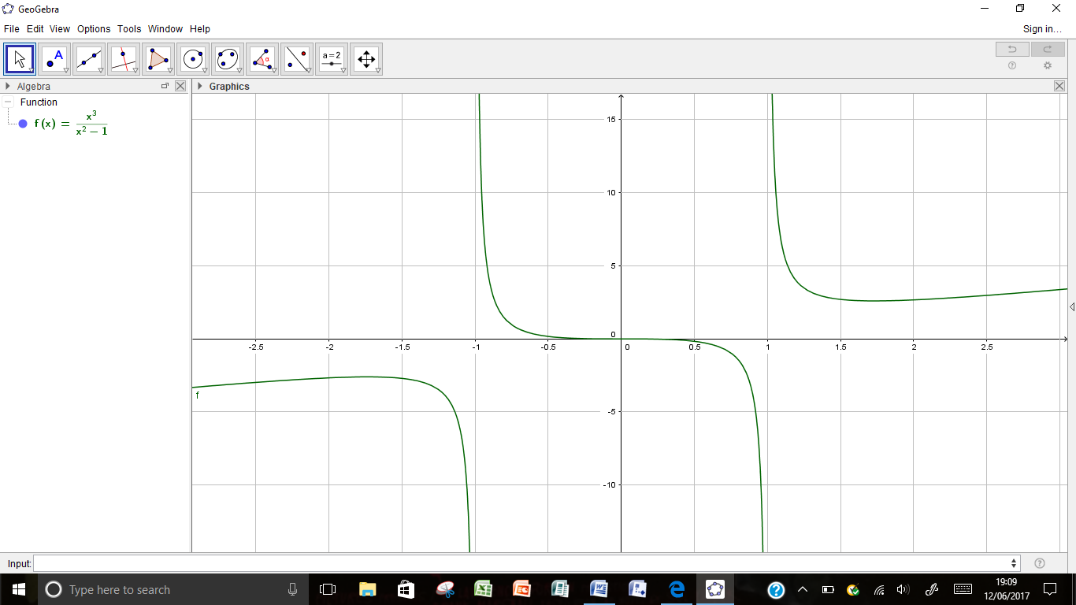



$f\left(x\right)=\frac{1}{x^{2}+1} Vertical Asymptote= none$

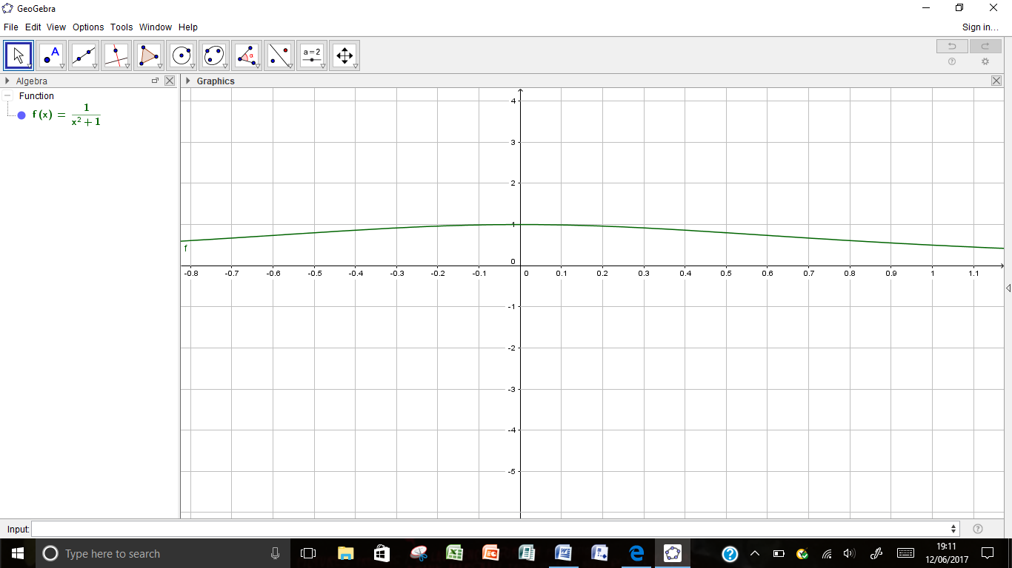

Ex1 – Vertical Asymptotes

$f\left(x\right)=\frac{4}{x-2} ; Vertical Asymptote x=2 ;$

$2^{-}=\left(\frac{+}{-}\right) y→ -∞ ; { 2}^{+}=\left(\frac{+}{+}\right) y→ ∞ ; {}_{⟶}^{}{I_{}^{⟵}}$

$f\left(x\right)=\frac{3x-1}{x^{2}+2x-3}=\frac{3x-1}{\left(x+3\right)(x-1)} ; Vertical Asymptotes x=-3 and x=1 ;$

${-3}^{-}=\left(\frac{(-)}{\left(-\right)(-)}\right) y→ -∞ ; {-3}^{+}=\left(\frac{(-)}{\left(+\right)(-)}\right) y→ ∞ ; x=-3 {}_{⟶}^{}{I_{}^{⟵}}$

$1^{-}=\left(\frac{(+)}{\left(+\right)(-)}\right) y→ -∞ ; 1^{+}=\left(\frac{(+)}{\left(+\right)(+)}\right) y→ ∞ ; x=1 {}_{⟶}^{}{I_{}^{⟵}}$

$f\left(x\right)=\frac{12}{x^{2}-2x-3}=\frac{12}{\left(x-3\right)(x+1)} ; Vertical Asymptotes x=-1 and x=3 ;$

${-1}^{-}=\left(\frac{(+)}{\left(-\right)(-)}\right) y→ ∞ ; {-1}^{+}=\left(\frac{(+)}{\left(-\right)(+)}\right) y→ -∞ ; x=-1 {}_{}^{⟶}{I_{⟵}^{}}$

$3^{-}=\left(\frac{(+)}{\left(-\right)(+)}\right) y→ -∞ ; 3^{+}=\left(\frac{(+)}{\left(+\right)(+)}\right) y→ ∞ ; x=1 {}_{⟶}^{}{I_{}^{⟵}}$

$f\left(x\right)=\frac{x+4}{x-2} ; Vertical Asymptote x=2$

$2^{-}=\left(\frac{(+)}{\left(-\right)}\right) y→ -∞ ; { 2}^{+}=\left(\frac{(+)}{(+)}\right) y→ ∞ ; x=2 {}_{⟶}^{}{I_{}^{⟵}}$

$f\left(x\right)=\frac{x^{2}}{{4-x}^{2}}=\frac{x^{2}}{\left(2-x\right)(2+x)} ; Vertical Asymptotes x=-2 and x=2 ;$

${-2}^{-}=\left(\frac{(+)}{\left(+\right)(-)}\right) y→- ∞ ; {-2}^{+}=\left(\frac{(+)}{\left(+\right)(+)}\right) y→ ∞ ; x=-2 {}_{⟶}^{}{I_{}^{⟵}}$

$2^{-}=\left(\frac{(+)}{\left(+\right)(+)}\right) y→ ∞ ; 2^{+}=\left(\frac{(+)}{\left(-\right)(+)}\right) y→ -∞ ; x=1 {}_{}^{⟶}{I_{⟵}^{}}$

$f\left(x\right)=\frac{x(x+1)}{\left(x-1\right)(x+2)} ; Vertical Asymptotes x=-2 and x=1 ;$

${-2}^{-}=\left(\frac{(-)(-)}{\left(-\right)(-)}\right) y→ ∞ ; {-2}^{+}=\left(\frac{(-)(-)}{\left(-\right)(+)}\right) y→ -∞ ; x=-2 {}_{}^{⟶}{I_{⟵}^{}}$

$1^{-}=\left(\frac{(+)(+)}{\left(-\right)(+)}\right) y→-∞ ; { 1}^{+}=\left(\frac{(+)(+)}{\left(+\right)(+)}\right) y→ ∞ ; x=1 {}_{⟶}^{}{I_{}^{⟵}}$

$f\left(x\right)=\frac{\left(x-1\right)(x-4)}{x} ; Vertical Asymptote x=0 ;$

$0^{-}=\left(\frac{(-)(-)}{(-)}\right) y→ -∞ ; 0^{+}=\left(\frac{(-)(-)}{(+)}\right) y→ ∞ ; x=0 {}_{⟶}^{}{I_{}^{⟵}}$

$f\left(x\right)=\frac{x^{2}+3}{x-1} ; Vertical Asymptote x=1 ;$

$1^{-}=\left(\frac{(+)}{(-)}\right) y→ -∞ ; { 1}^{+}=\left(\frac{(+)}{(+)}\right) y→ ∞ ; x=0 {}_{⟶}^{}{I_{}^{⟵}}$

$f\left(x\right)=\frac{x^{3}}{x^{2}+3} ; Vertical Asymptote none ;$

$f\left(x\right)=\frac{x}{x^{2}+4} ; Vertical Asymptote none ;$

$f\left(x\right)=\frac{x^{2}}{x-1} ; Vertical Asymptote x=1 ;$

$1^{-}=\left(\frac{(+)}{(-)}\right) y→ -∞ ; 1^{+}=\left(\frac{(+)}{(+)}\right) y→ ∞ ; x=0 {}_{⟶}^{}{I_{}^{⟵}}$

$f\left(x\right)=\frac{{2x}^{2}}{x^{2}-1}=\frac{{2x}^{2}}{\left(x-1\right)(x+1)} ; Vertical Asymptotes x=-1 and x=1 ;$

${-1}^{-}=\left(\frac{(+)}{\left(-\right)(-)}\right) y→∞ ; { -1}^{+}=\left(\frac{(+)}{\left(-\right)(+)}\right) y→ -∞ ; x=-2 {}_{}^{⟶}{I_{⟵}^{}}$

$1^{-}=\left(\frac{(+)}{\left(-\right)(+)}\right) y→-∞ ; { 1}^{+}=\left(\frac{(+)}{\left(+\right)(+)}\right) y→ ∞ ; x=1 {}_{⟶}^{}{I_{}^{⟵}}$

___________________________________________________________________________

___________________________________________________________________________

Ex2 – Non Vertical Asymptote

$f\left(x\right)=\frac{4}{x-2}=\frac{\frac{4}{x}}{1-\frac{2}{x}} ; Non Vertical Asymptote y=0$

$x→-∞ y→ 0^{-} ; x→∞ y→ 0^{+} ; y=0 {}_{⟶}^{}{-_{}^{⟵}}$

$f\left(x\right)=\frac{3x-1}{x^{2}+2x-3}=\frac{\frac{3}{x}-\frac{1}{x^{2}}}{1+\frac{2}{x}-\frac{3}{x^{2}}} ; Non Vertical Asymptote y=0$

$x→-∞ 0^{-}=\left(\frac{(-)}{(+)}\right) y→ -∞ ; x→∞ { 0}^{+}=\left(\frac{(+)}{\left(+\right)}\right) y→ ∞ ; y=0 {}_{⟶}^{}{-_{}^{⟵}}$

$f\left(x\right)=\frac{12}{x^{2}-2x-3}= \frac{\frac{12}{x^{2}}}{1-\frac{2}{x}-\frac{3}{x^{2}}} ; Non Vertical Asymptote y=0 ;$

$x→-∞ y→ 0^{+} ; x→∞ y→0^{+} ; y=0 {}_{}^{⟶}{-_{}^{⟵}}$

$f\left(x\right)=\frac{x+4}{x-2}= 1+\frac{6}{x-2}=1+\frac{\frac{6}{x}}{1-\frac{2}{x}} ; Non Vertical Asymptote y=1$

$x→-∞ y→ 1^{-} ; x→∞ y→ 1^{+} ; y=1 {}_{⟶}^{}{-_{}^{⟵}}$

$f\left(x\right)=\frac{x^{2}}{{4-x}^{2}}=-1+\frac{4}{4-x^{2}}= -1+\frac{\frac{4}{x^{2}}}{\frac{4}{x^{2}}-1} ; Non Vertical Asymptotes y=-1$

$x→-∞ y→ {-1}^{-} ; x→∞ y→ {-1}^{-} ; y=-1 {}_{⟶}^{}{-_{⟵}^{}}$

$f\left(x\right)=\frac{x(x+1)}{\left(x-1\right)(x+2)}=\frac{(x^{2}+x)}{(x^{2}+x-2)}=1+\frac{(x^{2}+x)}{(x^{2}+x-2)}=1+\frac{\frac{2}{x^{2}}}{(1+\frac{1}{x}-\frac{2}{x^{2}})} ; Non Vertical Asymptotes y=1$

$x→-∞ y→ 1^{+} ; x→∞ y→ 1^{+} ; y=1 {}_{}^{⟶}{-_{}^{⟵}}$

$f\left(x\right)=\frac{\left(x-1\right)(x-4)}{(x-2)}= \frac{(x^{2}-5x+4)}{(x-2)}=\left(x-3\right)-\frac{2}{(x-2)}=\left(x-3\right)-\frac{\frac{2}{x}}{(1-\frac{2}{x})} ; Non Vertical Asymptote y=(x-3) ;$

$$x→-∞ y→ {\left(x-3\right)}^{+} ;$$

$x→∞ y→ {(x-3)}^{-} ; y=\left(x-3\right) ; {}_{⟶}^{}{∕_{}^{⟵}}$

$f\left(x\right)=\frac{x^{2}+3}{x-1}=\left(x-1\right)+\frac{4}{(x-1)}=\left(x+1\right)+\frac{\frac{4}{x}}{(1-\frac{1}{x})} ; Non Vertical Asymptote y=(x+1) ;$

$$x→-∞ y→ {\left(x+1\right)}^{-} ;$$

$x→∞ y→ {(x+1)}^{+} ; y=(x+1) {}_{}^{⟶}{∕_{⟵}^{}}$

$f\left(x\right)=\frac{x^{3}}{x^{2}+3}=x-\frac{3x}{(x^{2}+3)}=x-\frac{\frac{3}{x}}{(1+\frac{3}{x^{2}})} ; Non Vertical Asymptote y=x ;$

$$x→-∞ y→ x^{+} ;$$

$$x→∞ y→ x^{-} ; y=x {}_{⟶}^{}{∕_{}^{⟵}}$$

$f\left(x\right)=\frac{x}{x^{2}+4}= \frac{\frac{1}{x}}{1+\frac{4}{x^{2}}} ; Non Vertical Asymptote y=0 ;$

$$x→-∞ y→ 0^{-} ; x→∞ y→ 0^{+} ; y=0 {}_{⟶}^{}{-_{}^{⟵}}$$

$f\left(x\right)=\frac{x^{2}}{x-1}=\left(x+1\right)+\frac{1}{(x-1)}=\left(x+1\right)+\frac{\frac{1}{x}}{(1-\frac{1}{x})} ; Non Vertical Asymptote y=(x+1) ;$

$$x→-∞ y→ {\left(x+1\right)}^{-} ;$$

$x→∞ y→ {(x+1)}^{+} ; y=(x+1) {}_{}^{⟶}{∕_{⟵}^{}}$

$f\left(x\right)=\frac{{2x}^{2}}{x^{2}-1}=2+\frac{2}{x^{2}-1} =2+\frac{\frac{2}{x^{2}}}{1-\frac{1}{x^{2}}} ; Non Vertical Asymptote y=2 ;$

$x→-∞ y→2^{∓} ; x→∞ y→ { 2}^{+} ; y=2 {}_{}^{⟶}{-_{}^{⟵}}$

___________________________________________________________________________

___________________________________________________________________________

Ex3 – Curve Sketching

Process: 1. Find where curve crosses x and y axis.

2. Find all asymptotes.

3. Find stationary points and their nature.

$f\left(x\right)=\frac{4}{x-2}=\frac{\frac{4}{x}}{1-\frac{2}{x}} ;$

$$x-axis when y=0 ; None ; y-axis when x=0 ⇒y=-2$$

$2. Asymptotes : Vertical : x-2=0 ; x=2$

$$2^{-}=\left(\frac{(+)}{(-)}\right) y→ -∞ ; 2^{+}=\left(\frac{(+)}{(+)}\right) y→ ∞ ; x=0 {}_{⟶}^{}{I_{}^{⟵}}$$

$Non Vertical : y=\frac{4}{x-2}=\frac{\frac{4}{x}}{1-\frac{2}{x}} Non Vertical y=0$

$$x→-∞ y→0^{-} ; x→∞ y→ 0^{+} ; y=0 {}_{⟶}^{}{-_{}^{⟵}}$$

$3. Stationary points : f^{'}\left(x\right)=0 ; f\left(x\right)=4{(x-2)}^{-1} ; f^{'}\left(x\right)=-4{(x-2)}^{-2}$

$f^{'}\left(x\right)=\frac{-4}{{(x-2)}^{2}} ; \frac{-4}{{(x-2)}^{2}}=0 ; no solution so no stationary points$

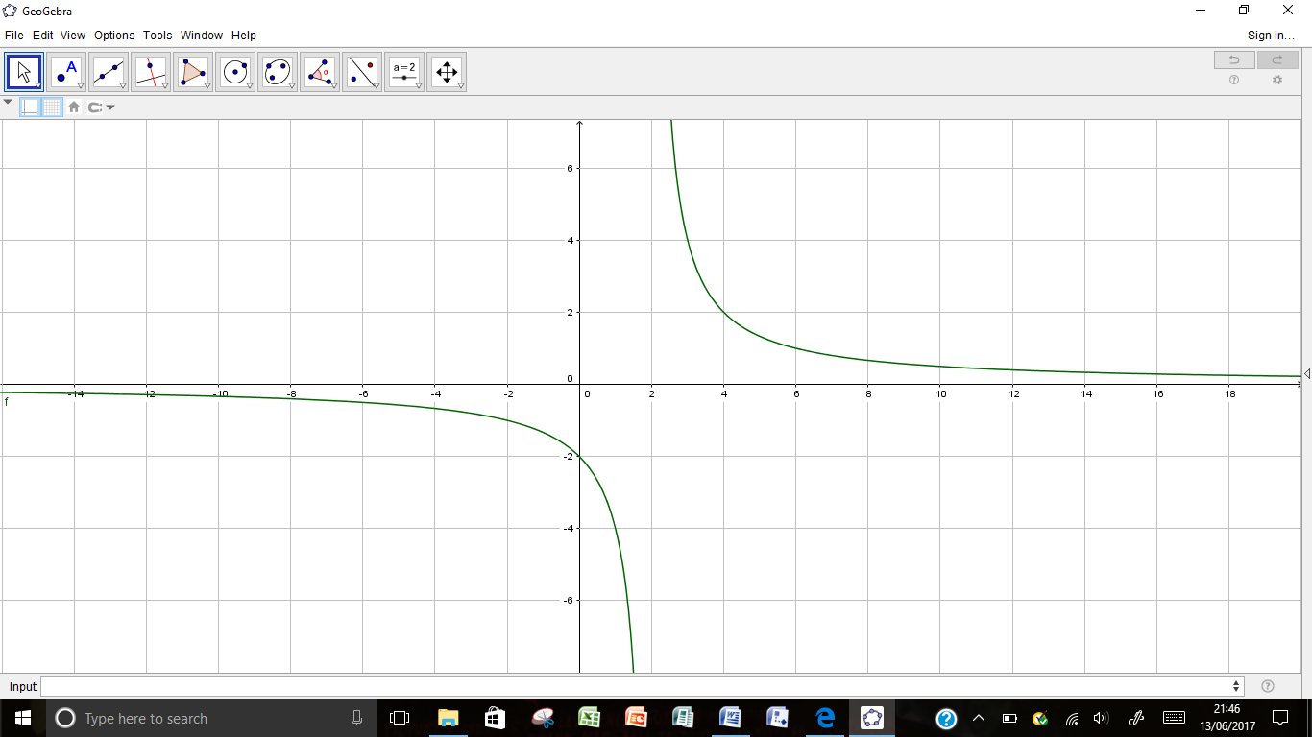

2.

$f\left(x\right)=\frac{x-2}{x-1}=1-\frac{1}{x-1}=1-\frac{\frac{1}{x}}{1-\frac{1}{x}}$

$$x-axis when y=0 ; x=2 ; \left(2,0\right) y-axis when x=0 ⇒y=2 (0,2)$$

$2. Asymptotes : Vertical : x-1=0 ; x=1$

$$1^{-}=\left(\frac{(-)}{(-)}\right) y→∞ ; 1^{+}=\left(\frac{(-)}{(+)}\right) y→ -∞ ; x=1 {}_{}^{⟶}{I_{⟵}^{}}$$

$Non Vertical : y=1-\frac{\frac{1}{x}}{1-\frac{1}{x}} Non Vertical y=1$

$$x→-∞ y→1^{+} ; x→∞ y→ 1^{-} ; y=2 {}_{}^{⟶}{-_{⟵}^{}}$$

$3. Stationary points : f^{'}\left(x\right)=0 ; f\left(x\right)=1-\frac{1}{x-1} ; f\left(x\right)=-{(x-1)}^{-1}$

$f^{'}\left(x\right)=\frac{1}{{(x-1)}^{2}} ; \frac{1}{{(x-1)}^{2}}=0 ; no solution so no stationary points$

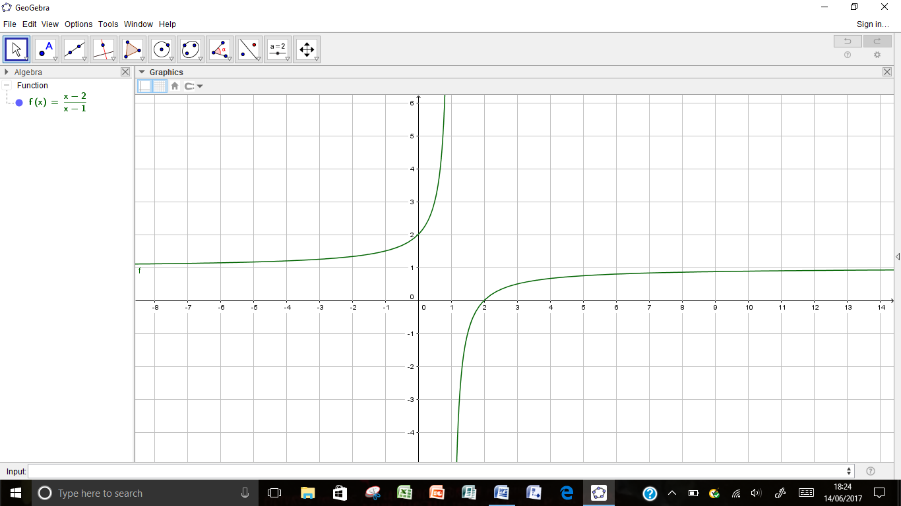

3.

$f\left(x\right)=\frac{x^{2}+x-2}{x^{2}+x-6}=\frac{\left(x+2\right)(x-1)}{\left(x+3\right)(x-2)}=1+\frac{4}{\left(x+3\right)(x-2)}=1+\frac{\frac{4}{x^{2}}}{1+\frac{1}{x}-\frac{6}{x^{2}}}$

$$x-axis when y=0 ; x^{2}+x-2=0 ; \left(x+2\right)\left(x-1\right)=0 ; x=-2,1 \left(-2,0\right) (1,0)$$

$$y-axis when x=0 ⇒y=\frac{1}{3} (0,\frac{1}{3} )$$

$2. Asymptotes : Vertical : \left(x+3\right)\left(x-2\right)=0 ; x=-3 and x=2$

$${-3}^{-}=\left(\frac{(-)(-)}{(-)(-)}\right) y→∞ ; {-3}^{+}=\left(\frac{(-)(-)}{(+)(-)}\right) y→ -∞ ; x=-3 {}_{}^{⟶}{I_{⟵}^{}}$$

$$2^{-}=\left(\frac{(+)(+)}{(+)(-)}\right) y→-∞ ; 2^{+}=\left(\frac{(+)(+)}{(+)(+)}\right) y→ ∞ ; x=2 {}_{⟶}^{}{I_{}^{⟵}}$$

$Non Vertical : y=1+\frac{\frac{4}{x^{2}}}{1+\frac{1}{x}-\frac{6}{x^{2}}} Non Vertical y=1$

$$x→-∞ y→1^{+} ; x→∞ y→ 1^{+} ; y=1 {}_{}^{⟶}{-_{}^{⟵}}$$

$3. Stationary points : f^{'}\left(x\right)=0 ; f\left(x\right)=1+\frac{4}{x^{2}+x-6} ;$

$f^{'}\left(x\right)=\frac{\left(x^{2}+x-6\right).0-4.(2x+1)}{{(x^{2}+x-6)}^{2}}=\frac{(-8x-4)}{{(x^{2}+x-6)}^{2}}=0 ; (-8x-4)=0 ; x=-\frac{1}{2}$

$For x=\frac{1}{2} y=1+\frac{4}{x^{2}+x-6}=1+\frac{4}{{\left(-\frac{1}{2}\right)}^{2}+\left(-\frac{1}{2}\right)-6}=1+\frac{4}{-\left(\frac{25}{4}\right)}=\frac{9}{25} T.P.=\left(-\frac{1}{2},\frac{9}{25}\right)$

$Nature Table :$

|  |  |  |  |
| --- | --- | --- | --- |
| x | → | $$-\frac{1}{2}$$ | → |
| f’(x) | + | 0 | - |
| Shape | $$↗$$ | $$→$$ | $$↘$$ |

$Hence Max.T.P. at \left(-\frac{1}{2},\frac{9}{25}\right)$

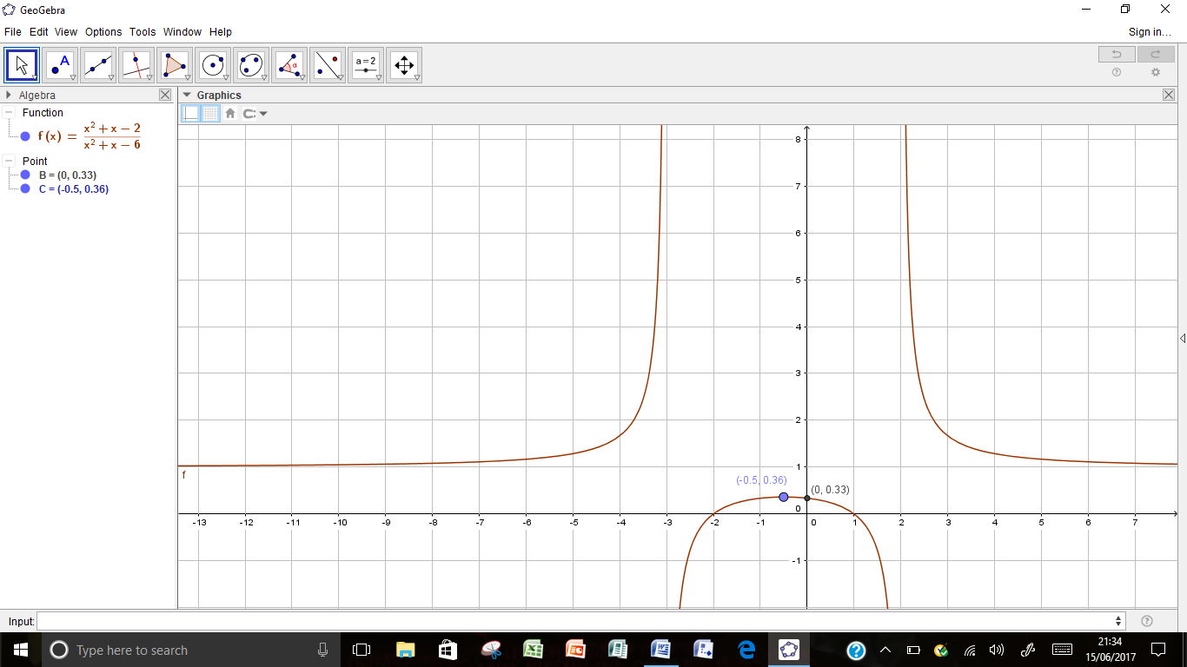

4.

$$1. f\left(x\right)=\frac{x^{2}+2x+5}{x+1}=\left(x+1\right)+\frac{4}{\left(x+1\right)}=(x+1)+\frac{\frac{4}{x}}{1+\frac{1}{x}}$$

$$x-axis when y=0 ; x^{2}+x-2=0 ; b^{2}-4ac<0 ; no real roots$$

$$y-axis when x=0 ⇒y=5 (0,5 )$$

$2. Asymptotes : Vertical : \left(x+1\right)=0 ; x=-1$

$$1^{-}=\left(\frac{(+)}{(-)}\right) y→-∞ ; 1^{+}=\left(\frac{(+)}{(+)}\right) y→ ∞ ; x=-1 {}_{⟶}^{}{I_{}^{⟵}}$$

$Non Vertical : y=(x+1)+\frac{\frac{4}{x}}{1+\frac{1}{x}} Non Vertical y=(x+1)$

$$x→-∞ y→{(x+1)}^{-} ; x→∞ y→ {(x+1)}^{+} ; y=(x+1) {}_{}^{⟶}{∕_{⟵}^{}}$$

$3. Stationary points : f^{'}\left(x\right)=0 ; f\left(x\right)=\left(x+1\right)+\frac{4}{\left(x+1\right)} ;$

$f^{'}\left(x\right)=1+\frac{\left(x+1\right).0-4.1}{{(x+1)}^{2}}=1-\frac{4}{{(x+1)}^{2}}=\frac{{(x+1)}^{2}-4}{{(x+1)}^{2}}=\frac{x^{2}+2x-3}{{(x+1)}^{2}}=0 ; x^{2}+2x-3=0$

$x^{2}+2x-3=\left(x+3\right)\left(x-1\right)=0 ; x=1 and x=-3$

$For x=1 y=\left(x+1\right)+\frac{4}{\left(x+1\right)}=2+2=4 T.P.=\left(1,4\right)$

$$For x=-3 y=\left(x+1\right)+\frac{4}{\left(x+1\right)}=-2-2=-4 T.P.=\left(-3,-4\right)$$

$Nature Table :$

|  |  |  |  |  |  |
| --- | --- | --- | --- | --- | --- |
| x | → | -3 | → | 1 | → |
| f’(x) | + | 0 | - | 0 | - |
| Shape | $$↗$$ | $$→$$ | $$↘$$ | $$→$$ | $$↗$$ |

$Hence Max.T.P. at \left(-3,-4\right) and Mini.TP.at (1,4)$

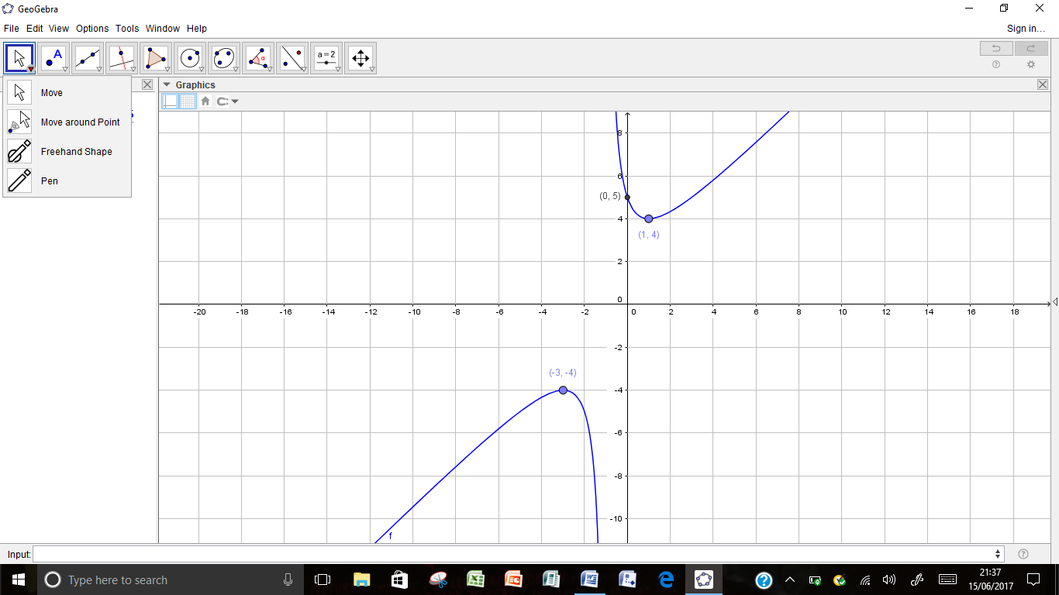

5.

$$1. f\left(x\right)=\frac{x+1}{x^{2}+2x+5}=\frac{\left(x+1\right)}{x^{2}+2x+5}=\frac{\left(\frac{1}{x}+\frac{1}{x^{2}}\right)}{1+\frac{2}{x}+\frac{5}{x^{2}}}$$

$$x-axis when y=0 ; x+1=0 ; x=-1 (-1,0)$$

$$y-axis when x=0 ⇒y=\frac{1}{5} (0,\frac{1}{5} )$$

$2. Asymptotes : Vertical : x^{2}+2x+5=0 ; b^{2}-4ac<0 ; no real roots$

$NO Vertical asymptotes$

$Non Vertical : y=\frac{\left(x+1\right)}{x^{2}+2x+5}=\frac{\left(\frac{1}{x}+\frac{1}{x^{2}}\right)}{1+\frac{2}{x}+\frac{5}{x^{2}}} Non Vertical y=0$

$$x→-∞ y→0^{-} ; x→∞ y→ 0^{+} ; y=0 {}_{⟶}^{}{-_{}^{⟵}}$$

$3. Stationary points : f^{'}\left(x\right)=0 ; \frac{x+1}{x^{2}+2x+5} ;$

$f^{'}\left(x\right)=\frac{\left(x^{2}+2x+5\right).1-2\left(x+1\right)(x+1)}{{(x^{2}+2x+5)}^{2}}=\frac{{(x}^{2}+2x+5)-2{(x}^{2}+2x+1)}{{(x^{2}+2x+5)}^{2}}=\frac{-x^{2}-2x+3}{{(x^{2}+2x+5)}^{2}}=0 ; x^{2}+2x-3=0$

$x^{2}+2x-3=\left(x+3\right)\left(x-1\right)=0 ; x=1 and x=-3$

$For x=1 y=\frac{x+1}{x^{2}+2x+5}=\frac{2}{8}=\frac{1}{4} T.P.=\left(1,\frac{1}{4}\right)$

$$For x=-3 y=\frac{x+1}{x^{2}+2x+5}=\frac{-2}{8}=-\frac{1}{4} T.P.=\left(-3,-\frac{1}{4}\right)$$

$Nature Table :$

|  |  |  |  |  |  |
| --- | --- | --- | --- | --- | --- |
| x | → | -3 | → | 1 | → |
| f’(x) | - | 0 | + | 0 | - |
| Shape | $$↘$$ | $$→$$ | $$↗$$ | $$→$$ | $$↘$$ |

$Hence Max.T.P. at \left(1,\frac{1}{4}\right) and Mini.TP.at \left(-3,-\frac{1}{4}\right)$

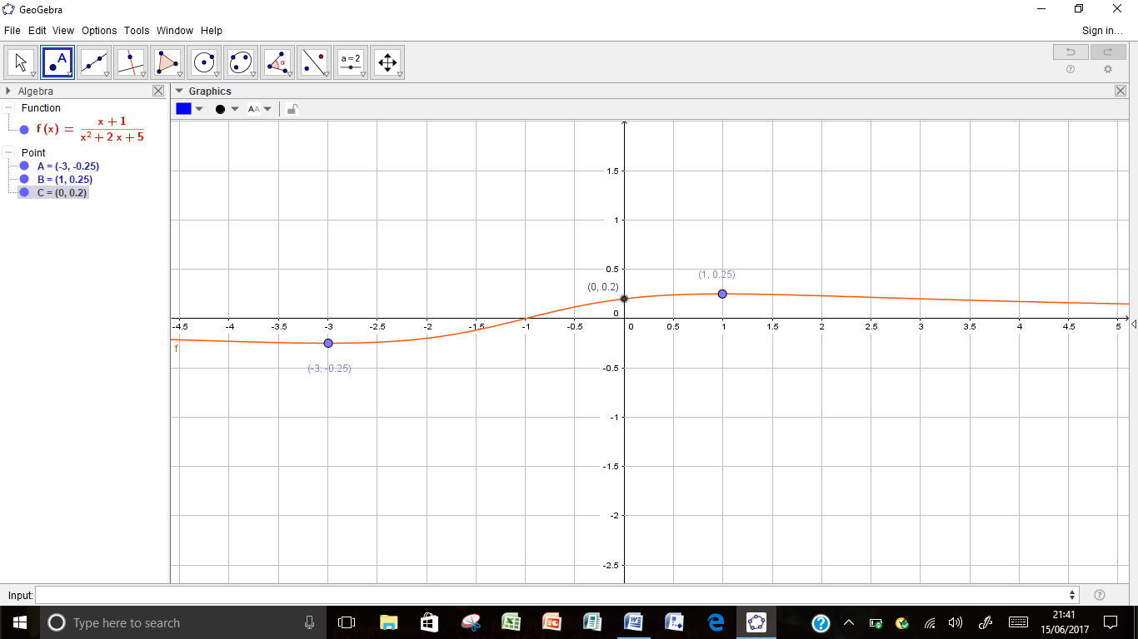

6.

$$1. f\left(x\right)=\frac{2x^{2}}{x^{2}-1}=2+\frac{2}{{(x}^{2}-1)}=2+\frac{2}{\left(x+1\right)(x-1)}=2+\frac{\frac{2}{x^{2}}}{1-\frac{1}{x^{2}}}$$

$$x-axis when y=0 ; \frac{2x^{2}}{x^{2}-1}=0 ; 2x^{2}=0 ; x=0$$

$$y-axis when x=0 ⇒y=-1 (0,0 )$$

$2. Asymptotes : Vertical : \left(x+1\right)\left(x-1\right)=0 ; x=-1 and x=1$

$${-1}^{-}=\left(\frac{(+)}{(+)}\right) y→∞ ; {-1}^{+}=\left(\frac{(+)}{(-)}\right) y→ -∞ ; x=-1 {}_{}^{⟶}{I_{⟵}^{}}$$

$$1^{-}=\left(\frac{(+)}{(-)}\right) y→-∞ ; 1^{+}=\left(\frac{(+)}{(+)}\right) y→ ∞ ; x=1 {}_{⟶}^{}{I_{}^{⟵}}$$

$Non Vertical : y=2+\frac{\frac{2}{x^{2}}}{1-\frac{1}{x^{2}}} Non Vertical y=2$

$$x→-∞ y→2^{+} ; x→∞ y→ 2^{+} ; y=2 {}_{}^{⟶}{-_{}^{⟵}}$$

$3. Stationary points : f^{'}\left(x\right)=0 ; f\left(x\right)= 2+\frac{2}{{(x}^{2}-1)} ;$

$f^{'}\left(x\right)=\frac{(x^{2}-1).0-2\left(2x\right)}{{(x^{2}-1)}^{2}}=\frac{-4x}{{(x^{2}-1)}^{2}}=0 ; x=0$

$For x=0 y=\frac{2x^{2}}{x^{2}-1}=0 T.P.=\left(0,0\right)$

$Nature Table :$

|  |  |  |  |
| --- | --- | --- | --- |
| x | → | 0 | → |
| f’(x) | + | 0 | - |
| Shape | $$↗$$ | $$→$$ | $$↘$$ |

$Hence Max.T.P. at \left(0,0\right)$

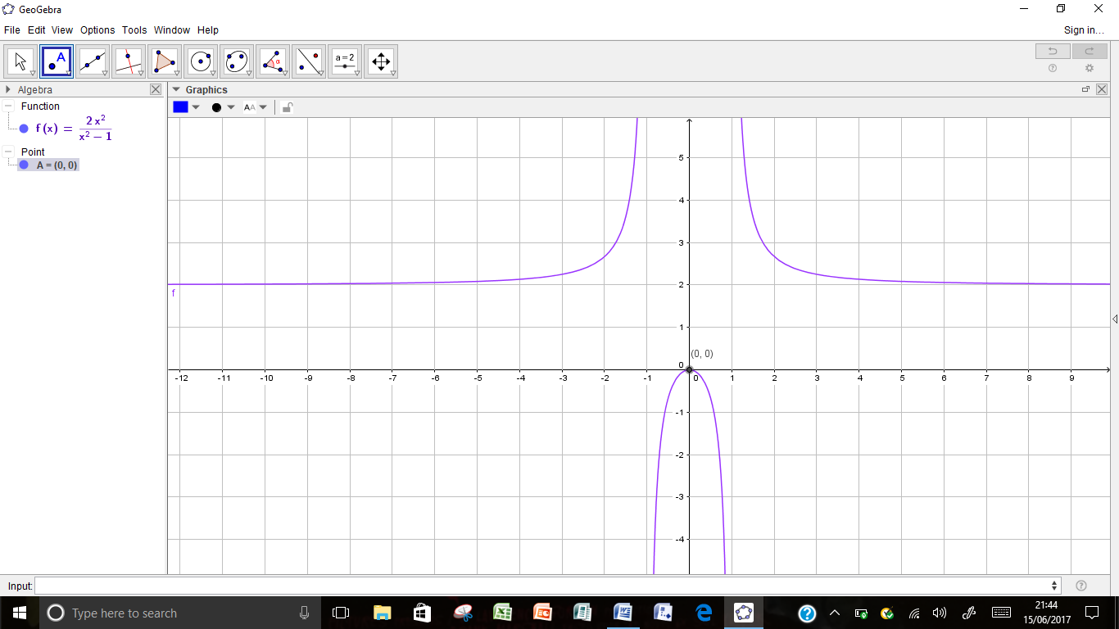

7.

$$1. f\left(x\right)=\frac{x^{2}-10x+9}{x^{2}+10x+9}=1-\frac{20x}{x^{2}+10x+9}=1-\frac{20x}{\left(x+1\right)(x+9)}=1-\frac{\frac{20}{x}}{1+\frac{10}{x}+\frac{9}{x^{2}}}$$

$$x-axis when y=0 ; \frac{x^{2}-10x+9}{x^{2}+10x+9}=0 ; \left(x-1\right)\left(x-9\right)=0 ; x=1 and x=9 \left(1,0\right),(9,0)$$

$$y-axis when x=0 ⇒y=1 (0,1)$$

$2. Asymptotes : Vertical : \left(x+1\right)\left(x+9\right)=0 ; x=-1 and x=-9$

$${-1}^{-}=\left(\frac{(+)}{(-)}\right) y→-∞ ; -1^{+}=\left(\frac{(+)}{(+)}\right) y→ ∞ ; x=-1 {}_{⟶}^{}{I_{}^{⟵}}$$

$$-9^{-}=\left(\frac{(+)}{(+)}\right) y→∞ ; {-9}^{+}=\left(\frac{(+)}{(-)}\right) y→ -∞ ; x=-9 {}_{}^{⟶}{I_{⟵}^{}}$$

$Non Vertical : y=1-\frac{20x}{\left(x+1\right)(x+9)}=1-\frac{\frac{20}{x}}{1+\frac{10}{x}+\frac{9}{x^{2}}} Non Vertical y=1$

$$x→-∞ y→1^{+} ; x→∞ y→ 1^{-} ; y=1 {}_{}^{⟶}{-_{⟵}^{}}$$

$3. Stationary points : f^{'}\left(x\right)=0 ; f\left(x\right)=1-\frac{20x}{x^{2}+10x+9} ;$

$$f^{'}\left(x\right)=\frac{\left(x^{2}+10x+9\right).\left(-20\right)-\left(-20x\right)\left(2x+10\right)}{{\left(x^{2}+10x+9\right)}^{2}}=\frac{\left(-20x^{2}-200x-180\right)+\left(40x^{2}+200x\right)}{{\left(x^{2}+10x+9\right)}^{2}}$$

$$=\frac{\left(-20x^{2}-200x-180\right)+(40x^{2}+200x)}{{(x^{2}+10x+9)}^{2}}=\frac{20x^{2}-180}{{(x^{2}+10x+9)}^{2}}=0$$

$$=\frac{20x^{2}-180}{{(x^{2}+10x+9)}^{2}}=0 ; 20\left(x^{2}-9\right)=0 ; \left(x-3\right)\left(x+3\right)=0 ; x=3 and x=-3$$

$For x=3 y=1-\frac{20x}{x^{2}+10x+9}=1-\frac{20(3)}{{(3)}^{2}+10(3)+9}=1-\frac{60}{48}=- \frac{12}{48}=-\frac{1}{4} T.P.=\left(3,-\frac{1}{4}\right)$

$$For x=-3 y=1-\frac{20x}{x^{2}+10x+9}=1-\frac{20(-3)}{{(-3)}^{2}+10(-3)+9}=1-\frac{-60}{-12}=- 4 T.P.=\left(-3,-4\right)$$

$Nature Table :$

|  |  |  |  |  |  |
| --- | --- | --- | --- | --- | --- |
| x | → | -3 | → | 3 | → |
| f’(x) | + | 0 | - | 0 | + |
| Shape | $$↗$$ | $$→$$ | $$↘$$ | $$→$$ | $$↗$$ |

$Hence Max.T.P. at \left(-3,-4\right) and Mini.T.P.at \left(3,-\frac{1}{4}\right)$

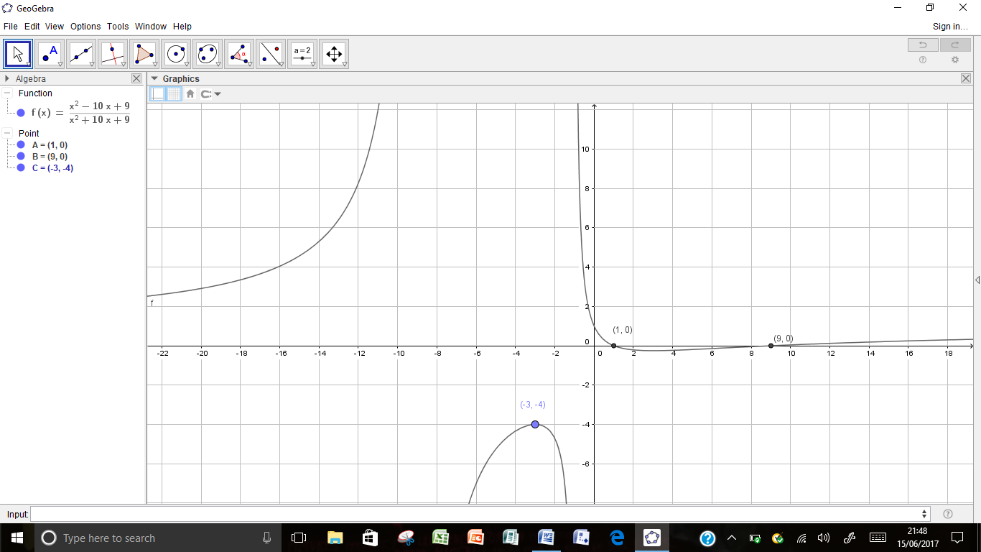

8.

$$1. f\left(x\right)=\frac{{2x}^{2}-3x-3}{x^{2}-3x+2}=2+\frac{3x-7}{x^{2}-3x+2}=2+\frac{3x-7}{\left(x-1\right)(x-2)}=2+\frac{\frac{3}{x}-\frac{7}{x^{2}}}{1-\frac{3}{x}+\frac{2}{x^{2}}}$$

$$x-axis when y=0 ; \frac{{2x}^{2}-3x-3}{x^{2}-3x+2}=0 ; too dificult to find roots so leave$$

$$y-axis when x=0 ⇒y=-\frac{3}{2} \left(0,-\frac{3}{2}\right)$$

$2. Asymptotes : Vertical : \left(x-1\right)\left(x-2\right)=0 ; x=1 and x=2$

$$1^{-}=\left(\frac{(-)}{(+)}\right) y→-∞ ; 1^{+}=\left(\frac{(-)}{(-)}\right) y→ ∞ ; x=1 {}_{⟶}^{}{I_{}^{⟵}}$$

$$2^{-}=\left(\frac{(-)}{(-)}\right) y→∞ ; 2^{+}=\left(\frac{(-)}{(+)}\right) y→ -∞ ; x=2 {}_{}^{⟶}{I_{⟵}^{}}$$

$Non Vertical : y=2+\frac{3x-7}{\left(x-1\right)(x-2)}=2+\frac{\frac{3}{x}-\frac{7}{x^{2}}}{1-\frac{3}{x}+\frac{2}{x^{2}}} Non Vertical y=2$

$$x→-∞ y→2^{-} ; x→∞ y→ 2^{+} ; y=2 {}_{⟶}^{}{-_{}^{⟵}}$$

$3. Stationary points : f^{'}\left(x\right)=0 ; f\left(x\right)=2+\frac{3x-7}{x^{2}-3x+2} ;$

$$f^{'}\left(x\right)=\frac{\left(x^{2}-3x+2\right).\left(3\right)-\left(3x-7\right)\left(2x-3\right)}{{\left(x^{2}-3x+2\right)}^{2}}=\frac{\left({3x}^{2}-9x+6\right)-\left(6x^{2}-23x+21\right)}{{\left(x^{2}-3x+2\right)}^{2}}$$

$$=\frac{\left(-3x^{2}+14x-15\right)}{{(x^{2}+10x+9)}^{2}}=0$$

$$=3x^{2}-14x+15=0 ; \left(3x-5\right)\left(x-3\right)=0 ; \left(3x-5\right)\left(x-3\right)=0 ; x=\frac{5}{3} and x=3$$

$For x=3 y=2+\frac{3x-7}{\left(x-1\right)(x-2)}=2+\frac{9-7}{\left(2\right)(1)}=3 T.P.=\left(3,3\right)$

$$For x=\frac{5}{3} y=2+\frac{3\left(\frac{5}{3}\right)-7}{\left(\frac{2}{3}\right)\left(-\frac{1}{3}\right)}=2+\frac{-2}{\left(-\frac{2}{9}\right)}=11 T.P.=\left(\frac{5}{3},11\right)$$

$Nature Table :$

|  |  |  |  |  |  |
| --- | --- | --- | --- | --- | --- |
| x | → | $$\frac{5}{3}$$ | → | 3 | → |
| f’(x) | - | 0 | + | 0 | - |
| Shape | $$↘$$ | $$→$$ | $$↗$$ | $$→$$ | $$↘$$ |

$Hence Max.T.P. at \left(3,3\right) and Mini.T.P.at \left(\frac{5}{3},11\right)$

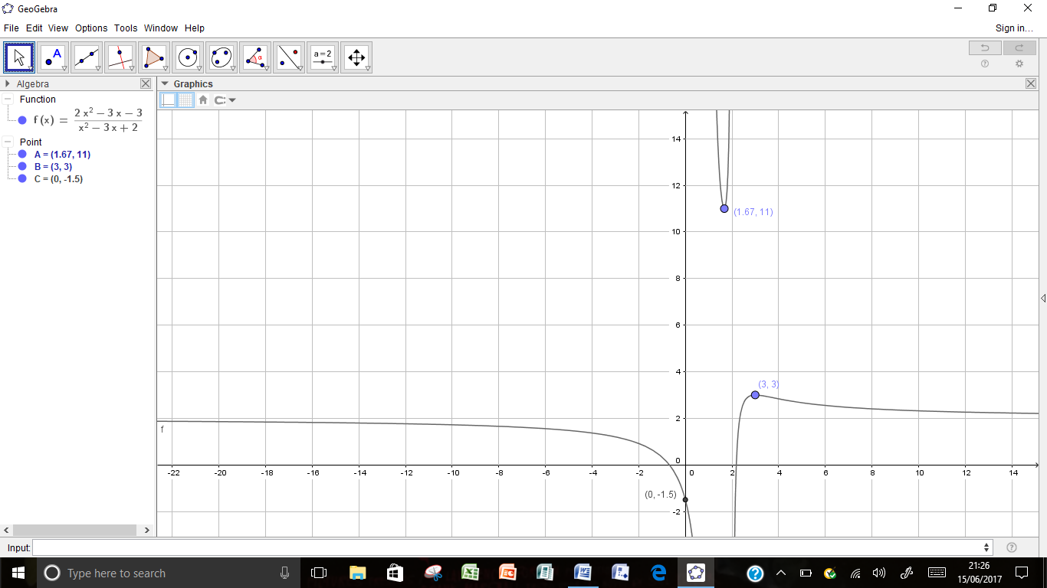

Ex 5 – Inverse, Odd and Even Functions

$\left(a\right) f\left(x\right)=2x ; y=2x ; x=\frac{1}{2}y ; f^{-1}\left(x\right)=\frac{1}{2}x$

$\left(b\right) \left(fx\right)=2-x ; y=2-x ; x=2-y ; f^{-1}\left(x\right)=2-x$

$\left(c\right) \left(fx\right)=\frac{2}{x} ; y=\frac{2}{x} ; x=\frac{2}{x} ; f^{-1}\left(x\right)=\frac{2}{x}$

$\left(d\right) \left(fx\right)=2^{x} ; y=2^{x} ; \log_{2}y=\log_{2}2^{x} ; \log_{2}y=x ; \log_{2}y=x ; f^{-1}\left(x\right)=\log_{2}x$

$\left(e\right) \left(fx\right)=1-2x ; y=1-2x ; 2x=1-y ; x=\frac{1-y}{2} ; f^{-1}\left(x\right)=\frac{1-x}{2}$

$\left(f\right) \left(fx\right)=ln\left(x-2\right) ; y=ln\left(x-2\right) ; e^{y}+2=x ; x=e^{y}+2 ; f^{-1}\left(x\right)=e^{x}+2$

$\left(a\right) \sin^{-1}\left(\frac{\sqrt{3}}{2}\right)=\frac{π}{3} \left(b\right) \tan^{-1}\left(\frac{1}{\sqrt{3}}\right)=\frac{π}{6} \left(c\right) \tan^{-1}\left(1\right)=\frac{π}{4} \left(d\right) \sin^{-1}\left(\frac{1}{2}\right)=\frac{π}{6}$

$$\left(e\right) \cos^{-1}\left(-\frac{\sqrt{3}}{2}\right)=\frac{5π}{6} \left(b\right) \tan^{-1}\left(\sqrt{3}\right)=\frac{π}{3}$$

1. 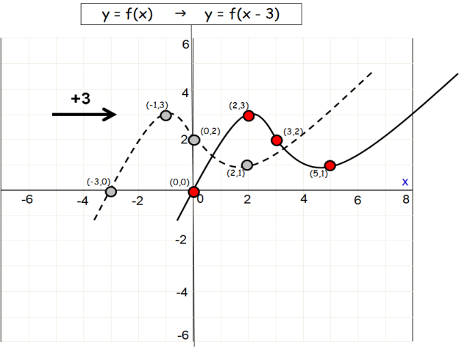(a)

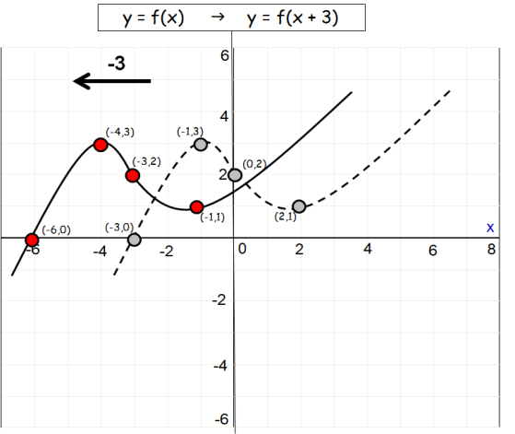

(b)

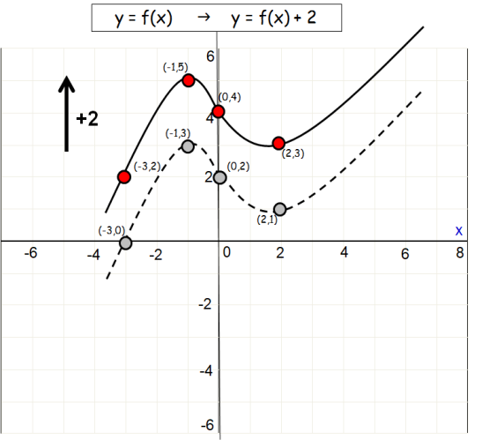(c)

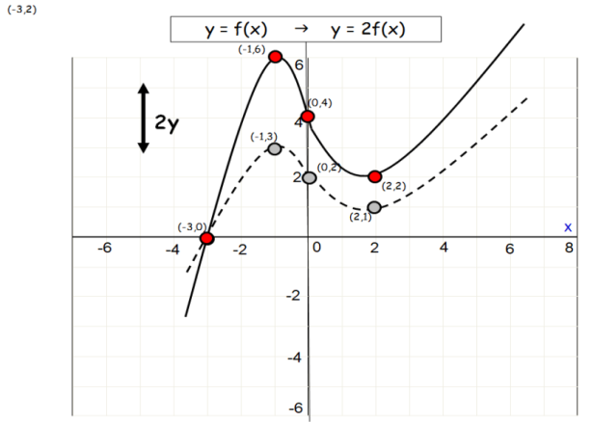(d)

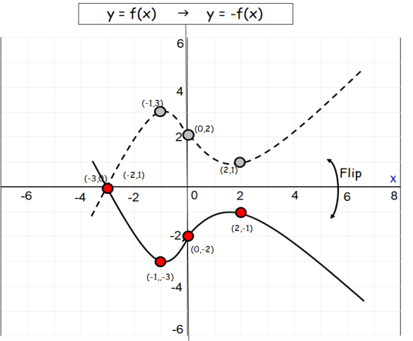

(e)

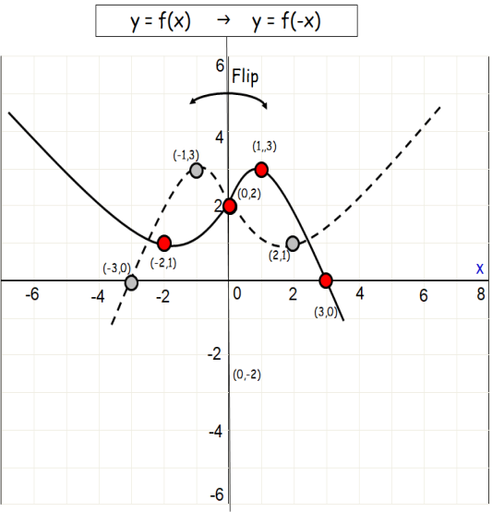(f)

1. 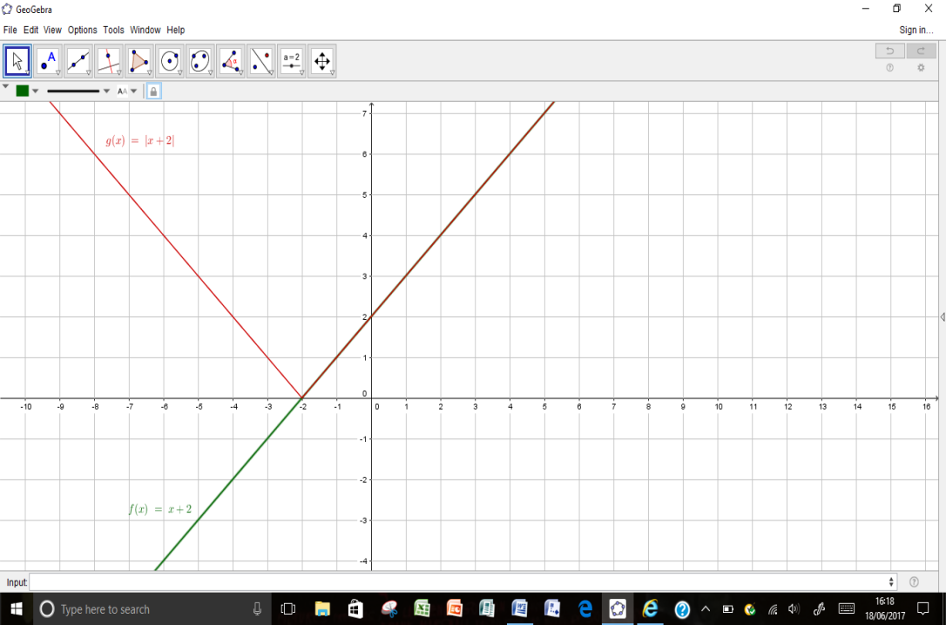

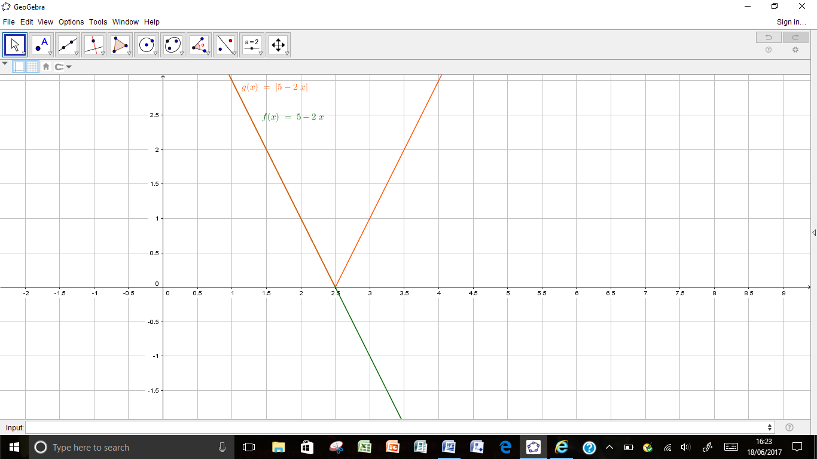

(b)

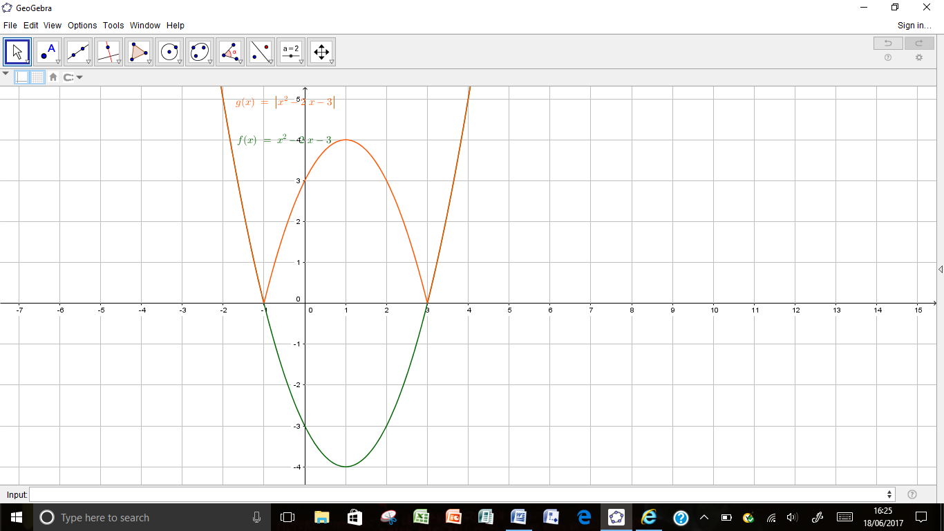

(c)

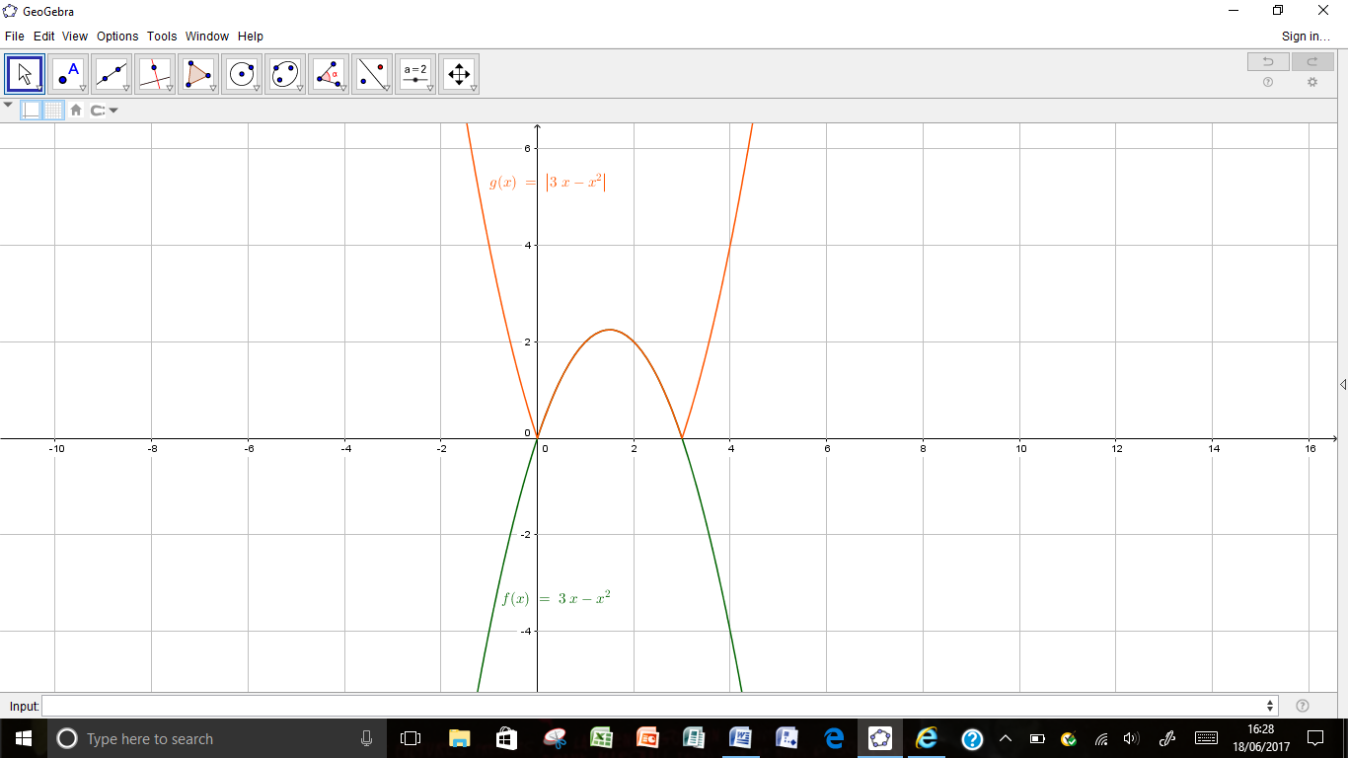(d)

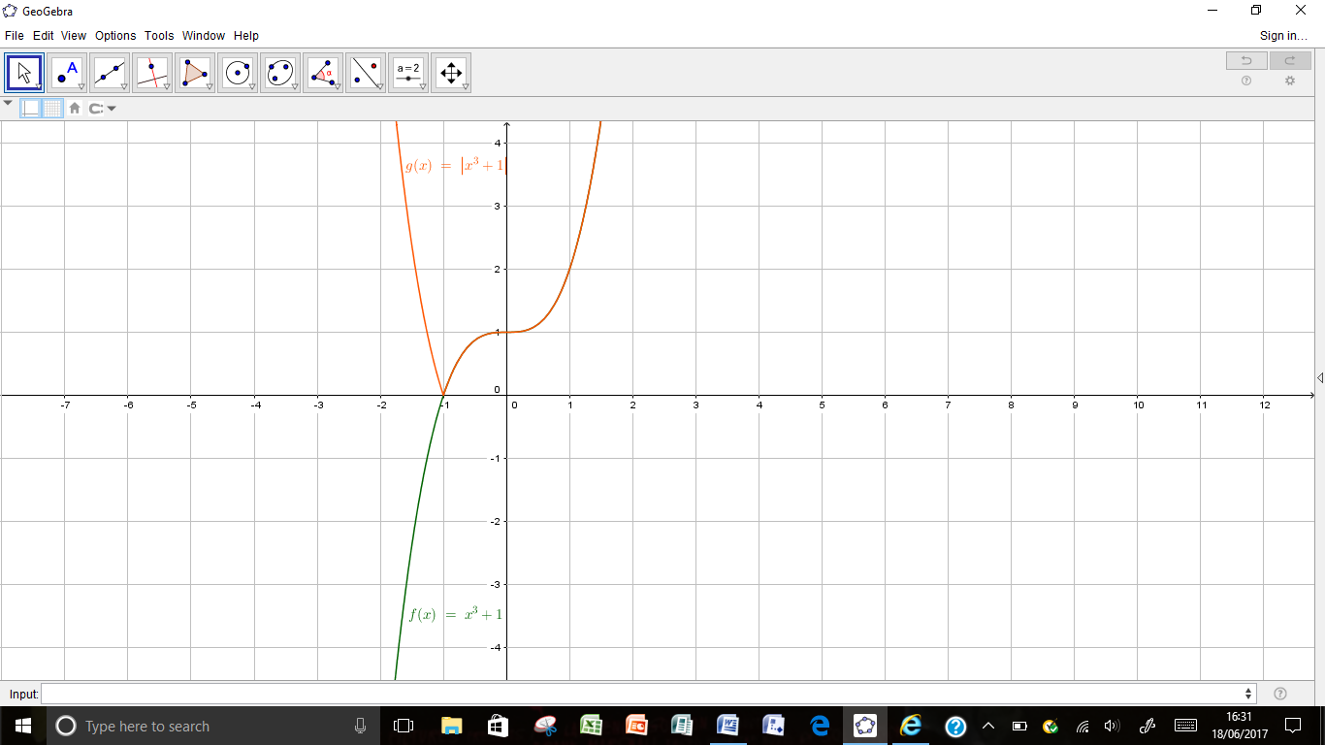

(e)

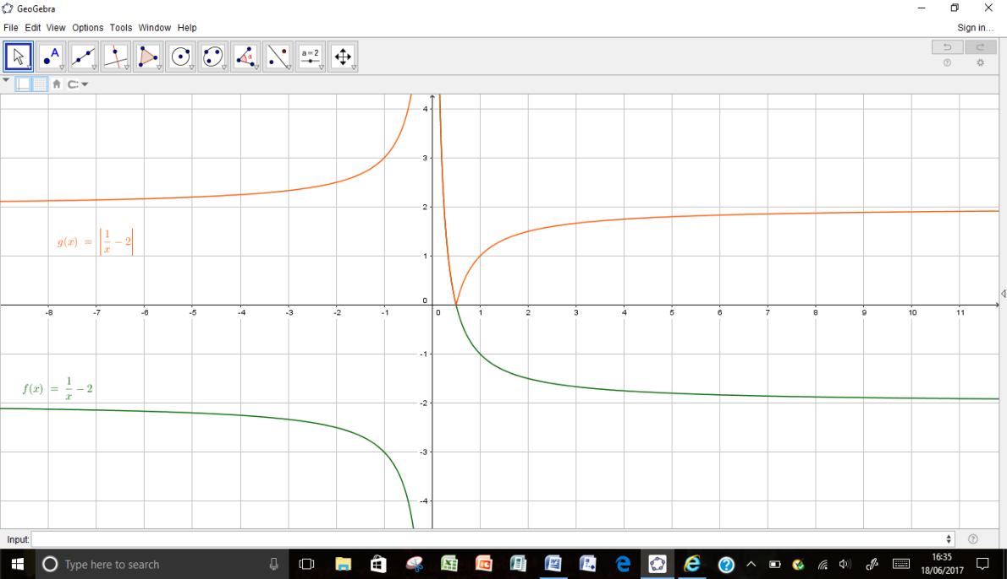

(f)

$\left(a\right) f\left(x\right)=\left(x+4\right)\left(x-2\right)=x^{2}+2x-8 ; Since powers both odd and even :Neither$

$$\left(b\right) f\left(x\right)={3x}^{2}+5 ; Even powers only ; f\left(-x\right)={3x}^{2}+5=f\left(x\right) ; Even function$$

$$\left(c\right) f\left(x\right)={2x+x}^{3} ; Odd powers only ; f\left(-x\right)=-2x-x^{3}=-f\left(x\right) ; Odd function$$

$$\left(d\right) f\left(x\right)=sin2x ; f\left(-x\right)=\sin\left(-2x\right)=-sin2x=-f\left(x\right) ; Odd function$$